A versatile approach to evaluate the occurrence of microfibers in mussels Mytilus galloprovincialis from the Tyrrhenian Sea

Michela Volgare¹†, Serena Santonicola^{1,2}†, Mariacristina Cocca¹*, Roberto Avolio¹, Rachele Castaldo¹, Maria Emanuela Errico¹, Gennaro Gentile¹, Gennaro Raimo², Maurizio Gasperi², Giampaolo Colavita²

¹ Institute for Polymers, Composites and Biomaterials, National Research Council of Italy, Via Campi Flegrei 34, 80078, Pozzuoli (NA) Italy
² Department of Medicine and Health Sciences “V. Tiberio”, University of Molise, Via F. De Santis, 86100 Campobasso, Italy

* Corresponding author: Mariacristina Cocca (mariacristina.cocca@ipcb.cnr.it)
†These authors contributed equally to this work.

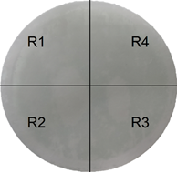
Fig. S1. Representation of filter surface divided in four ideal frames, related to “Filter observation and identification of microfibers” section.

- 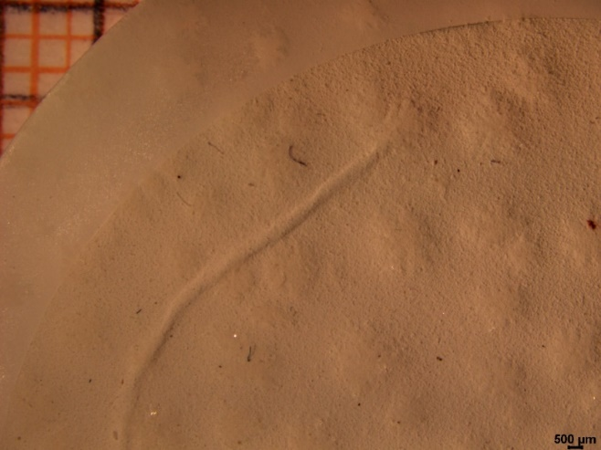
- 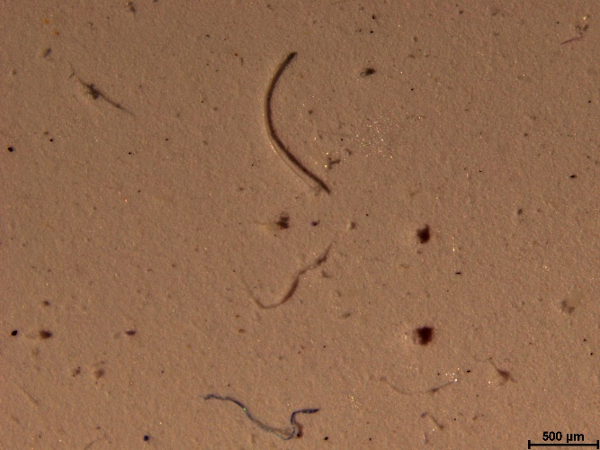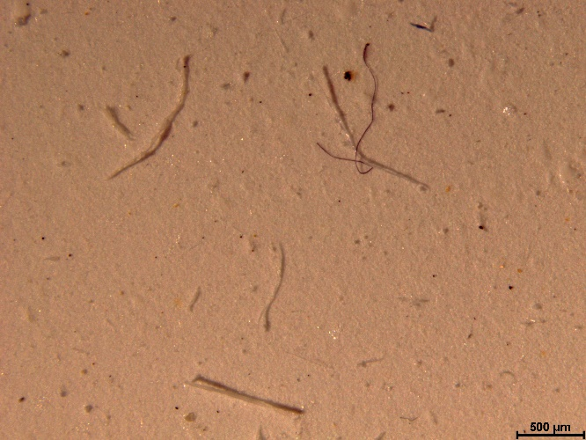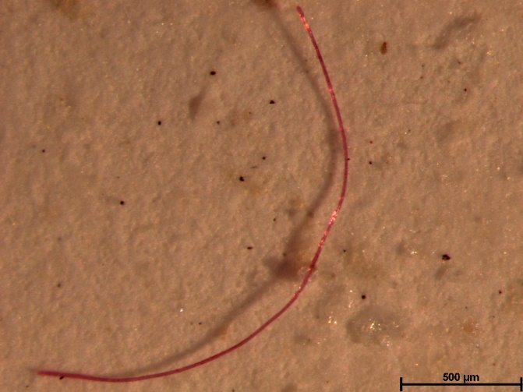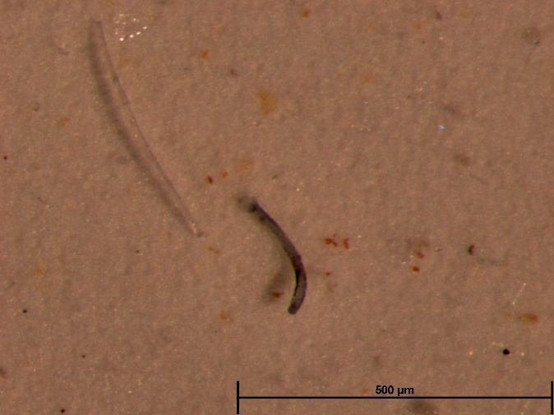
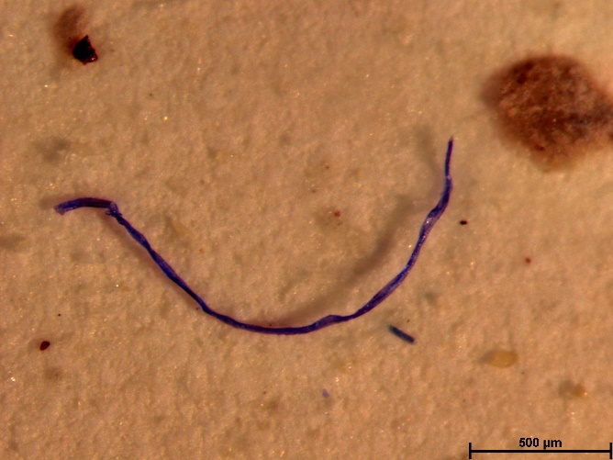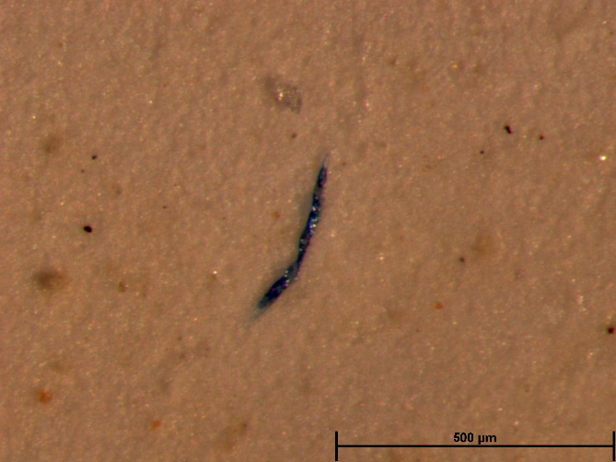
Fig. S2. a) Micrograph of filter surface with a magnification of 0.78x b) Micrographs of natural and synthetic fibers recovered from filter surface at different magnification, related to “Filter observation and identification of microfibers” section.

Table S1. Kruskal-Wallis test on number of microfibers observed per g wet weight (MF/g w.w.) in mussels with size <4.5g w.w. (group I), from 4.5 to 6.0 g w.w. (group II), and >6.0g w.w. (group III), related to “Mussel size and microfiber content” section.
Hypothesis Test Summary
 | Null Hypothesis | Test | Sig. | Decision
1 | The distribution of MF/g w.w. is the same across categories of size. | Independent-Samples Kruskal-Wallis Test | .047 | Reject the null hypothesis.
Asymptotic significances are displayed. The significance level is .050.

Table S2. Pairwise comparison of the Kruskal Wallis test on microfiber per gram wet weight (MF/g w.w.) observed in mussels with size <4.5g w.w. (group I), from 4.5 to 6.0 g w.w. (group II), and >6.0g w.w. (group III), related to “Mussel size and microfiber content” section.
Pairwise Comparisons of size
Sample 1-Sample 2 | Test Statistic | Std. Error | Std. Test Statistic | Sig. | Adj. Sig.
III-II | 10.820 | 5.078 | 2.131 | .033 | .099
III-I | 11.055 | 5.078 | 2.177 | .029 | .088
II-I | .235 | 5.000 | .047 | .962 | 1.000
Each row tests the null hypothesis that the Sample 1 and Sample 2 distributions are the same.
Asymptotic significances (2-sided tests) are displayed. The significance level is .05.

Table S3. Pearson correlation among microfiber per gram wet weight (MF/g w.w.) and mussel size (g w.w.), related to Figure 3.

Correlations
 |  | MF/g | size
MF/g w.w. | Pearson Correlation | 1 | -.339*
MF/g w.w. | Sig. (2-tailed) |  | .016
MF/g w.w. | N | 50 | 50
size | Pearson Correlation | -.339* | 1
size | Sig. (2-tailed) | .016
size | N | 50 | 50
*. Correlation is significant at the 0.05 level (2-tailed).

Table S4. ANOVA on average length of microfibers recovered from filter after the digestion and filtering process performed on mussels with a size <4.5g w.w. (group I), from 4.5 to 6.0 g w.w. (group II), and >6.0g w.w. (group III), related to “Characteristics of recovered microfibers” section.
ANOVA
 | Sum of Squares | df | Mean Square | F | Sig.
Between Groups | 425833.311 | 2 | 212916.656 | 2.242 | .118
Within Groups | 4464369.353 | 47 | 94986.582
Total | 4890202.665 | 49

Table S5. Pearson correlations among lengths of microfibers recovered from filter and mussel size (g w.w.), related to Figure 7.

Correlations
 |  | size | length
size | Pearson Correlation | 1 | -.159
size | Sig. (2-tailed) |  | .271
size | N | 50 | 50
length | Pearson Correlation | -.159 | 1
length | Sig. (2-tailed) | .271
length | N | 50 | 50

