Unsupervised Ensemble Learning Using High-dimensional Spectroscopy Data of Organic Compounds
Kedan He*, Djenerly G. Massena
* Correspondence: hek@easternct.edu

Department of Physical Sciences, School of Arts and Sciences, Eastern Connecticut State University, Willimantic, CT 06226, USA.

Table of Contents

Appendix 0. GitHub Repository.................................................................................................................S2

Appendix A. Terminology and Definition...............................................................................................S2
Appendix B. Calculation of Vibrational Spectra of NPS Compounds.............................................S3
Appendix C. Spectrum Simulation Using Lorentzian Broadening..................................................S4
Appendix D. Spectral and Chemical Structure Similarity Measure.................................................S5
Appendix E. NPS Compound Dataset Cluster Label Assignment.................................................S6
Appendix F. Additional Results Not Presented in Manuscript.........................................................S8

Appendix 0. GitHub Repository

For additional files and python codes used in this study, please go to the following GitHub repository: https://github.com/nina23bom/Cluster-Ensemble-Selection-Project

Appendix A. Terminology and Definition
Dataset $X=\left\{x_{1},…,x_{N}\right\}$ with $N$ data points, datapoint $x_{p}∈X$;
Each datapoint $x_{p}=(x_{p,1},…,x_{p,D})$ is represented by a vector of $D$ attribute values (or features);
Full ensemble of base clustering library $Π=\left\{π_{1},…,π_{M}\right\}$ with $M$ base clustering ensemble members, $π_{i}∈Π$;
Each base clustering solution $π_{i}=\left\{C_{1}^{i},C_{2}^{i}…,C_{k_{i}}^{i}\right\}$ is an $N$-dimensional vector denotes a set of cluster labels of $N$ data points, $k_{i}$ is the number of clusters in the $i$-th run of the clustering;
$G$ multiple subsets of full ensemble are formed using Hierarchical Cluster and Select (HCAS) method with different quality indices $Q_{g}$, $Π^{S}=\{Π_{1}^{S},…,Π_{G}^{S}\}$, where $g=(1,…,G)$;
A subset of full ensemble $Π_{g}^{S}=\{π_{1},…,π_{J_{g}}\}$ has $J_{g}$ selected ensemble members, where $J_{g}≤M$;
Direct combination (DC) strategy directly combining selected ensemble members in each subset $Π_{g}^{S}$to obtain a new subset $Π_{DC}^{S}=Π_{1}^{S}∪Π_{2}^{S}{∪⋯∪Π}_{G}^{S}=\left\{π_{1},…,π_{H}\right\}$, where $H≤M$;
Weighted combining (WC) strategy calculated the weight $χ\left(π_{i}\right)$ of each ensemble member $π_{i}$ based on the weights of the subsets and individual weight $w_{j}^{g}$ of ensemble member in each subset as:
$$χ\left(π_{i}\right)=\sum_{g=1}^{G}{\tilde{w_{g}}}∙w_{i}^{g}$$
and choose $J^{*}$ ensemble members with the largest weights by considering all the subsets for the final reduced ensemble subset $Π_{WC}^{S}=\left\{π_{1},…,π_{J^{*}}\right\}$, where $J^{*}≤M$.
Bagging combining (BC) strategy mapping $T$ rankings of $H$ selected ensemble members in $Π_{DC}^{S}$ into a single combined ranking. The top-ranked ensemble members forming the final reduced ensemble subset $Π_{BC}^{S}=\left\{π_{1},…,π_{J^{*}}\right\}$, where $J^{*}≤H$.
A consensus function generates the final consensus partition $π^{*}$ ($π^{*}=C_{1}^{*},…C_{K}^{*}$) using the final reduced ensemble subset $Π_{DC}^{S}$, $Π_{WC}^{S}$, or $Π_{BC}^{S}$, where $K$ denotes the number of clusters in the final clustering partition result of a dataset $X$.

Appendix B. Calculation of Vibrational Spectra of NPS Compounds
A total of 127 unique NPS compounds were selected. These include 17 natural or synthetic opioids, 62 stimulants (piperidines, tropane alkaloids, amphetamines, cathinones, aminoindanes, and benzofurans), 35 hallucinogens (2C, 2C-B, and 2C-T series and tryptamines), 6 sedatives (benzodiazepines), and 7 cannabinoids. A total of 10 low-energy conformers were generated by PubChem3D[1, 2], which samples the energetically accessible and biologically relevant conformations of chemical structures using the average atomic pair-wise rmsd.

The geometry optimizations were performed using the Gaussian 16 program using the B3LYP level of DFT in combination with the 6-311++G(d, p) basis set. Redundant conformers converged to the same structure were eliminated from the dataset. The harmonic vibrational wavenumbers of all conformers were determined at the corresponding optimized structures, which were confirmed to be local minima by checking that there were no imaginary frequencies. The vibrational normal modes were optimized using the scaling factor (0.971) derived from comparing to experimental gas-phase IR data from NIST.

The dynamic Raman scattering activity$S_{i}$ was calculated with the polarizability gradient method with laser excitation wavelength set at 785 nm, which corresponds to a wavelength of 12739 cm^{–1} and 0.0580 Hartree.

Raman intensities have been calculated as:[3]
$$I_{i}=C\frac{S_{i}}{{\tilde{ν}}_{i}}\frac{{({\tilde{ν}}_{0}-{\tilde{ν}}_{i})}^{4}}{1-exp⁡(-\frac{hc{\tilde{ν}}_{i}}{k_{B}T})}$$
where C is a constant, ${\tilde{ν}}_{i}$ is the wavenumber of normal mode after scaling, ${\tilde{ν}}_{0}$ is the incident wavenumber (785 nm or 12739 cm^{–1}), $h$ and $k_{B}$ are Planck and Boltzmann constants, respectively, and $c$ is speed of light, $T$ is temperature which is assumed to be 300 K.

Appendix C. Spectrum Simulation Using Lorentzian Broadening
The spectrum simulation python code reads molecule’s DFT calculated vibrational spectrum (normal mode frequency X, IR or Raman intensity Y) and generate the simulated experimental spectrum.
The peaks of the simulated spectrum are widened using the probability density function of the Lorentzian distribution [4]:

$$f\left(x\right)=\frac{1}{πγ(1+{\left(\frac{x-x_{0}}{γ}\right)}^{2})}=\frac{1}{πγ}\left(\frac{γ^{2}}{{\left(x-x_{0}\right)}^{2}+γ^{2}}\right), (1)$$
where $x_{0}$ is the frequency X from the input file, and $γ$ is the scale parameter which specifies the half-width at half-maximum (HWHM).
In a distribution, full width at half maximum (FWHM)[5] is the difference between the two values of the independent variable at which the dependent variable is equal to half of its maximum value. In other words, it is the width of a spectrum curve measured between those points on the y-axis which are half the maximum amplitude. Half width at half maximum (HWHM) is half of the FWHM if the function is symmetric, hence:
$$γ=\frac{FWHM}{2}, (2)$$
Single ideal peak (X, Y) is widened by
$$y=Yf\left(x\right), (3)$$
However, when a customized FWHM is used, $f(x)$ changes accordingly and the simulated peak height $y$ is not equal to the given peak height Y anymore. In order to keep the original peak height unchanged, when $x=x_{0}=X$, it should force the $f\left(x\right)=1$, then we have:
$$f\left(x\right)=\frac{1}{πγ(1+{\left(\frac{x-x_{0}}{γ}\right)}^{2})}=\frac{1}{πγ}=\frac{2}{πFWHM}=1, (4)$$
$$FWHM=\frac{2}{π}, (5)$$
and we get ${FWHM}_{0}=2/π$. If the $FWHM$ is changed, $f\left(x\right)$ should be scaled by $FWHM/{FWHM}_{0}$
The equation for the simulated spectrum is the sum of all the simulated peaks
$$y_{sim}=\sum{y}$$
numpy is used to create the array for plotting the figure, matplotlib to draw the figure.

The theoretical vibrational frequencies and intensities (both IR and Raman intensities) were convoluted with a Lorentzian distribution. The FWHM of each distribution was set to 24 cm^{–1} on the basis of the estimated bandwidth observed in the NIST database. Finally, the resulting spectra were normalized with respect to the area under the curve and scaled from 0 to 1. The IR spectra and Raman spectra were truncated from 400 to 4000 cm^{–1} and 200 to 1800 cm^{–1}, respectively, with an interval of 2 cm^{–1}.

Appendix D. Spectral and Chemical Structure Similarity Measure
The similarity between two spectra, represented by vectors $x_{A}$ and $x_{B}$, is characterized by two statistical measures. The Pearson’s product moment correlation coefficient based on mean centered intensities:
$$r=\frac{\sum_{i}{(x_{A,i}-{\overline{x}}_{A})(x_{B,i}-{\overline{x}}_{B})}}{\sqrt{\sum_{i}{{(x_{A,i}-{\overline{x}}_{A})}^{2}}}\sqrt{\sum_{i}{{(x_{B,i}-{\overline{x}}_{B})}^{2}}}} (2)$$
where $x_{A,i}$ and $x_{B,i}$ are the elements of the intensity vectors representing the spectra under comparison and ${\overline{x}}_{A}$ and ${\overline{x}}_{B}$ are the mean intensity values of spectra A and B, respectively. The Spearman’s rank correlation coefficient is based on the mean of the intensity differences. A vector $d$ is the difference between the ranks of $x_{A,i}$ and $x_{B,i}$ in their respective data set:
$$ρ=1-\frac{6\sum_{i}{d_{i}^{2}}}{n∙\left(n^{2}-1\right)} (3)$$
where n is the number of elements in each vector. Both correlation coefficients range from –1 to +1. A positive Pearson score indicates that all data points are linearly associated, whereas two variables are monotonically related in Spearman correlation even if their relationship is not linear.
The chemical structural similarity is defined as the maximum common substructure (MCS) similarity ($T_{MCS}$) was calculated only on the matched heavy atoms as described:[6]
$$T_{MCS}=\frac{N_{C}}{N_{A}+N_{B}-N_{C}} \left(9\right)$$
where $N_{C}$ is the number of matched heavy atoms in MCS of molecule A and B, $N_{A}$ and $N_{B}$ are the number of heavy atoms in molecule A and B, respectively. It was calculated using the rdFMCS modules implemented in RDKit software.[7]

Appendix E. NPS Compound Dataset Cluster Label Assignment

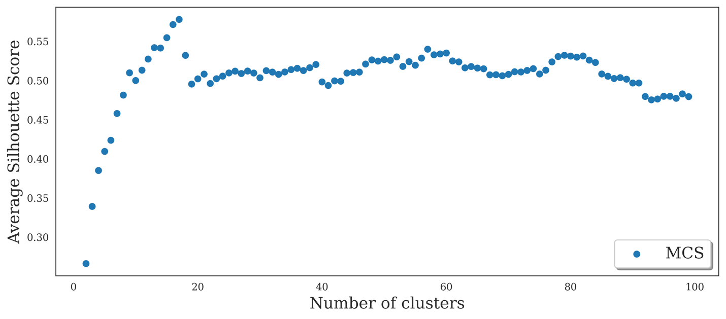
Figure S1.
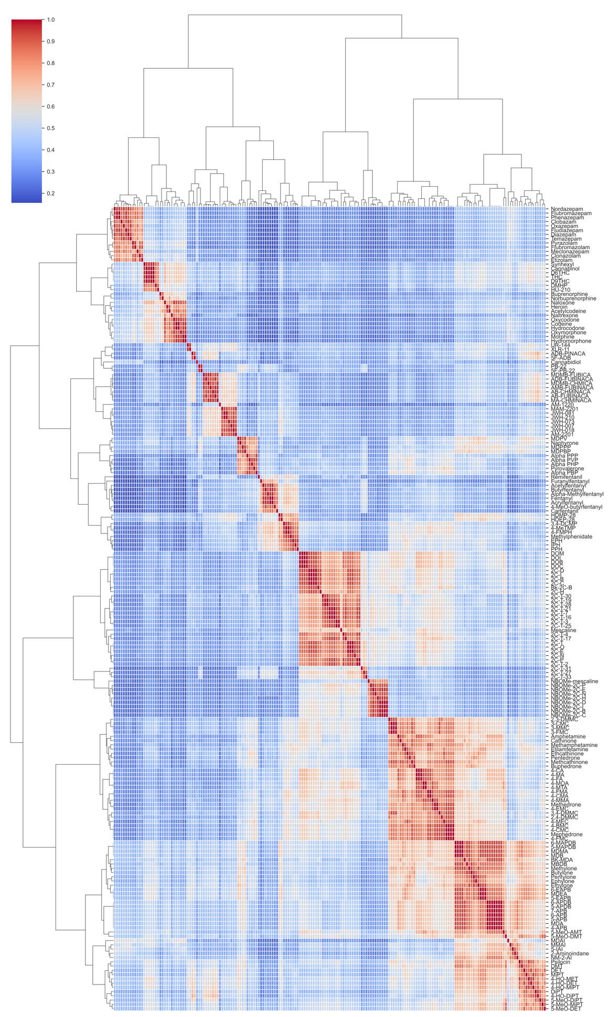
Figure S2. Heatmap of the MCS clustering of NPS compound dataset
Appendix F. Additional Results Not Presented in Manuscript
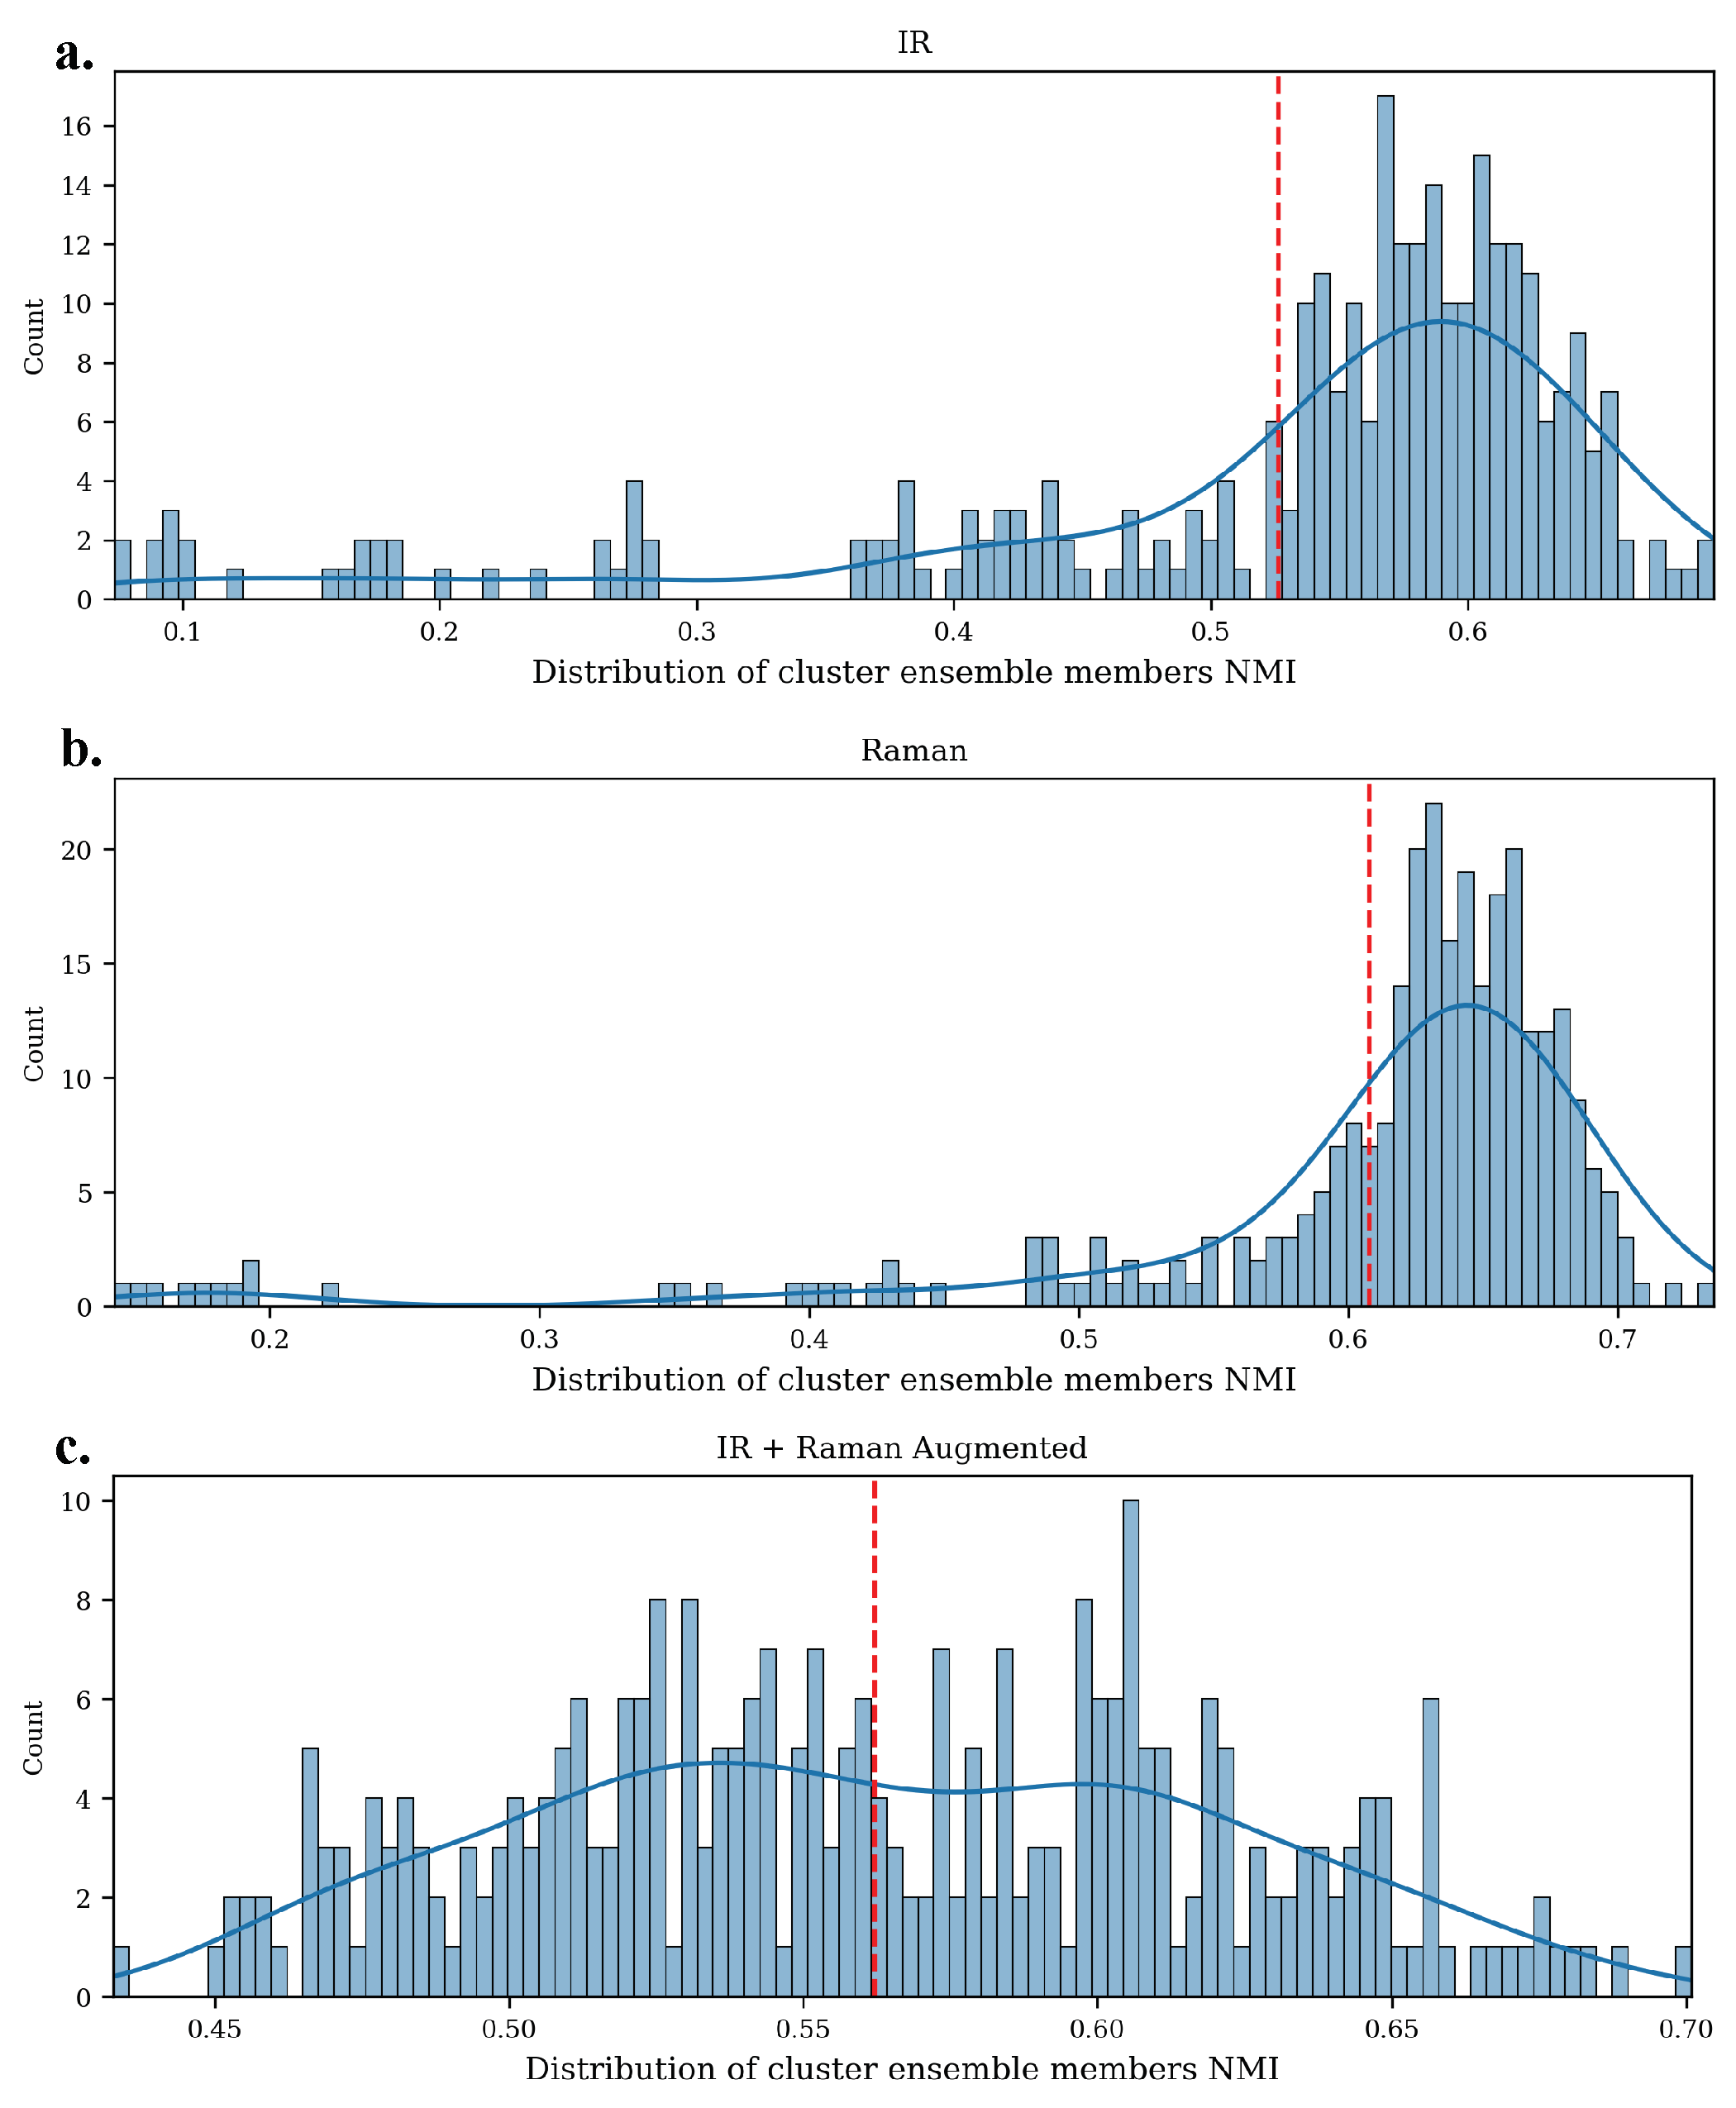
Figure S3. Distribution of cluster ensemble members' NMI.
The vertical red dashed line represents the average NMI of all ensemble members.
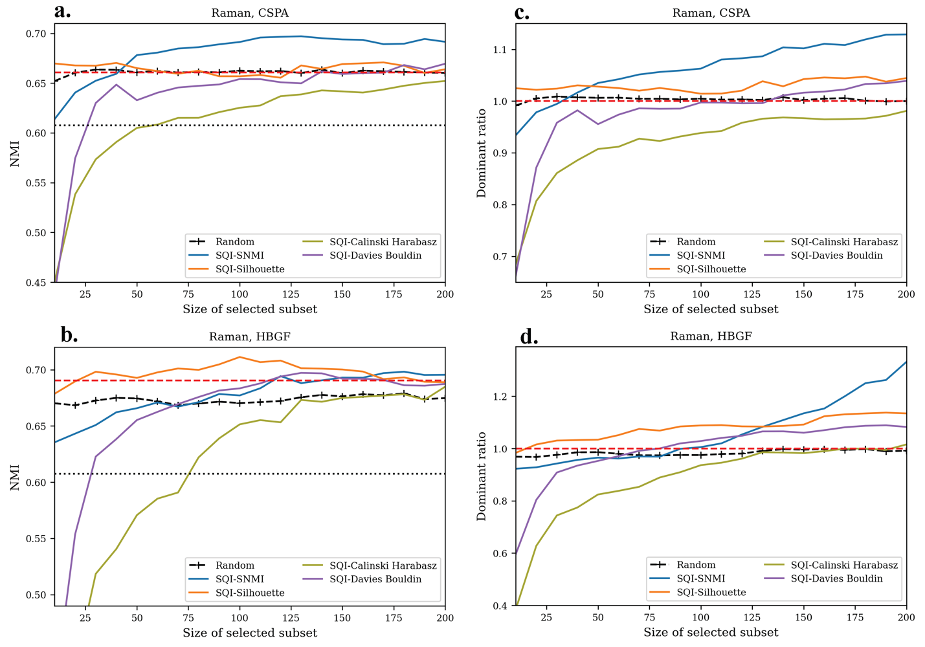
Figure S4. Performance of SQI using different quality indices and consensus function using Raman dataset

Table S1. Results of HCAS-SQI using CSPA consensus function and Raman Dataset
 | Q₁-SNMI |  | Q₂-Silhouette
 | NMI | Dominant ratio | NMI | Dominant ratio
single | 0.693 | 1.06 | 0.668 | 1.05
complete | 0.700 | 1.08 | 0.672 | 1.04
average | 0.695 | 1.07 | 0.673 | 1.04
weighted | 0.694 | 1.07 | 0.670 | 1.04
ward | 0.698 | 1.08 | 0.672 | 1.04

1. Kim, S., et al., (2021) PubChem in 2021: new data content and improved web interfaces. Nucleic Acids Res. 49: D1388–D1395.
2. Bolton, E.E., et al., (2011) PubChem3D: a new resource for scientists. J. Cheminf. 3: 32-32 DOI: 10.1186/1758-2946-3-32.
3. Polavarapu, P.L., (1990) Ab initio vibrational Raman and Raman optical activity spectra. J. Phys. Chem. 94: 8106-8112 DOI: 10.1021/j100384a024.
4. Johnson, N.L., Kotz, S., and Balakrishnan, N., (1994). Continuous Univariate Distributions, Volume 1. New York: Wiley. Chapter 16.
5. Weik, M.H., (2001). full-width at half-maximum, in Computer Science and Communications Dictionary. Springer US: Boston, MA. p. 661-661.
6. Zhang, B., et al., (2015) Design of chemical space networks using a Tanimoto similarity variant based upon maximum common substructures. J. Comput.-Aided Mol. Des. 29: 937-950 DOI: 10.1007/s10822-015-9872-1.
7. RDKit: Open-source cheminformatics; http://www.rdkit.org

