Supplemental Material

List of Content

- Supplemental Methods
- Detection of hotspot mutations in JMML
- Next-generation sequencing
- Supplemental Figures
- Figure S1. ROC analysis for determining the optimal cutoff value in predicting OS for RDW-CV.
- Figure S2. Details of treatment therapies of patients receiving HSCT
- Figure S3. Kaplan–Meier curves for overall survival of JMML patients according to RDW-CV
- Figure S4. Kaplan–Meier curves for overall survival of JMML patients according to the combination of PTPN11 mutation, HSCT and RDW-SD level.
- Figure S5. Kaplan–Meier curves for overall survival of JMML patients according to the combination of KRAS or NRAS mutation and RDW-SD level.
- Figure S6. Kaplan–Meier curves for overall survival of JMML patients according to the combination of KRAS/NRAS/NF1 mutation or PTPN11 mutation and RDW-SD level.
- Supplemental Tables
- Table S1. Mutations in canonical and secondary genes
- Table S2. Comparison of cytokines in RDW-low and high groups(detected by immunological method)
- Table S3. Comparison of Cytokines in RDW-low and high groups (detected by flow cytometry)
- Table S4. Comparison of PTPN11 mutation and non-PTPN11 mutation
- Table S5. Details of treatment therapies (N=24)
- Table S6. Other clinical and laboratory features of patients with JMML

1. Supplemental Methods
  - Detection of hotspot mutations in JMML
Genomic DNA was extracted using the EZNA blood DNA Midi Kit (Omega Bio-Tek, Norcross, GA, USA). DNA samples were sequenced using the MiSeq platform (Illumina, San Diego, CA), which is a custom, targeted, amplicon-based sequencing approach by next-generation sequencing. Libraries were prepared with a custom amplicon panel targeting PTPN11, NRAS, KRAS, NF1, and CBL genes, including KRAS exon 2, NRAS exon 2, 3, CBL exon 7, 8, 9, PTPN11 exon2,3,4,7,8,12,13,14, NF1 exon 35, which are recurrently mutated in JMML.
  - Next-generation sequencing
    - Targeted gene sequencing
DNA from bone marrow aspirates was extracted and prepared for sequencing. Each DNA sample was quantiﬁed by agarose gel electrophoresis and Nanodrop2000 (Thermo, Wilmington, Delaware, USA). Libraries were prepared using Illumina’s standard protocol. The amplified DNA was captured with a 112 Gene Panel using biotinylated oligo-probes (MyGenostics GenCap Enrichment technologies, Beijing, China). The capture experiment was conducted according to the manufacturer’s protocol. Illumina utilizes a unique "bridged" amplification reaction that occurs on the surface of the flow cell. A flow cell containing millions of unique clusters is loaded into the HiSeq 2000 for automated cycles of extension and imaging. Illumina's Sequencing-by-Synthesis utilizes four proprietary nucleotides possessing reversible fluorophore and termination properties. Each sequencing cycle occurs in the presence of all four nucleotides leading to higher accuracy than methods where only one nucleotide is present in the reaction mix at a time. This cycle is repeated, one base at a time, generating a series of images each representing a single base extension at a specific cluster.
    - Basic bioinformatics analysis
For nuclear gene sequencing analysis, high-quality reads were retrieved from raw reads by filtering out low quality reads and adaptor sequences using the Solexa QA package and the cutadapt program (http://code.google.com/p/cutadapt/), respectively. SOAPaligner program was then used to align the clean read sequences to the human reference genome (hg19).
After the PCR duplicates were removed by the Picard software, the SNPs were firstly identified using the SOAPsnp program (http://soap.genomics.org.cn/soapsnp.html). Subsequently, we realigned the reads to the reference genome using BWA and identified the insertions or deletions (InDels) using the GATK program (http://www.broadinstitute.org/gsa/wiki/index.php/Home_Page). The identified SNPs and InDels were annotated using the Exome-assistant program (http://122.228.158.106/exomeassistant). MagicViewer was used to view the short read alignment and validate the candidate SNPs and InDels.
    - Sequence variant annotation
Once low confidence (Depth <5 or VAF <2%) or likely polymorphisms were removed from the dataset, each high confidence variant was annotated by 1000 Genomes, ESP6500, Inhouse, PolyPhen, SIFT and COSMIC to determine pathogenicity.
    - Germline mutation exclusion
To ascertain possible germline mutations, oral epithelial cells from every patient were collected as matched control samples. DNA from oral epithelial cells was extracted and prepared for sequencing. Pathogenic variants observed in bone marrow DNA were tested in matched control samples using Sanger sequencing to exclude germline mutations.
    - The list of 112 AML and MDS related Gene Panel
ABCB1 | ABL1 | ADAMTS13 | AKT1 | ALAS2 | ARID1A | ASXL1 | ATM
BCL2 | BCL6 | BIRC3 | BRAF | CALR | CBL | CCND1 | CCND3
CDKN1A | CEBPA | MAF | MYC | CREBBP | CRLF2 | CSF3R | CUX1
CXCR4 | CYLD | DDX3X | DIS3 | DNM2 | DNMT3A | ECT2L | EED
EGFR | EP300 | EPHA7 | EZH2 | FAM46C | FANCA | FANCC | FANCG
FAT1 | FBXW7 | FGFR3 | FLT3 | GATA2 | GATA3 | IDH1 | IDH2
IKZF1 | IL7R | ITK | JAK1 | JAK2 | JAK3 | KIT | KRAS
SH2B3 | LYST | MAFB | MAPK1 | MLL2 | MPL | MUM1 | MYD88
MYH11 | NF1 | NOTCH1 | NOTCH2 | NPM1 | NRAS | PAX5 | PDGFRB
PHF6 | PIK3CA | PRDM1 | PRF1 | PRMT5 | PRPF40B | PTEN | PTPN11
RAB27A | RB1 | RELN | RUNX1 | SAMHD1 | SETBP1 | SF1 | SF3A1
SF3B1 | SH2D1A | SMC1A | SMC3 | SRSF2 | STX11 | STXBP2 | SUZ12
TAL1 | TEL | TET2 | TNFAIP3 | TP53 | TRAF3 | U2AF1 | U2AF2
UNC13D | WAS | WHSC1 | WT1 | XIAP | XPO1 | ZMYM3 | ZRSR2

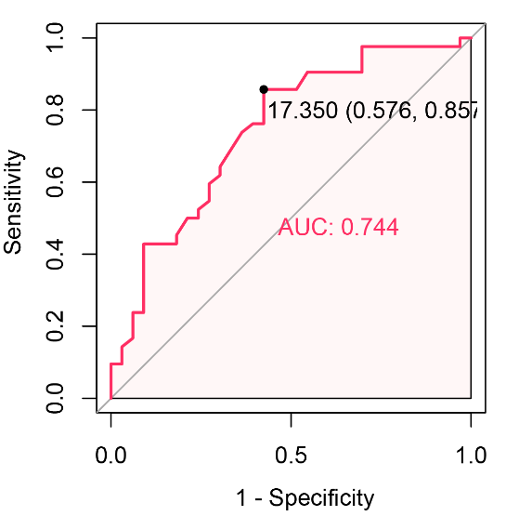
Figure S1. ROC analysis for determining the optimal cutoff value in predicting OS for RDW-CV.
Abbreviations: ROC=receiver operating characteristic curve, OS=overall survival. RDW-CV= red cell distribution width coefficient of variation

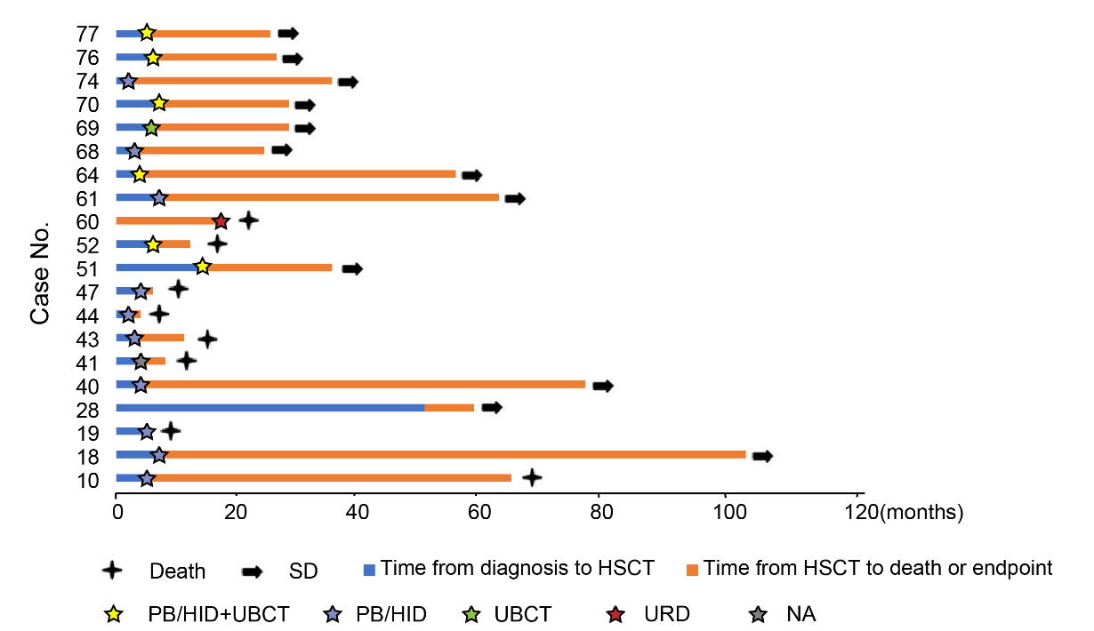
Figure S2. Details of treatment therapies of patients receiving HSCT
Abbreviations: HSCT=hematopoietic stem cell transplantation; SD=stable disease; PB/HID= peripheral blood/haploidentical donor; UBCT= umbilical cord blood transplantation; URD=unrelated donor; NA= not any.
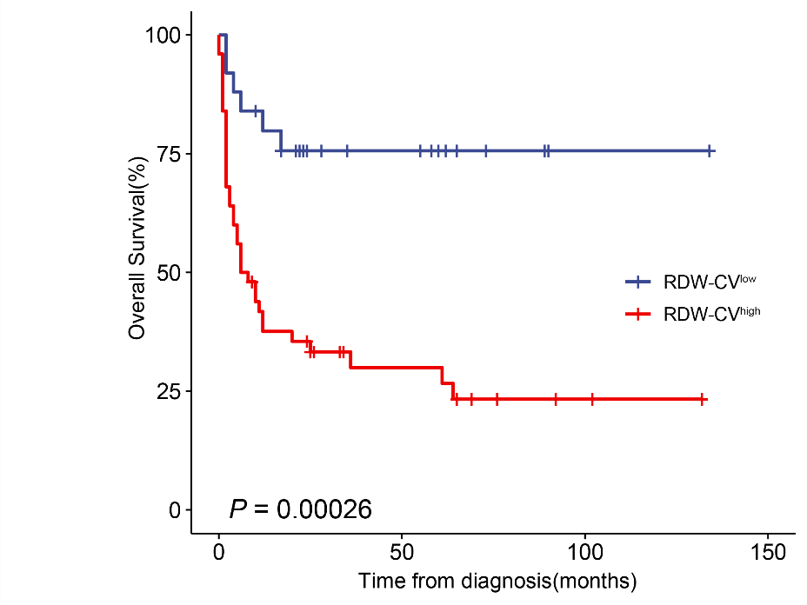
Figure S3. Kaplan–Meier curves for overall survival of JMML patients according to RDW-CV
Abbreviations: RDW-CV=red cell distribution width coefficient of variation.

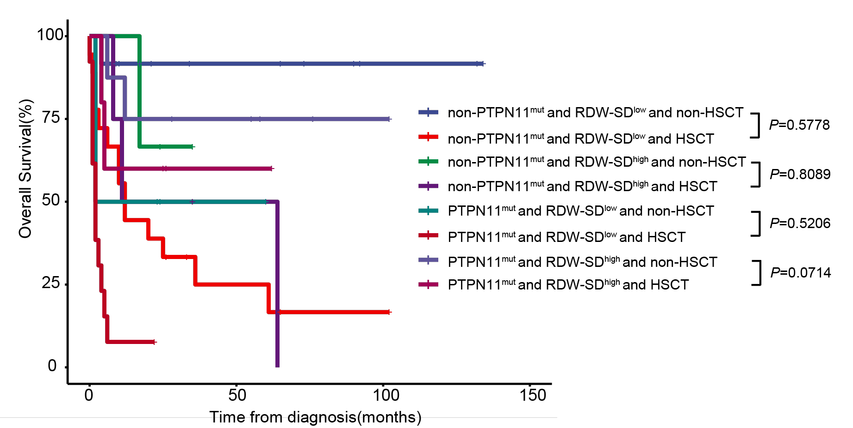
Figure S4. Kaplan–Meier curves for overall survival of JMML patients according to the combination of PTPN11 mutation, HSCT and RDW-SD level.
Abbreviations: HSCT=hematopoietic stem cell transplantation; RDW-SD=red cell distribution width standard deviation.

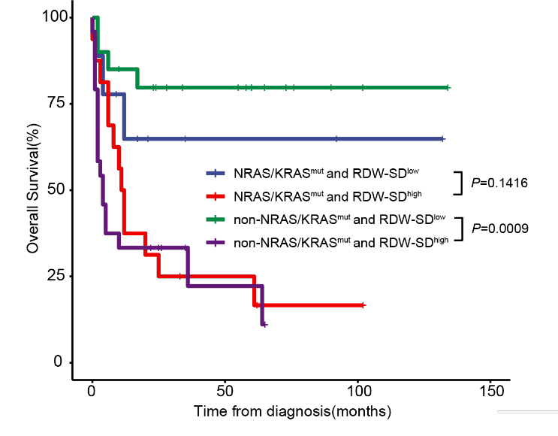
Figure S5. Kaplan–Meier curves for overall survival of JMML patients according to the combination of KRAS or NRAS mutation and RDW-SD level.
Abbreviations: RDW-SD=red cell distribution width standard deviation.
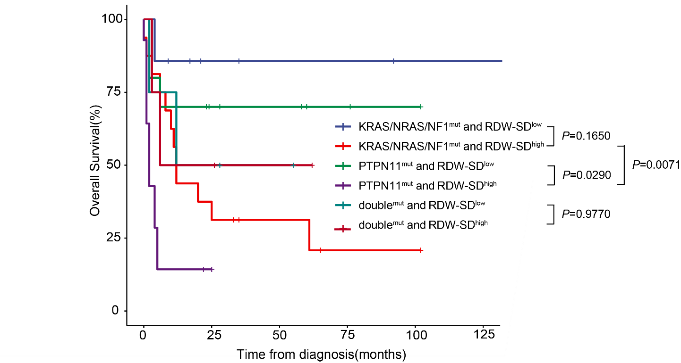
Figure S6. Kaplan–Meier curves for overall survival of JMML patients according to the combination of KRAS/NRAS/NF1 mutation or PTPN11 mutation and RDW-SD level.
Abbreviations: RDW-SD=red cell distribution width standard deviation.

Gene | Pathway | NCBI gene ID | Position
PTPN11 | Ras pathway | 5781 | 12q24.13
NRAS | Ras pathway | 4893 | 1p13.2
KRAS | Ras pathway | 3845 | 12p12.1
NF1 | Ras pathway | 4763 | 17q11.2
DNMT3A | DNA methylation | 1788 | 2p23
SETD2 | DNA methylation | 29072 | 3p21.31
TET2 | DNA methylation | 54790 | 4q24
ARID1A | Chromatin & histones modifier | 8289 | 1p36.11
ASXL1 | Chromatin & histones modifier | 171023 | 20q11.1
EP300 | Chromatin & histones modifier | 2033 | 22q13.2
KMT2A | Chromatin & histones modifier | 4297 | 11q23.3
KMT2D | Chromatin & histones modifier | 8085 | 12q13.12
TCF3 | Transcription regulation | 6929 | 19p13.3
SETBP1 | Transcription regulation | 45859 | 18q12.3
ZRSR2 | RNA splicing | 8233 | Xp22.1
JAK3 | Signaling | 3718 | 19p13.11
NOTCH1 | Signaling | 4851 | 9p34.3
NOTCH2 | Signaling | 4853 | 1p12
SH2B3 | Signaling | 10019 | 12q24.12
MPL | Signaling | 4352 | 1p34
ATM | Signaling | 472 | 11q22.3
PTEN | Tumor suppressor | 5728 | 10q23.31
FAM46C | Tumor suppressor | 54855 | 1p12
FAT1 | Tumor suppressor | 2196 | 4q35.2
MYH11 | Others | 4629 | 16p13.11
CCND3 | Others | 896 | 6p21.1
Table S1. Mutations in canonical and secondary genes

Table S2. Comparison of cytokines in RDW-SD low and high groups (detected by immunological method)
Variable | RDW-SD-low(n=13) | RDW-SD-high(n=15) | P-value
IL-1b, pg/ml(range) | 13.80(5.00-318.00) | 35.60(5.00-172.00) | 0.738
IL-2R, U/L(range) | 3064.00(246.00-4538.00) | 3128.00(859.00-6045.00) | 0.703
IL-6, pg/ml(range) | 11.12(2.90-146.00) | 23.15(6.46-124.00) | 0.111
IL-8, pg/ml(range) | 383.00(6.07-6892) | 490.50(8.38-3673) | 0.884
IL-10, pg/ml(range) | 13.10(5.64-61.40) | 9.36(5.27-93.60) | 0.501
TNF-α, pg/ml(range) | 113.50(46.30-731.00) | 141.00(45.20-889.00) | 0.573
Abbreviation: IL=interleukin; TNF=tumor necrosis factor; RDW-SD=red cell distribution width standard deviation.

Table S3. Comparison of Cytokines in RDW-SD low and high groups (detected by flow cytometry)
Variable | RDW-SD-low(n=5) | RDW-SD-high(n=2) | P-value
IL-1,ng/ml(range) | 0.17(0.11-0.23) | 0.30(0.13-0.43) | 0.245
IL-2,ng/ml(range) | 2.54(2.11-2.97) | 2.12(0.85-3.42) | 0.699
IL-4,ng/ml(range) | 2.57(2.04-3.10) | 1.52(1.15-2.36) | 0.121
IL-6,pg/ml(range) | 142.795(119.61-165.98) | 153.10(45.30-390.70) | 1.000
TNF,ng/ml(range) | 1.305(0.45-2.16) | 1.88(0.98-2.59) | 0.699
Abbreviation: IL=interleukin; TNF=tumor necrosis factor; RDW-SD=red cell distribution width standard deviation.

Table S4. Comparison of PTPN11 mutation and non-PTPN11 mutation
Variable | non-PTPN11 mutation(n=38) | PTPN11 mutation(n=32) | P-value
Age, months (median [IQR]) | 12.00 [10.00, 36.00] | 36.00 [21.50, 41.00] | 0.021
Gender, male n (%) | 1.21 (0.41) | 1.22 (0.42) | 0.935
WBC,×10⁹/L (median [IQR]) | 22.48 [12.15, 40.77] | 29.82 [17.20, 55.25] | 0.220
Mo,×10⁹/L (median [IQR]) | 4.20 [2.04, 7.18] | 4.18 [2.71, 5.94] | 0.807
PLT,×10⁹/L (median [IQR]) | 56.00 [31.50, 133.25] | 27.00 [17.00, 39.00] | 0.001
Hb, g/L (median [IQR]) | 93.50 [77.00, 102.00] | 95.00 [80.50, 104.00] | 0.490
MCHC, % (median [IQR]) | 316.00 [305.50, 331.00] | 305.00 [294.00, 314.50] | 0.014
LDH, U/L (median [IQR]) | 344.00 [274.00, 537.50] | 267.00 [209.00, 395.85] | 0.037
Ferritin, μg/L (median [IQR]) | 106.50 [34.55, 203.00] | 48.90 [28.60, 71.12] | 0.026
EPO, U/L (median [IQR]) | 25.19 [3.02, 51.53] | 18.33 [4.60, 37.64] | 0.686
Folic acid, nmol/L (median [IQR]) | 14.68 [10.81, 29.40] | 15.42 [13.15, 19.52] | 0.953
Vitamin B12, pg/mL (median [IQR]) | 582.05 [490.80, 792.60] | 518.60 [312.62, 826.55] | 0.605
Serum iron, μmol/L (median [IQR]) | 9.42 [8.03, 24.20] | 9.04 [5.44, 12.33] | 0.143
Erythroblast, % (median [IQR]) | 4.35 [2.02, 9.49] | 10.90 [4.23, 14.32] | 0.042
Median percentage of HbF, % (median [IQR]) | 6.65 [4.15, 14.50] | 43.10 [28.72, 51.53] | 0.001
HbF elevated for age, n (%) | 22(84.62%) | 10(35.71%) | <0.001
RDW-CV, % (median [IQR]) | 18.50 [16.80, 19.80] | 18.00 [16.60, 19.62] | 0.866
RDW-SD, fl (median [IQR]) | 54.00 [47.90, 60.20] | 52.55 [47.53, 57.88] | 0.555
Abnormal cytogenetics, n(%) | 4(10.53) | 4(12.50) | 1.000
Abbreviation: Mo=monocyte; PLT=platelet; Hb=hemoglobin; MCHC=mean corpuscular hemoglobin concentration; LDH=lactate dehydrogenase; EPO=erythropoietin; HbF=hemoglobin F; RDW-CV=red cell distribution width coefficient of variation; RDW-SD=red cell distribution width standard deviation.

Table S5. Details of treatment therapies (N=24)
Case.No | Pre-transplant therapy | HSCT donor type | Outcome
10 | N/A | Haplo | 59 mo after transplantation, die of disease progression
18 | N/A | Haplo | 65 mo after transplantation at the last follow-up, and is alive
19 | N/A | Haplo | 10 days after transplantation, die of aGVHD and MODS
28 | N/A | Unknown | 8 mo after transplantation at the last follow-up, and is alive
34 | Hydroxyurea | None | Alive at the last follow-up
36 | Hydroxyurea | None | 12 mo, die of disease progression
40 | N/A | Haplo | disease relapse 3 mo after transplantation, and receive secondary HSCT from , now disease stable
41 | N/A | Haplo | 4 mo after transplantation, die of gastrointestinal GVHD
42 | Unknown chemotherapy | None | 20mo, die of disease progression
43 | N/A | Haplo | 8 mo after transplantation, die of pulmonary infection
44 | N/A | Haplo | 2 mo after transplantation, die of pulmonary infection
47 | N/A | Haplo | 2 mo after transplantation, die of graft failure
51 | VP-16, Dac for 2 cycles | Haplo+UCBT | Relapsed 3 mo after transplantation, and receive secondary Haplo+CBT , now disease stable
52 | DAC for 6 cycles | Haplo+UCBT | 6 mo after transplantation, die of GVHD
56 | DAC for 4 cycles | None | 9 mo Alive at the last follow-up
60 | N/A | Matched unrelated | 17 mo after transplantation, die of GVHD
61 | N/A | Mismatched siblings (9/10) | 42 mo after transplantation at the last follow-up, and is alive
64 | N/A | Haplo+UCBT | 38 mo after transplantation at the last follow-up, and is alive
68 | Ara-C for 1 cycle | Haplo | 42 mo after transplantation at the last follow-up, with gastrointestinal GVHD
69 | DAC for 2 cycles | UCBT | 9 mo after transplantation at the last follow-up, and is alive
70 | DAC for 3 cycles | Haplo+UCBT | 8 mo after transplantation at the last follow-up, and is alive
72 | DAC for 1 cycle | Haplo | Early die after transplantation
74 | N/A | Haplo | 20 mo after transplantation at the last follow-up, and is alive
75 | DAC for 3 cycles | N/A | 3 mo, die of disease progression
76 | DAC for 3 cycles | Haplo+UCBT | 7 mo after transplantation at the last follow-up, and is alive
77 | DAC for 4 cycles | Haplo+UCBT | 7 mo after transplantation at the last follow-up, and is alive
Abbreviation: DAC=decitabin; HSCT=hematopoietic stem cell transplantation; UCBT=umbilical cord blood transplant; GVHD=graft versus host disease; Haplo=haploidentical transplant; CBT= cord blood transplant; N/A=not any; MODS=multiple organ dysfunction syndrome.

Table S6. Other clinical and laboratory features of patients with JMML
Variable | Value | Total cases（N）
Reticulocyte, ×10⁹/L(IQR) | 0.11 [0.07, 0.18] | 72
Reticulocyte hemoglobin equivalent，pg(IQR) | 24.90 [22.40, 27.30] | 69
MCH, pg(IQR) | 26.20 [23.80, 28.40] | 72
MCV, fl(IQR) | 83.45 [78.53, 89.32] | 72
Prothrombin time, s(IQR) | 13.80 [12.55, 15.55] | 43
D-Dimer, mg/l(IQR) | 1.00 [0.63, 3.96] | 42
Fibrinogen, g/L(IQR) | 1.93 [1.59, 2.78] | 43
Antithrombin-Ⅲ, %(IQR) | 67.10 [51.70, 86.80] | 43
International normalized ratio(IQR) | 1.17 [1.08, 1.37] | 43
Thrombin time, s(IQR) | 17.70 [16.40, 19.10] | 43
Lactic dehydrogenase, U/L(IQR) | 303.50 [240.50, 458.75] | 56
Ferritin, μg/L(IQR) | 54.00 [31.00, 109.70] | 45
EPO, U/L(IQR) | 23.00 [4.48, 44.36] | 39
Folic acid, nmol/L(IQR) | 15.90 [11.98, 21.05] | 42
Vitamin B12, pg/mL(IQR) | 547.10 [346.22, 823.75] | 42
Serum iron, μmol/L(IQR) | 9.39 [7.56, 20.95] | 27
Erythroblast, %(IQR) | 6.75 [3.10, 13.21] | 50
Immunoglobulin G, g/L(IQR) | 11.80 [10.30, 16.60] | 41
Immunoglobulin A, g/L(IQR) | 1.03 [0.48, 1.56] | 41
Immunoglobulin M, g/L (IQR) | 1.32 [0.97, 1.73] | 41
Complement 3, g/L(IQR) | 0.69 [0.47, 0.84] | 41
Complement 4, g/L(IQR) | 0.14 [0.11, 0.22] | 41
Abbreviation: MCH=mean corpuscular hemoglobin; MCV=mean corpuscular volume; EPO= erythropoietin.

