Supplementary material

Electrospun mats based on poly(vinyl fluoride-co-hexafluoropropylene) and hybrid carbon nanofillers as high performance ultrafiltration membranes
Roberto Scaffaro*, Michele Gammino, Andrea Maio
Department of Engineering, University of Palermo, Viale delle Scienze, ed. 6, 90128 Palermo (Italy).
*Corresponding author: roberto.scaffaro@unipa.it

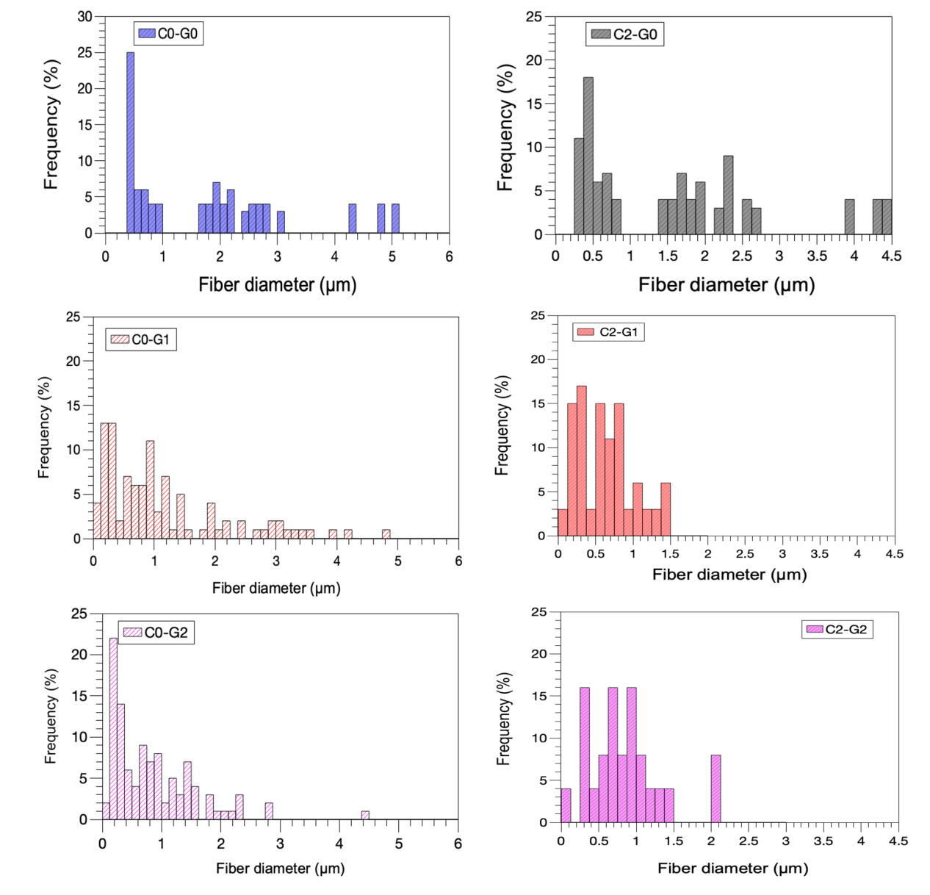
Figure S1. Size distribution of fiber diameter for the samples investigated

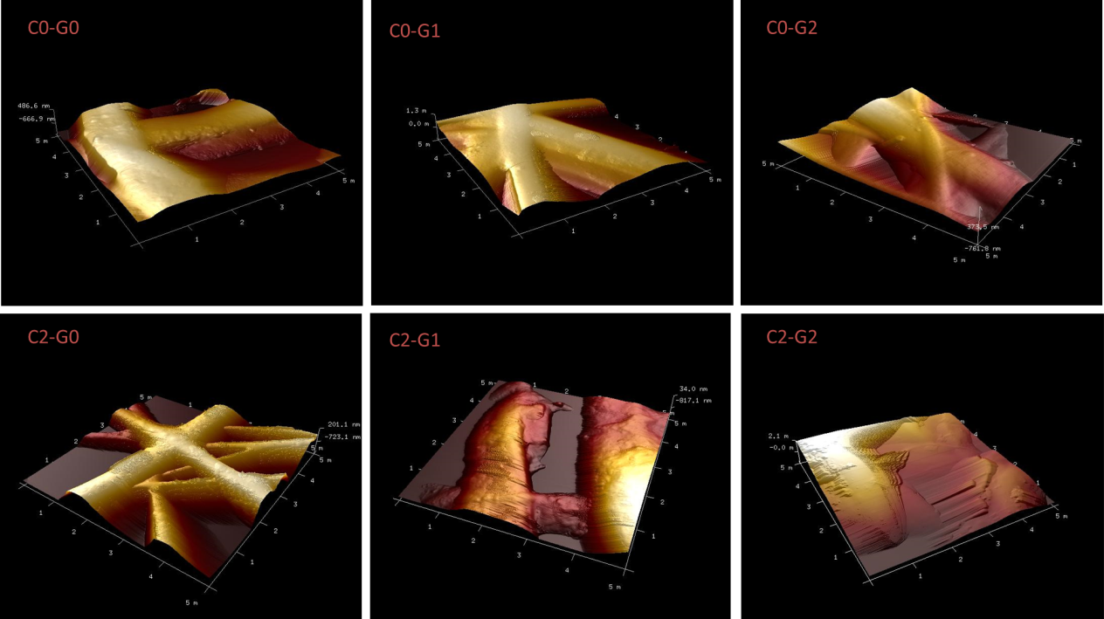
Figure S2. 3D view of AFM images recorded on squared regions (5 µm per side) of the samples
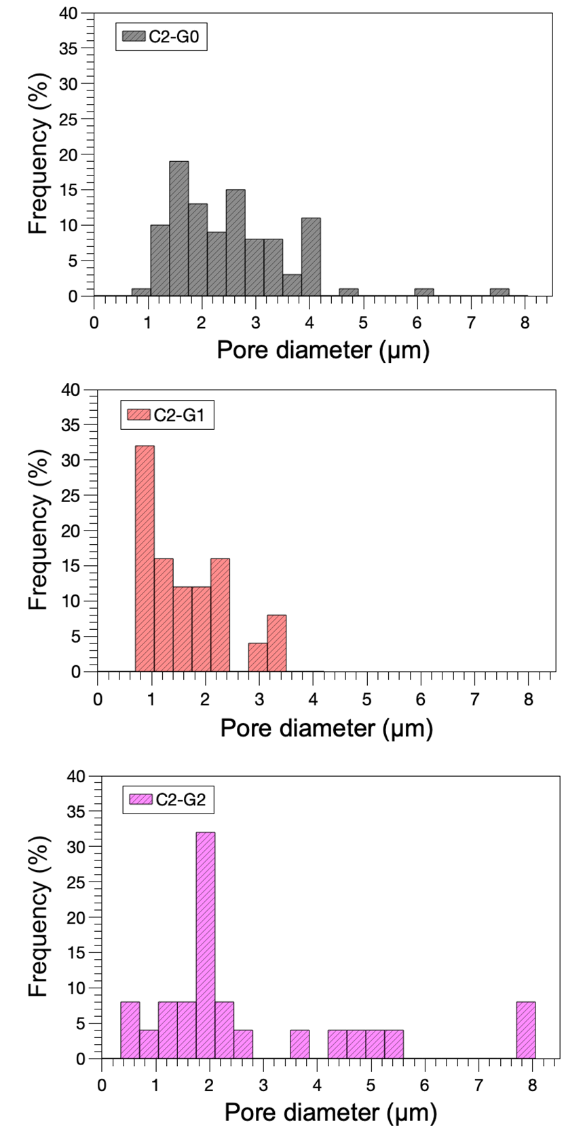
Figure S3. Pore diameter distribution of the membranes tested for vacuum-assisted ultrafiltration.

