Supporting Information:

Endogenous/Exogenous Nanovaccines Synergistically Enhance Dendritic Cell-mediated Tumor Immunotherapy
Yu Zhang^{1†}, Qiang Li^{1†}, Meng Ding¹, Weijun Xiu², Jingyang Shan³, Lihui Yuwen², Dongliang Yang⁴, Xuejiao Song⁴, Guangwen Yang¹, Xiaodan Su², Yongbin Mou^{1,*}, Zhaogang Teng^{2,*}, Heng Dong^{1,*}.
1. Nanjing Stomatological Hospital, Medical School of Nanjing University, 30 Zhongyang Road, 210008 Nanjing, China.
2. Key Laboratory for Organic Electronics and Information Displays, Jiangsu Key Laboratory for Biosensors, Institute of Advanced Materials, Jiangsu National Synergetic Innovation Centre for Advanced Materials, Nanjing University of Posts and Telecommunications, 9 Wenyuan Road 210023, Nanjing, China.
3. Department of Neurology, Shenzhen Institute of Translational Medicine, The First Affiliated Hospital of Shenzhen University, Shenzhen Second People's Hospital, Shenzhen 518000, China
4. School of Physical and Mathematical Sciences, Nanjing Tech University, 30 South Puzhu Road, 211816 Nanjing, China
Corresponding authors
Correspondence to Yongbin Mou, Zhaogang Teng, Heng Dong.

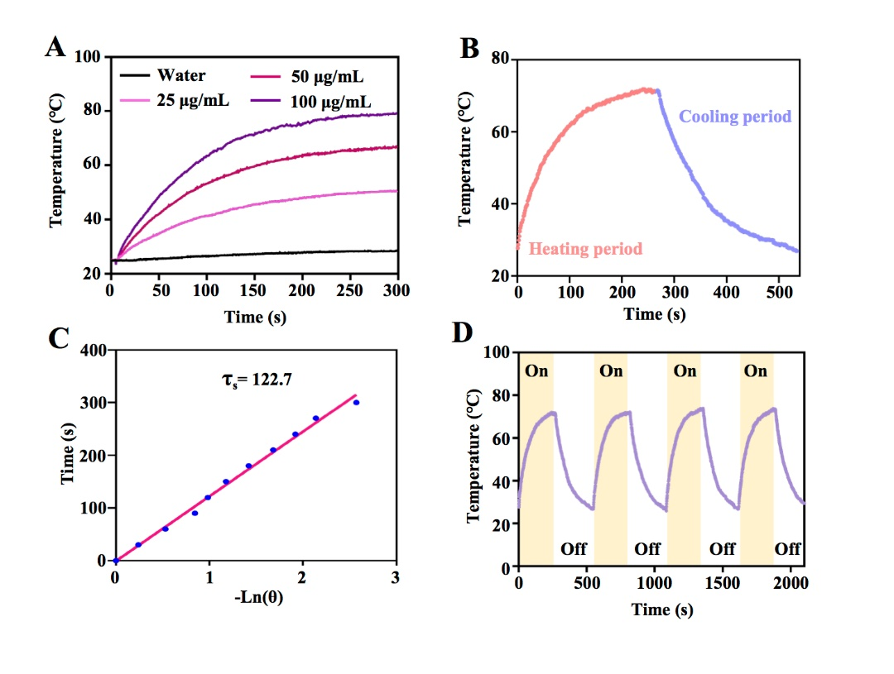
Fig. S1. Photothermal properties of MXP.
(A) Temperature changes of MXP at various concentrations (0, 25, 50 and 100 μg/mL) after 808 nm NIR laser irradiation. (B) The temperature changes of MXP over laser irradiation on/off cycles at a constant concentration of 100 μg/mL under irradiation (1 W/cm², 5 min). (C) The heat transferring time constant was determined by using the linear time data from the cooling period versus the negative natural logarithm of the driving force temperature, which was obtained from the cooling stage. (D) The MXP solution was irradiated with an 808 nm continuous-wave laser (1 W/cm²) for 300 s, and then cooled at room temperature for 300 s. We recorded 4 cycles continuously. Heating/cooling curves of MXP solution at a constant concentration of 100 μg/mL exposed to 808 nm NIR laser irradiation (1 W/cm²) for four laser switched on/off cycles.

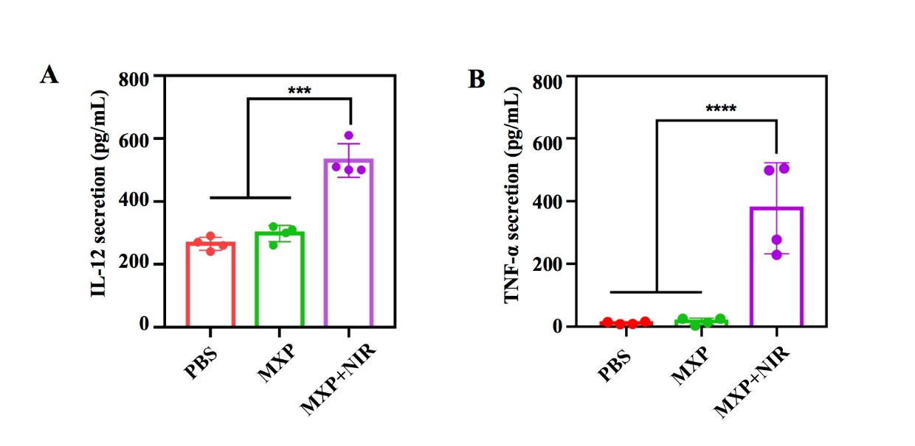
Fig. S2. Cytokines secreted in the culture medium by DCs.
Cytokines (A) IL-12 and (B) TNF-α secreted in the culture medium in transwell experiments in vitro. Significant differences are shown as follows: ***P< 0.001 and ****P< 0.001.
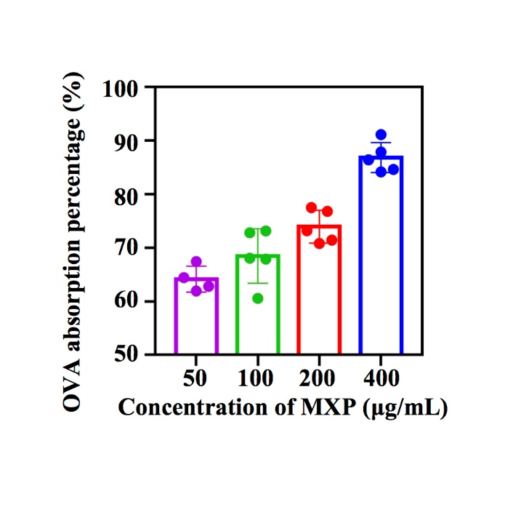
Fig. S3. Model antigen OVA adsorption isotherms of MXP with varying initial concentrations.
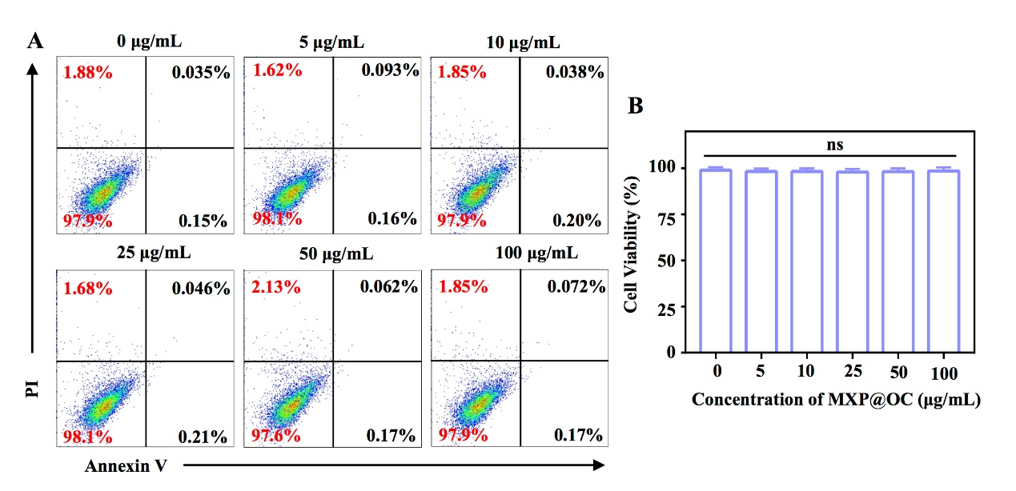
Fig. S4. Cytotoxicity assay of mutuDCs cultured with MXP@OC at different concentrations. Data are presented as the means ± s.d. (n = 3).
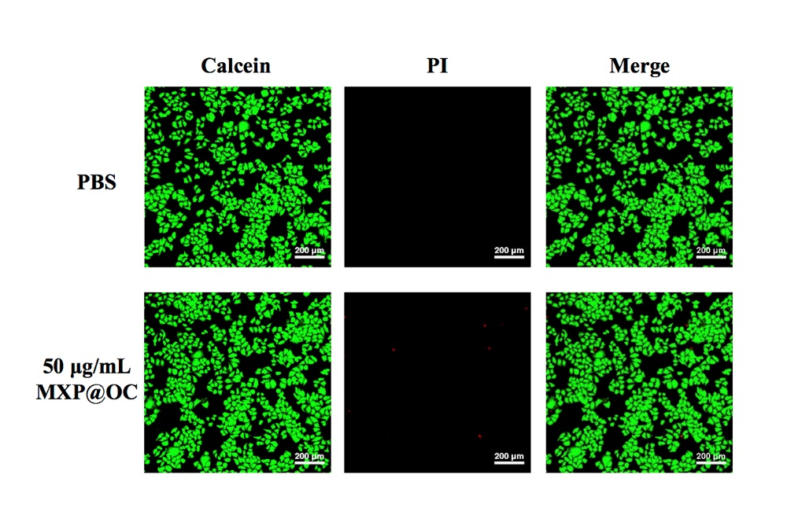
Fig. S5. CLSM images of Calcein-AM/PI-stained DC2.4 cells treated with PBS and MXP@OC.

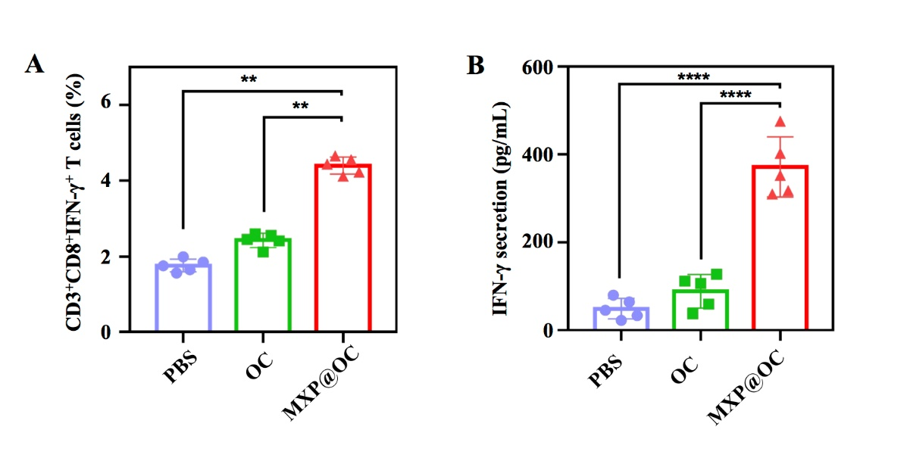
Fig. S6. Detection of induced cytotoxic T cell immune responses.
(A) Flow cytometry analysis illustrating the proportion of CD3⁺CD8⁺IFN-γ⁺ T cells and IFN-γ secretion (B) among splenocytes from tumor-bearing mice after restimulation with SIINFEKL ex vivo.

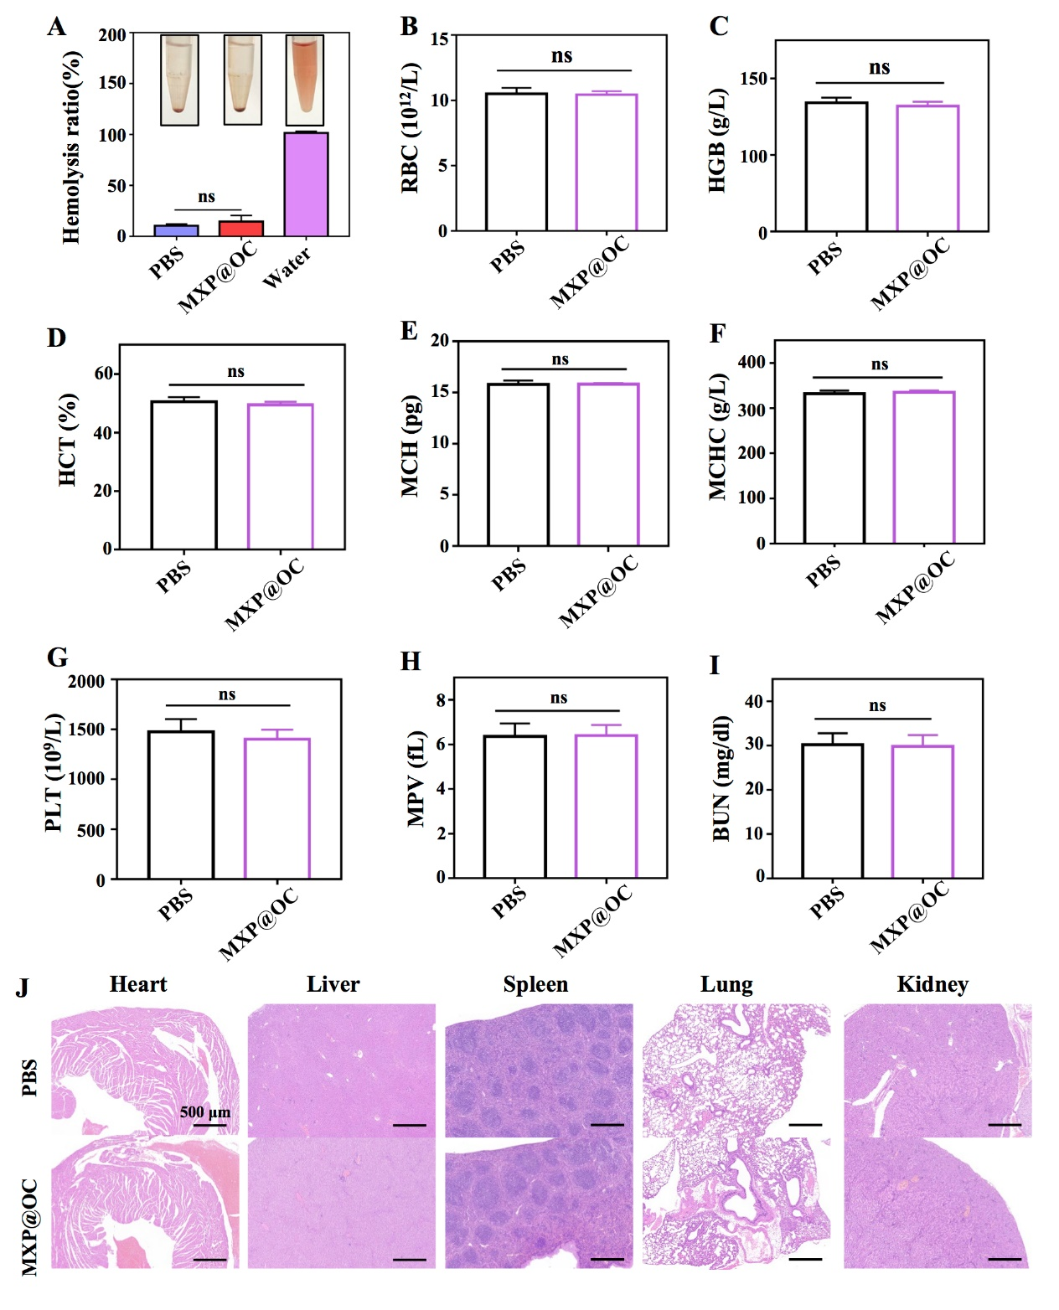
Fig. S7. Biocompatibility of MXP@OC in vivo
(A) Representative pictures and hemolysis ratio of mouse erythrocytes incubated with 200 μg/mL MXP@OC for 2 h. (B) Number of red blood cells (RBC), (C) hemoglobin (HGB), (D) hematocrit (HCT), (E) mean corpuscular hemoglobin (MCH) levels, (F) mean corpuscular hemoglobin concentration (MCHC), (G) platelets (PLT), (H) mean platelet volume (MPV), and (I) blood urea nitrogen (BUN) in the blood at 28 days post-injection of PBS or MXP@OC. (J) H&E-stained sections of major organs (heart, liver, spleen, lung, and kidney) from mice immunized with PBS or MXP@OC.

