Facile Conversion of glycerol to 1, 3-dihydroxyacetone using mesoporous CuO-SnO₂ composite oxide supported Au catalyst

Yi-Hu Ke^{1, 2}*, Hong-Yu Qin^{1, 2}, Xue Wang^{1, 2}, Hui Li^{1, 2}*, Hai Liu^{1, 2}, Hong Yuan ^{1, 2}
¹ Key Laboratory for Chemical Engineering and Technology, State Ethnic Affairs Commission, North Minzu University, Yinchuan, 750021, P. R. China
² Ningxia Key Laboratory of Solar Chemical Conversion Technology, North Minzu University, Yinchuan 750021, P. R. China
* To whom correspondence should be addressed. E-mail: keyihu123@nmu.edu.cn
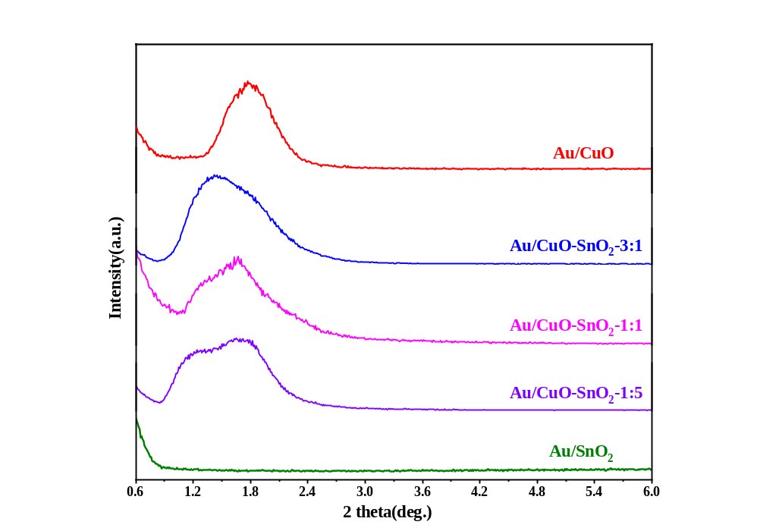
Fig. S1 The low-angle XRD patterns of supported Au catalysts
Fig. S2. TEM micrographs and the corresponding Au particle size distributions of (a) Au/CuO and (b) Au/SnO₂ catalysts

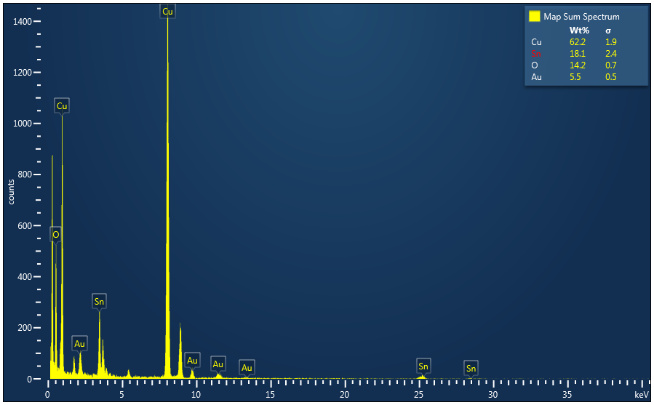
Fig. S3 The EDS of the Au/CuO-SnO₂-3:1 catalyst
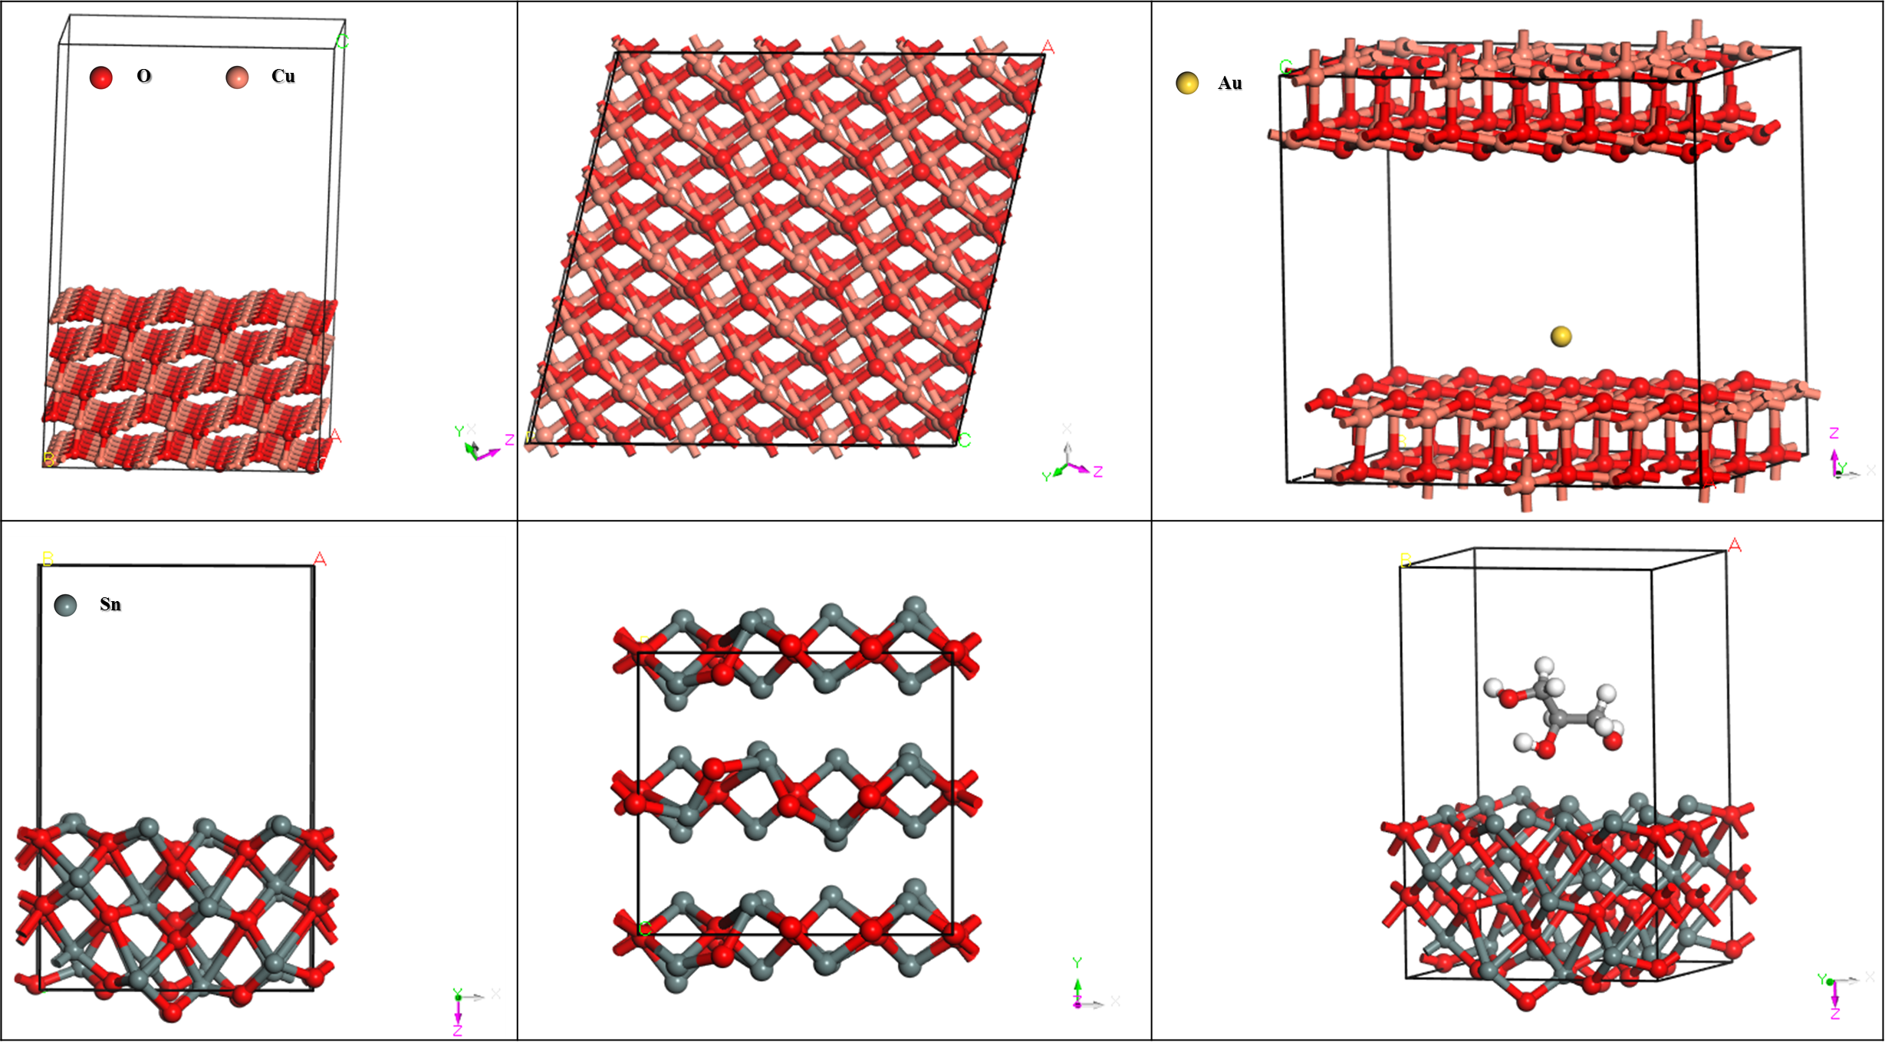
Fig. S4. Different perspectives of the final adsorption configurations

