Neurofilament-light chain quantification by SimoaTM and EllaTM in plasma from patients with dementia: a comparative study

Marta Truffi¹⁺, Maria Garofalo²⁺, Alessandra Ricciardi¹, Matteo Cotta Ramusino³, Giulia Perini^{3,4}, Silvia Scaranzin⁵, Matteo Gastaldi⁵, Sara Albasini¹, Alfredo Costa^{3,4}, Viola Chiavetta¹, Fabio Corsi^{1,6}, Carlo Morasso¹°*, Stella Gagliardi²°*

1 Istituti Clinici Scientifici Maugeri IRCCS Spa SB, Pavia, 27100, Italy
2 IRCCS Mondino Foundation, Molecular Biology and Transcriptomics Unit, Pavia, 27100, Italy
3 IRCCS Mondino Foundation, Unit of Behavioral Neurology and Center for Cognitive Disorders and Dementia (CDCD), Pavia, 27100, Italy
4 University of Pavia, Department of Brain and Behavioral Sciences, Pavia, 27100, Italy
5 IRCCS Mondino Foundation, Neuroimmunology Laboratory, Pavia, 27100, Italy
6 University of Milan, Department of Biomedical and Clinical Sciences, Milan, 20157, Italy
* corresponding authors: Stella Gagliardi, stella.gagliardi@mondino.it; Carlo Morasso, carlo.morasso@icsmaugeri.it
+,° these authors contributed equally to this work

SUPPLEMENTARY INFORMATION

Supplementary Figure S1. Boxplot showing the coefficient of variation (CV) for the NfL results measured by SiMoA™ and Ella™ in the study population (n = 50).
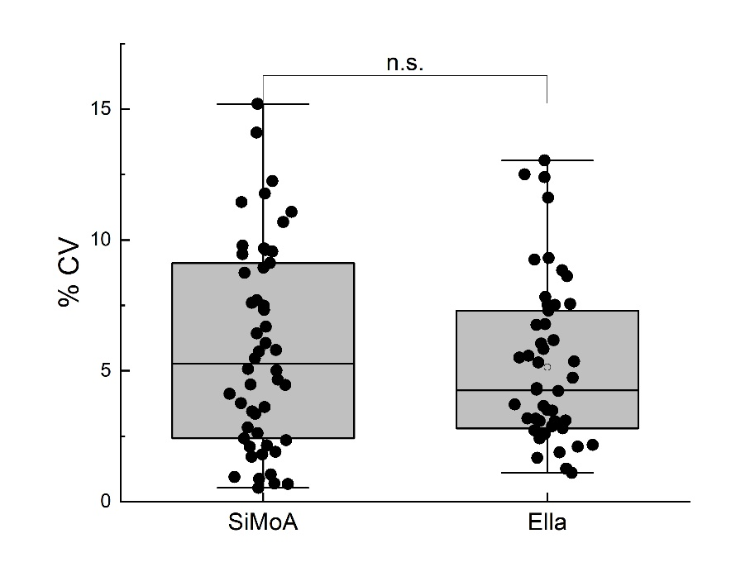

Supplementary Figure S2. Receiver operating characteristic (ROC) curve for NfL level’s accuracy to distinguish patients with dementia from healthy controls by means of SiMoA™.
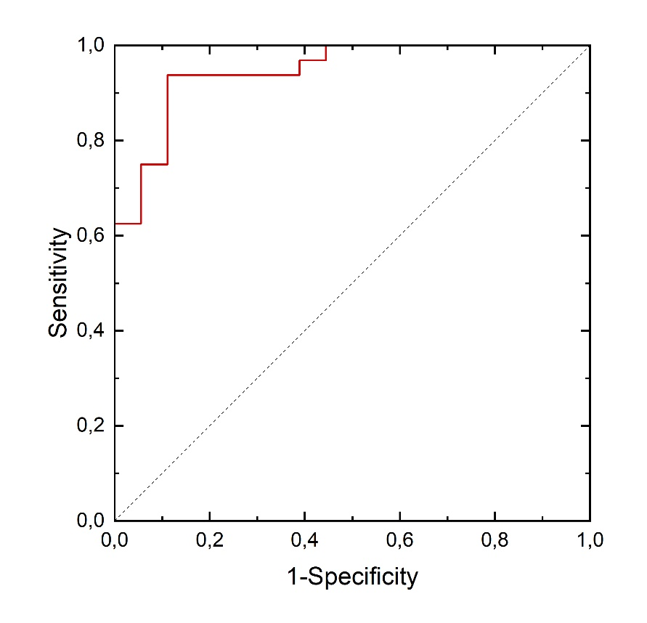

Supplementary Figure S3. Receiver operating characteristic (ROC) curve for NfL level’s accuracy to distinguish patients with dementia from healthy controls by means of Ella™.
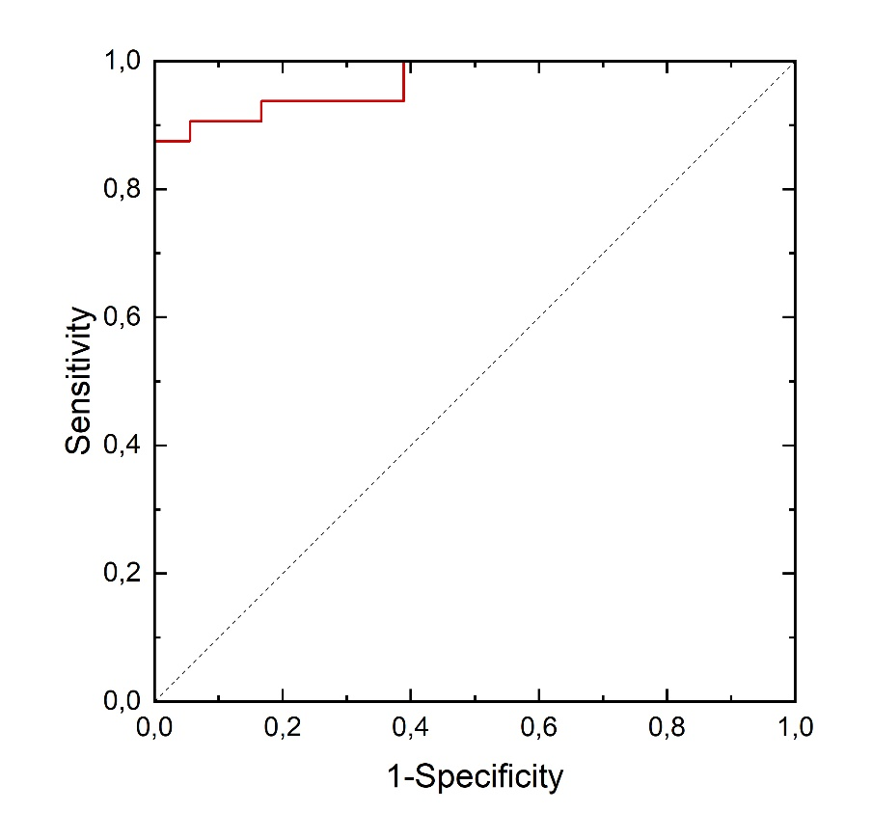

Supplementary Table S1. NfL Mean Concentration [pg/ml] and CV [%] obtained by SiMoA and Ella platform.
SAMPLES | AGE | GENDER | NF-L Mean Conc SiMoA [pg/ml] | %CV | NF-L Mean Conc ELLA [pg/ml] | %CV
FTD1 | 78 | M | 13,58 | 9,78 | 23,50 | 3,08
FTD2 | 67 | M | 37,58 | 5,48 | 64,10 | 2,17
FTD3 | 64 | F | 31,58 | 2,83 | 50,90 | 6,04
FTD4 | 63 | F | 60,03 | 2,35 | 98,20 | 3,47
FTD5 | 72 | M | 32,32 | 0,93 | 51,00 | 4,73
FTD6 | 68 | M | 28,52 | 2,14 | 45,20 | 3,71
FTD7 | 65 | M | 43,45 | 0,53 | 86,40 | 1,88
FTD8 | 62 | F | 40,69 | 3,76 | 58,40 | 3,65
FTD9 | 70 | M | 34,04 | 9,67 | 48,30 | 3,07
FTD10 | 74 | M | 25,39 | 1,90 | 44,70 | 2,10
FTD11 | 58 | M | 23,85 | 9,46 | 35,80 | 5,50
FTD12 | 67 | F | 21,63 | 4,12 | 39,40 | 2,94
AD1 | 77 | F | 38,62 | 9,56 | 60,50 | 2,88
AD2 | 80 | F | 47,96 | 5,79 | 87,00 | 2,72
AD3 | 51 | F | 9,09 | 2,10 | 17,20 | 8,61
AD4 | 69 | F | 24,65 | 8,94 | 45,60 | 2,80
AD5 | 73 | M | 44,95 | 6,68 | 95,40 | 1,67
AD6 | 70 | M | 15,95 | 6,06 | 29,70 | 3,10
AD7 | 57 | M | 9,95 | 0,69 | 17,40 | 4,34
AD8 | 84 | M | 22,84 | 3,35 | 37,10 | 1,26
AD9 | 78 | F | 18,37 | 14,10 | 29,10 | 3,50
AD10 | 81 | F | 35,81 | 9,61 | 80,60 | 3,17
AD11 | 35 | F | 12,95 | 5,00 | 31,60 | 2,58
AD12 | 77 | F | 20,37 | 0,67 | 38,20 | 7,51
AD13 | 76 | M | 14,77 | 2,61 | 25,60 | 5,32
AD14 | 77 | M | 34,54 | 2,42 | 64,50 | 1,25
AD15 | 69 | F | 25,05 | 7,70 | 46,30 | 8,84
AD16 | 85 | F | 46,92 | 3,44 | 74,80 | 4,28
AD17 | 73 | F | 29,07 | 10,69 | 60,60 | 6,17
AD18 | 82 | F | 32,67 | 6,43 | 74,30 | 2,56
AD19 | 69 | F | 16,11 | 15,20 | 36,90 | 7,52
AD20 | 67 | F | 14,90 | 3,62 | 29,70 | 7,82
HC1 | 47 | F | 7,86 | 4,67 | 16,70 | 5,36
HC2 | 54 | M | 5,91 | 8,75 | 10,60 | 5,83
HC3 | 55 | M | 5,59 | 5,73 | 11,00 | 7,55
HC4 | 46 | F | 4,20 | 11,45 | 11,60 | 12,40
HC5 | 69 | M | 9,90 | 1,71 | 18,30 | 2,41
HC6 | 70 | M | 11,16 | 1,80 | 16,70 | 4,23
HC7 | 67 | F | 17,02 | 5,07 | 27,50 | 9,31
HC8 | 69 | M | 7,46 | 7,32 | 18,00 | 6,75
HC9 | 59 | F | 7,13 | 1,03 | 15,30 | 13,04
HC10 | 60 | M | 6,47 | 0,87 | 10,30 | 1,10
HC11 | 64 | M | 5,86 | 11,07 | 11,30 | 3,18
HC12 | 60 | F | 10,31 | 4,45 | 20,80 | 6,78
HC13 | 60 | M | 23,84 | 11,77 | 10,80 | 12,51
HC14 | 65 | M | 12,90 | 9,12 | 24,10 | 11,61
HC15 | 55 | F | 6,55 | 7,60 | 12,80 | 7,30
HC16 | 67 | M | 11,14 | 4,48 | 18,90 | 5,57
HC17 | 61 | M | 11,09 | 7,48 | 24,30 | 2,58
HC18 | 59 | F | 8,76 | 12,25 | 15,50 | 9,25

