Supplementary Information for
Bioaccumulation and phytotoxicity of ZnO nanoparticles in soil-grown Brassica chinensis and potential risks
Meimei Shen, Weitao Liu *, Aurang Zeb, Jiapan Lian, Jiani Wu
MOE Key Laboratory of Pollution Processes and Environmental Criteria, Tianjin Key Laboratory of Urban Ecology Environmental Remediation and Pollution Control, College of Environmental Science and Engineering, Nankai University, Tianjin 300350, China
*Corresponding author: Weitao Liu
  - Full postal Address: No. 38 Tongyan Road, College of Environmental Science and Engineering, Nankai University, Tianjin 300350, P R China
  - Phone: +86 22 23501117
  - Fax: +86 22 23501117
  - E-mail: lwt@nankai.edu.cn

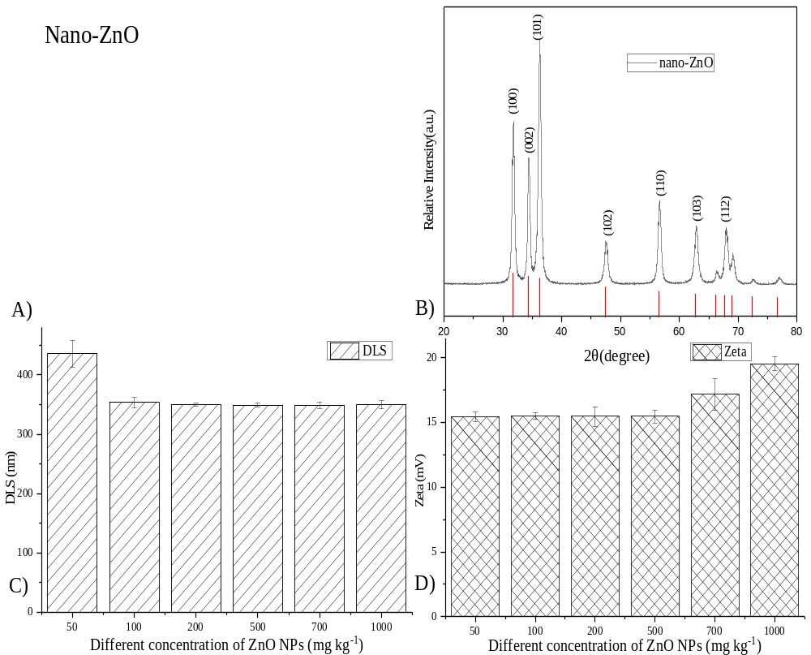Supplementary Figure 1. Characterization results of physical and chemical properties of ZnO NPs. A) Transmission electron microscopy of ZnO NPs; B) X ray diffraction pattern; C) Particle size distribution of ZnO NPs suspensions with different concentrations; D) Surface charge of ZnO NPs suspensions with different concentrations.

