Supplementary Information to:
OR2H2 Activation Suppresses Cellular Senescence and Aging by Activating AMPK and Inducing Senolysis in VK2/E6E7 Cells

Table S1. qPCR primers
Gene | Forward 5’-3’ | Reverse 3’-5’ | Product size (bp)
OR2H2 | GGTCCCAGCTCTAATTCGACT | CACTGCCCAGGTAATGGCTC | 136
OR2H1 | TGCAAGAACTGAACCGACCA | ACCTCACATTGGTGCCTCTG | 194
OR51E1 | GATTGTCCATGGTGCATCGC | TGCGCTGTCGAATCTCCTTT | 138
OR51E2 | CATATTTGCAAGCTCGGCCC | GGCATGTGTGAAGTTGCAGG | 172
OR1D2 | AGAGCAGTGGGACTTTTGGT | GCCAGGAAGAAGTACACGGG | 251
OR2J3 | GCATGTATCTCCAGCCACCA | CATACACAGGCTCATTCCCAC | 169
OR2B6 | CAGATCGACCTTGGCTGGAG | GGGCTACACAGCCACGATAA | 246
OR2A4/7 | TCCTACAGCCCCCTTCTAGG | GGAATGCCGATCCATGATGA | 215

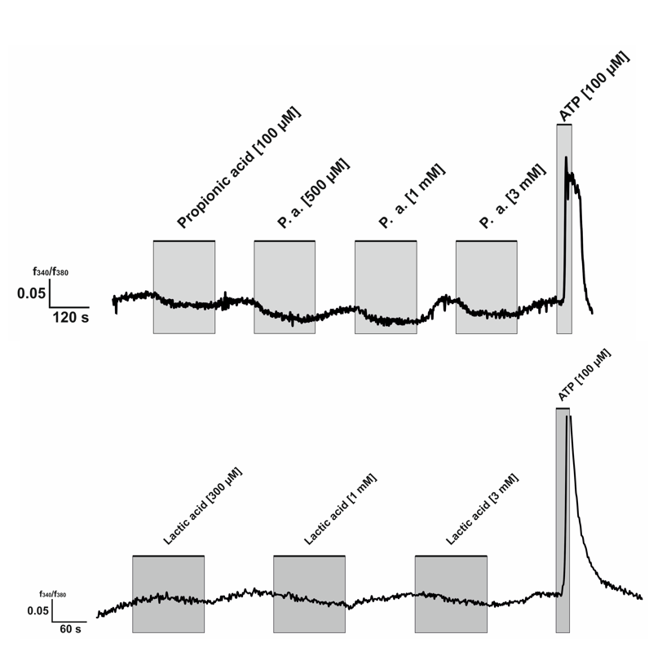

Figure S1. Intracellular Ca²⁺ response upon pripionic acid (100, 500 µM and 1, 3 mM) and lactic acid (300 µM and 1, 3 mM) stimulation. Application time was labeled by the grey square. ATP (100 µM) was applied as a positive control.

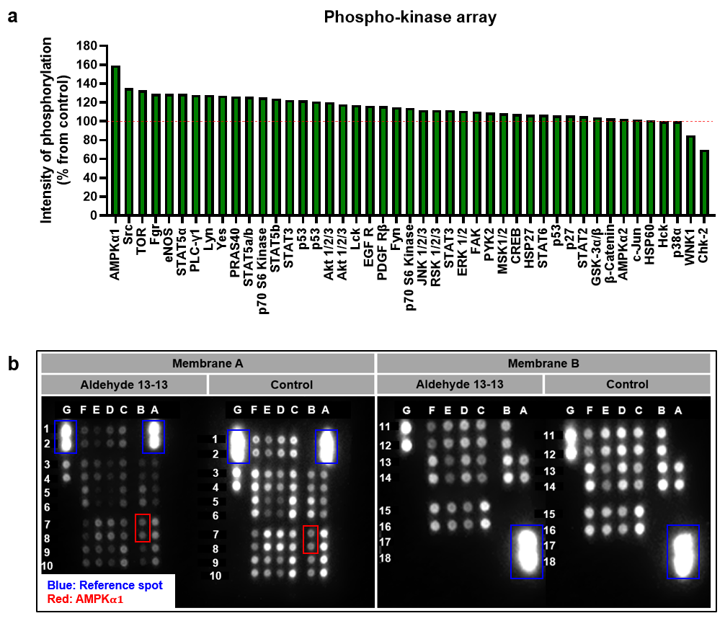
Membrane A
Row | Column | Target |  | Phosphorylation site
1 | A | Reference spot |  | -
1 | B | - |  | -
1 | C | TOR |  | S2448
1 | D | Src |  | Y419
1 | E | Fyn |  | Y420
1 | F | Hck |  | Y411
1 | G | Reference spot |  | -
2 | A | Reference spot |  | -
2 | B | - |  | -
2 | C | TOR |  | S2448
2 | D | Src |  | Y419
2 | E | Fyn |  | Y420
2 | F | Hck |  | Y411
2 | G | Reference spot |  | -
3 | A | p38$α$ |  | T180/Y182
3 | B | EGF R |  | Y1086
3 | C | CREB |  | S133
3 | D | Lyn |  | Y397
3 | E | Yes |  | Y426
3 | F | Chk-2 |  | T68
3 | G | PRAS40 |  | T246
4 | A | p38$α$ |  | T180/Y182
4 | B | EGF R |  | Y1086
4 | C | CREB |  | S133
4 | D | Lyn |  | Y397
4 | E | Yes |  | Y426
4 | F | Chk-2 |  | T68
4 | G | PRAS40 |  | T246
5 | A | ERK1/2 |  | T202/Y204, T185/Y187
5 | B | MSK1/2 |  | S376/S360
5 | C | HSP27 |  | S78/S82
5 | D | Lck |  | Y394
5 | E | Fgr |  | Y412
5 | F | FAK |  | Y397
5 | G | - |  | -
6 | A | ERK1/2 |  | T202/Y204, T185/Y187
6 | B | MSK1/2 |  | S376/S360
6 | C | HSP27 |  | S78/S82
6 | D | Lck |  | Y394
6 | E | Fgr |  | Y412
6 | F | FAK |  | Y397
6 | G | - |  | -
7 | A | JNK1/2/3 |  | T183/Y185, T221/Y223
7 | B | AMPK$α$1 |  | T183
7 | C | AMPK$α2$ |  | T172
7 | D | STAT2 |  | Y689
7 | E | STAT6 |  | Y641
7 | F | PDGF Rβ |  | Y751
7 | G | - |  | -
8 | A | JNK1/2/3 |  | T183/Y185, T221/Y223
8 | B | AMPK$α$1 |  | T183
8 | C | AMPK$α2$ |  | T172
8 | D | STAT2 |  | Y689
8 | E | STAT6 |  | Y641
8 | F | PDGF Rβ |  | Y751
8 | G | - |  | -
9 | A | GSK-3$α/β$ |  | S21/S9
9 | B | Akt1/2/3 |  | S473
9 | C | $β$-Catenin |  | -
9 | D | STAT5$α$ |  | Y694
9 | E | STAT5$β$ |  | Y699
9 | F | STAT5$α/β$ |  | Y694/Y699
9 | G | PBS (Negative control) |  | -
10 | A | GSK-3$α/β$ |  | S21/S9
10 | B | Akt1/2/3 |  | S473
10 | C | $β$-Catenin |  | -
10 | D | STAT5$α$ |  | Y694
10 | E | STAT5$β$ |  | Y699
10 | F | STAT5$α/β$ |  | Y694/Y699
10 | G | PBS (Negative control) |  | -
Membrane B
Row | Column | Target | Phosphorylation site
11 | A | - | -
11 | B | Akt1/2/3 | T308
11 | C | p70 S6 Kinase | T389
11 | D | p70 S6 Kinase | T421/S424
11 | E | STAT3 | Y705
11 | F | STAT3 | S727
11 | G | HSP60 | -
12 | A | - | -
12 | B | Akt1/2/3 | T308
12 | C | p70 S6 Kinase | T389
12 | D | p70 S6 Kinase | T421/S424
12 | E | STAT3 | Y705
12 | F | STAT3 | S727
12 | G | HSP60 | -
13 | A | p53 | S392
13 | B | p53 | S46
13 | C | p53 | S15
13 | D | RSK1/2/3 | S380/S386/S377
13 | E | p27 | T198
13 | F | WNK1 | T60
13 | G | - | -
14 | A | p53 | S392
14 | B | p53 | S46
14 | C | p53 | S15
14 | D | RSK1/2/3 | S380/S386/S377
14 | E | p27 | T198
14 | F | WNK1 | T60
14 | G | - | -
15 | A | - | -
15 | B | - | -
15 | C | c-Jun | S63
15 | D | eNOS | S1177
15 | E | PLC-γ1 | Y783
15 | F | PYK2 | Y402
15 | G | - | -
16 | A | - | -
16 | B | - | -
16 | C | c-Jun | S63
16 | D | eNOS | S1177
16 | E | PLC-γ1 | Y783
16 | F | PYK2 | Y402
16 | G | - | -
17 | A | Reference spot | -
17 | B | - | -
17 | C | - | -
17 | D | - | -
17 | E | - | -
17 | F | - | -
17 | G | PBS (Negative control) | -
18 | A | Reference spot | -
18 | B | - | -
18 | C | - | -
18 | D | - | -
18 | E | - | -
18 | F | - | -
18 | G | PBS (Negative control) | -

Figure S2. (a) Results from the phosphokinase array assay in cells treated with aldehyde 13-13. VK2/E6E7 cells were stimulated with 500 μM of aldehyde 13-13 for 30 minutes and phosphorylation intensities normalized to the ethanol-treated control and expressed as a percentage increase or decrease. The x-axis represents the 43 different kinases. The signals spots were analyzed with Image J software. (b) Image of the whole blot of the phospho-kinase array. Blue box indicates reference spot, red box indicates AMPK$α$1. The data table indicates target of each blot and its phosphorylation sites.

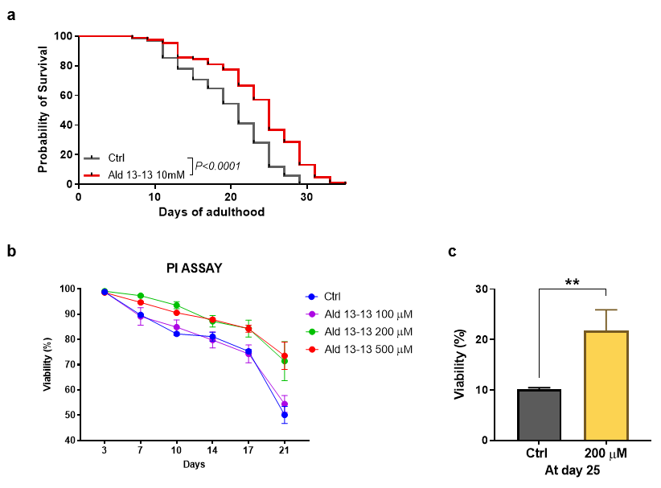
Figure S3. Effect of aldehyde 13-13 on the lifespan of C. elegans and budding yeast. (a) Survival of C. elegans (black, control; red, aldehyde 13-13 at 10 mM) (b) Cell survival assay of budding yeast assessed by propidium iodine (PI) assay (blue, control; purple, 100 $µ$M; green, 200 $µ$M; red, 500 $µ$M of aldehyde 13-13). One-way ANOVA between control and aldehyde 13-13. 100 $µ$M, P = 0.4067; 200 μM, P = 0.0246; 500 μM, P = 0.0275. (c) Cell viability of budding yeast at 25 days of experiments. Aldehyde 13-13 (200 $µ$M) was compared to vehicle control. Data are means ± SEM. A two-tailed unpaired t-test was performed for multiple or two-group comparisons. *, P < 0.05; **, P < 0.01; ***, P < 0.001.

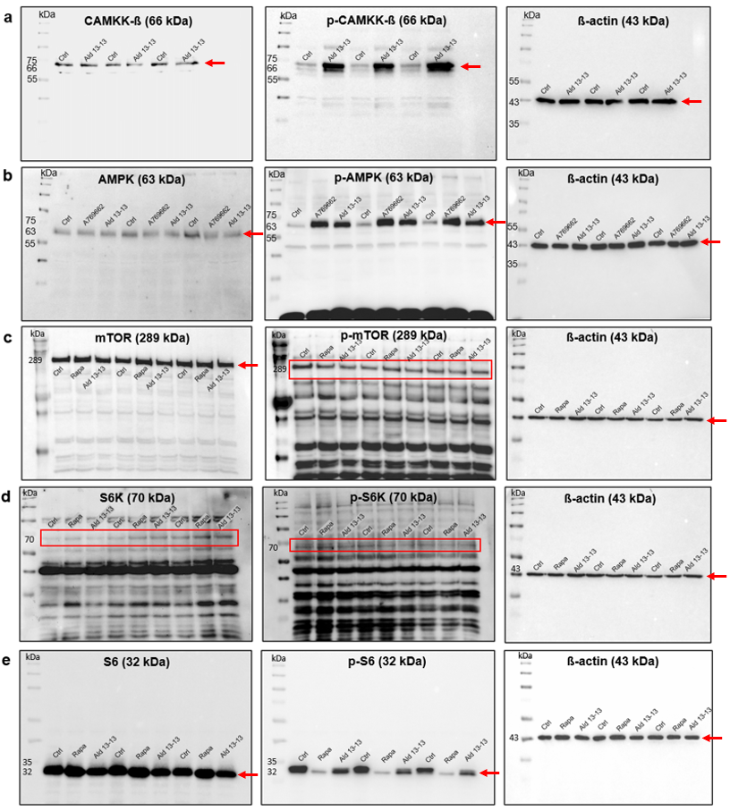
Figure S4. Full length uncropped westernblot images used to generate Fig 4. (a) CAMKK-$β$, p-CAMKK-$β$ and $β$-actin blot respectively. (b) AMPK, p-AMPK and $β$-actin blot respectively. (c) mTOR, p-mTOR and $β$-actin blot respectively. (d) S6K, p-S6K and $β$-actin blot respectively. (e) S6, p-S6 and $β$-actin blot respectively. Ctrl: control, Ald 13-13: Aldehyde 13-13, A769662: AMPK agonist, Rapa: rapamycin.

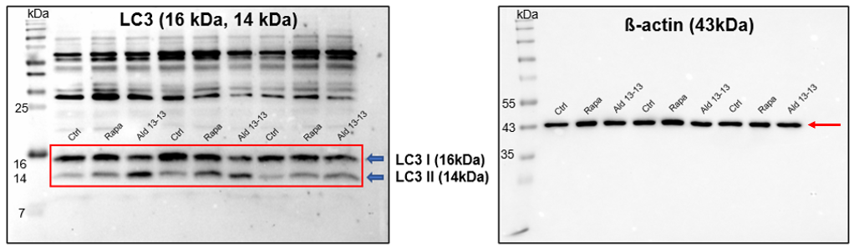
Figure S5. Full length uncropped westernblot images used to generate Fig 5a. LC3 I/II and $β$-actin blot respectively. Ctrl: control, Rapa: rapamycin, Ald 13-13: Aldehyde 13-13.

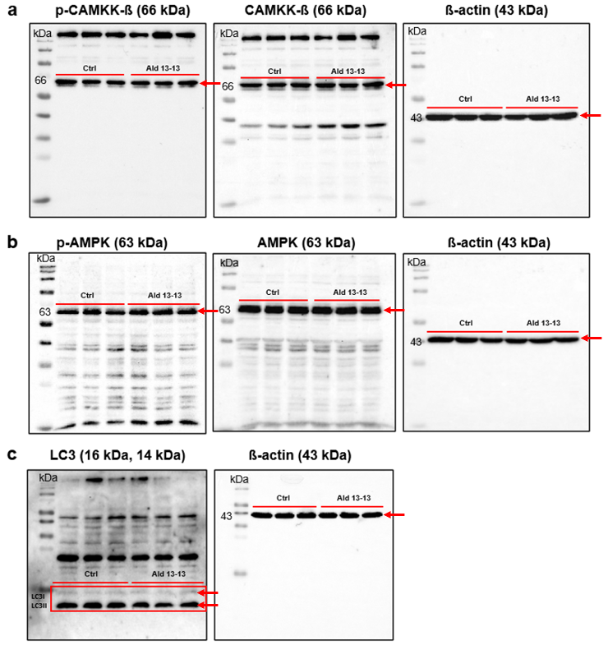
Figure S6. Full length uncropped westernblot images used to generate Fig 6b-d. (a) CAMKK-$β$, p-CAMKK-$β$ and $β$-actin blot respectively. (b) AMPK, p-AMPK and $β$-actin blot respectively. (c) LC3 I/II and $β$-actin blot respectively. Ctrl: control, Ald 13-13: Aldehyde 13-13.

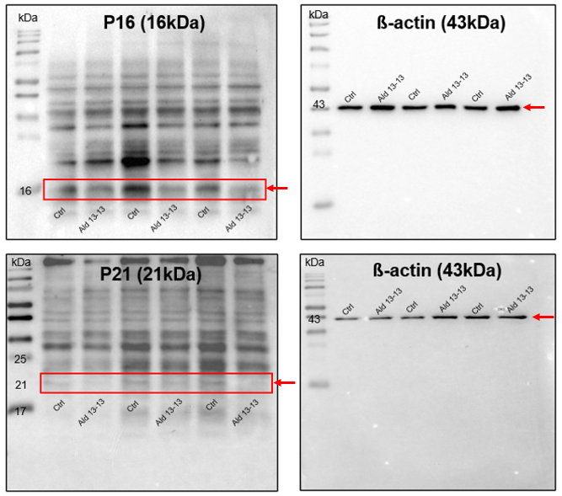
Figure S7. Full length uncropped westernblot images used to generate Fig 7b. P16 and its $β$-actin blot; P21 and its $β$-actin blot respectively. Ctrl: control, Ald 13-13: Aldehyde 13-13.

