Construction of first high-density SNP genetic map and identification of QTL for the natural rubber content in Taraxacum kok-saghyz Rodin
Yushuang Yang¹, Bi Qin¹, Qiuhui Chen¹, Qiuhai Nie², Jichuan Zhang³, Liqun Zhang³, Shizhong Liu^{1,*}
(¹Rubber Research Institute, Chinese Academy of Tropical Agricultural Science, Haikou 571101;
²Beijing Linglong Dandelion Technology and Development Ltd, Beijing, 101102;
³College of Materials and Engineering, Beijing University of Chemical Technology, Beijing 100029)

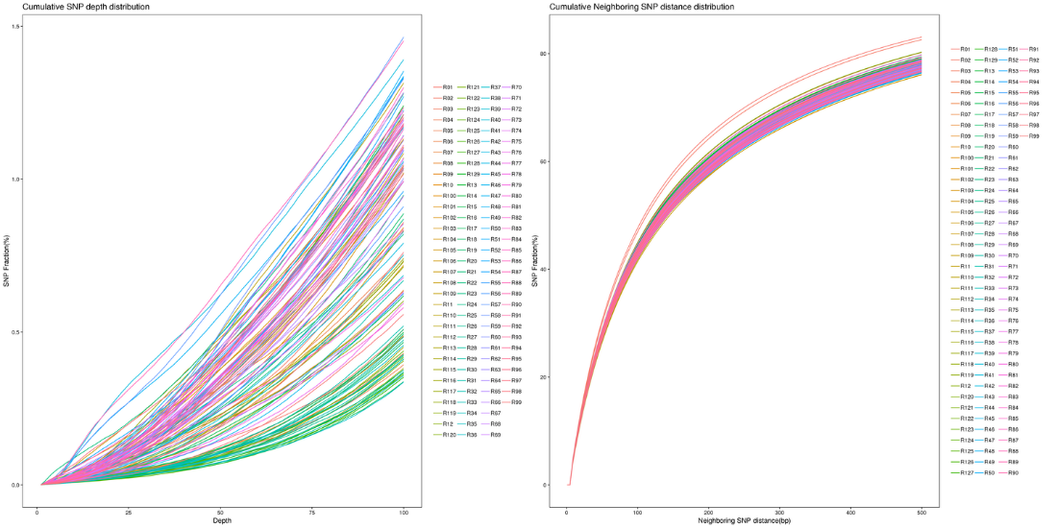
Fig. S1. Distribution of SNP quality in resequenced lines. R1 and R2 represent the two parents. R3-R129 represent the individuals of the F₁ population.

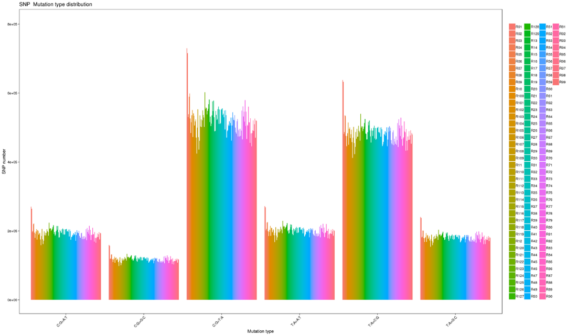
Fig. S2. Distribution of SNP mutation types in resequenced lines. R1 and R2 represent the two parents. R3-R129 represent the individuals of the F₁ population.
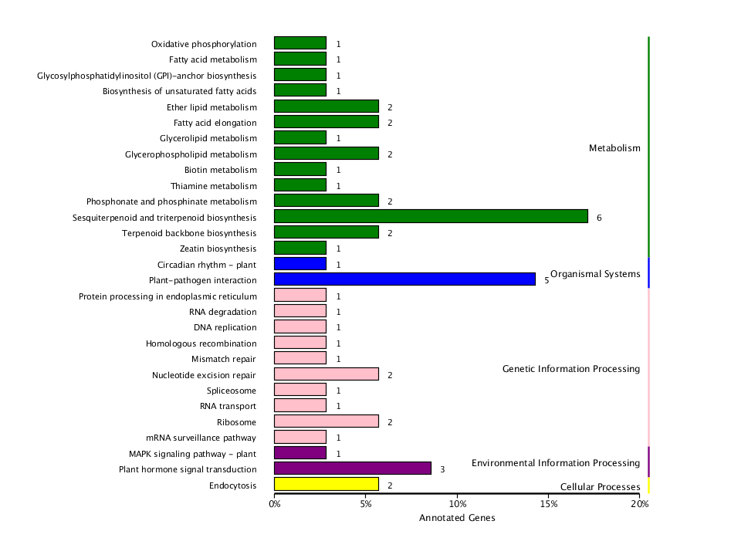
Fig. S3. KEGG classification of genes in the region between qHRC-C6-1 and qHRC-C6-2.

