Text S1. Chemicals and reagents
Sodium hypochlorite solution (NaOCl, available chlorine 4.00-4.99%), sodium chloride (NaCl, ≥99.0%), sodium hydroxide (NaOH, ≥98.0%), sodium bicarbonate (NaHCO₃, ≥99.0%), monopotassium phosphate (KH₂PO₄, ≥99.0%), potassium iodate (KIO₃, ≥99.0%), potassium iodide (KI, 99.5%), nitrobenzene (NB, 99.0%), and tert-butyl-alcohol (TBA, ≥99.0%) were purchased from Sigma-Aldrich (St. Louis, MO, USA). Sulfuric acid (H₂SO₄, 95.0-98.0%) and sodium thiosulfate (Na₂S₂O₃, 99%) were provided by Sinopharm Chemical Reagent Co., Ltd. (Shanghai, China). Humic acid (HA) was obtained from the International Humic Substances Society (St. Paul, MN, USA). All solutions were prepared with ultra-pure water (18.2 MΩ cm) produced by a Milli-Q water purification system (Millipore, USA).

Text S2. Determination of average UV irradiation intensity (I)
In this study, the average irradiance intensity of each UV light source was determined using the KI/KIO₃ method, respectively, which can be expressed in following Eq. (S1).
$$\begin{aligned}{\text{8I}}^{\text{-}}\text{ + }{\text{IO}}_{\text{3}}^{\text{-}}\text{ + 3}{\text{H}}_{\text{2}}\text{O + }\text{hv} \text{→} {\text{3I}}_{\text{3}}^{\text{-}}\text{ + }{\text{6OH}}^{\text{-}}\#\text{(S1)}\text{\#}\end{aligned}$$
This solution consists of 0.6 M potassium iodide (KI) and 0.1 M potassium iodate (KIO₃) in 0.01 M sodium tetraborate (Na₂B₄O₇) buffer solution. Because the maximum spectral absorption at 352 nm (molar absorption coefficient ε_{I3-} = 27636 M⁻¹ cm⁻¹), the concentration of the photoproduct (triiodide complex, I₃⁻) can be accurately quantified without interference from other components in the radiometer solution. The quantum yields of I₃⁻ (Φ) at different wavelengths were calculated using the linear equation developed in a previous study (Φ = 3.558 - 0.0113λ, where λ represents the wavelength of UV sources) (Wang et al. 2017).
The irradiance intensity can be calculated by using Eqs. (S2)-(S6).
$$\begin{aligned}\left[{\text{I}}_{\text{3}}^{\text{-}}\right] \left(\text{M}\right)\text{ = }\frac{{\text{A}}_{\text{352}}\left(\text{sample}\right) \text{-}{\text{ A}}_{\text{352}}\left(\text{blank}\right)}{\text{ε} \left({\text{M}}^{\text{-1}} {\text{cm}}^{\text{-1}}\right)}\#\text{(S2)}\text{\#}\end{aligned}$$
$$\begin{aligned}\text{Moles} \text{of }{\text{I}}_{\text{3}}^{\text{-}}\text{ = }\left[{\text{I}}_{\text{3}}^{\text{-}}\right]\text{ × }\text{V} \left(\text{L}\right)\#\text{(S3)}\text{\#}\end{aligned}$$
$$\begin{aligned}\text{Einsteins (moles of photons) }\text{= }\frac{\text{Moles} \text{of }{\text{I}}_{\text{3}}^{\text{-}}}{\text{Φ }\left(\text{mol }{\text{einsteins}}^{\text{-1}}\right)}\#\text{(S4)}\text{\#}\end{aligned}$$
$$\begin{aligned}\text{Photon irradiance }\left({\text{E}}_{\text{p}}\text{, einstein }{\text{s}}^{\text{-1}} {\text{cm}}^{\text{-2}}\right)\text{ = }\frac{\text{Einsteins}}{\text{Area }\left({\text{cm}}^{\text{2}}\right)\text{ × Time }\left(\text{s}\right)}\#\text{(S5)}\text{\#}\end{aligned}$$
$$\begin{aligned}\text{Irradiance }\left(\text{E}\text{, W }{\text{cm}}^{\text{-2}}\right)\text{ = }{\text{E}}_{\text{p}}\text{ × Photon energy = }{\text{E}}_{\text{p}}\text{ × }\text{h}{\text{ν}}_{\text{λ}}{\text{N}}_{\text{A}}\#\text{(S6)}\text{\#}\end{aligned}$$
Where A₃₅₂ (sample) and A₃₅₂ (blank) represent the absorbance of the KI/KIO₃ solution at 352 nm after and before UV irradiation, ε represents the molar absorbance coefficient of I₃⁻ at 352 nm (27636 M⁻¹ cm⁻¹), V is the volume of the solution irradiated by UV light (mL), h is the Planck constant (6.626×10⁻³⁴ J s), N_{A} is the Avogadro constant (6.022×10²³ mol⁻¹), and ν_{λ} is the wave frequency of the UV light at a specific wavelength (s⁻¹).

Text S3. Determination of 2,4,6-TCA
The concentration of 2,4,6-TCA was liquid-liquid extracted (LLE) with n-hexane and then analyzed by using GC-MS (QP2010 Ultra, Shimadzu, Japan). The oven temperature program was set at 45 ℃ for 4 min, ramped to 125 ℃ at 10 ℃ min-1, ramped to 165 ℃ at 20 ℃ min-1, ramped to 240 ℃ at 15 ℃ min-1 and held for 1 min, and then ramped to 280 ℃ at 30 ℃ min-1 and held for 10 min. The GC-MS was coupled with a flame ionization detector (FID) and HP-5 capillary column (30 m × 0.25 mm, 0.25 μm film thickness, J&W, USA). The sample injector and FID detector had temperatures of 230℃ and 250 ℃, respectively. The carrier gas was high purity helium (≥ 99.99%).

Text S4. Determination of 2.4.6-TCA degradation intermediates
The 2,4,6-TCA degradation intermediates during UV/chlorination were determined by an ultra performance liquid chromatography-quadrupole-time of flight-mass spectrometer (UPLC-Q-TOF-MS, Waters, USA) equipped with an XterraR MS C18 column (2.1 mm × 250 mm, 5 µm, Waters, USA). The mobile phase used 70% water and 30% methanol, the flow rate was 0.2 mL min⁻¹.

Text S5. Determination of the electrical energy
The electrical energy of UVC lamp (E_{EO-UVC}) and the consumption of the oxidants (E_{EO-Oxidant}) would be considered in this study, total energy consumption (E_{EO-total}) can be calculated as Eq. (S7) (Yao et al. 2013).
$$\begin{aligned}{\text{E}}_{\text{EO-total}} \text{=} {\text{E}}_{\text{EO-UV}} \text{+} {\text{E}}_{\text{EO-Oxidant}} \text{=} \frac{\text{Pt}}{\text{V}\text{×}\text{lg}{\frac{{\text{c}}_{\text{0}}}{{\text{c}}_{\text{t}}}}} \text{+} \frac{\text{α}\left[\text{Oxidant}\right]}{\text{lg}{\frac{{\text{c}}_{\text{0}}}{{\text{c}}_{\text{t}}}}}\#\text{(S7)}\text{\#}\end{aligned}$$
Where P is the energy input of UV sources (kW), t is the irradiation time (h), V is the reactor volume (L), [Oxidant] is the concentration of chlorine (mM), α is the unit convertor to translate oxidant amount to energy unit (2.11×10⁻⁴ kWh mM⁻¹ for chlorine) (Sun et al. 2016).

Text S6. Set of equations for the 2,4,6-TCA degradation in the presence of NOM during UV/chlorination process.
Based on the reactions listed in Table S1 during 2,4,6-TCA degradation in the presence of NOM, the differential equations for each species in the system can be expressed as Eqs. (S8)-(S12).
$$\begin{aligned}\frac{{\text{d}\left[\text{HOCl}\right]}_{\text{T}}}{\text{dt}}\text{=-}{\text{k}}_{\text{1}}\left[\text{HOCl}\right]\text{-}{\text{k}}_{\text{2}}\left[{\text{OCl}}^{\text{-}}\right]\text{-}{\text{k}}_{\text{6}}\left[\text{HOCl}\right]\left[\text{HO}\text{•}\right]\text{-}{\text{k}}_{\text{7}}\left[{\text{OCl}}^{\text{-}}\right]\left[\text{HO}\text{•}\right]\#\text{(S8)}\text{\#}\end{aligned}$$
$$\begin{aligned}\frac{{\text{d}\left[\text{HO}\text{•}\right]}_{\text{T}}}{\text{dt}}\text{=}{\text{k}}_{\text{1}}\left[\text{HOCl}\right]\text{-}{\text{k}}_{\text{6}}\left[\text{HOCl}\right]\left[\text{HO}\text{•}\right]\text{-}{\text{k}}_{\text{7}}\left[{\text{OCl}}^{\text{-}}\right]\left[\text{HO}\text{•}\right]\text{-}{\text{k}}_{\text{8}}\left[\text{HO}\text{•}\right]\left[{\text{OH}}^{\text{-}}\right]\#\left(\text{S9}\right)\end{aligned}$$
$$\text{-}k_{\text{10}}\left[\text{HO}\text{•}\right]\left[\text{2,4,6-TCA}\right]\text{-}k_{\text{11}}\left[\text{HO}\text{•}\right]\left[\text{NOM}\right]$$
$$\begin{aligned}\frac{{\text{d}\left[\text{Cl}\text{•}\right]}_{\text{T}}}{\text{dt}}\text{=}{\text{k}}_{\text{1}}\left[\text{HOCl}\right]\text{+}{\text{k}}_{\text{2}}\left[{\text{OCl}}^{\text{-}}\right]\text{-}{\text{k}}_{\text{3}}\left[\text{Cl}\text{•}\right]\text{-}{\text{k}}_{\text{4}}\left[\text{Cl}\text{•}\right]\left[{\text{OH}}^{\text{-}}\right]\text{-}{\text{k}}_{\text{5}}{\left[\text{Cl}\text{•}\right]}^{\text{2}}\text{-}k_{\text{12}}\left[\text{Cl}\text{•}\right]\left[\text{NOM}\right]\#\text{(S10)}\text{\#}\end{aligned}$$
$$\begin{aligned}\frac{{\text{d}\left[\text{2,4,6-TCA}\right]}_{\text{T}}}{\text{dt}}\text{=-}{\text{k}}_{\text{9}}\left[\text{2,4,6-TCA}\right]\text{-}{\text{k}}_{\text{10}}\left[\text{2,4,6-TCA}\right]\left[\text{HO}\text{•}\right]\#\text{(S11)}\text{\#}\end{aligned}$$
$$\begin{aligned}\frac{{\text{d}\left[\text{NOM}\right]}_{\text{T}}}{\text{dt}}\text{=}\text{-}k_{\text{11}}\left[\text{HO}\text{•}\right]\left[\text{NOM}\right]\text{-}k_{\text{12}}\left[\text{Cl}\text{•}\right]\left[\text{NOM}\right]\#\text{(S12)}\text{\#}\end{aligned}$$

Table S1. The structure and properties of 2,4,6-TCA.
Compound  (CAS number) | Structure | Odor | Odor threshold  (ng L⁻¹) | Source
2,4,6-trichloroanisole (TCA)  (87-40-1) | 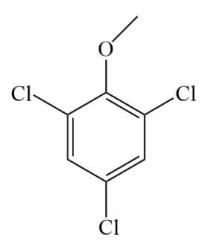 | Musty | 0.03 (Malleret et al. 2001) | Methylation of chlorophenol by microorganisms

Table S2. The reactions and rate constants during UV/chlorination process.
NO. | Reaction | Rate constant | Reference
1 | HOCl + hv → HO• + Cl• | k₁ = 1.5 × 10⁻³ s⁻¹ | This study
2 | OCl⁻ + hv → O⁻• + Cl• | k₂ = 9.3 × 10⁻³ s⁻¹ | This study
3 | Cl• + H₂O → ClOH⁻• + H⁺ | k₃ = 4.5 × 10³ M⁻¹ s⁻¹ | (NIST 2020)
4 | Cl• + OH⁻ → ClOH⁻• | k₄ = 1.8 × 10¹⁰ M⁻¹ s⁻¹ | (Grebel et al. 2010)
5 | Cl• + Cl• → Cl₂ | k₅ = 1.0 × 10⁸ M⁻¹ s⁻¹ | (Grebel et al. 2010)
6 | HOCl + HO• → ClO• + H₂O | k₆ = 2.0 × 10⁹ M⁻¹ s⁻¹ | (Watts &Linden 2007)
7 | OCl⁻ + HO• → ClO• + OH⁻ | k₇ = 8.8 × 10⁹ M⁻¹ s⁻¹ | (Watts &Linden 2007)
8 | HO• + OH⁻→ O⁻• + H₂O | k₈ = 1.3 × 10¹⁰ M⁻¹ s⁻¹ | (Feng et al. 2007)
9 | 2,4,6-TCA + hv → products | k₉ = 4.0 × 10⁻⁴ s⁻¹ | This study
10 | 2,4,6-TCA + HO• → products | k₁₀ = 3.1 × 10⁹ M⁻¹ s⁻¹ | This study
11 | NOM + HO• → products | k₁₁ = 2.5 × 10⁴ (mg L⁻¹)⁻¹ s⁻¹ | (Fang et al. 2014)
12 | NOM + Cl• → products | k₁₂ = 1.3 × 10⁴ (mg L⁻¹)⁻¹ s⁻¹ | (Fang et al. 2014)
11 | HOCl ⇔ OCl⁻ + H⁺ | k_{ac} = 2.88 × 10⁻⁸ | (Feng et al. 2007)

Table S3. The correlation coefficients between the model predictions and experimental data.
Initial NOM concentration (mg-C L-1) | 0 | 1 | 3 | 5 | 10
R | 0.9818 | 0.9948 | 0.9964 | 0.9904 | 0.9913

Table S4. The water quality parameters of the finished water of different water matrices
 | pH | Turbidity  (NTU) | TOC  (mg-C L⁻¹) | TN  (mg-N L⁻¹) | UV₂₅₄  (cm⁻¹) | UV₂₇₂  (cm⁻¹) | NH3-N  (mg-N L⁻¹)
Raw water | 8.06 | 16.3 | 4.46 | 2.593 | 0.092 | 0.204 |  | 0.26
Finished water | 7.54 | 0.12 | 2.651 | 2.724 | 0.030 | 0.022 |  | 0.24
Tap water | 7.47 | 0.16 | 2.765 | 2.665 | 0.021 | 0.019 |  | 0.18

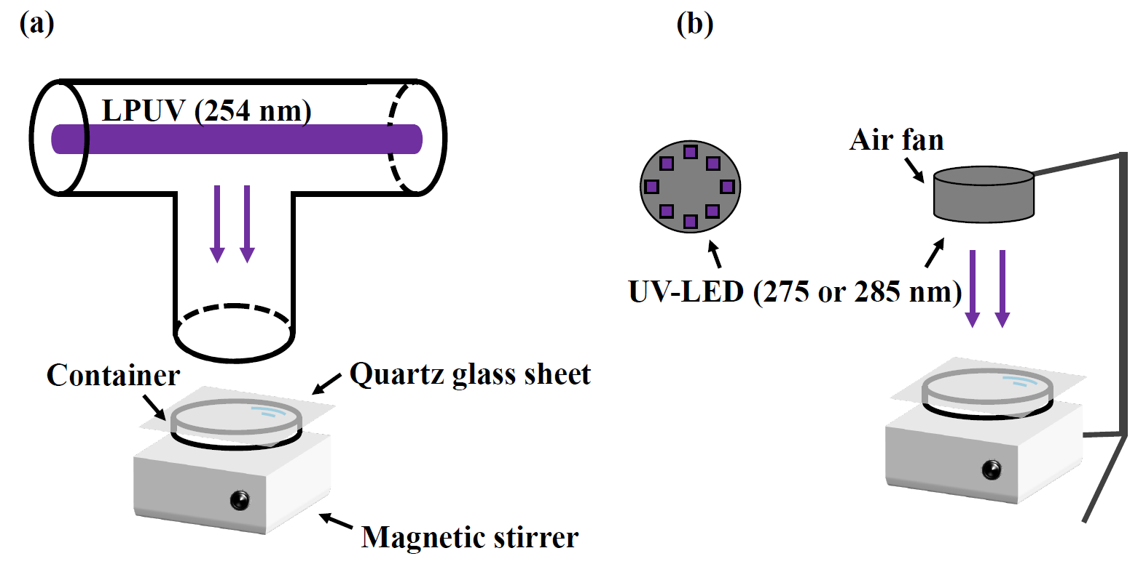

Fig. S1 Photochemical reaction apparatus of (a) LPUV (254 nm) and (b) UV-LED (275 and 285 nm) reactors.

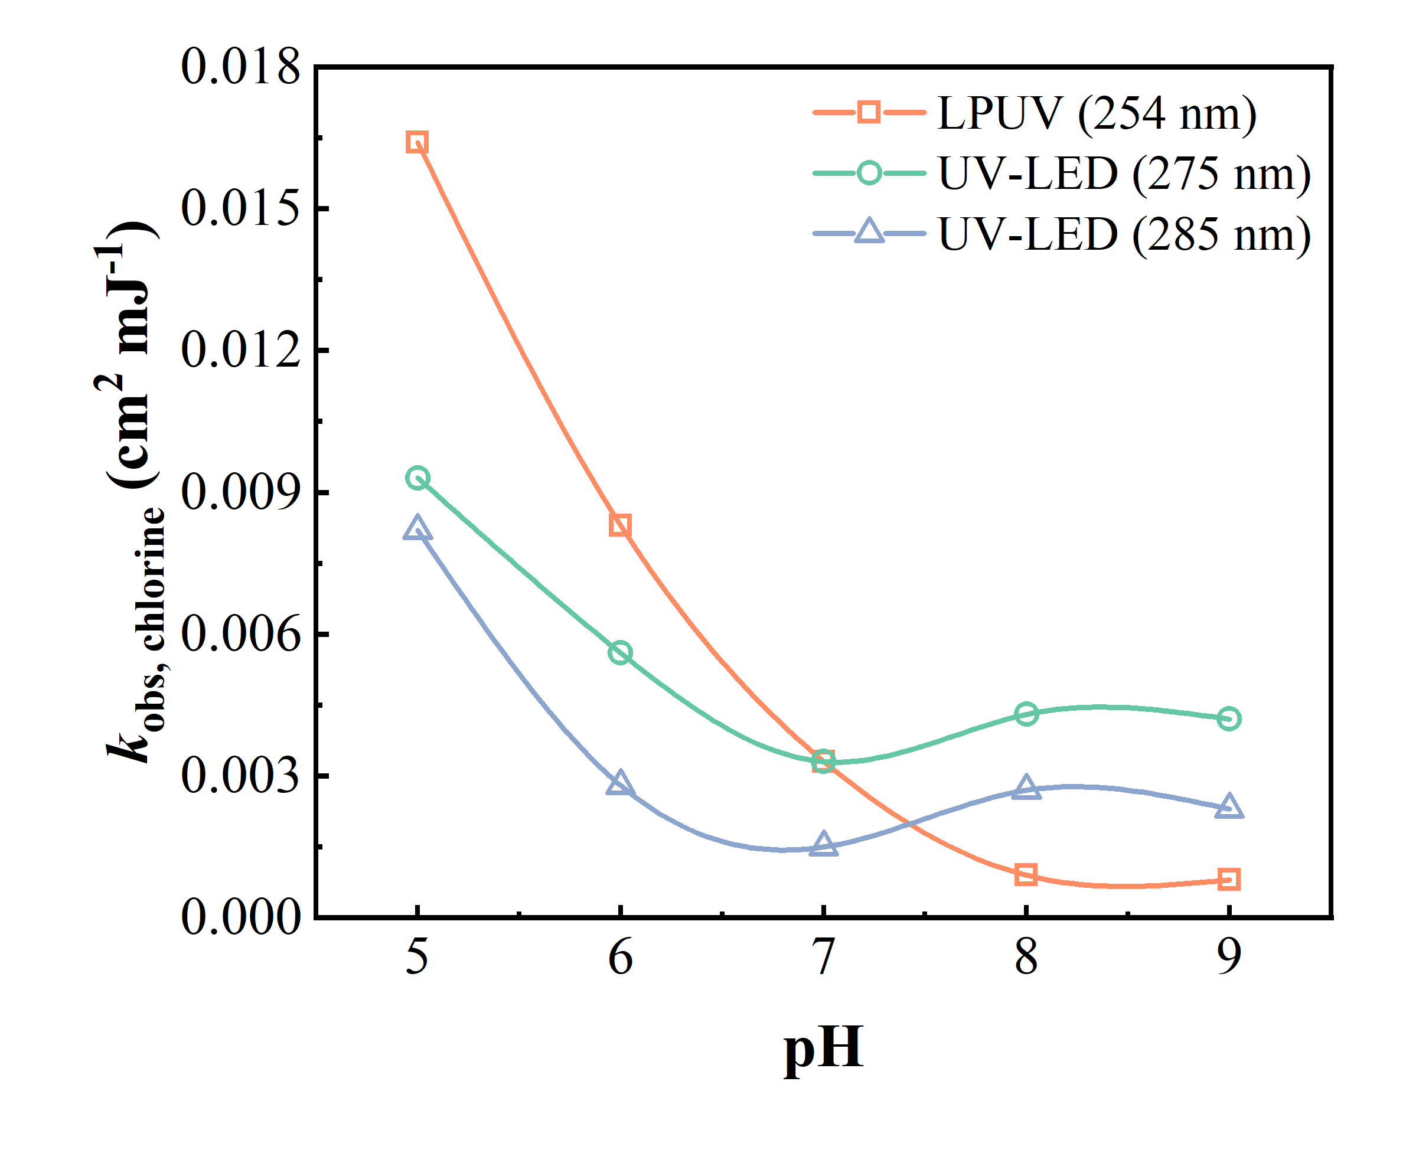

Fig. S2 Fluence-based rate constants (k_{obs}) of the chlorine degradation during UV/chlorination process at different pH values and wavelengths. Experimental conditions: [Chlorine]₀ = 200 μM, pH = 5.0-9.0, [phosphate buffer] = 10 mM, T = 25 ± 1.0 ℃, and UV intensity = 0.28, 0.42, and 0.31 mW cm⁻¹ for 254, 275, and 285 nm, respectively.

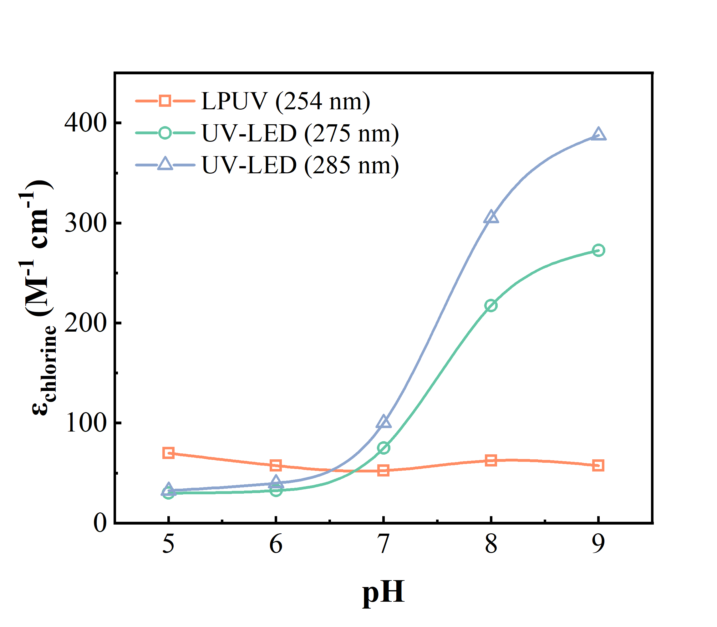

Fig. S3 Molar absorption coefficient of chlorine at the different pH values and UV wavelengths. Experimental conditions: [chlorine]₀ = 200 μM, pH = 5.0-9.0, [phosphate buffer] = 10 mM, T = 25 ± 1.0 ℃.

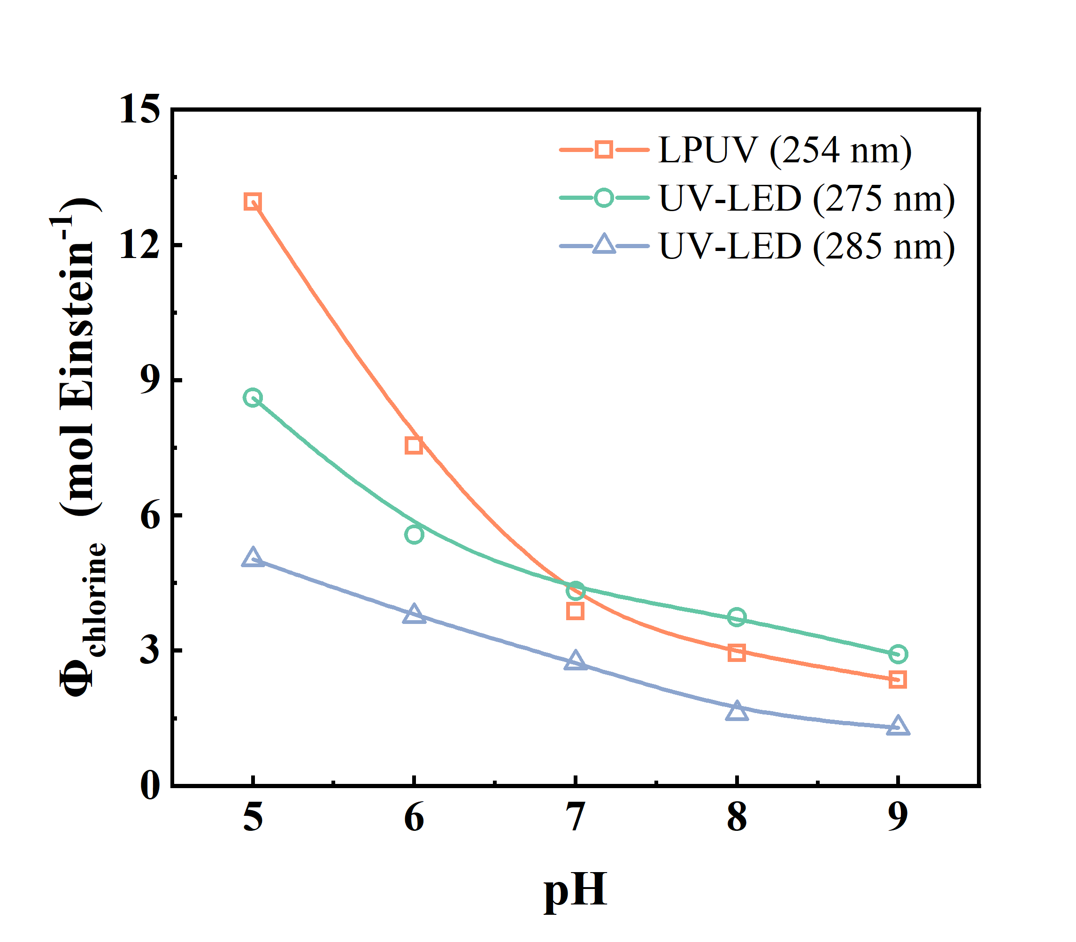

Fig. S4 Quantum yield of chlorine at different pH values and UV wavelengths. Experimental conditions: [Chlorine]₀ = 200 μM, pH = 5.0-9.0, [phosphate buffer] = 10 mM, T = 25 ± 1.0 ℃.

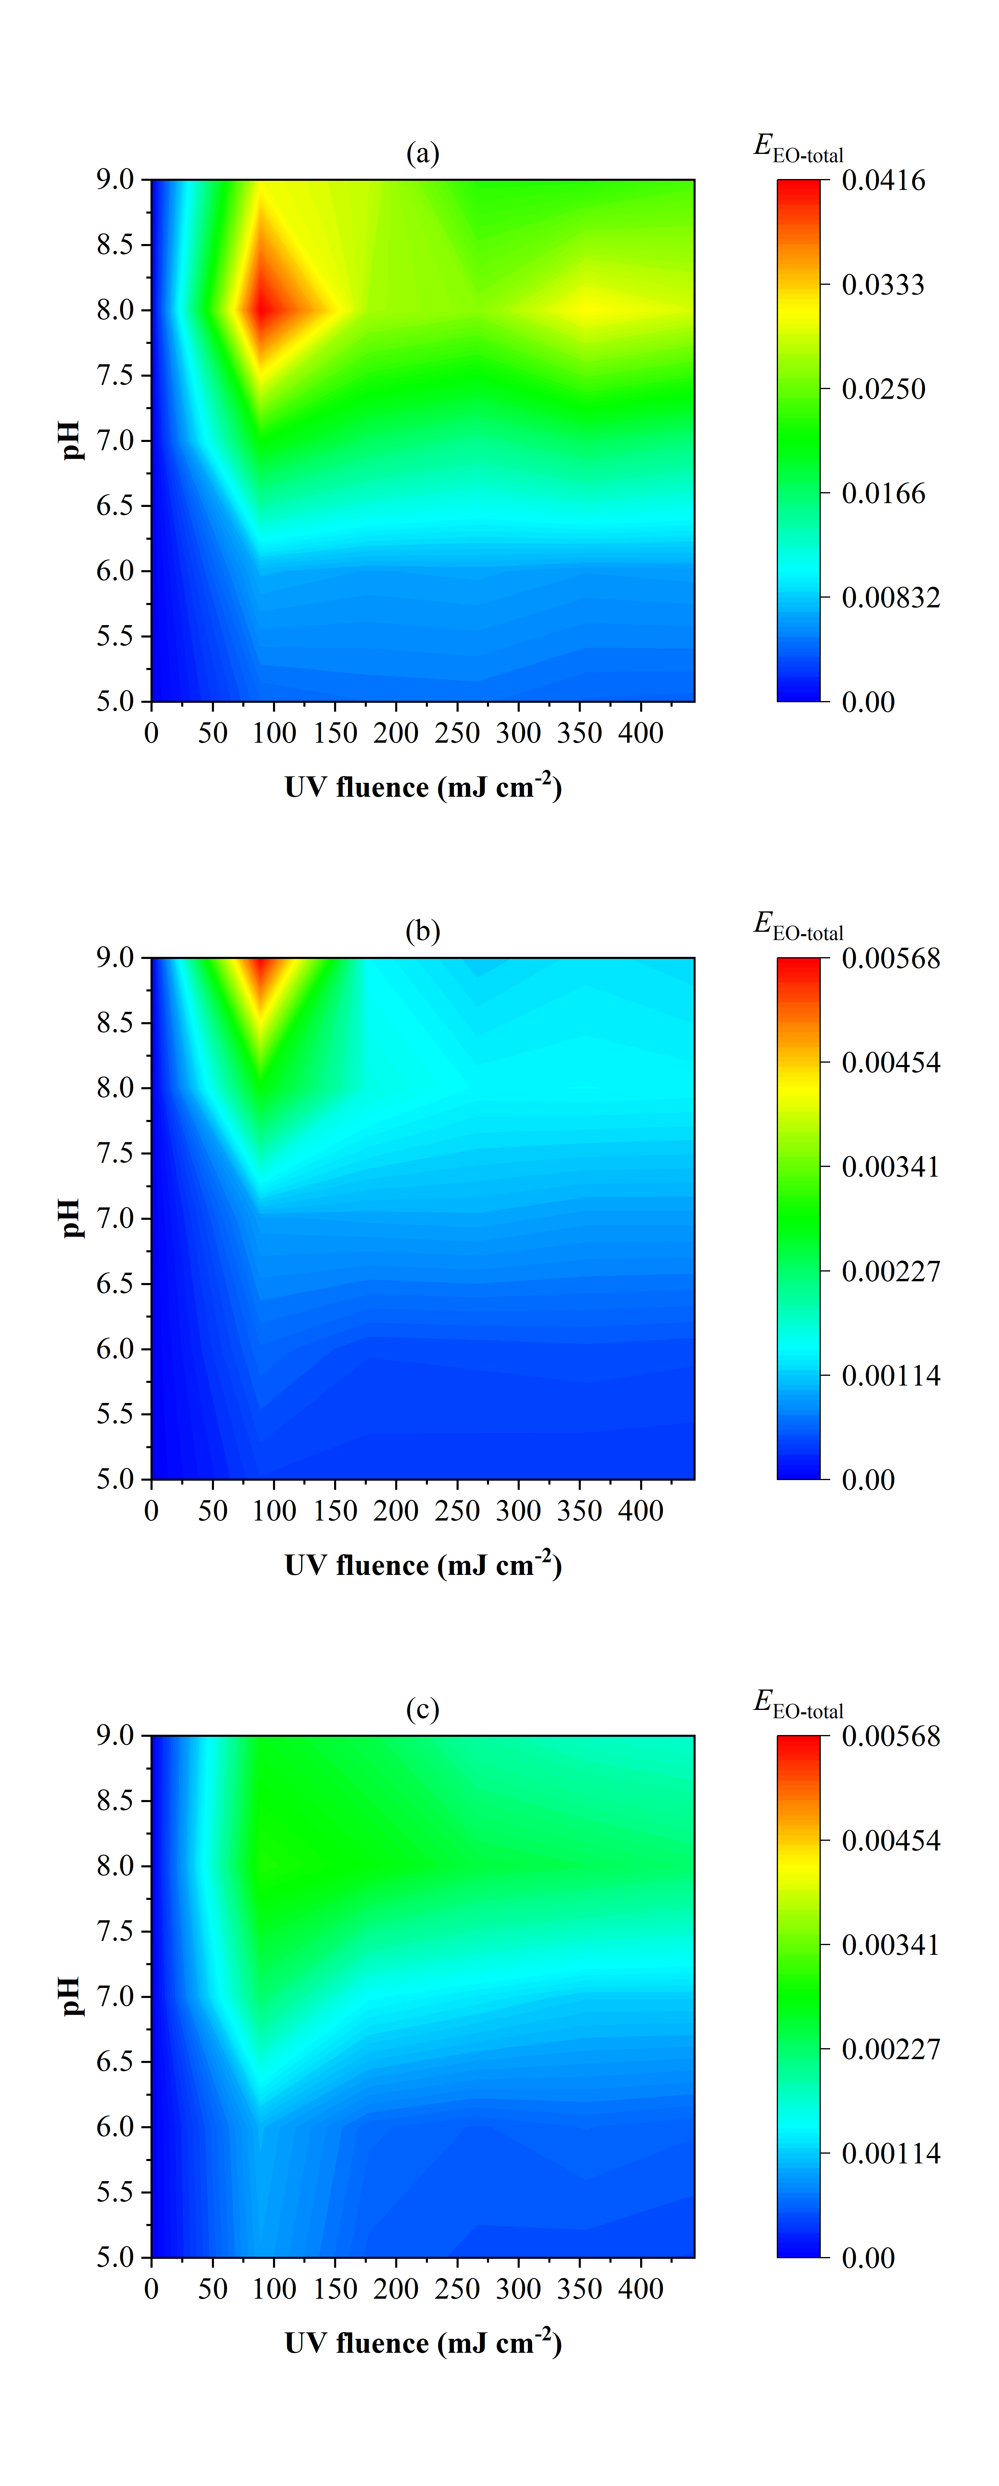

Fig. S5 E_{EO-total} of UV/chlorination processes at the wavelength of (a) 254 nm, (b) 275 nm, (c) 285 nm. Experimental conditions: [Chlorine]₀ = 200 μM, [2,4,6-TCA]₀ = 20 μg L⁻¹, pH = 5.0-9.0, [phosphate buffer] = 10 mM, T = 25 ± 1.0 ℃, and UV intensity = 0.28, 0.42, and 0.31 mW cm⁻¹ for 254, 275, and 285 nm, respectively.
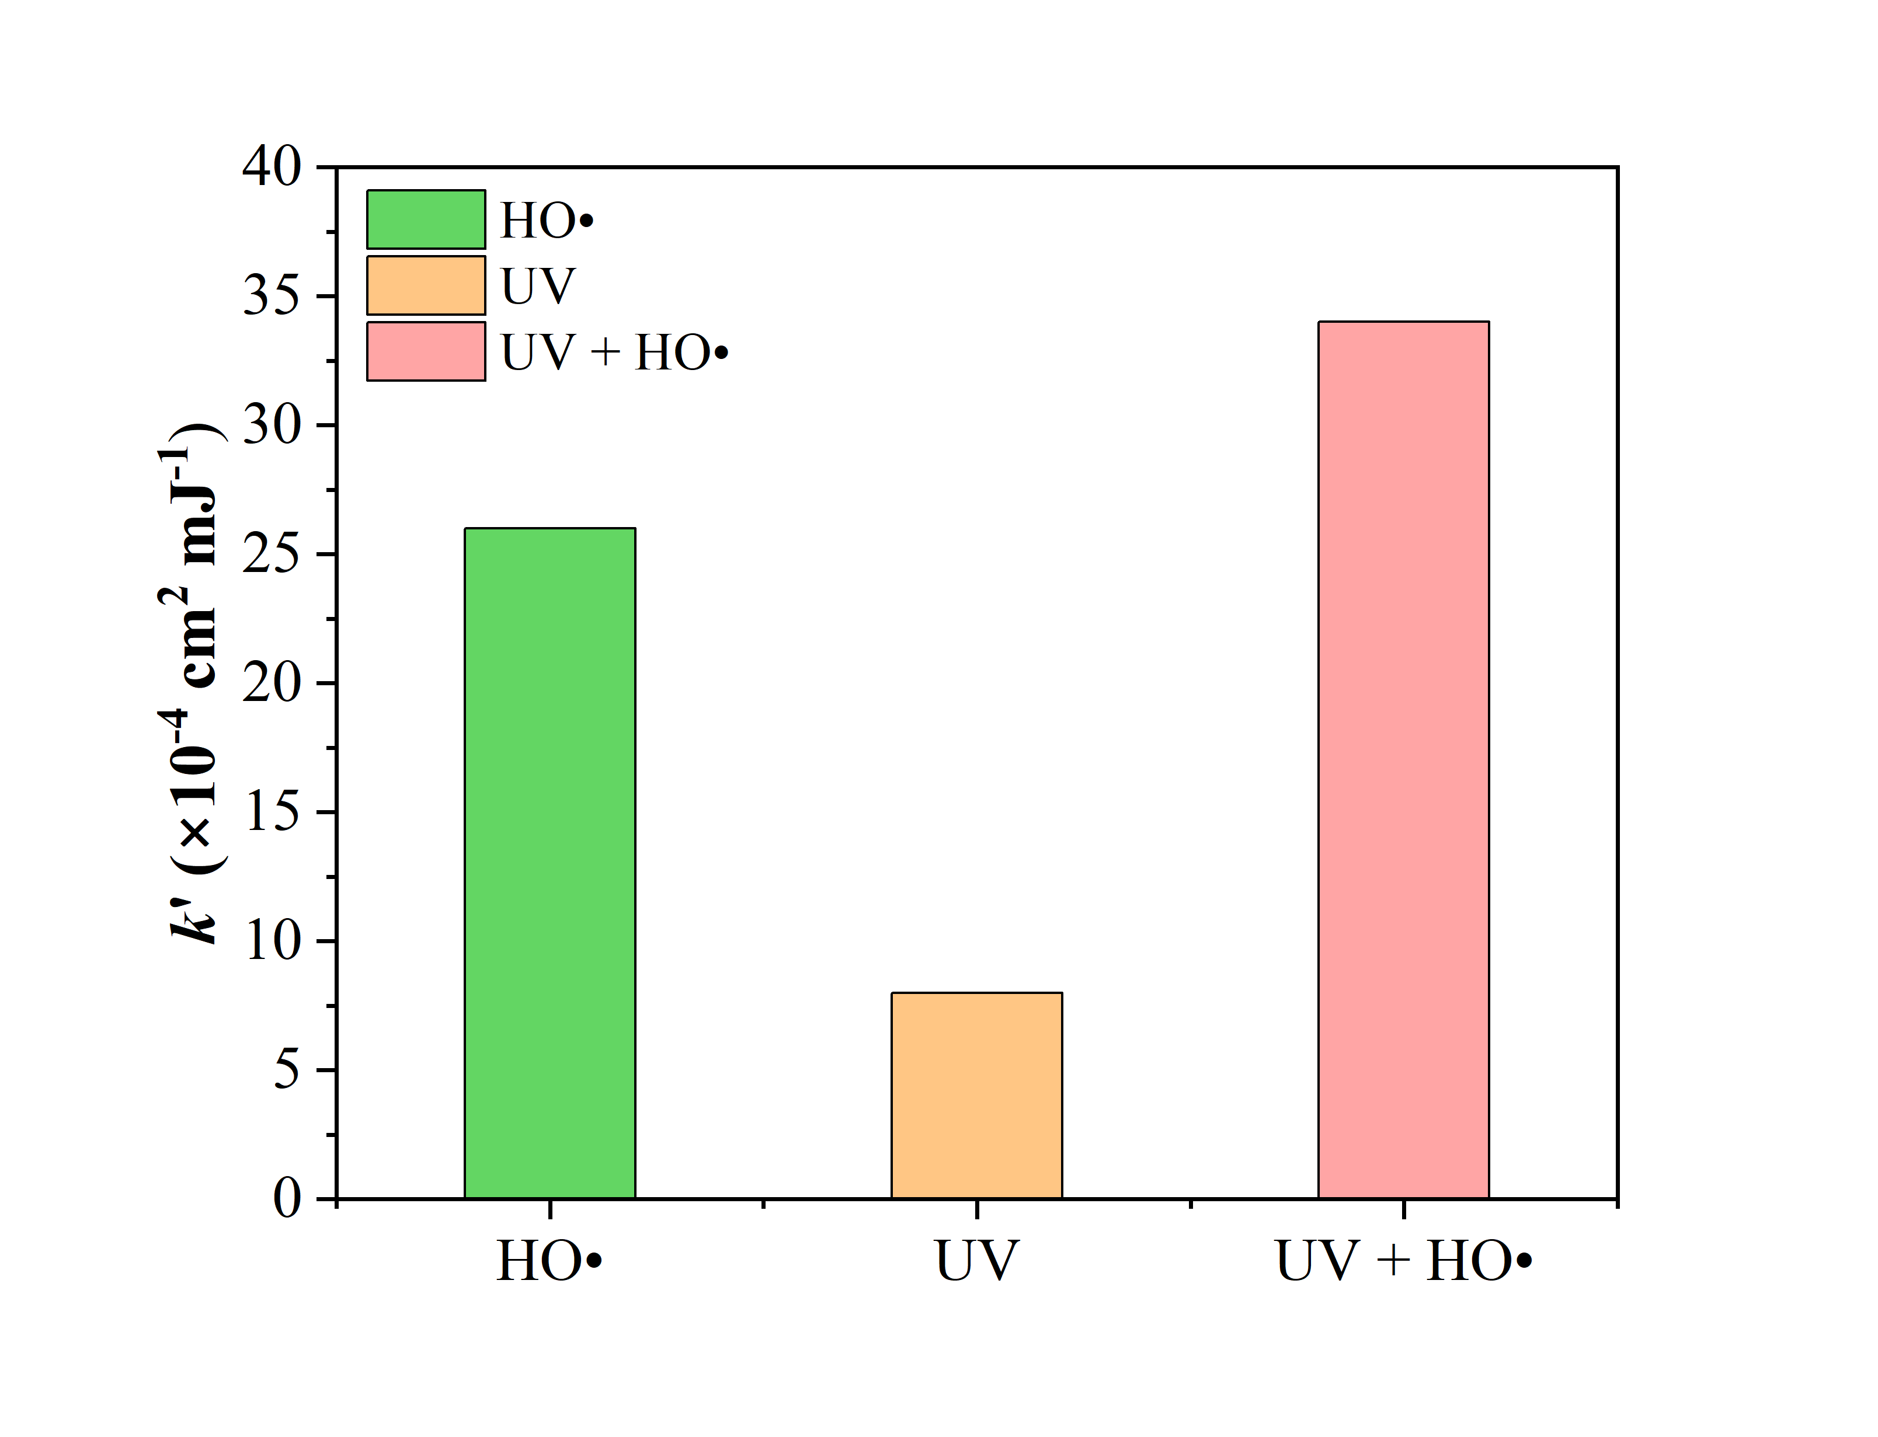

Fig. S6 Pseudo-first-order rate constants (k′) of the degradation of 2,4,6-TCA during UV/chlorination. Experimental conditions: [Chlorine]₀ = 200 μM, [2,4,6-TCA]₀ = 20 μg L⁻¹, pH = 7.0 ± 0.1, [phosphate buffer] = 10 mM, T = 25 ± 1.0 ℃, and UV intensity = 0.42 mW cm⁻¹ for 275 nm, respectively.

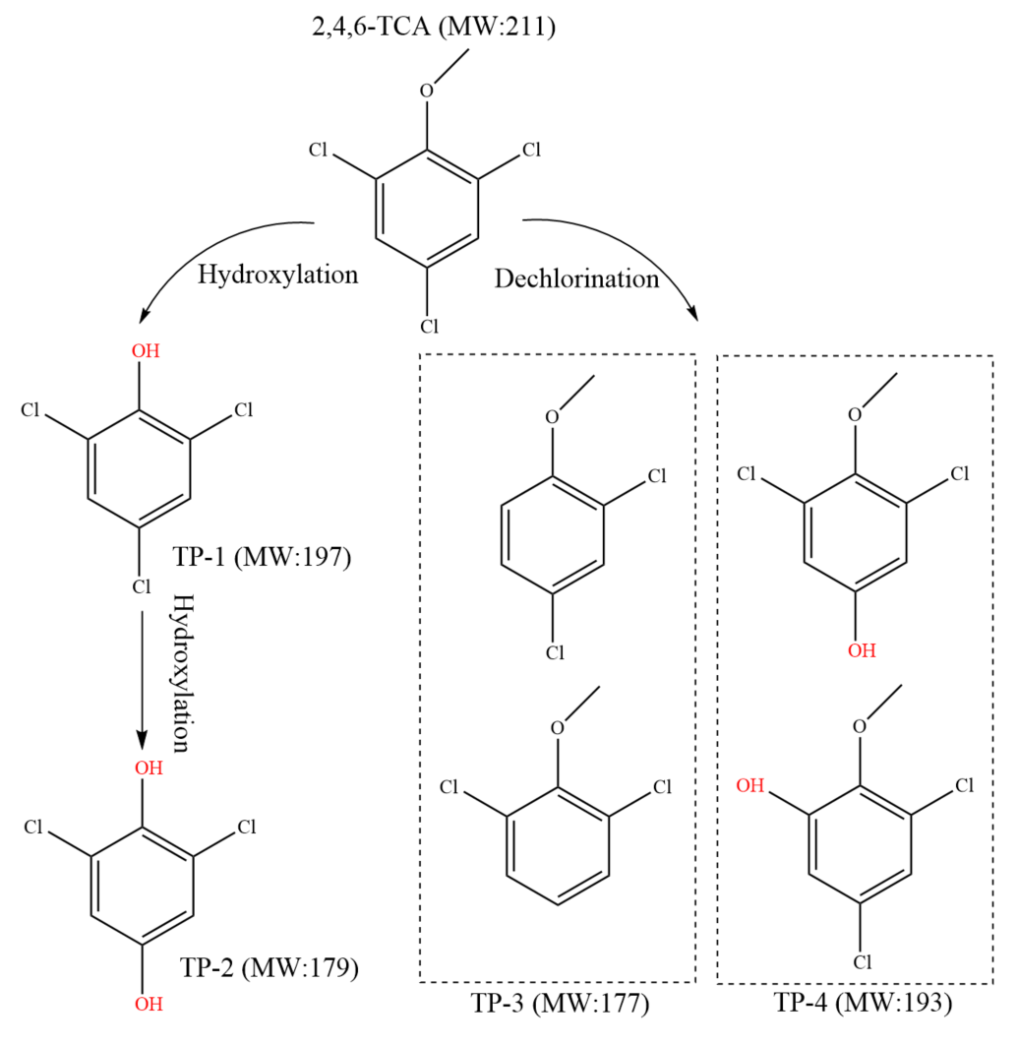

Fig. S7 Proposed degradation pathways of 2,4,6-TCA in UV/chlorination process.

References
Fang JY, Fu Y, Shang C (2014) The Roles of Reactive Species in Micropollutant Degradation in the UV/Free Chlorine System. Environ. Sci. Technol. 48:1859-1868
Feng YG, Smith DW, Bolton JR (2007) Photolysis of aqueous free chlorine species (NOCI and OCI-) with 254 nm ultraviolet light. J. Environ. Eng. Sci. 6:277-284
Grebel JE, Pignatello JJ, Mitch WA (2010) Effect of Halide Ions and Carbonates on Organic Contaminant Degradation by Hydroxyl Radical-Based Advanced Oxidation Processes in Saline Waters. Environ. Sci. Technol. 44:6822-6828
Malleret L, Bruchet A, Hennion MC (2001) Picogram Determination of “Earthy-Musty” Odorous Compounds in Water Using Modified Closed Loop Stripping Analysis and Large Volume Injection GC/MS. Anal. Chem. 73:1485-1490
NIST (2020) The Radiation Chemistry Data Center of the Notre Dame Radiation Laboratory (ndrlRCDC) Kinetics Database.
Sun P, Tyree C, Huang CH (2016) Inactivation of Escherichia coli, Bacteriophage MS2, and Bacillus Spores under UV/H₂O₂ and UV/Peroxydisulfate Advanced Disinfection Conditions. Environmental Science & Technology 50:4448-58
Wang W-L, Wu Q-Y, Li Z-M, Lu Y, Du Y, Wang T, Huang N, Hu H-Y (2017) Light-emitting diodes as an emerging UV source for UV/chlorine oxidation: Carbamazepine degradation and toxicity changes. Chem. Eng. J. 310:148-156
Watts MJ, Linden KG (2007) Chlorine photolysis and subsequent OH radical production during UV treatment of chlorinated water. Water Res. 41:2871-2878
Yao H, Sun P, Minakata D, Crittenden JC, Huang C (2013) Kinetics and modeling of degradation of Ionophore antibiotics by UV and UV/H₂O₂. Environmental Science & Technology 47:4581-4589

