Additional file 3
LPS causes lung damage
1 Design ideas and experimental purposes
Acute lung injury (ALI)/acute respiratory distress syndrome (ARDS) is a clinical syndrome characterised by an excessive or uncontrolled inflammatory response caused by direct or indirect lung injury, resulting in irreversible hypoxaemia, diffuse bilateral lung injury, pulmonary oedema, reduced lung compliance and dyspnoea. The clinical syndrome is characterised by symptoms such as reduced lung compliance and dyspnoea¹. Sepsis is an acute systemic inflammatory syndrome and is the most common cause of acute lung injury (ALI), which can be simulated by the injection of LPS^{2,3}. This project explores the clinical manifestations of septic acute lung injury in rats by making a model rat of septic acute lung injury caused by LPS, and establishes a reliable animal model for further research on the mechanism of diagnosis and treatment.
2 Experimental content (knowledge points involved, theoretical principles)
The lipopolysaccharide (LPS) fraction of Gram-negative bacteria is an important risk factor for ARDS. The mitogen-activated protein kinases (MAPKs) signalling pathway is the main signalling pathway regulating inflammatory cell production and is closely associated with LPS-induced ARDS. Activation of MAPKs has been observed to be facilitated by various extracellular stimuli including cytokines and growth factors. Attenuating tumour necrosis factor (TNF)-a, interleukin (IL)-1β, and IL -6 messenger RNA (mRNA) expression inhibits the activation of mitogen-activated protein kinases (MAPKs) and reduces histological abnormalities.
3 Experimental methodology and results
3.1 Isolation and purification of LPS
The initial OD600nm value of 0.02 was transferred to 1000 ml of LB culture medium and incubated at 37°C with shaking at 170 r/min until the OD600nm value was 1.2. Bacteria were then collected by centrifugation at 5000 r/min for 8 minutes, washed twice with phosphate buffer and the sediment was weighed wet.
Method 1: Suspend the bacteria in 5 times the volume of deionised water, repeatedly freeze-thaw 3 times and sonicate on ice for 10 minutes. Add an equal volume of 90% phenol solution, shake and mix at 68 °C for 30 minutes, cool on ice for 5 minutes, centrifuge at 4000 r/min for 30 minutes, collect the upper aqueous phase, add an equal amount of deionised water to the lower phenol phase and repeat the extraction once, combine the two aqueous phases and repeat the extraction once with phenol. All aqueous phases were collected and placed in a dialysis bag and dialyzed in running water for 24 hours and distilled water for 24 hours (with water changes every 5-6 hours), and the sample was freeze-dried to obtain the LPS crude extract.
Method 2: The concentrated bacterial solution was boiled in a boiling water bath for 2 h and left in the refrigerator for more than 2 weeks (to allow the residue to sink freely). 3000 r/min centrifuged for 30 min and the supernatant was taken as E. coli lipopolysaccharide and stored at 4°C in the refrigerator.
Method 3: The obtained bacterial broth was washed by centrifugation at 2500 r/min for 20 min and washed 1-2 times to make a concentrated broth. The solution was centrifuged at 3000 r/min for 30 min and the supernatant was aspirated as E. coli lipopolysaccharide. Store at 4°C in the refrigerator.
Add 10 ml of 100 mmol/L Tris-Hcl (pH 8), 100 μg/ml of DNase I and 50 μg/ml of RNaseA at final concentration and digest overnight at 37°C. Add 100 μg/ml of proteinase K at final concentration and digest at 65°C for 2 hours. The supernatant was extracted by centrifugation at 4000 r/min for 30 minutes, placed in a dialysis bag and dialyzed in distilled water for 12 hours (water was changed every 5-6 hours).
3.2 Sugar fixation, nucleic acid detection and determination of LPS concentration
(1) Polysaccharide content determination (LPS sugar content by phenol-sulphuric acid method)
Add 0,0.10, 0.20, 0.40, 0.60, 0.80 and 1.00 mL of each 100 mg/mL glucose solution into test tubes, and make up to 1.00 mL with deionized water; add 100 μL of the sample to be measured into 900 μL of deionized water; add 0.50 mL of 6% phenol solution into each tube, then add 3.00 mL of concentrated sulfuric acid, shake well; boiling water bath The sample was then cooled to room temperature with running water. The D490nm value was measured by an enzyme standard meter and repeated three times, and the standard curve was calculated using the equation of the standard curve.
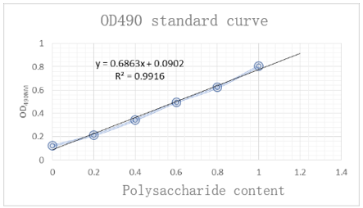
(2) Determination of nucleic acid content
The OD260nm value of the purified LPS sample was measured using nanodrop and its content was calculated as 0.06%.
(3) Determination of protein content
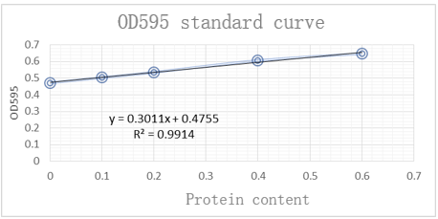
The sample was filled with 0.1 mg/mL of BSA (bovine serum albumin) solution at 0, 0.05, 0.20, 0.40 and 0.60 mL and made up to 1.00 mL with deionised water solution. The BSA standard curve was calculated using the equation of the standard curve and the protein content of the sample was calculated as 0.51%.

3.3 Determining LPS activity
Take a pyrogen-free tube and add 100μl of bacterial endotoxin test water, endotoxin standard solution, or the test article. Add 100μl of horseshoe crab reagent solution and mix well, incubate at 37ºC for T1 minutes. At the end of incubation, add 100 μl of colour developing substrate solution, mix well and incubate at 37ºC for T2 minutes. At the end of incubation, add 500 μl of Azo Reagent 1 solution, mix well, add 500 μl of Azo Reagent 2 solution, mix well, add 500 μl of Azo Reagent 3 solution, mix well, leave for 5 minutes and read the absorbance at 545 nm. The LPS activity was measured to be 1.5 x 10^6 EU/mg.
(1) Induction of lung injury by intraperitoneal and endotracheal injection of LPS
Rats were divided into 2 groups; one group was injected intraperitoneally with LPS (10mg/kg) and the other group was injected intratracheally with LPS (0.5mg/kg) to induce lung injury. Rats were executed at 6, 12 and 24 hours for alveolar lavage and blood collection respectively.
(2) Alveolar lavage fluid protein content measurement to confirm the formation of lung injury
Open the rat's chest cavity, cut the trachea, insert the syringe into the trachea, ligate it with surgical silk, push 2ml of saline, after pushing and suctioning were repeated 3 times, remove the syringe, transfer the lavage solution to a test tube, centrifuge at 1500 r/min, take the supernatant, and measure the protein content. 0.1 mg/mL BSA (bovine serum albumin) solution was filled into test tubes at 0, 0.05, 0.20, 0.40 and 0.60 mL, respectively, and made up to 1.00 mL with deionised water solution; another 100 μL of the sample to be tested was added to 900 μL of deionised water; 4.00 mL of Komas Brilliant Blue was added to all test tubes and shaken well; after 5 min, the D595 nm value was measured by enzyme marker The BSA standard curve was repeated 3 times, and the protein content of the samples was calculated using the equation of the standard curve.
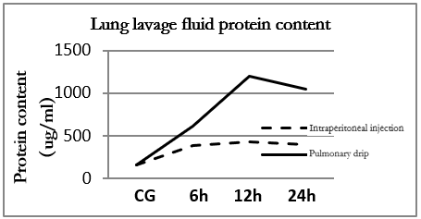
(3) Expression of inflammatory factors
Rat blood was centrifuged for 30 minutes and 20 ul of supernatant was taken to complete the assay of serum TNF-alpha concentration according to the ELISA kit instructions.
Group | TNF-alpha（ug/ml）
CG | 31.5±7.2
LPS | 136±27.8

Reference
1. Xu F, He B, Huang C, Hu M. [Research progress of non-coding RNA regulation of macrophage inflammatory response in ALI/ARDS]. Chinese Journal of Lung Diseases(Electronic Edition). 2021;14(5):677-680.
2. Domscheit H, Hegeman MA, Carvalho N, Spieth PM. Molecular Dynamics of Lipopolysaccharide-Induced Lung Injury in Rodents. Front Physiol. 2020;11. doi:10.3389/fphys.2020.00036
3. Wepler M, Preuss JM, Merz T, et al. Impaired Glucocorticoid Receptor Dimerization Aggravates LPS-Induced Circulatory and Pulmonary Dysfunction. Front Immunol. 2019;10:3152. doi:10.3389/fimmu.2019.03152

