Supplementary information

Hydrothermal converting dye into pyrrolic-N for sustainable activated carbon regeneration

Xiaonuan Wang¹, Yajie Qian¹, Hong Chen¹, Xiang Li¹, Ai Zhang¹, Changyu Chen¹, Yueling He¹, Gang Xue^{1,2*}

¹College of Environmental Science and Engineering, Donghua University, Shanghai, 201620, China
²Shanghai Institute of Pollution Control and Ecological Security, Shanghai, 200000, China

*Corresponding author:
Gang Xue
College of Environmental Science and Engineering
Donghua University, Shanghai, 201620, China
Email: xuegang@dhu.edu.cn

Contents:
Supplementary Fig. 1 ∣ Proposed scheme of source separation coupled with comprehensive PDW wastewater treatment for dye and Cr(VI) removal. 2
Supplementary Fig. 2 ∣ MB adsorption modeling. 3
Supplementary Fig. 3 ∣ Contact angle. 4
Supplementary Fig. 4 ∣ Element distribution determined by EDX attached to TEM. 5
Supplementary Fig. 5 ∣ PFRs signal of pristine AC and regenerated AC-11. 6
Supplementary Fig. 6 ∣ Zeta potential of pristine AC and regenerated AC-11, and ORP of Cr(VI) solution. 7
Supplementary Fig. 7 ∣ XPS spectra of C 1s of regenerated AC-11 before and after reaction with Cr(VI). 9
Supplementary Fig. 8 ∣ XPS spectra of C 1s of pristine AC before and after reaction with Cr(VI). 10
Supplementary Fig. 9 ∣ XPS spectra of Cr 2p of regenerated AC-11 and pristine AC before and after reaction with Cr(VI). 12
Supplementary Fig. 10 ∣ Pathway of reducing Cr(VI) by pyrrolic-N. 13
Supplementary Fig. 11 ∣ Structure of nitrogen-containing dyes. 15
Supplementary Fig. 12 ∣ Cr(VI) removal by regenerated AC derived from adsorption-regeneration cycle of other nitrogen-containing dyes. 16
Supplementary Table 1. Kinetics parameters of pseudo-first-order (PFO) and pseudo-second-order (PSO) models. 18
Supplementary Table 2. Kinetic model parameters of intraparticle diffusion model. 19
Supplementary Table 3. Thermal properties of MB, MB hydrochar, pristine and regenerated AC. 20
Supplementary Table 4 ∣ Textural properties of pristine AC, regenerated AC and unregenerated AC. 21

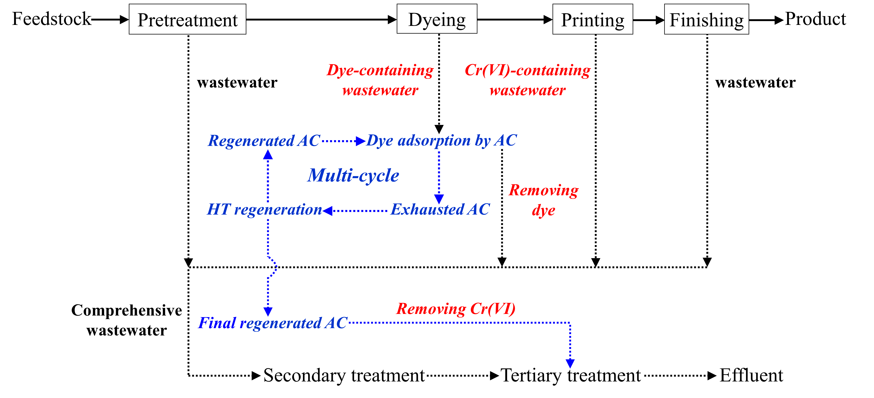

Supplementary Fig. 1 ∣ Proposed scheme of source separation coupled with comprehensive PDW wastewater treatment for dye and Cr(VI) removal.
b
a

Supplementary Fig. 2 ∣ MB adsorption modeling. a, Pseudo-first-order and pseudo-second-order modeling for MB adsorption by pristine and unregenerated AC. b, Intraparticle diffusion modeling for MB removal by pristine and unregenerated AC. The experimental conditions for kinetics modeling were: 0.5 g of pristine or unregenerated AC was dosed in 50 mL of MB solution (500 mg/L); 16.5 h dark stirring reaction at 30 °C. With regard to unregenerated AC-n, n denotes the times of adsorption-regeneration cycle.

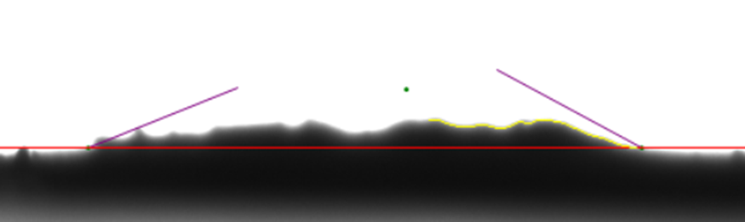
a
Pristine AC: θ=24.31°

b
MB hydrochar: θ=58.36°
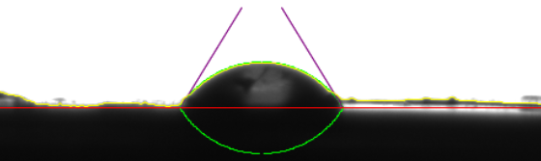

Supplementary Fig. 3 ∣ Contact angle. a, Pristine AC. b, MB hydrochar. The contact angle was measured at room temperature using a goniometer (SL200KS, KINO, USA). All samples were ground into powder and passed through the 100-mesh sieve (0.15 mm) before used. Water droplets (3 μL) were dropped onto the sample surface, and the camera integrated with the goniometer was used to record the changing process of water droplets.

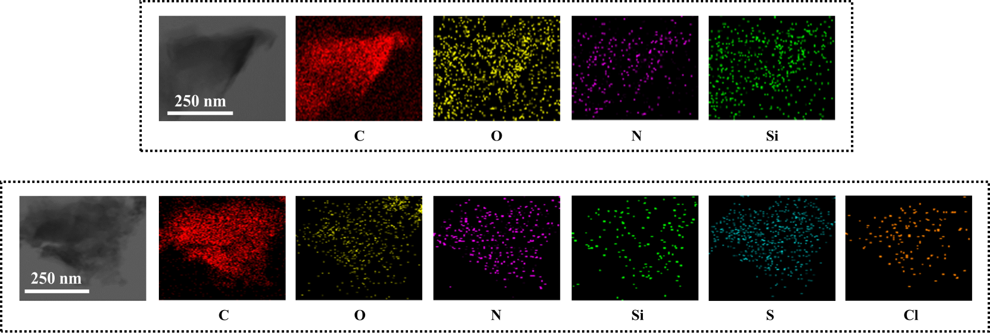
a

b

Supplementary Fig. 4 ∣ Element distribution determined by EDX attached to TEM. a, Pristine AC. b, Regenerated AC-11. The samples were suspended in ethanol and deposited directly on a molybdenum wire mesh prior to analysis. Scale bar of 250 nm.

b
a

Supplementary Fig. 5 ∣ PFRs signal of pristine AC and regenerated AC-11. a, Comparison of PFRs signal between pristine AC and regenerated AC-11. b, PFRs variation of regenerated AC-11 before and after reaction with Cr(VI) at different pH. The initial Cr(VI) concentration was 1.4 mg/L. The initial pH of Cr(VI) solution was adjusted to 3.0, 5.0, 7.0 and 9.0 by adding H₂SO₄ or NaOH (1 mM), respectively. Then, 0.5 g of regenerated AC-11 was dosed in 50 mL of Cr(VI) solution in a 250 mL conical flask. Subsequently, the mixture underwent the dark stirring reaction with 150 rpm and 30 °C for 2 h. After the reaction, the mixture was separated through 0.22 μm cellulose esters membrane. The obtained solid of regenerated AC-11 was dried for 24.0 h at -60 °C using a vacuum freeze dryer, and then measured for PFRs analysis. Regenerated AC-11 represents regenerated AC derived from the eleventh adsorption-regeneration cycle.
b
a

Supplementary Fig. 6 ∣ Zeta potential of pristine AC and regenerated AC-11, and ORP of Cr(VI) solution. a, Zeta potential variation of pristine AC and regenerated AC-11versus pH. All samples were ground into powder and passed through the 100-mesh sieve (0.15 mm) before used. 500 mg of sample were dosed in 500 mL of NaCl solution (1 mM) in a 1 L beaker, and the mixture was stirred with 150 rpm at room temperature for 1 h. Afterwards, the mixture was divided equally into 8 fractions, and the pH was adjusted by H₂SO₄ or NaOH (1 mM) to 2.0-9.0, respectively. All solutions were stirred for 12.0 h to achieve homogeneity. Then, all solutions were immediately measured for zeta potential. b, ORP variation of Cr(VI) solution versus pH. The pH of Cr(VI) solution (1.4 mg/L) was adjusted to 1.0-9.0 using H₂SO₄ or NaOH (1 mM), and the ORP was monitored simultaneously. Regenerated AC-11 represents regenerated AC derived from the eleventh adsorption-regeneration cycle. Error bars represent standard variations from duplicate experiments.

b
a

e
d
c

Supplementary Fig. 7 ∣ XPS spectra of C 1s of regenerated AC-11 before and after reaction with Cr(VI). a, Regenerated AC-11 before reaction. b-e, Regenerated AC-11 after reaction at pH 3.0 (b), pH 5.0 (c), 7.0 (d) and 9.0 (e). The initial Cr(VI) concentration was set at 1.4 mg/L according to authentic comprehensive PDW. The initial pH of Cr(VI) solution was adjusted to 3.0, 5.0, 7.0 and 9.0 by adding H₂SO₄ or NaOH (1 mM), respectively. 0.5 g of regenerated AC-11 was dosed in 50 mL of Cr(VI) solution in a 250 mL conical flask. Subsequently, the mixture underwent the dark stirring reaction with 150 rpm at 30 °C for 2.0 h. For the C 1s spectrum, the peak at 284.8 eV is attributed to the sp² hybridized graphitic carbon atoms of C-C/C=C moiety in the form of conjugated honeycomb lattice. The peak at 286.0 eV is assigned to C-O moiety (alcoholic hydroxyl group, phenolic hydroxyl group or ether). The peak at 287.6 eV corresponds to C=O moiety (carbonyl or quinonyl). The peak at 289.8 eV is COOH moiety (carboxyl or ester group). Regenerated AC-11 represents regenerated AC derived from the eleventh adsorption-regeneration cycle.
b
c
a

Supplementary Fig. 8 ∣ XPS spectra of C 1s of pristine AC before and after reaction with Cr(VI). a, Pristine AC before reaction. b-c, Pristine AC after reaction at pH 3.0 (b) and 5.0 (c). The initial Cr(VI) concentration was set at 1.4 mg/L according to authentic comprehensive PDW. The initial pH of Cr(VI) solution was adjusted to 3.0 and 5.0 by adding H₂SO₄ or NaOH (1 mM), respectively. 0.5 g of pristine AC was dosed in 50 mL of Cr(VI) solution in a 250 mL conical flask. Subsequently, the mixture underwent the dark stirring reaction with 150 rpm at 30 °C for 2.0 h. For the C 1s spectrum, the peak at 284.8 eV is attributed to the sp² hybridized graphitic carbon atoms of C-C/C=C moiety in the form of conjugated honeycomb lattice. The peak at 286.0 eV is assigned to C-O moiety (alcoholic hydroxyl group, phenolic hydroxyl group or ether). The peak at 287.6 eV corresponds to C=O moiety (carbonyl or quinonyl). The peak at 289.8 eV is COOH moiety (carboxyl or ester group).

b
c
a

e
d
f

Supplementary Fig. 9 ∣ XPS spectra of Cr 2p of regenerated AC-11 and pristine AC before and after reaction with Cr(VI). a-d, Regenerated AC-11 after reaction at pH 3.0 (a), pH 5.0 (b), pH 7.0 (c) and 9.0 (d). e-f, Pristine AC after reaction at pH 3.0 (e) and pH 5.0 (f). The initial Cr(VI) concentration was set at 1.4 mg/L according to authentic comprehensive PDW. The initial pH of Cr(VI) solution was adjusted to 3.0, 5.0, 7.0 and 9.0 by adding H₂SO₄ or NaOH (1 mM), respectively. 0.5 g of regenerated AC-11 or pristine AC was dosed in 50 mL of Cr(VI) solution in a 250 mL conical flask. Subsequently, the mixture underwent the dark stirring reaction with 150 rpm at 30 °C for 2.0 h. For the Cr 2p spectrum, Cr 2p region generates two pairs of spin-orbit doublet peaks including Cr 2p_{3/2} and Cr 2p_{1/2} components. The peaks at 577.3 eV (Cr 2p_{3/2}) and 586.9 eV (Cr 2p_{1/2}) corresponds to Cr(III). The peaks at 579.6 eV (Cr 2p_{3/2}) and 589.2 eV (Cr 2p_{1/2}) are attributed to Cr(VI). Regenerated AC-11 represents regenerated AC derived from the eleventh adsorption-regeneration cycle.

c
b
a

Supplementary Fig. 10 ∣ Pathway of reducing Cr(VI) by pyrrolic-N. a, Influence of O₂^{•−} quenching by BQ on Cr(VI) removal. 0.5 g of regenerated AC-11 was dosed in 50 mL of Cr(VI) solution (1.4 mg/L) in a 250 mL conical flask, without pH adjustment (pH=5.2 ± 0.5). Four experimental groups were set based on the BQ dosage of 0.0, 3.0, 30.0 and 60.0 mM, respectively. All groups underwent the dark stirring reaction with 150 rpm at 30 °C for 2.0 h. Since Cr(III) was not detected after the reaction, the Cr(VI) concentration was equal to the total chromium concentration in solution. b, Influence of O₂ as O₂^{•−} precursor on Cr(VI) removal. The Cr(VI) solution of 1.4 mg/L was prepared in the anoxic glovebox using deoxygenated water, which was sparged by ultrapure N₂ for 4.0 h. Then, the solution was equilibrated at the anoxic environment in glovebox for at least 12.0 h. Meanwhile, regenerated AC-11 was also placed in the anoxic glovebox for at least 12.0 h before used. Subsequently, 0.5 g of deoxygenated regenerated AC-11 was dosed in 50 mL of deoxygenated Cr(VI) solution in a 250 mL conical flask, without pH adjustment (pH=5.2 ± 0.5). The experiment without deoxygenation was set as the control group. The mixture underwent the dark stirring reaction with 150 rpm at 30 °C for 2.0 h. c, Reusability of regenerated AC-11. 0.5 g of regenerated AC-11 was dosed in 50 mL of Cr(VI) solution (1.4 mg/L) in a 250 mL conical flask, without pH adjustment (pH=5.2 ± 0.5). Subsequently, the mixture underwent the dark stirring reaction with 150 rpm and 30 °C for 2.0 h. After reaction, the mixture was separated through 0.22 μm cellulose esters membrane. The filtrate was immediately analyzed to determine the Cr(VI) concentration, and regenerated AC-11 after reaction was reused to next cycle again. Regenerated AC-11 represents regenerated AC derived from the eleventh adsorption-regeneration cycle. Error bars represent standard variations from duplicate experiments.

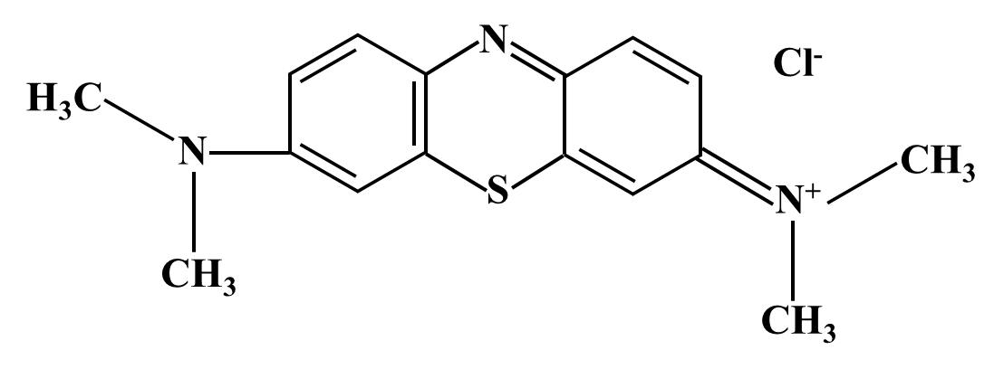
a

b
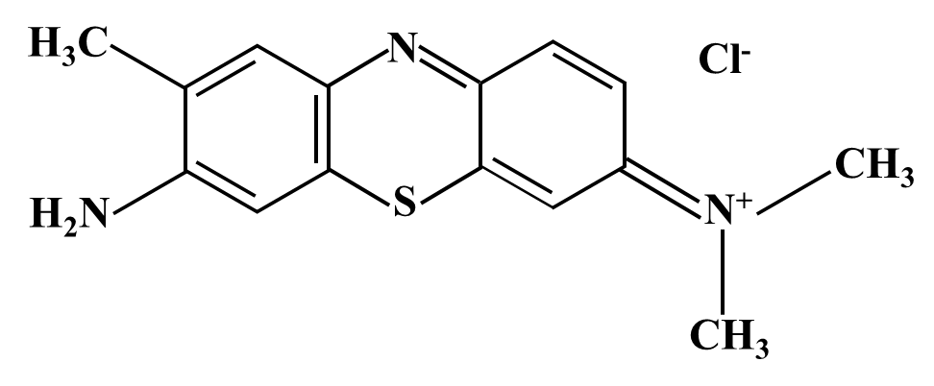

c
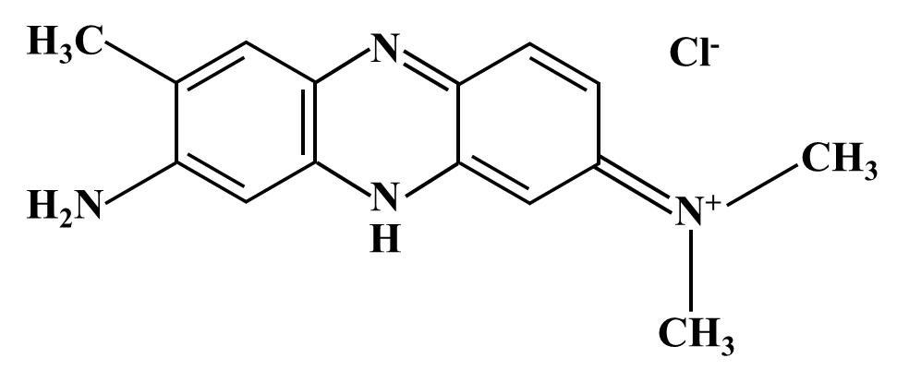

d
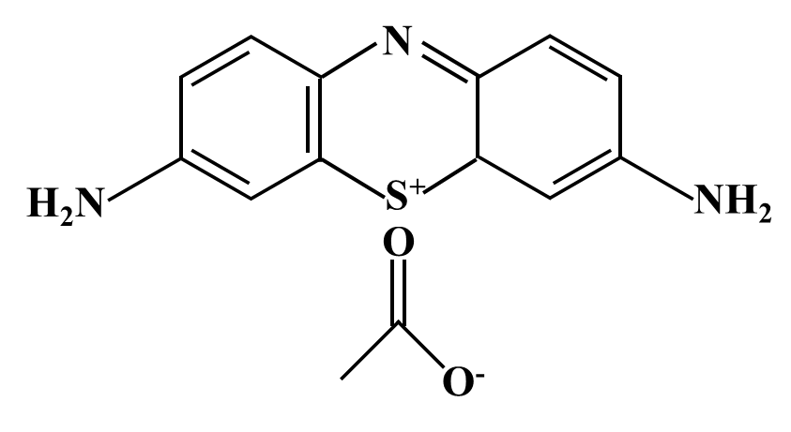

Supplementary Fig. 11 ∣ Structure of nitrogen-containing dyes. a, Methylene blue (MB). b, Toluidine blue (TB). c, Neutral red (NR). d, Thionin acetate (TA). The same structures of MB, TB and NR within the red dotted lines belong to quinonimine group.

c
b
a

Supplementary Fig. 12 ∣ Cr(VI) removal by regenerated AC derived from adsorption-regeneration cycle of other nitrogen-containing dyes. a-c, Regenerated AC-7 derived from the seventh adsorption-regeneration cycle of TB (a), NR (b) and TA (c). 0.5 g pristine AC was dosed in 50 mL of dye solution with 500 mg/L of TB, NR and TA at the first cycle, respectively, which was used in the following cycles persistently. After 16.5 h dark stirring reaction at 30 °C, HT regeneration of exhausted AC of each cycle was conducted, with reaction temperature of 220 °C maintained for 4.0 h stably. The adsorption-regeneration cycle was conducted for 7 cycles and the obtained regenerated AC-7 was used to remove Cr(VI). The initial Cr(VI) concentration was set at 1.4 mg/L according to authentic comprehensive PDW. The initial pH of Cr(VI) solution was adjusted to 3.0, 5.0, 7.0 and 9.0 by adding H₂SO₄ or NaOH (1 mM), respectively. 0.5 g of regenerated AC-7 was dosed in 50 mL of Cr(VI) solution. Subsequently, the mixture underwent the dark stirring reaction with 150 rpm and 30 °C for 4.0 h. Error bars represent standard variations from duplicate experiments.

Supplementary Table 1. Kinetics parameters of pseudo-first-order (PFO) and pseudo-second-order (PSO) models. The experimental conditions for kinetics modeling were: 0.5 g of pristine AC, regenerated and unregenerated AC were dosed in 50 mL of MB solution (500 mg/L), respectively; 16.5 h stirring dark reaction at 30 °C. The q_{e,exp} is the adsorption capacity for MB at equilibrium based on experimental data. q_{e1,cal} and q_{e2,cal} represent the adsorption capacities for MB at equilibrium calculated as PFO and PSO models, respectively. k₁ and k₂ are the rate constants of PFO and PSO models, respectively. R₁² and R₂² are the correlation coefficients of PFO and PSO models, respectively. Sum of squared error (SSE) is a statistical value necessary for the best fit of an adsorption system. Generally, the higher R² and lower SSE indicate a more applicable model to the MB adsorption kinetics. With regard to regenerated or unregenerated AC-n, n denotes the times of adsorption-regeneration cycle.
Sample | q_{e,exp}(mg/g) | Pseudo-first-order |  |  |  |  | Pseudo-second-order
Sample | q_{e,exp}(mg/g) | q_{e1,cal} (mg/g) | R₁² | k₁ (h⁻¹) | SSE | q_{e2,cal} (mg/g) |  | R₂² | k₂ (h⁻¹) | SSE
Pristine AC | 49.90 | 49.59 | 0.992 | 0.030 | 26.005 | 52.56 |  | 0.989 | 8.89E-04 | 37.803
Regenerated AC-3 | 48.44 | 45.59 | 0.966 | 0.011 | 121.762 | 51.17 |  | 0.993 | 2.82E-04 | 25.741
Regenerated AC-7 | 45.45 | 40.44 | 0.934 | 0.011 | 188.353 | 45.72 |  | 0.977 | 2.96E-04 | 66.594
Regenerated AC-11 | 41.16 | 36.25 | 0.941 | 0.009 | 137.419 | 41.65 |  | 0.979 | 2.6240E-4 | 49.162
Unregenerated AC-3 | 46.86 | 44.72 | 0.959 | 0.005 | 145.694 | 54.16 |  | 0.981 | 1.05225E-4 | 69.105
Unregenerated AC-7 | 34.57 | 33.75 | 0.930 | 0.004 | 127.693 | 41.97 |  | 0.954 | 9.16657E-5 | 84.529
Unregenerated AC-11 | 25.97 | 25.89 | 0.911 | 0.003 | 69.338 | 32.39 |  | 0.916 | 1.10782E-4 | 69.338

Supplementary Table 2. Kinetic model parameters of intraparticle diffusion model. The experimental conditions for kinetics modeling were: 0.5 g of pristine AC, regenerated and unregenerated AC were dosed in 50 mL of MB solution (500 mg/L), respectively; 16.5 h stirring dark reaction at 30 °C. K_{p1}, k_{p2} and k_{p3} are the rate constants of intraparticle diffusion model, corresponding to liquid film diffusion, intraparticle diffusion and adsorption, respectively. C₁, C₂ and C₃ are the constants associated with boundary layer thickness, corresponding to liquid film diffusion, intraparticle diffusion and adsorption, respectively. The larger value of C means the greater thickness of boundary layer. R₁², R₂²and R₃² are the correlation coefficients of intraparticle diffusion model, corresponding to liquid film diffusion, intraparticle diffusion and adsorption, respectively. With regard to regenerated or unregenerated AC-n, n denotes the times of adsorption-regeneration cycle.
Sample | Film diffusion |  |  | Intraparticle diffusion |  |  | Adsorption
Sample | k_{p1} | C₁ | R₁² | k_{p2} | C₂ | R₂² | k_{p3} | C₃ | R₃²
Pristine AC | 4.931 | 1.264 | 0.987 | 1.201 | 33.655 | 0.935 | — | — | —
Regenerated AC-3 | 2.832 | 0.938 | 0.999 | 1.178 | 18.860 | 0.944 | 0.393 | 36.679 | 0.911
Regenerated AC-7 | 2.565 | 0.863 | 0.997 | 0.985 | 16.720 | 0.974 | 0.668 | 25.487 | 0.974
Regenerated AC-11 | 2.179 | 0.028 | 0.998 | 0.927 | 13.189 | 0.976 | 0.684 | 19.695 | 0.977
Unregenerated AC-3 | 1.567 | 4.307 | 0.989 | 1.582 | 1.911 | 0.974 | 0.911 | 19.611 | 0.952
Unregenerated AC-7 | 1.095 | 1.647 | 0.996 | — | — | — | — | — | —
Unregenerated AC-11 | 0.803 | 1.822 | 0.992 | — | — | — | — | — | —

Supplementary Table 3. Thermal properties of MB, MB hydrochar, pristine and regenerated AC. The weight of sample was around 5-10 mg and its initial weight was determined before heating. The temperature increased from 50 to 800 °C, with the N₂ flow rate of 60 mL/min and heating rate of 10 °C/min. The mass loss rate (%) is the ratio of the lost mass to the initial mass within this temperature range. T_{m} represents the characteristic pyrolysis temperature corresponding to the maximum rate of mass loss. With regard to regenerated AC-n, n denotes the times of adsorption-regeneration cycle.
Sample | Mass loss below 350 °C (%) |  |  |  | Mass loss above 350 °C (%) | Characteristic temperatures (°C)
Sample | Free water  (50-150 °C) | Bound water  (150-350 °C) |  |  | Pyrolysis | T_{m}
MB | 3.53 |  | 15.02 | 78.22 |  | 640
MB hydrochar | 3.36 |  | ― | 90.96 |  | 520
Pristine AC | 0.43 |  | 1.17 | 2.71 |  | 690
Regenerated AC-3 | 0.43 |  | 0.72 | 4.44 |  | 690
Regenerated AC-7 | 0.59 |  | 0.83 | 6.17 |  | 520
Regenerated AC-11 | 0.58 |  | 1.21 | 9.15 |  | 520

Supplementary Table 4 ∣ Textural properties of pristine AC, regenerated AC and unregenerated AC. With regard to regenerated or unregenerated AC-n, n denotes the times of adsorption-regeneration cycle.
Sample | BET surface area (m²/g） | Pore volume (cm³/g) | Average pore size (nm)
Pristine AC | 1352 | 0.82 | 2.38
Regenerated AC-3 | 1207 | 0.71 | 2.35
Regenerated AC-7 | 1005 | 0.66 | 2.42
Regenerated AC-11 | 931 | 0.58 | 2.50
Unregenerated AC-3 | 967 | 0.63 | 2.47
Unregenerated AC-7 | 857 | 0.55 | 2.63
Unregenerated AC-11 | 729 | 0.49 | 2.44

