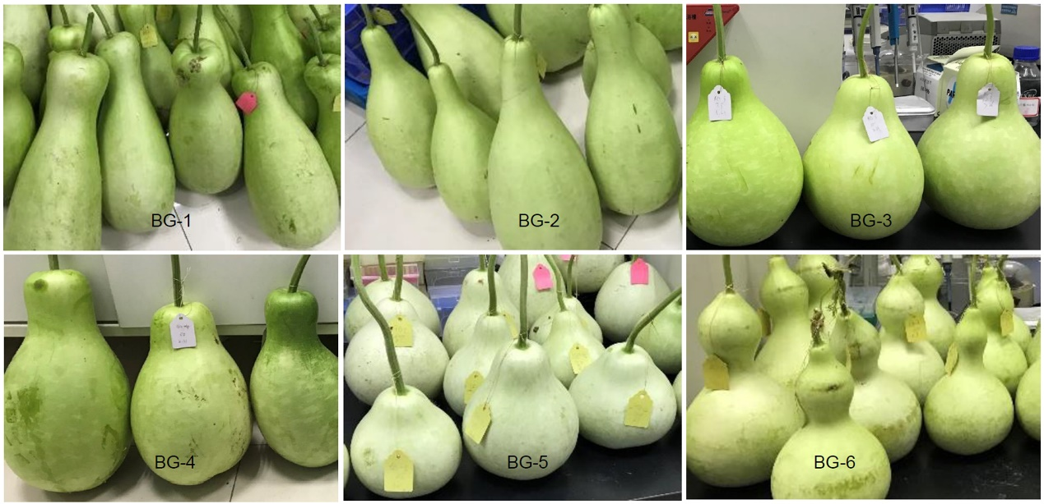
Fig. S1 Genotypes of bottle gourd pollinated with irradiated pollen

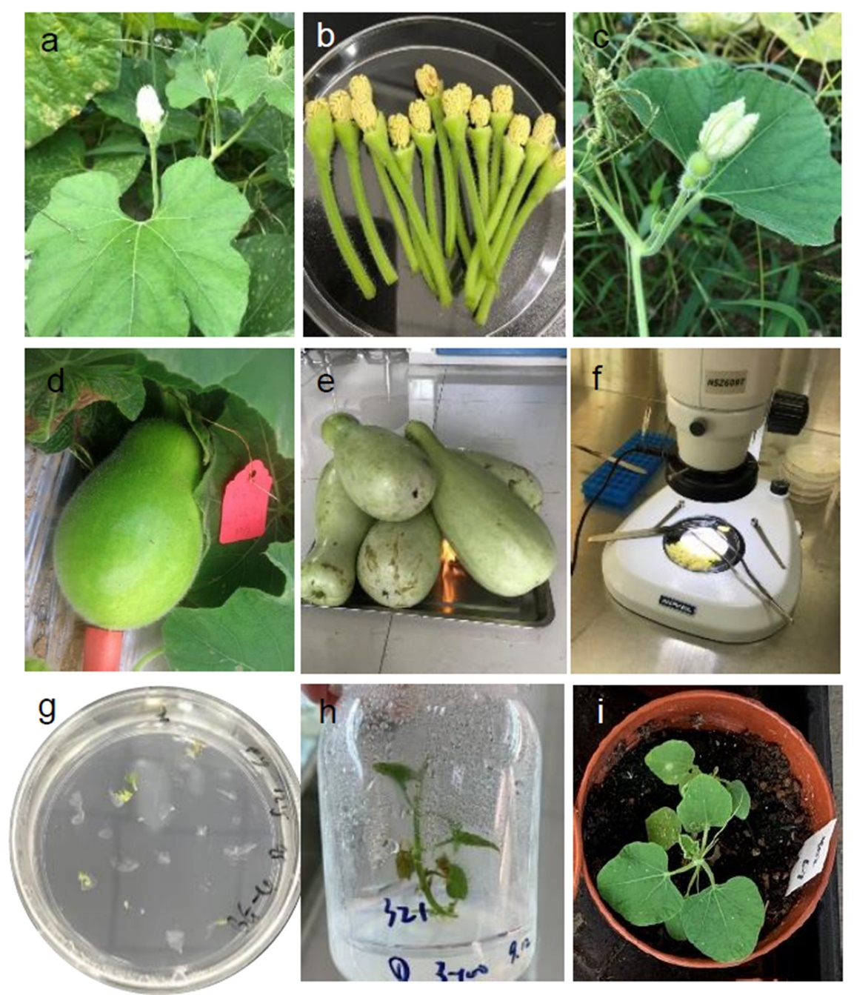
Fig. S2 Flow chart of haploid induction through pollination with irradiated pollen
a Male bottle gourd flower used for irradiation; b extracted anthers for irradiation; c female bottle gourd flower to be pollinated; d parthenogenetic fruit at 17 to 21 days after pollination with irradiated pollen; e sterilization of harvested immature parthenogenetic fruits; f extraction of haploid embryos under fluorescent light; g in vitro embryo rescue; h haploid plantlet; i haploid plantlet transferred to greenhouse.

