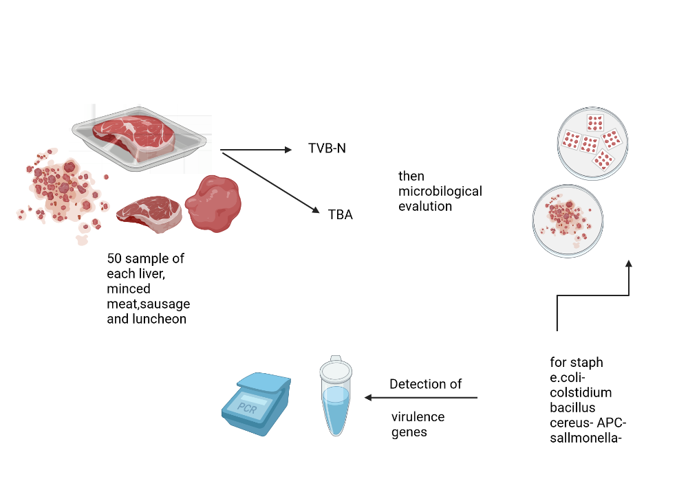
Abstract

Regarding virulence genes:-
(Pvl and Sea) and (invA and Stn) were detected in 100% of isolated Staph. aureus and Salmonella strains, respectively.
eaeA was detected in 100% of isolated E.coli strains while Stx2 was detected in only one strain.
Isolated strains of Clostridium perfringens were positive for enterotoxin gene (cpe) and alpha-toxin (cpa) at percent 100%.

