Supplementary Figures
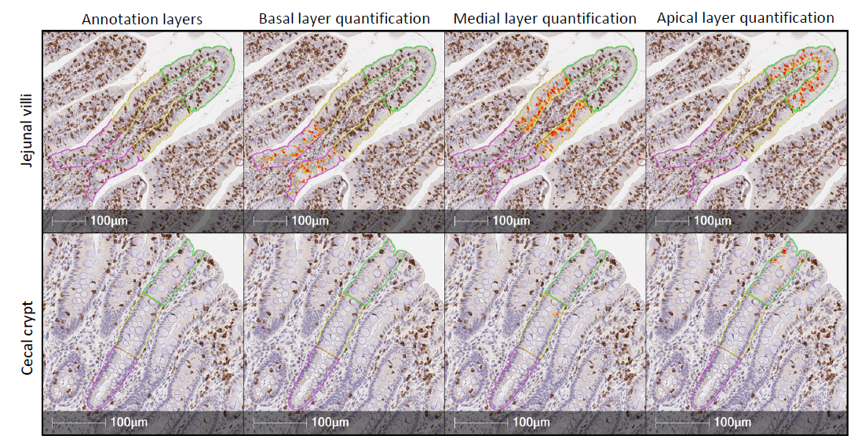
Supplementary Figure 1. In-situ staining and quantification of T-IELs.
Representative images of epithelial annotation (left, column 1) and stain quantification (right, columns 2-4) in jejunal/ileal villi and cecal crypts of tissues stained for CD3ε protein. Abbreviations: T-IEL = intraepithelial T lymphocyte
Supplementary Figure 2. Flow cytometry event filtering strategy.
(A) Top: gating strategy used in FlowJo to isolate CD3ε⁺ acquired events with forward- and side-scatter patterns consistent with lymphocytes. Bottom: axes scaling of cell surface marker fluorescent intensities that were converted to channel values (1,000 linear bins) exported from FlowJo for all subsequent analyses. Gating and axes scaling for a single sample of ileum from a 5wo pig (#25) are shown. (B) t-SNE plot showing FlowSOM clusters derived from clustering of gated CD3ε⁺ events shown in A based on batch-corrected expression of γδTCR, CD2, CD4, CD8α, CD8β, CD16, and CD27. Each dot represents one cell. Color of a dot corresponds to cluster annotation. Clusters 6 and 12 are circled and indicated as CD4 T cells and non-T cells, respectively. (C) t-SNE plots of cell marker expression. Each dot represents one cell. The color of a dot corresponds to batch-corrected fluorescent intensity values of analyzed cell surface markers. In B-C, a subset of 500 cells from each sample (24,000 total cells) are shown in each t-SNE plot. (D) Heatmap of FlowSOM clusters based on expression of γδTCR, CD2, CD4, CD8α, CD8β, CD16, and CD27. Cell color corresponds to average batch-corrected fluorescent intensity of a cell marker (y-axis) within a cluster (x-axis). (E) Stacked barplot showing the number of cells (y-axis) derived from FlowSOM clusters (x-axis) present in each sample type (color of stacked bars). In D-E, data belonging to clusters 6 and 12 are boxed to indicate identification of non-T cells and CD4 T cells, respectively, that were filtered out of the dataset. Data are derived from a total of eight pigs within each tissue/age group combination. Abbreviations: FSC-A = forward-scatter area; FSC-H = forward-scatter height; SSC-A = side-scatter area; T-IEL = intraepithelial T lymphocyte; t-SNE = t-distributed stochastic neighbor embedding; wo = weeks old
Supplementary Figure 3. Flow cytometry gating strategy.
Gating strategy used to identify eight T-IEL primary populations (A) and functional subsets (B). Cells remaining after removal of non-T cell and CD4 T cell events (see Supplementary Figure 2B,D-E) are shown in plots. All remaining T-IEL events are shown in plots, with an equal number of cells representing each sample. Data are derived from a total of eight pigs within each tissue/age group combination. (C) Table showing 32 T-IEL subsets defined by patterns of expression for eight primary populations (A) and four functional subsets (B). Abbreviations: SSC-A = side-scatter area; T-IEL = intraepithelial T lymphocyte
Supplementary Figure 4. T-IEL primary population distributions in individual samples.
Stacked bar plot for frequencies (y-axes) of T-IEL primary populations within individual samples (x-axis; n=48). Different sample types based on tissue/age group are indicated by brackets above plot. Sample IDs on lower x-axis indicates the pig ID number followed by tissue ID. Left y-axis indicates the proportion within total T-IELs, while the right y-axis indicates the total number of T-IELs in a sample (measurement possible since equal number of T-IELs analyzed from every sample). Fill color within each bar represents proportional abundance of respective primary populations shown in the color key. Data are derived from a total of eight pigs within each tissue/age group combination. Abbreviations: T-IEL = intraepithelial T lymphocyte; wo = weeks old
Supplementary Figure 5. T-IEL functional subsets within T-IEL primary populations.
(A-D) Stacked bar plots for frequencies (y-axes) of T-IEL functional subsets within CD8α⁺CD8β⁻ αβ (A), CD8α⁺CD8β⁺ αβ (B), CD2⁺CD8α⁺ γδ (C), and CD2⁺CD8α⁻ γδ (D) T-IELs of individual samples (x-axes; n=32 in A,D; n=48 in B,C). Different sample types based on tissue/age group are indicated by brackets above plots. Sample IDs on lower x-axes indicates the pig ID number followed by tissue ID. Fill color within each bar represents proportional abundance of respective functional subsets shown in the color keys. (E) Stacked bar plot of the average proportion of T-IELs belonging to functional subsets (y-axis) for primary T-IEL populations derived from different tissues and ages (x-axis; tissue/age and primary T-IEL population indicated by color bars). Fill color within each bar represents proportional abundance of respective functional subsets shown in the color key. A dendrogram showing the relatedness of different T-IEL populations based on the percent belonging to each functional subset is shown above the heatmap. Nodes of the heatmap that are referred to in the text are indicated with a number (1-4). Data are derived from a total of eight pigs within each tissue/age/primary population combination. Abbreviations: T-IEL = intraepithelial T lymphocyte; wo = weeks old
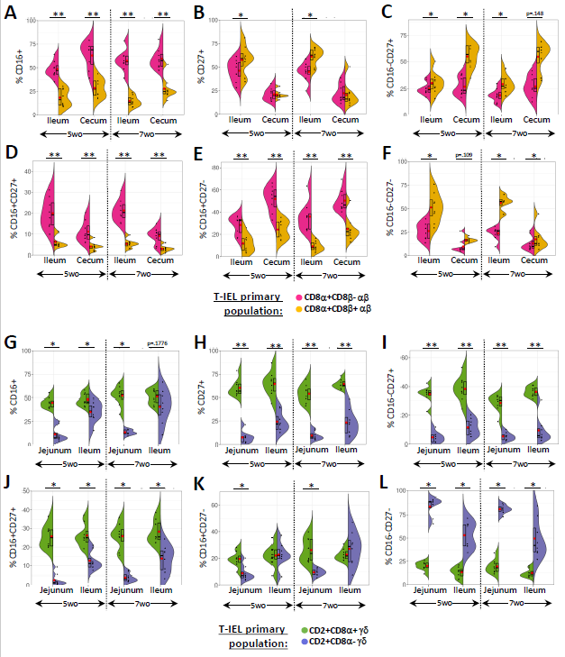
Supplementary Figure 6. Differences in expression of CD16 and CD27 within αβ and γδ T-IEL lineages.
Split violin plots showing the percentages of CD16⁺ (A, G), CD27⁺ (B, H), CD16⁻CD27⁺ (C, I), CD16⁺CD27⁺ (D, J), CD16⁺CD27⁻ (E, K), and CD16⁻CD27⁻ (F, L) cells (y-axes) within total CD8α⁺CD8β⁻ (pink) versus CD8α⁺CD8β⁺ (gold) αβ T-IELs (A-F) or CD2⁺CD8α⁺ (green) versus CD2⁺CD8α⁻ (blue) γδ T-IELs (G-L) within a specific tissue/age group (x-axes). Each half of a violin corresponds to results for a T-IEL primary population, as indicated by violin fill color. Individual data points are shown by black dots. Bars within a plot represent the IQR. Red dots represent the data mean. Statistical comparisons were performed between T-IEL primary populations within a single tissue/age group using the Wilcoxon rank sum test for non-parametric, paired comparisons. Comparisons were paired by animal ID. Data are derived from a total of eight pigs within each tissue/age group combination. *p<0.05, **p<0.01. p-values <0.15 but not <0.05 are also listed. Abbreviations: IQR = interquartile range; T-IEL = intraepithelial T lymphocyte; wo = weeks old
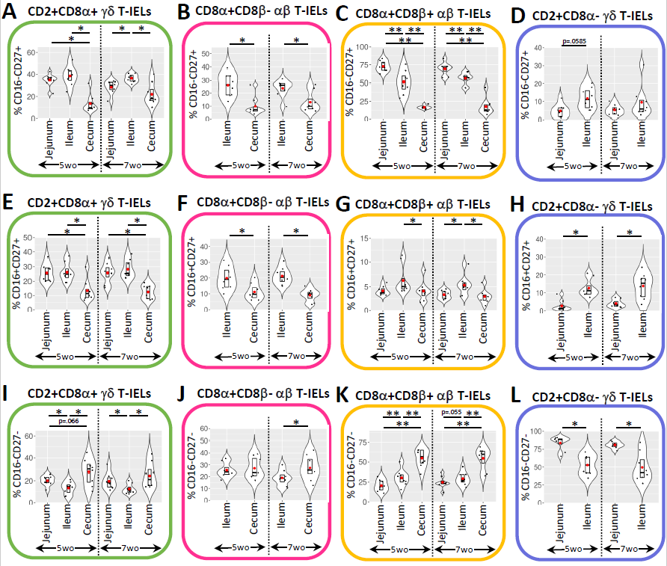
Supplementary Figure 7. Expression of additional functional subsets in different T-IEL primary populations is tissue-dependent.
Violin plots showing the percentages of CD16⁻CD27⁺ (A-D), CD16⁺CD27⁺ (E-H), and CD16⁻CD27⁻ (I-L) cells within total CD2⁺CD8α⁺ γδ (A, E, I), CD8α⁺CD8β⁻ αβ (B, F, J), CD8α⁺CD8β⁺ αβ (C, G, K), and CD2⁺CD8α⁻ γδ (D, H, L) T-IELs of different tissue/age combinations. In all violin plots, individual data points are shown by black dots. Bars within a plot represent the IQR. Red dots represent the data mean. Y-axes indicate the percentage within parent populations of T-IELs listed above each plot. Statistical comparisons were performed between tissues within a single age group using the Wilcoxon rank sum test for non-parametric, paired comparisons. Comparisons were paired by animal ID. Data are derived from a total of eight pigs within each tissue/age group combination. *p<0.05, **p<0.01. p-values <0.15 but not <0.05 are also listed. Abbreviations: IQR = interquartile range; T-IEL = intraepithelial T lymphocyte; wo = weeks old
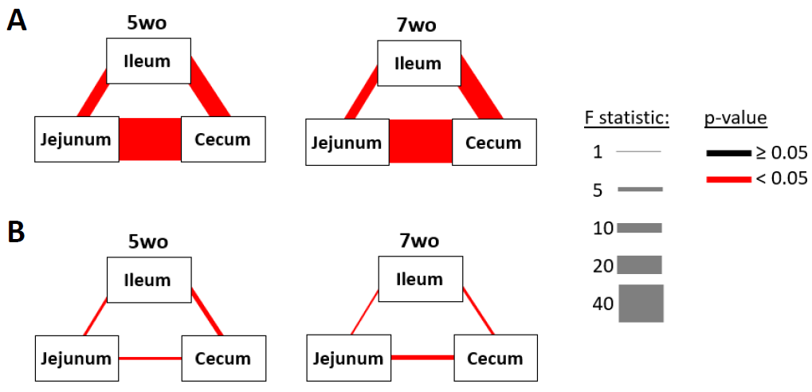
Supplementary Figure 8. T-IEL and microbiota communities differ by intestinal tissue location.
Plots showing results of pairwise comparisons of T-IEL (A) and microbial (B) communities across tissues within each age group. Color of connecting lines indicate if pairwise comparisons were statistically significant (p<0.05). Width of connecting lines indicates magnitude of age effect (F statistic). Data are derived from a total of eight pigs within each tissue/age group combination for T-IELs. Data are missing for microbiota of one jejunum/5wo, one ileum/5wo, one ileum/7wo, one cecum/7wo sample. Abbreviations: T-IEL = intraepithelial T lymphocyte; wo = weeks old
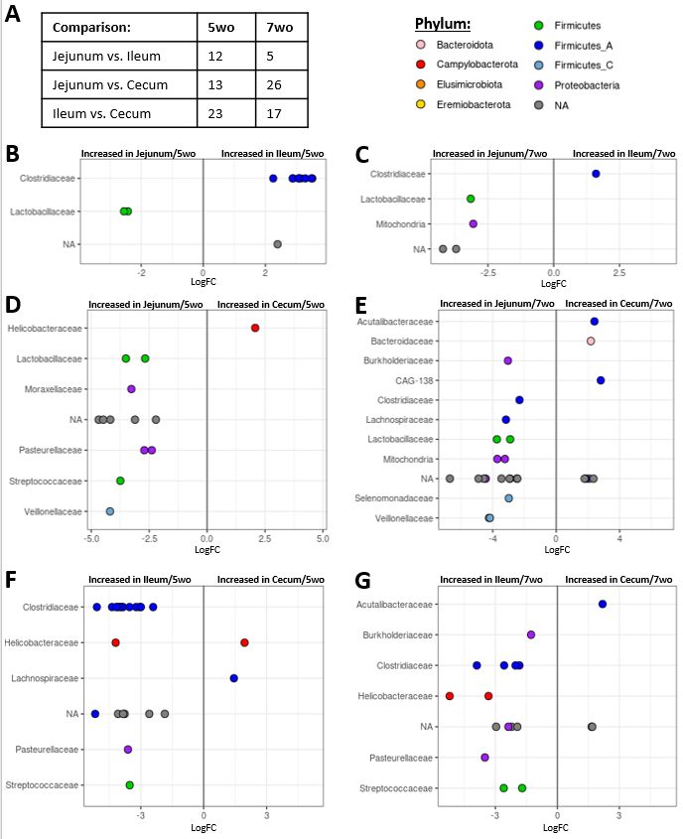
Supplementary Figure 9. Differentially abundant ASVs between intestinal locations.
(A) Table of the number of differentially abundant ASVs between intestinal tissues. (B-G) Plots of differentially abundant ASVs (corrected p <0.05) between intestinal tissues. Points represent individual ASVs. Microbial families each ASV belongs to are indicated on x axes. Fill color of each point corresponds to the microbial phyla each ASV belongs to. Abbreviations: ASV = amplicon sequence variant; LogFC = log fold-change; NA = taxonomy not assigned; wo = weeks old
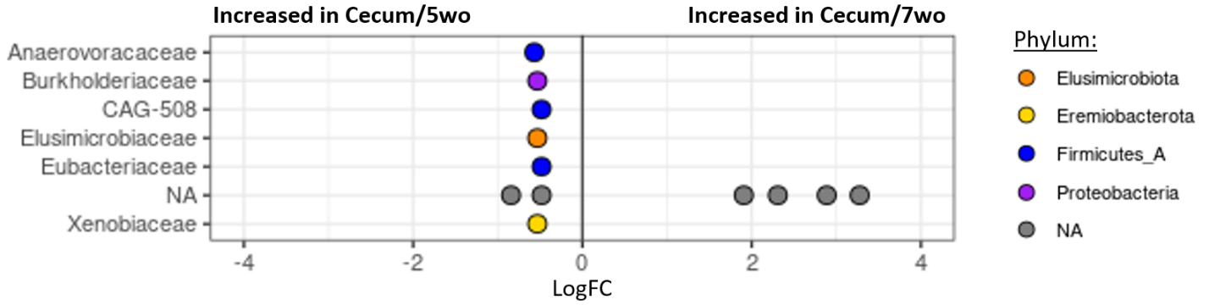
Supplementary Figure 10. Differentially abundant ASVs between cecum of 5wo and 7wo pigs.
Plot of differentially abundant ASVs (corrected p <0.05) between cecum of 5wo and 7wo pigs. Points represent individual ASVs. Microbial families each ASV belongs to are indicated on x axis. Fill color of each point corresponds to the microbial phyla each ASV belongs to. Abbreviations: ASV = amplicon sequence variant; LogFC = log fold-change; NA = taxonomy not assigned; wo = weeks old

