Intracranial carotid artery calcification patterns and ischemic stroke: a novel marker for stroke etiology?

Mazzacane Federico^{1,2}; Beatrice Del Bello¹; Federica Ferrari^{1,2}; Alessandra Persico²; Elisa Rognone⁴; Anna Pichiecchio^{1,4}; Alessandro Padovani^{3,5}; Anna Cavallini²; Andrea Morotti⁵; Francesco Arba⁶.

Online Resource 1

Figure 1. Distribution of internal carotid arteries calcification predominant patterns in ischemic stroke etiologic subtypes.

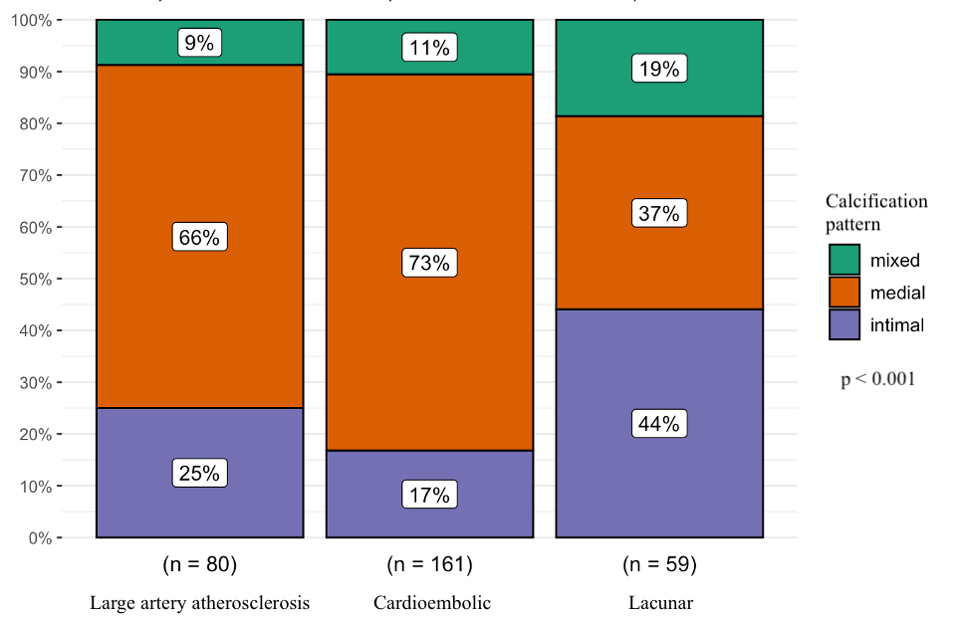
Table 1. Intracranial carotid artery calcification scoring system. Patients with a score < 7: dominant Intimal; Patients with a score >= 7: dominant medial.
Points | Circularity | Thickness | Morphology
0 | Absent | Absent | Indistinguishable
1 | Dot(s) | Thick > 1.5mm | Irregular/Patchy
2 | <90 degrees
3 | 90–270 degrees | Thin < 1.5mm
4 | 270–360 degrees |  | Continuous

Table 2. Multivariate logistic regression; * p value < 0.05.
Model 1 - Included variables: calcification pattern, age, sex, NIHSS, smoke, hypertension, diabetes.
Model 2 - Included variables: calcification pattern, age, sex, ischemic cardiopathy, admission NIHSS, calcification severity, active smoke, dyslipidemia.

Model 1 | Stroke etiologic subtype (reference: other subtypes of stroke)
Calcification pattern | Lacunar |  |  | Large artery atherosclerosis |  |  | Cardioembolic
Calcification pattern | OR | CI 95% | p value | OR | CI 95% | p value | OR | CI 95% | p value
Intimal pattern | 2.39* | 1.22 - 4.69 | 0.011 | 0.71 | 0.36 - 1.34 | 0.301 | 0.70 | 0.38 -1.29 | 0.257
Mixed pattern | 1.59 | 0.66 - 3.63 | 0.283 | 0.46 | 0.17 - 1.11 | 0.103 | 1.30 | 0.59 - 2.86 | 0.512
Medial Pattern | 0.334* | 0.17 0.65 | 0.001 | 2.03* | 1.09 - 3.90 | 0.029 | 1.18 | 0.672- 2.06 | 0.561

Model 2 | Stroke etiologic subtype (reference: other subtypes of stroke)
Calcification pattern | Lacunar |  |  | Large artery atherosclerosis |  |  | Cardioembolic
Calcification pattern | OR | CI 95% | p value | OR | CI 95% | p value | OR | CI 95% | p value
Intimal pattern | 2.14 * | 1.07 - 4.30 | 0.032 | 0.800 | 0.40 - 1.56 | 0.518 | 0.587 | 0.30 - 1.13 | 0.110
Mixed pattern | 1.76 | 0.72 - 4.12 | 0.202 | 0.511 | 0.19 - 1.24 | 0.161 | 1.05 | 0.47 - 2.32 | 0.909
Medial Pattern | 0.334 * | 0.16 - 0.67 | 0.003 | 0.572 | 0.92 - 3.49 | 0.090 | 1.57 | 0.85 - 2.91 | 0.152

