Appendix

Table S 1. Zeta Potentials of blank-NS formulations
Blanks | Zeta Potential (24 h) | Zeta Potential (30 Days) | Zeta Potential (90 Days)
Q-S154 | -17.7 ± 0.06 | -11.20 ± 0.35 | -6.45 ± 0.28
Q-C888 | -8.90 ± 1.09 | -11.4 ± 0.65 | -4.62 ± 0.66
Q-CHD 5 | -12.9 ± 0.20 | -8.75 ± 0.59 | -6.56 ± 0.35
Key: QHCl = Quinine hydrochloride, S154 = Softisan® 154, C888 = Compritol® 888 ATO, CHD 5 = Compritol® HD 5 ATO. Q-S154 = blank formulation of QHCl made with S154; Q-C888 = blank formulation of QHCl made with C888; Q-CHD 5 = blank formulation of QHCl made with CHD 5.

Q9 20000x
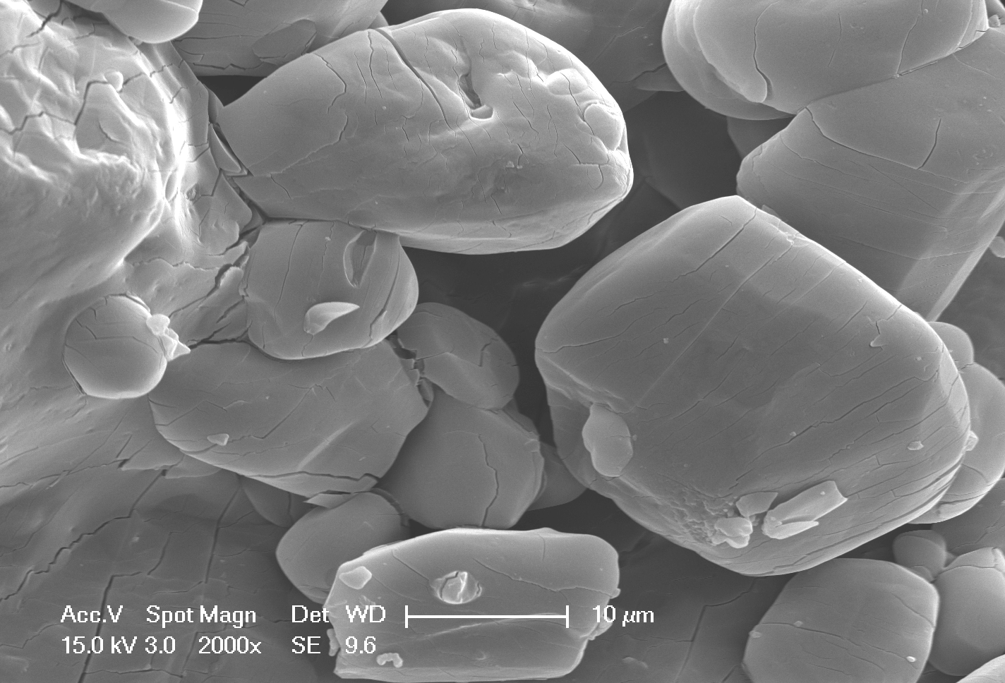Quinine Hydrochloride 2000 X
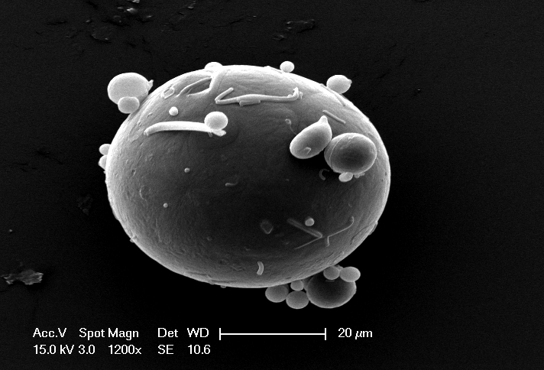Phospholipon® 90H 1200 X
Softisan®154 500 X
Q7 20000x

Q12 20000x

Figure S1. SEM micrographs of drug and some excipients
Key: QHCl = Quinine hydrochloride, S154 = Softisan® 154, C888 = Compritol® 888 ATO, CHD 5 = Compritol® HD 5 ATO. Selected formulations of QHCl-NS = Q7, Q9 and Q12, made with S154, CHD 5 and C888 respectively.

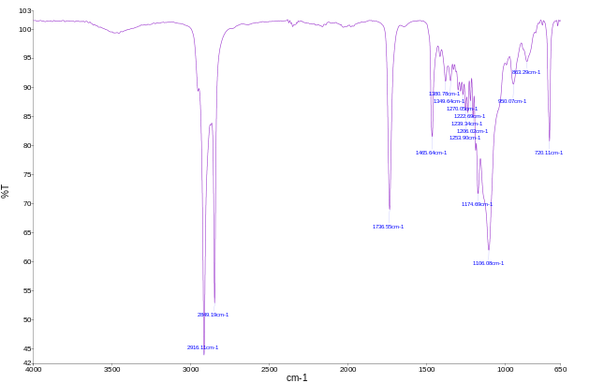FTIR spectra of Compritol® HD5 ATO (F)

FTIR spectra of Compritol® HD5 ATO (E)

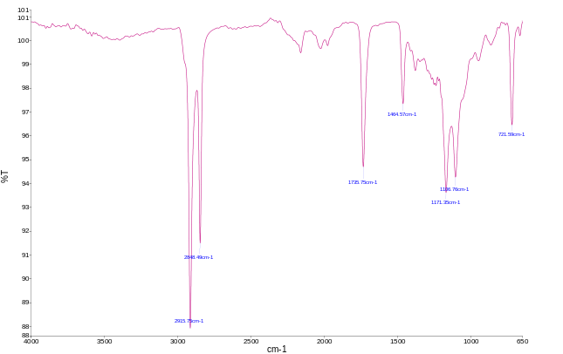
FTIR spectra of Compritol® 888 ATO (D)

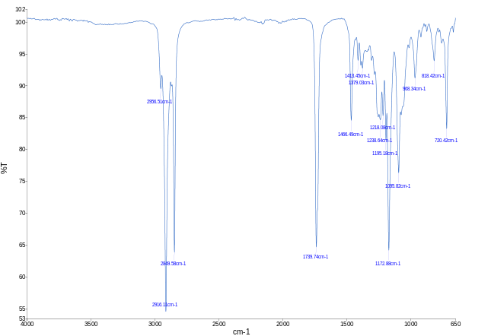
FTIR spectra of Lipid matrix made with Softisan® 154 and Phospholipon® 90H (C)

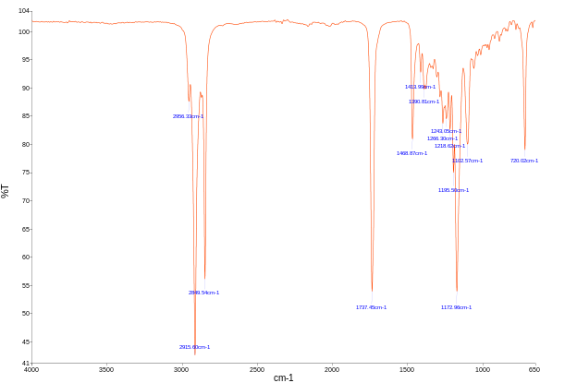
FTIR spectra of S154 (B)

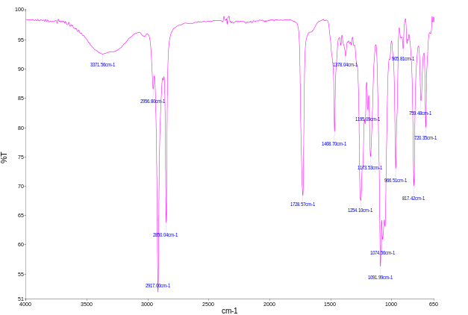
FTIR spectra of Phospholipon® 90H (A)

Figure S2. FTIR Spectra of Excipients and QHCL-NS formulation (A-L)

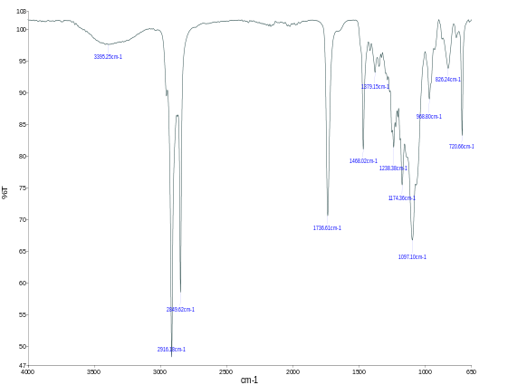
FTIR spectra of Lipid matrix made with Compritol® HD5 ATO and Phospholipon® 90H (H)

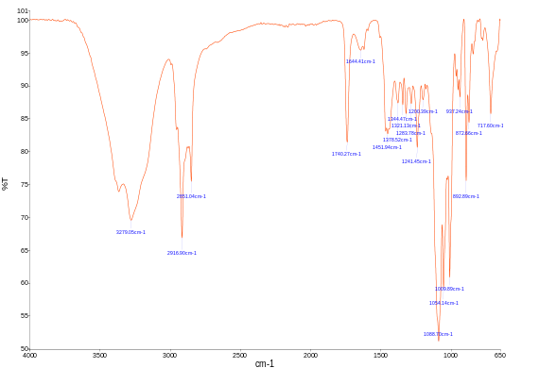 FTIR spectra of Q7 (containing 1.5 % w/v QHCl, 3 % w/v CHD 5, 2 % w/v T80 and sonicated for 90 min) (J)

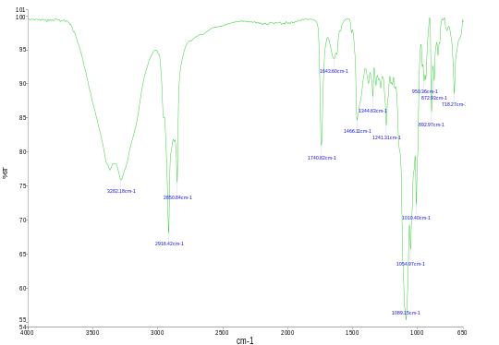
FTIR spectra of Q12 (containing 1.5 %w/v QHCl, 3 %w/v C888, 5 %w/v T80 and sonicated for 60 min) (L)

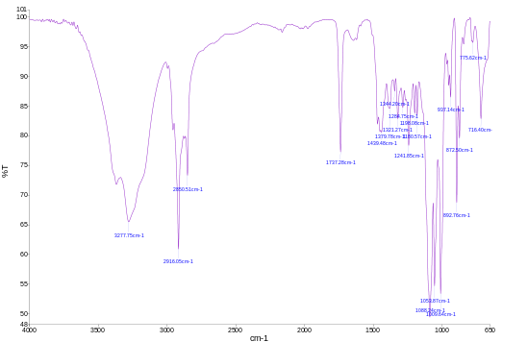
FTIR spectra of Q9 (containing 1.5 %w/v QHCl, 3 % w/v S154, 2 %w/v T80 and sonicated for 60 min) (K)

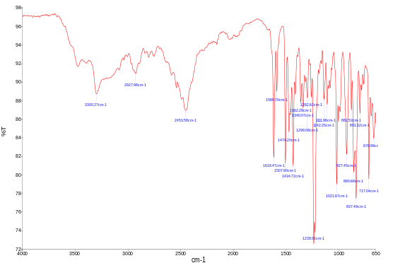
FTIR spectra of Quinine Hydrochloride (I)

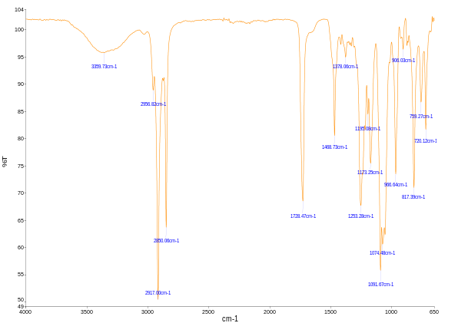
FTIR spectra of Lipid matrix made with Compritol® 888 ATO and Phospholipon® 90H (G)

Table S2. DSC analysis results of plain drugs and, lipids and lipid matrices
Materials | Melting peak (°C) | Enthalpy (J/g) | Type of peak
Quinine hydrochloride | 115.67 | 75.066 | Endothermic
S154 | 57.68 | 94.675 | Endothermic
S154 + P90H | 57.55 | 56.923 | Endothermic
S154 in S154 + P90H + THP | 55.67 | 44.533
S154 in S154 + P90H + THP+MCT | 47.99
C888 | 72.53 | 116.25 | Endothermic
C888 in C888 + P90H | 67.03 | 95.464 | Endothermic
C888 in C888 + P90H + THP | 64.17 | 93.656
C888 in C888 + P90H + THP+MCT | 57.35
CHD5 | 59.56 | 117.83 | Endothermic
CHD5 in CHD5 + P90H | 53.93 | 41.709 | Endothermic
CHD5 in CHD5 + P90H + THP | 44.87 | 11.189
CHD5 in CHD5 + P90H + THP+MCT | 24.46
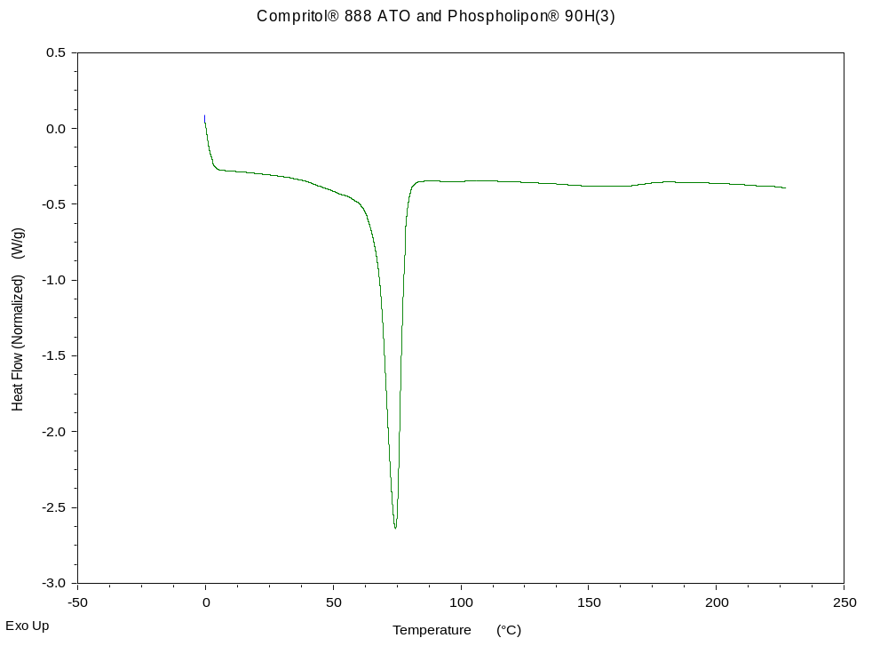
Figure S3: DSC thermogram of lipid matrix made with C888 and P90H.

