Supplementary Figures

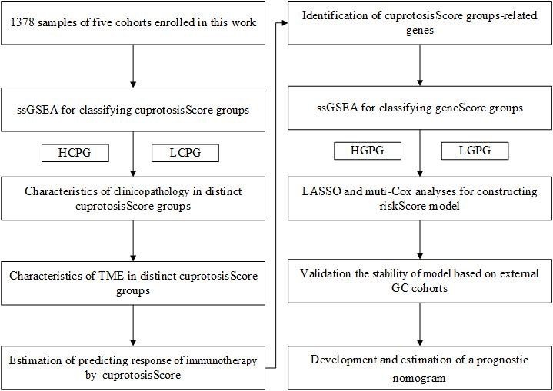

Figure S1 The flowchart of this study.

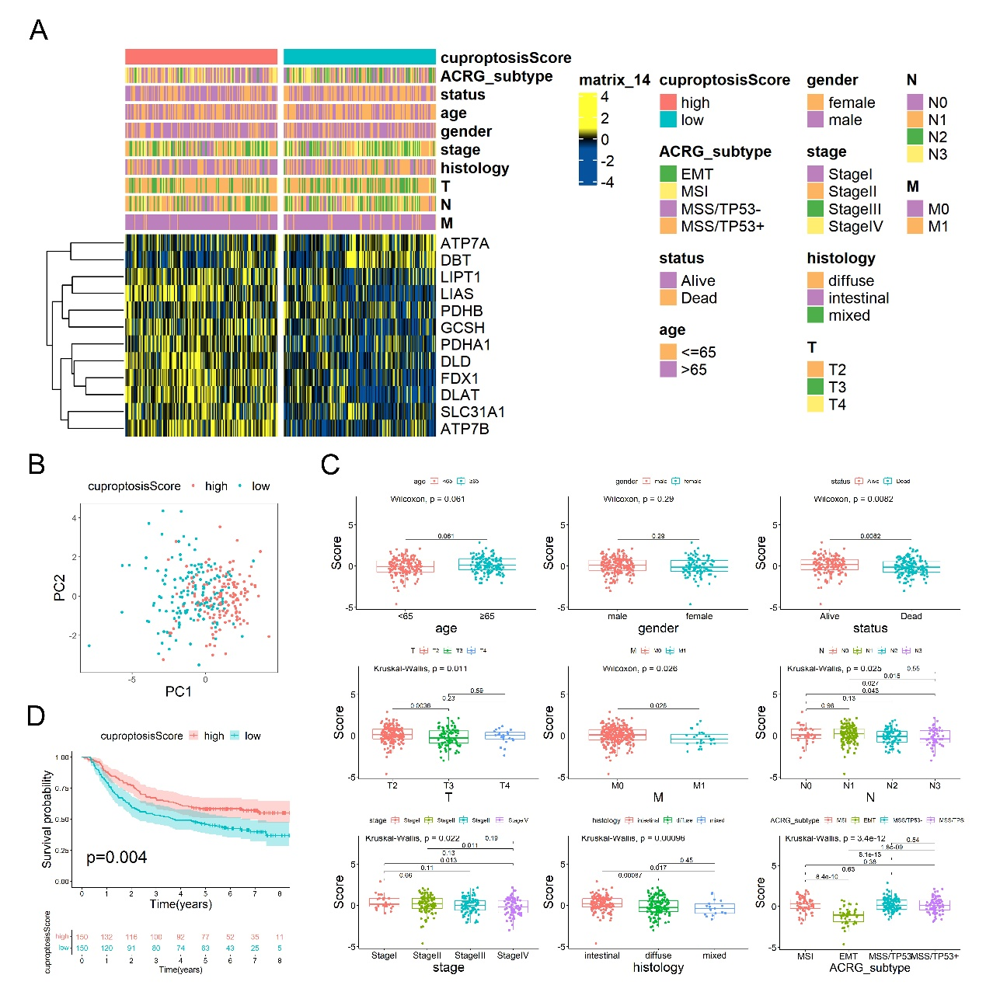

Figure S2 Clinicopathological characteristics of cpS groups constructed based on GSE62254/ACRG cohort. A. The heatmap showed the differences in clinicopathological features and expression levels of CRGs between two cpS groups. B. PCA for the expression profiles of two cpS groups. C. The comparison of different clinicopathological features between two cpS groups. D. Survival analysis showed OS time of two cpS groups. cpS, cuproptosisScore; PCA, principal component analysis; OS, overall survival.

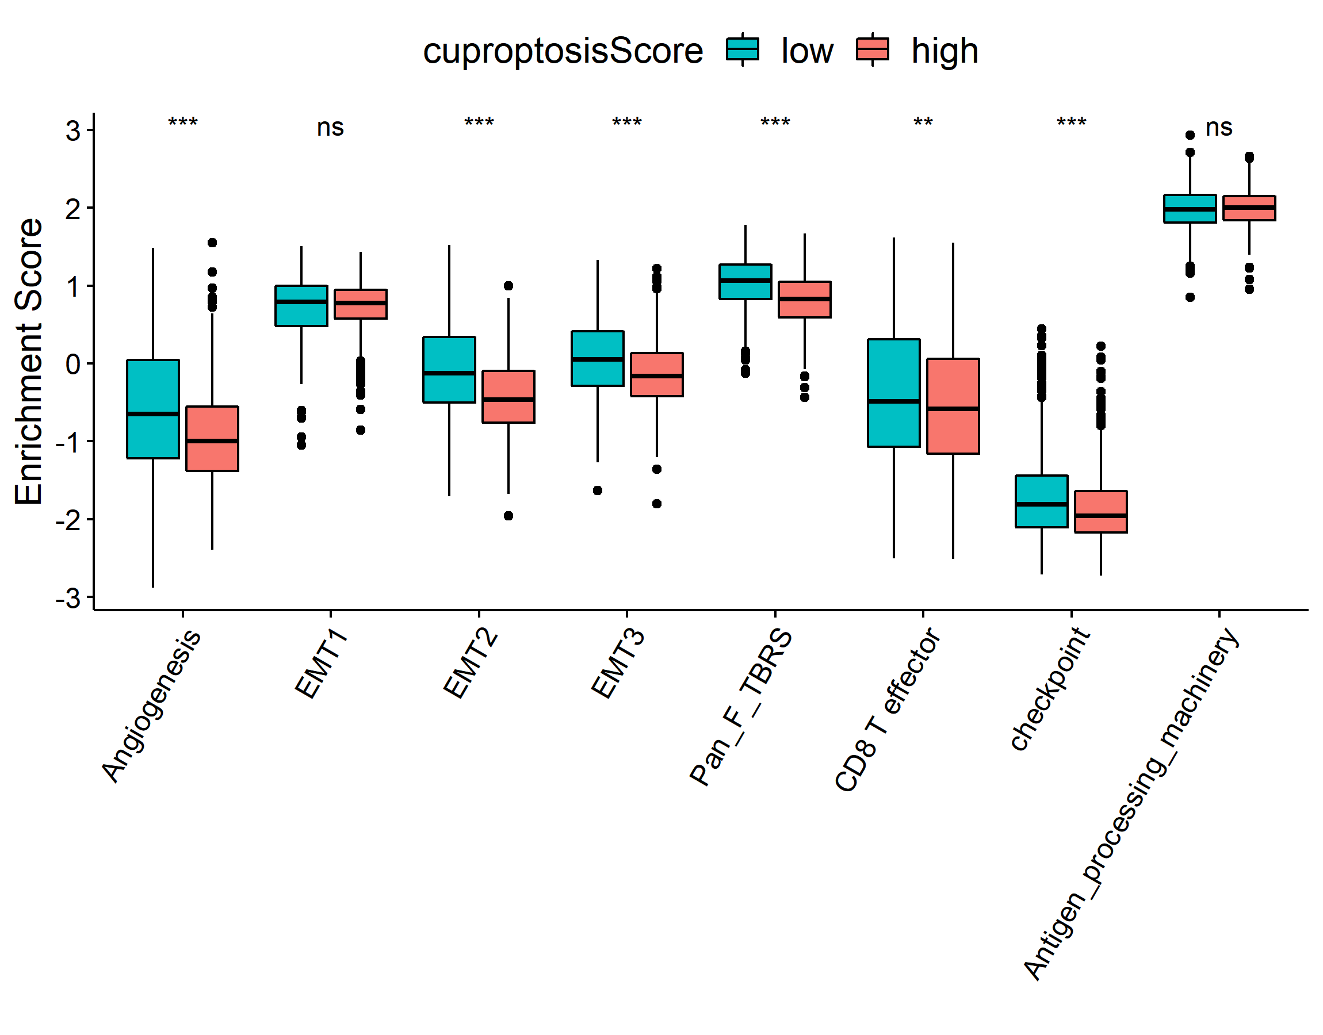

Figure S3 The difference of biological processes between two cuproptosisScore groups. Stromal activation pathways include EMT1, EMT2, EMT3, Angiogenesis, and Pan-F-TBRS. Immune activation pathways include CD8 T effector, Antigen processing machinery, and immune checkpoint. EMT, epithelial mesenchymal transition; Pan-F-TBRS, pan-fibroblast TGFβ response signature.

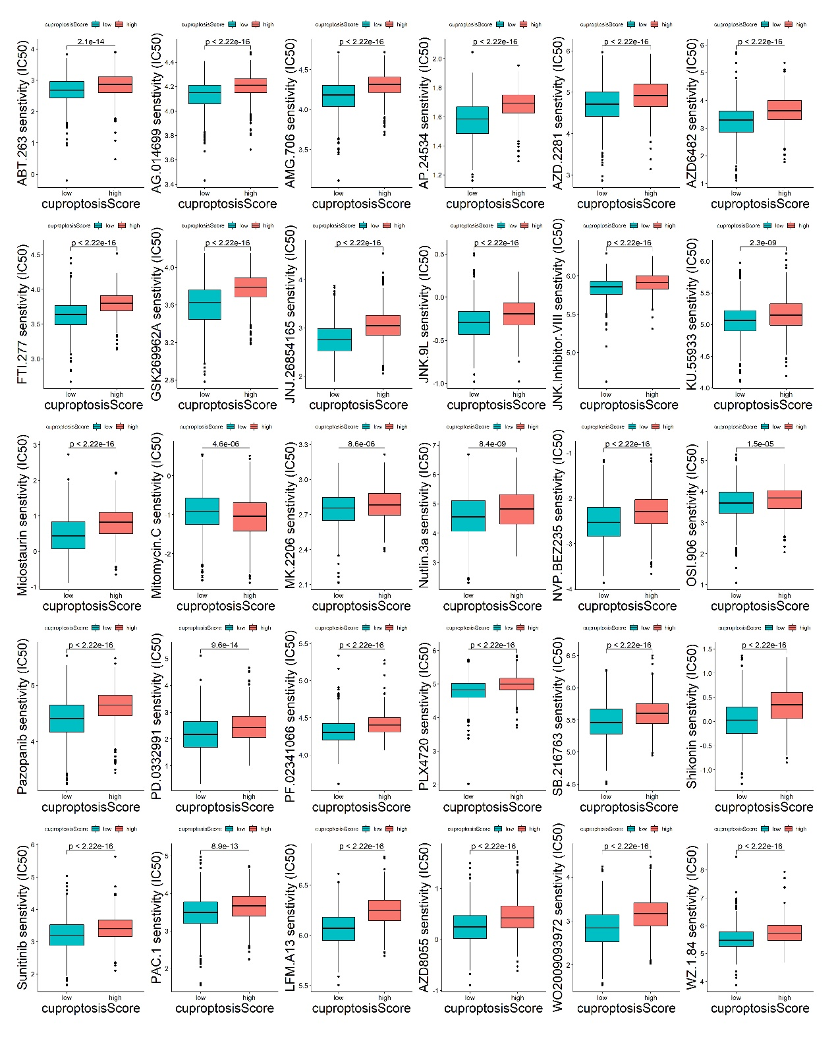
Figure S4 The comparison of semi-inhibitory concentration (IC50) of chemotherapeutic drugs between two cpS groups.

Figure S5 The activation status of biological pathways in two geneScore groups by GSEA analysis.

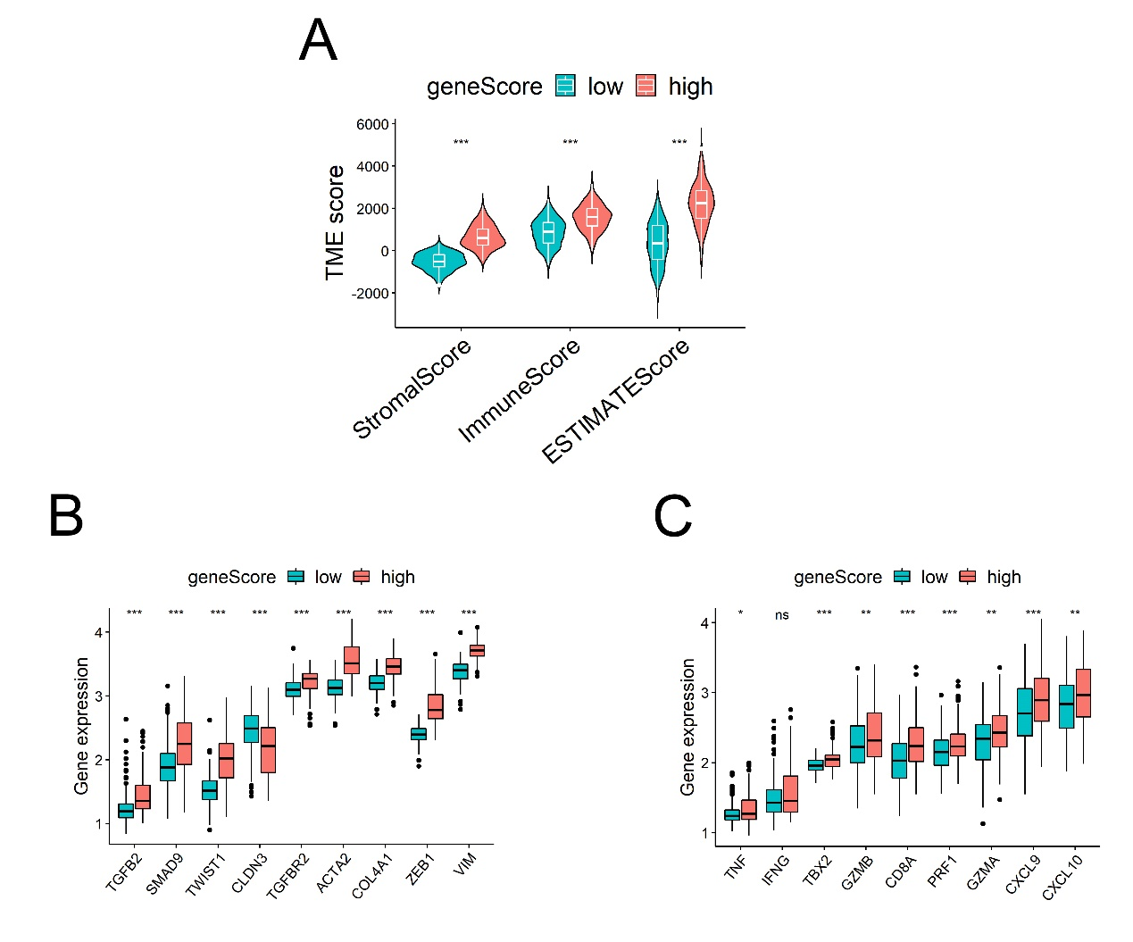
Figure S6 ESTIMATE analysis and cytokine- and chemokine-related signatures in ACRG cohort. A. The comparison of stromal, immune, and ESTIMATE score between two geneScore groups. B. The expression levels of TGFβ/EMT pathway-related genes in two geneScore groups. C. The expression levels of immune activation pathway-related genes in two geneScore groups. *p<0.05, **p<0.01, ***p<0.001, ns (p>0.05).

