Additional File 1

Supplemental Figure 1
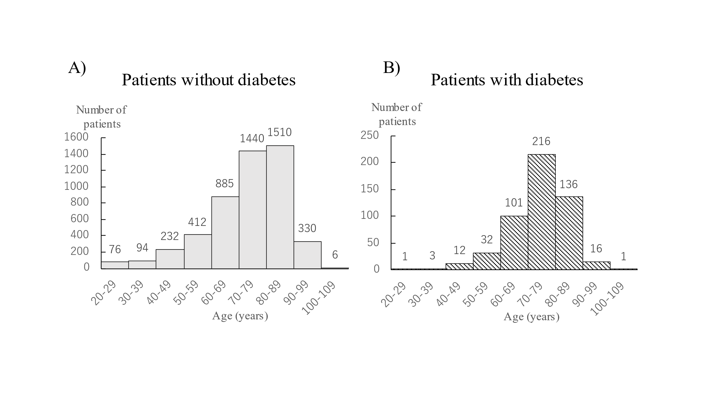
Supplemental Figure 2
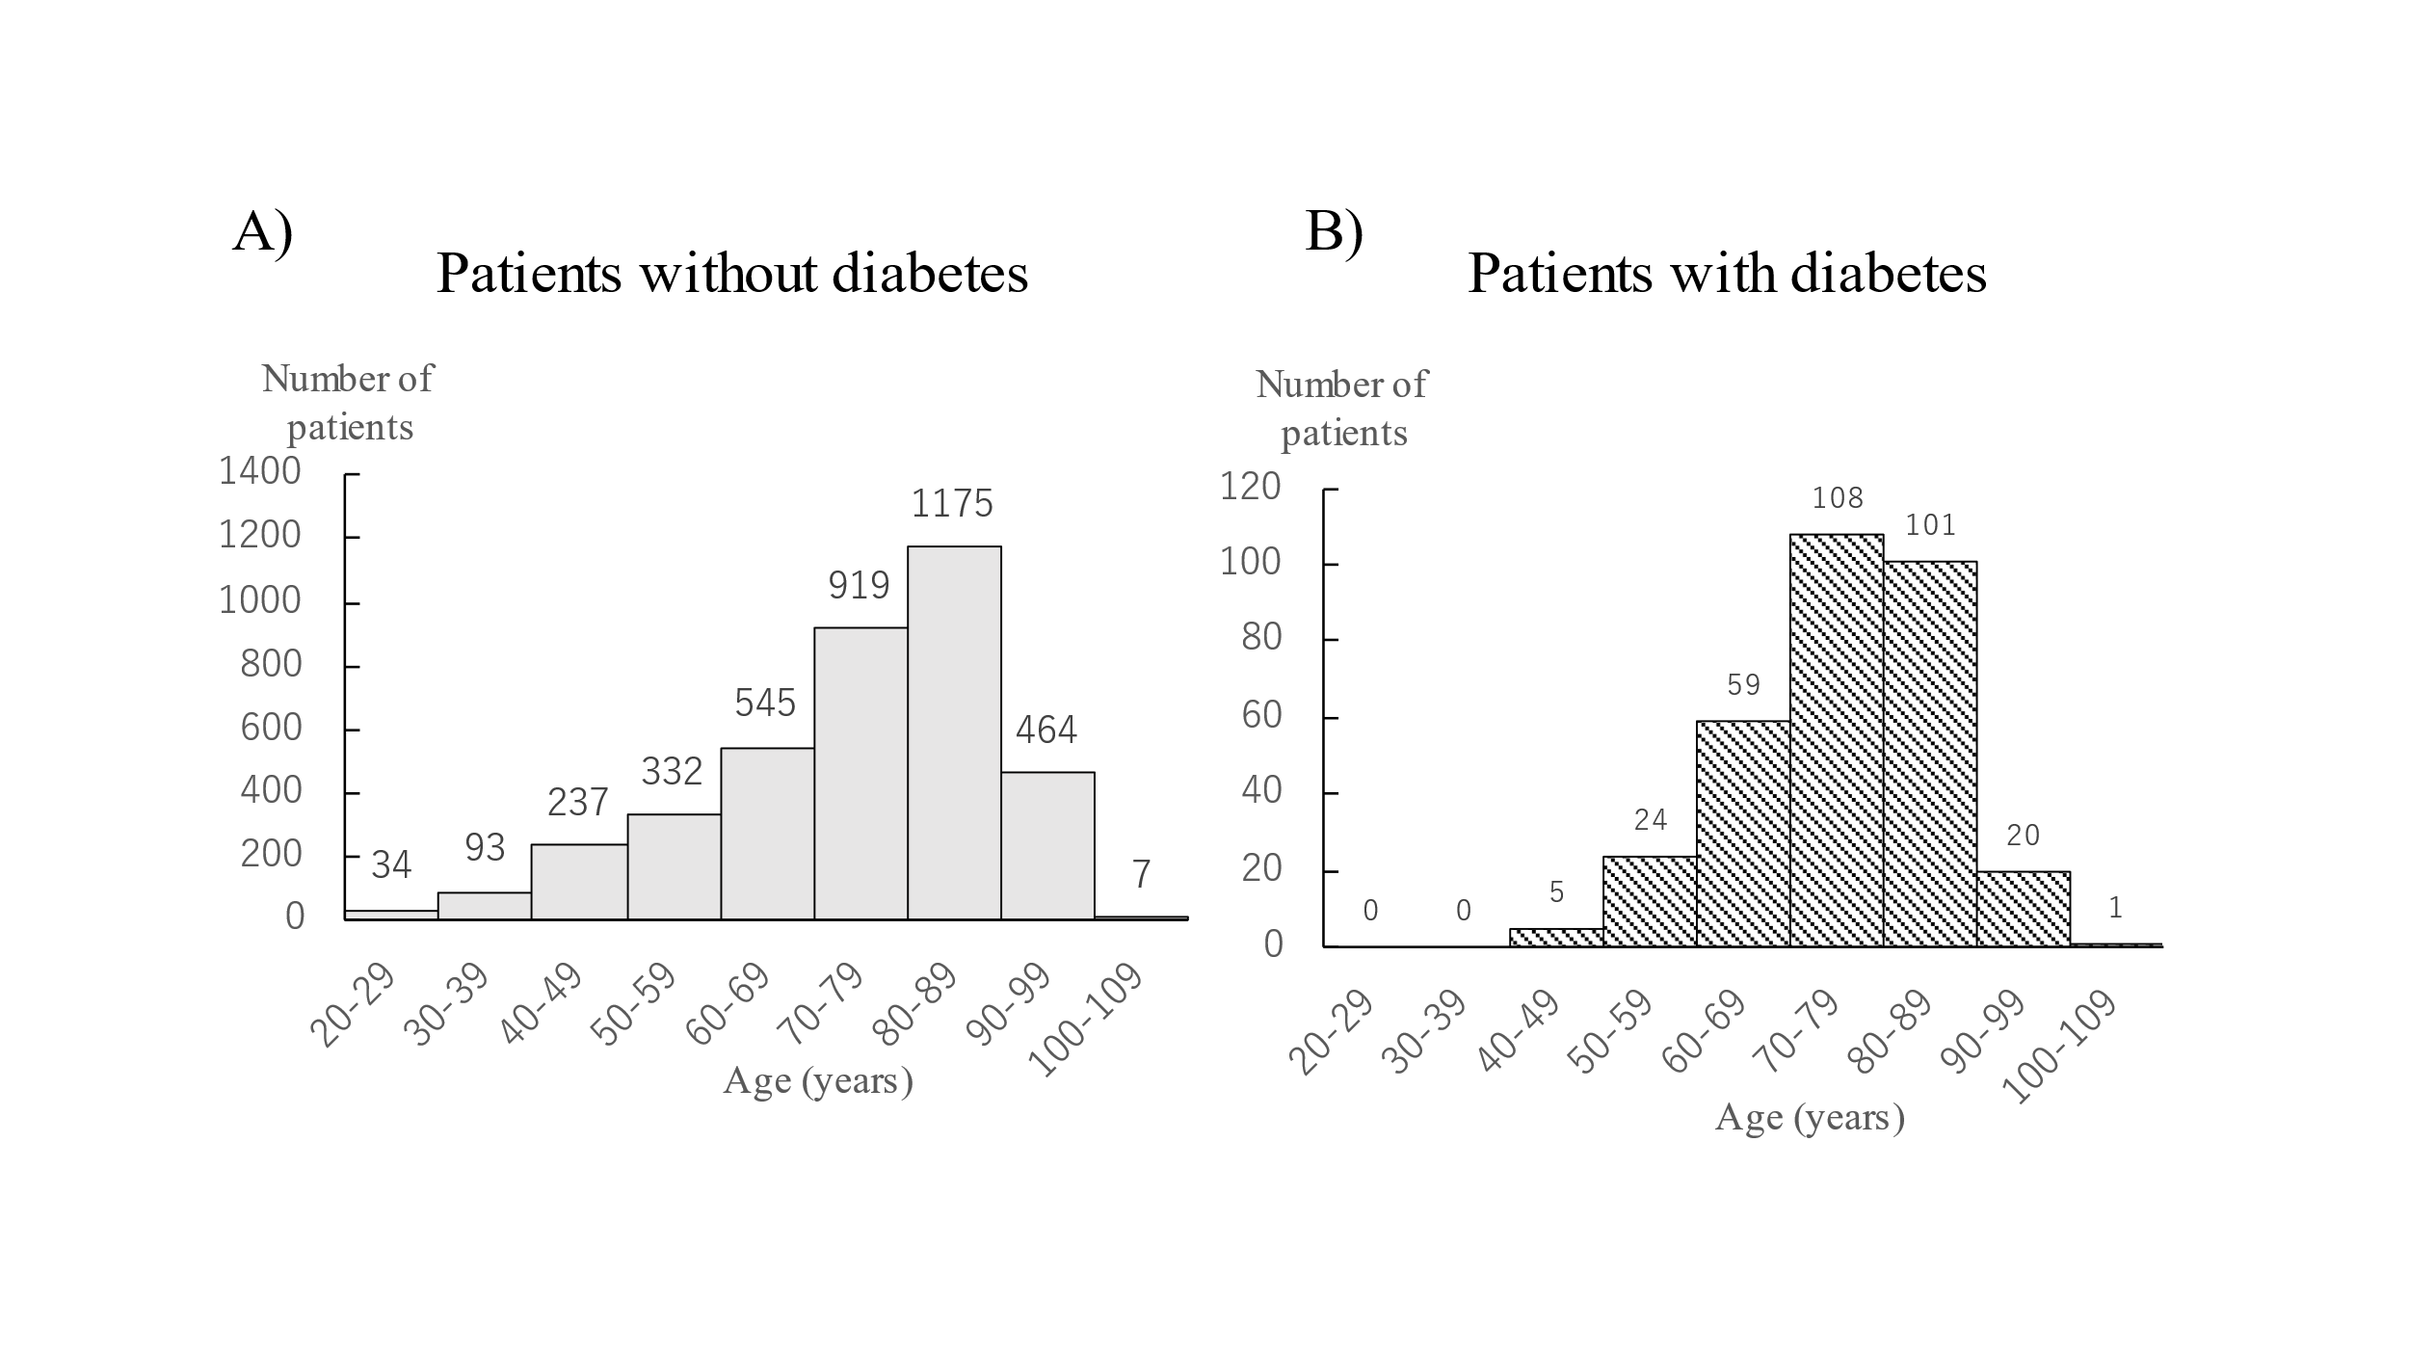

Supplemental Table 1-1

Supplemental Table 1-1. Main causes of death among Japanese patients in our hospital between 2011 and 2020 (men)
Sex and number | Patients without diabetes  (n = 4,985) |  | Patients with diabetes  (n = 518) |  | P-value
 | (%) | (n) | (%) | (n)
Cause of death
Malignant neoplasia | 26.3 | 1,309 | 41.5 | 215 | <0.001
Infectious diseases | 8.9 | 442 | 11.4 | 59 | 0.065
Cerebrovascular diseases | 3.5 | 174 | 5.2 | 27 | 0.063
Ischemic heart diseases | 5.6 | 277 | 5.4 | 28 | 1.000
Liver cirrhosis | 0.7 | 35 | 1.4 | 7 | 0.110

Supplemental Table 1-2

Supplemental Table 1-2. Main causes of death among Japanese patients in our hospital between 2011 and 2020 (women)
Sex and number | Patients without diabetes  (n = 3,806) |  | Patients with diabetes  (n = 318) |  | P-value
 | (%) | (n) | (%) | (n)
Cause of death
Malignant neoplasia | 31.8 | 1,212 | 33.3 | 106 | 0.574
Infectious diseases | 6.0 | 228 | 14.2 | 45 | <0.001
Cerebrovascular diseases | 4.6 | 174 | 6.3 | 20 | 0.167
Ischemic heart diseases | 3.6 | 138 | 4.7 | 15 | 0.352
Liver cirrhosis | 0.8 | 30 | 0.9 | 3 | 0.738

Supplemental Table 2-1

Supplemental Table 2-1. Details of the causes of death among Japanese patients in our hospital (men)
Sex and number | Patients without diabetes  (n = 4,985) | Patients with diabetes  (n = 518) | P-value
 | n (%) | n (%)
Cause of death
Malignant neoplasia | 1,309 (26.3) | 215 (41.5) | <0.001
Esophagus | 77 (1.5) | 5 (1.0) | 0.443
Stomach | 107 (2.1) | 13 (2.5) | 0.530
Lung | 345 (6.9) | 64 (12.4) | <0.001
Colon | 80 (1.6) | 9 (1.7) | 0.717
Liver | 85 (1.7) | 20 (3.9) | 0.002
Pancreas | 89 (1.8) | 24 (4.6) | <0.001
Uterus | - | - | -
Ovary | - | - | -
Breast | 1 (0.0) | 1 (0.2) | 0.179
Leukemia/lymphoma | 203 (4.1) | 37 (7.1) | 0.002
Prostate | 47 (0.9) | 6 (1.2) | 0.633
Bladder | 16 (0.3) | 3 (0.6) | 0.415
Others | 259 (5.2) | 33 (6.4) | 0.257
Infectious diseases | 442 (8.9) | 59 (11.4) | 0.065
Tuberculosis | 5 (0.1) | 1 (0.2) | 0.448
Pneumonia | 170 (3.4) | 19 (3.7) | 0.705
Others | 267 (5.4) | 39 (7.5) | 0.044
Ischemic heart diseases | 277 (5.6) | 28 (5.4) | 1.000
Myocardial infarction | 141 (2.8) | 11 (2.1) | 0.401
Angina pectoris | 4 (0.1) | 2 (0.4) | 0.103
Cerebrovascular diseases | 174 (3.5) | 27 (5.2) | 0.063
Hemorrhage | 89 (1.8) | 10 (1.9) | 0.730
Infarction | 44 (0.9) | 16 (3.1) | <0.001
Subarachnoid hemorrhage | 38 (0.8) | 1 (0.2) | 0.175
Others | 3 (0.1) | 0 (0.0) | 1.000
Heart diseases (other than ischemic heart diseases)
Arrythmia | 56 (1.1) | 4 (0.8) | 0.655
Heart failure | 76 (1.5) | 11 (2.1) | 0.269
Others | 206 (4.1) | 7 (1.4) | 0.001
Chronic renal failure | 31 (0.6) | 12 (2.3) | <0.001
Diabetic coma | 0 (0.0) | 4 (0.8) | <0.001
Hypoglycemia coma | 1 (0.0) | 3 (0.6) | 0.003
COVID-19 | 18 (0.4) | 1 (0.2) | 1.000
Suicide | 0 (0.0) | 0 (0.0) | NA
Others | 1,041 (20.9) | 139 (26.8) | 0.002
Unknown | 1,451 (29.1) | 16 (3.1) | <0.001

Supplemental Table 2-2.
Supplemental Table 2-2 Details of the causes of death among Japanese patients in our hospital (women)
Sex and number | Patients without diabetes  (n = 3,806) | Patients with diabetes  (n = 318) | P-value
 | n (%) | n (%)
Cause of death
Malignant neoplasia | 1,212 (31.8) | 106 (33.3) | 0.574
Esophagus | 10 (0.3) | 1 (0.3) | 0.587
Stomach | 54 (1.4) | 3 (0.9) | 0.623
Lung | 129 (3.4) | 25 (7.9) | <0.001
Colon | 77 (2.0) | 4 (1.3) | 0.525
Liver | 36 (0.9) | 3 (0.9) | 1.000
Pancreas | 63 (1.7) | 10 (3.1) | 0.071
Uterus | 87 (2.3) | 8 (2.5) | 0.699
Ovary | 78 (2.0) | 8 (2.5) | 0.539
Breast | 188 (4.9) | 11 (3.5) | 0.276
Leukemia/lymphoma | 125 (3.3) | 8 (2.5) | 0.619
Prostate | - | - | -
Bladder | 20 (0.5) | 1 (0.3) | 1.000
Others | 345 (9.1) | 24 (7.5) | 0.414
Infectious diseases | 228 (6.0) | 45 (14.2) | <0.001
Tuberculosis | 0 (0.0) | 0 (0.0) | NA
Pneumonia | 68 (1.8) | 10 (3.1) | 0.128
Others | 160 (4.2) | 35 (11.0) | <0.001
Ischemic heart diseases | 138 (3.6) | 15 (4.7) | 0.352
Myocardial infarction | 57 (1.5) | 5 (1.6) | 0.811
Angina pectoris | 2 (0.1) | 0 (0.0) | 1.000
Cerebrovascular diseases | 174 (4.6) | 20 (6.3) | 0.167
Hemorrhage | 60 (1.6) | 7 (2.2) | 0.356
Infarction | 50 (1.3) | 8 (2.5) | 0.084
Subarachnoid hemorrhage | 63 (1.7) | 4 (1.3) | 0.817
Others | 1 (0.0) | 1 (0.3) | 0.148
Heart diseases (other than ischemic heart diseases)
Arrythmia | 17 (0.4) | 3 (0.9) | 0.197
Heart failure | 62 (1.6) | 7 (2.2) | 0.490
Others | 131 (3.4) | 13 (4.1) | 0.524
Chronic renal failure | 27 (0.7) | 8 (2.5) | 0.004
Diabetic coma | 0 (0.0) | 5 (1.6) | <0.001
Hypoglycemia coma | 4 (0.1) | 0 (0.0) | 1.000
COVID-19 | 5 (0.3) | 0 (0.0) | 1.000
Suicide | 0 (0.0) | 0 (0.0) | NA
Others | 711 (18.7) | 93 (29.2) | <0.001
Unknown | 1,146 (30.1) | 10 (3.1) | <0.001

