Supplement 1.

STAR Form – Supervisor Tool for Assessment of Readiness

of international HDR candidates

A supervisor’s screening tool to ascertain readiness of international HDR students to commence a PhD at an Anglophone University

This tool is and assessment rubric to be applied to all applicants from a non-Australian education system before selection/admission.
It can also be used for applicants who are Australian residents but whose first language is not English.
The tool contains subjective and objective domains.

The target users of this tool
- are ECR in first stages of supervision experience and associate supervisors
- but this tool can be a refresher for those senior staff who have not supervised international students that are unfamiliar with the Australian education system or the specific university rules and requirements.

The assessment covers both the candidate qualities and the merit of the proposal.
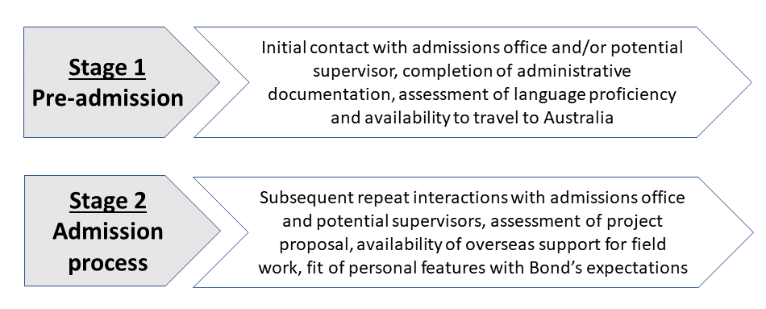

STAGE 1- Processes ranking below Satisfactory may be given opportunity to enhance the application.
STAGE 2- It is recommended that only applications ranked as Very good or Outstanding are approved. Those ranked as Poor are not to be considered
further.
STAR form – Supervisor Tool for Assessment of Readiness

of international HDR candidates

1a) Supervisor’s assessment of candidate engagement in the pre-admission process
This is a qualitative/subjective assessment by members of the prospective supervisory team. The numbering is to give supervisors a feel for extent of concerns, i.e. 5 out of 14-15 issues of concern is acceptable (see example in grey below check for patterns) but 10 out of 14 concerns may not be.

 | Description of supervisor’s direct experience with candidate | Poorly planned, inconsistent | Very good, some room for improvement | Outstanding, or Consistently satisfactory effort
Stage 1 | - Initial communication with university/Institutes | X
 | - English proficiency of verbal communication § | X
 | - English proficiency of written communication § | X
 | - Provided IELTS >6.5/ or TOEFL score >79^{[ref1]} |  | X
 | - Responsiveness to initial exchange with Admissions’ Office |  |  | X
 | - Adherence to University instructions sent by Admissions’ Office |  |  | X
Stage 2 | - Engagement of overseas mentor if spending time abroad for field work |  | X
 | - Attendance at supervisor’s online meeting(s) |  | X
 | - Articulated research experience during interview |  | X
 | - Clear explanation of own proposed methods and context |  |  | X
 | - Demonstrated ability to explain research concepts relevant to field of research | X
 | - Meeting deadlines for application and feedback |  | X
 | - Incorporation of prospective supervisor feedback |  | X
 | - Displays initiative and enthusiasm throughout the peer-review process | X
Other | Add your own concern or good feature |  | X
§ regardless of IELTS results

1b). Student Self-assessment of Readiness (for potential supervisors to request from applicants)

Your honesty is appreciated in self-reflecting on how confident you (the student) feel about the listed aspects/tasks/priorities to help yourself and us make a fair assessment of your current situation
(add the score one box for each row as appropriate – see example in grey text).

 | I am definitely not ready  1 | I feel I need a bit of help  2 | I am very confident  3
COMMUNICATION READINESS
- I am comfortable with my written language proficiency |  | 2
- I have some experience writing essays or assignments |  | 2
- My listening skills are fine for online learning |  |  | 3
- Reading technical academic information is not a problem for me |  | 2
- I am confident in or can cope with public speaking if I need to | 1
- I can achieve high-level communication with my supervisor | 1
ACADEMIC READINESS
- I am confident that I meet all or most academic pre-requisites | 1
- My professional experience will facilitate this process |  | 2
- I understand the ethical implications of my research topic |  | 2
- I am familiar with the technology and library location | 1
- I have good study skills and time management techniques | 1
- My critical thinking skills are appropriate to get me started | 1
- I understand some unwritten academic rules in the host country | 1
SOCIAL AND CULTURAL READINESS
- I feel at ease in my social skills with classmates in the host country | 1
- I am familiar with and enjoy teamwork |  | 2
- I can adapt to the lifestyle of the host country |  |  | 3
- I feel I could develop a sense of belonging with this university |  | 2
- My family/work duties will not interfere much with my studies |  |  | 3
- My financial situation will enable me to go through the degree |  |  | 3
- I know where to seek help when I need it | 1

Total score out of 60 (add points for all columns)___35_____

Scoring interpretation:

<24 = Should defer admission until areas for improvement are addressed
25-49 = Might be considered for admission but will need ongoing support initially
50+ = Ready for admission with limited or no additional support

2) Assessment of initial project proposal and review criteria²
[adjudicate points in one box on each row according to best fit and tick the box; document row score and total]

 | Poor  1-2 point each | Satisfactory  3 points each | Very good  4 points each | Outstanding  5 points each | Row score
Scientific merit | A proposal that replicates previous research, or has limited originality, weak theoretical justification, limited evidence of preparation, or evidence gathering to support the research questions, proposed methods, or planned activities ______ | A proposal with sound but limited theoretical justification for the study, clear gaps in the literature are not identified; unclear or not best choice of scientific methods to answer the research questions, and planned outputs /outcomes  ______ | An important or innovative development with scientifically robust theoretical justification, research questions, identified relevant gaps in the literature; and appropriate methods to answer the research question  ______ | Exceptional proposal with robust evidence-based questions; strong and well-argued theoretical justification for the study, which identifies relevant gaps in the literature; flawless methodology.  ______
Significance | Study does not demonstrate how this research builds on current knowledge, or considers Implications for practice change resulting from this research are absent or not well articulated.  ______ | Limited explanation presented on how the research may improve health status, systems, services, policy, programs. Outputs may benefit a particular population/ patient subgroup or service at the local level  ______ | Appropriate explanation of how the research that may contribute to improve either health status, systems, services, policy, programs or clinical practice at the regional level; room for improvement on extent of benefit for a large number of people or services  ______ | Clearly demonstrates how the research will contribute substantial new knowledge, change practice, services, policy, or health outcomes and benefit substantial number of people, sub-groups or services at the national or international level  ______
Impact & Sustainability | No chance of sustainability beyond the setting of the proposal or the life of the project  ______ | Limited scope for scalability or sustainability in health systems or services or expected modest impact on a small number of individuals  ______ | Amenable to scalability and sustainable change in national or statewide health systems and services  ______ | Likely will significantly influence the specific field of research, or transform current status, or lead to innovative directions at global scale, or generate commercial benefits  ______

Scoring Interpretation: Total Score _______ out of 15
≤6 The student does not warrant further consideration
7-9 Student’s application is poor and supervisory team should be aware that supervision could be resource-intensive. Team may consider helping the student to improve their application and request them to seek local overseas supervisor from the outset
10-12 Student’s application may be worth considering but higher performance scores are required before confirmation date
13-15 Student's application is competitive and supervisory team should support the candidate to apply for scholarships

3) Overall assessment: Scientific quality of the project proposal /original submission and overall merit of candidate [Potential supervisor can give feedback to candidate from table below (minus scoring). This table can be replicated to re-assess a resubmission]

Domains |  | Score  1 - 10 | Assessor justification, concerns, or compliments
SM | Project rationale/need for this research |  | e.g. a gap identified in existing literature
SM | Appropriateness of methods |  | e.g. RCT to investigate effectiveness of an intervention
SM | Ethical considerations |  | As appropriate if involving humans and/or animals in data collection
SM | Expected impact (policy/practice) |  | e.g. from unknown/unclear/undeveloped to anticipated high/immediate/global
F | Proposed materials & timeframes |  | e.g. specific monthly or quarterly details of activities, realistic timelines
F | Proposed budget |  | e.g. insufficient for field testing, or excessive for project scope
F | Contextual/setting feasibility |  | e.g. too ambitious, problematic data access, insufficient government/clinician support, not enough personnel to facilitate completion of tasks
CS | Research capability (Candidate CV aligned with topic, has identified an overseas mentor, arranged data access abroad or likelihood of field collection) |  | e.g. beware of candidate’s motivation, achievements and topics not in the candidate area of previous study; or lack of access to local talent or basic mentor while collecting and analysing local data
CS | Language proficiency and potential need of excessive support |  | e.g. judged based on written proposal and eloquence during zoom/email communications
CS | Candidate motivation and likelihood of completion |  | Use any prior email correspondence and overseas support to judge
Domain-based score (add score): SM=Scientific Merit_______ F=Feasibility ______ CS=Candidate Suitability _____

Overall quality score for the submission _______ (out of max 100 points)

Instructions: Assign the points minimum 1 and maximum 10 for each according to best fit on each domain as specified below.
≤50 the student does not warrant further consideration
51-79 could be assisted in improving the application and requested to seek local overseas supervisor from the outset
80-90 may be worth considering but higher performance scores required before confirmation date
91-100 student should be invited to apply for scholarships

Preliminary recommendation □ Accept
□ Revise and resubmit □ Seek second opinion/ transfer to another academic as potential supervisor
□ Reject without invitation to resubmission

Add comments on scoring assessment in case of referral to another potential supervisor

___________________________________________________________________________________________________________________

___________________________________________________________________________________________________________________

___________________________________________________________________________________________________________________

Final recommendation to Admissions office □ Accept □ Reject

