Supplementary methods

The recombineering techniques
There are 6 transcripts in Bace1 gene, only with 3 transcripts expressing proteins.

Name | Transcript ID | bp | Protein | Biotype | CCDS | Uniprot | Refseq
Bace1-001 | ENSMUST00000034591.10 | 6058 | 501 aa | Protein coding | CCDS23135 | P56818 | NM_011792  NP_035922
Bace1-002 | ENSMUST00000078111.10 | 4041 | 467 aa | Protein coding | CCDS52784 | Q8C4F4 | NM_0011792  NP_035922
Bace1-006 | ENSMUST000000162587.1 | 1148 | 360 aa | Protein coding | - | F6TV37 | -
Bace1-004 | ENSMUST000000159499.1 | 365 | 65 aa | Nonsense mediated decay | - | F6UH57 | -
Bace1-005 | ENSMUST000000162559.1 | 295 | No protein | Processed transcript | - | - | -
Bace1-003 | ENSMUST000000159970.1 | 3146 | No protein | Retained intron | - | - | -
Targeting strategy:
For conditional knockout, the loxP fragments are usually inserted into the introns downstream of the ATG-containing-exon, and removal of the flanked exon(s) will result in a frame shift for protein translation. After scanning the gene structure and the size of exons, we found that exon6 (ENSMUSE00001272357), exon7 (ENSMUSE00001309825), and exon8 (ENSMUSE00001213983) can be conditionally removed. The deletion of exon6-8 may result in a truncated protein which may be subjected to non-sense mediated decay (NMD). Finally, the following strategy, as shown in Supplementary figure 1, was designed.

Supplementary figures:
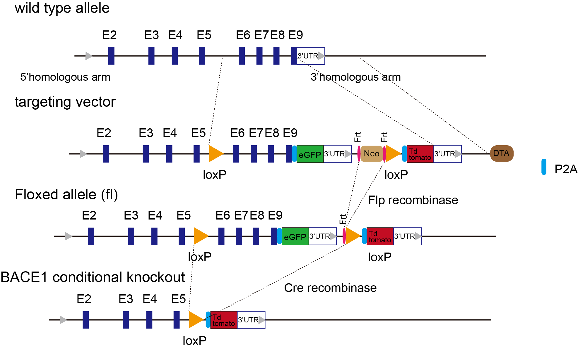
Supplementary Figure 1. This design is to conditionally knockout the exon6-9 by the Cre-loxP system. The intron 5-6 and the non-coding region following 3’UTR are big and insertion of loxP elements will not interfere with mRNA splicing. To minimize the possibility of disruption of Bace1 expression, both of the loxP sites were inserted into non-conserved regions. The Frt-flanked neo cassette was taken as a positive screening marker and DTA as a negative screening marker to enhance the screening efficiency of ES cells carrying the target allele.

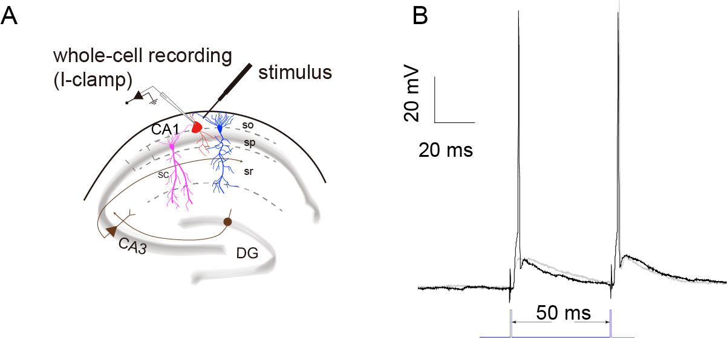
Supplementary Figure 2. The method of paired presynaptic stimulation. A, schematic diagram of whole-cell recording for PV INs in a current-clamp mode. so, stratum oriens; sp, stratum pyramidale; sr, stratum radiatum; sc, Schaffer collateral; B, representative traces of evoked spikes by a glass theta electrode with an output of two consecutive stimulations (paired-pulse) at a 50 ms interstimulus interval. The black traces display two consecutive spikes evoked by a paired-pulse stimulation with minimal necessary intensity.
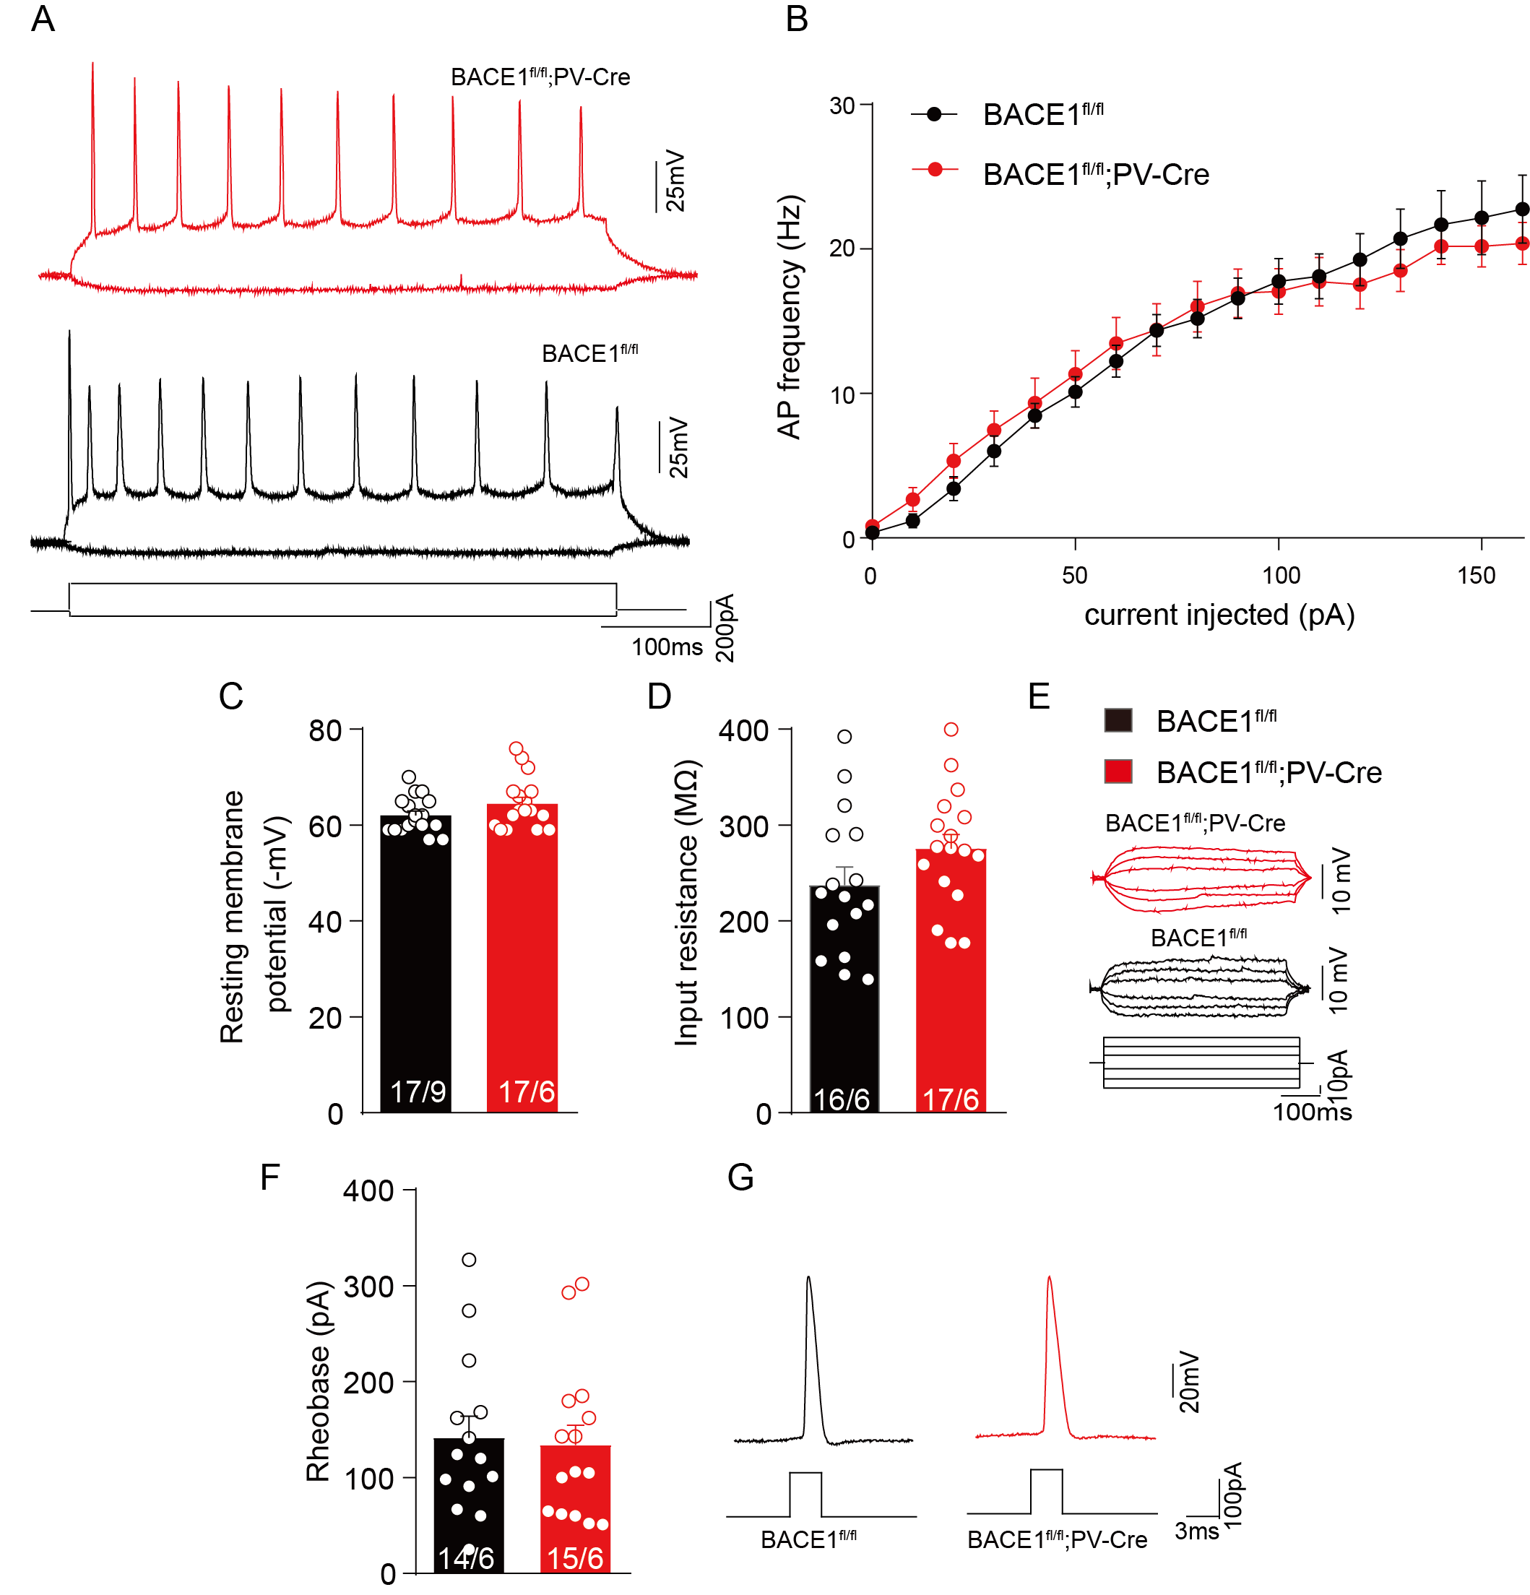
Supplementary Figure 3. BACE1 deletion did not change the excitability of CA1 pyramidal neurons. A, representative traces of action potential (AP) of CA1 Pyramidal neurons in response to 500ms-long step currents in BACE1^{fl/fl} and BACE1^{fl/fl};PV-Cre mice. B, plots of AP frequency against current injections. C, the resting membrane potential of all these recorded neurons. D, the input resistance of CA1 Pyramidal neurons from BACE1^{fl/fl} and BACE1^{fl/fl};PV-Cre mice was calculated by Ohm’s law from E, subthreshold stimulation of current injections from -30 to +30 pA in the duration of 500 ms. F, step current injections (increment: 10 pA) crossing threshold was performed to determine neurons' short pulse (3 ms) rheobase. G, Representative traces of the first firing triggered by suprathreshold current injection. Dots indicate individual neurons recorded, and data are presented as mean $±$ SEM. In B, multiple t-tests were used to compare the two groups. C, D, F, unpaired t-test was used. The n values are shown in bars and indicate cells/mouse.

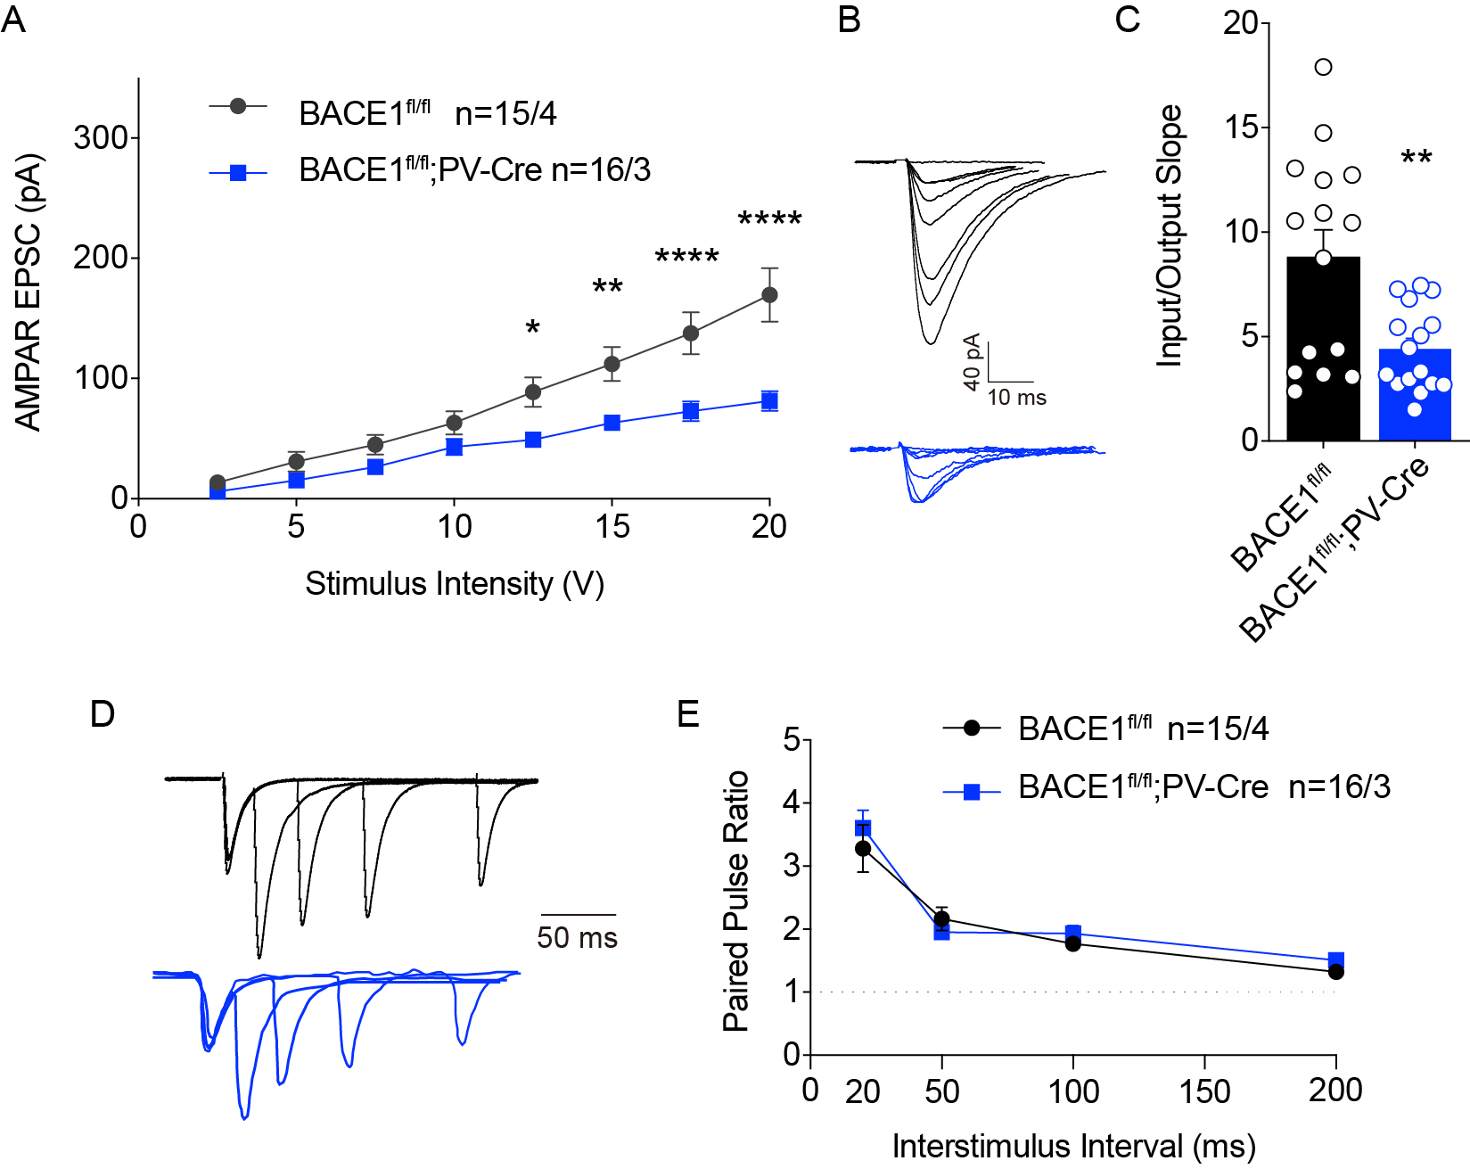
Supplementary Figure 4. The decrease in AMPAR EPSCs of CA1 deep layer PNs responding to SC stimulation in BACE1;PV-Cre mice at 6 months old. A, B, plots and representative traces of AMPAR EPSCs on CA1 deep layer PNs in BACE1^{fl/fl} and BACE1^{fl/fl};PV-Cre mice. C, analysis of input-output (I-O) relationship between AMPAR EPSCs and incremental stimulus intensities (in V with theta glass electrode). D, E, representative traces and plots showing paired-pulse ratio (PPRs) of CA1 deep layer PNs at interstimulus intervals of 20, 50, 100, and 200 ms. The data are presented as Mean ± SEM. Two-way ANOVA analysis followed by Bonferroni’s multiple comparisons test was used in A, E. Unpaired student’s t-test was used in C. *p < 0.05, **p < 0.01, ****p < 0.0001 vs. BACE1^{fl/fl}. The n value indicates cells/mouse.

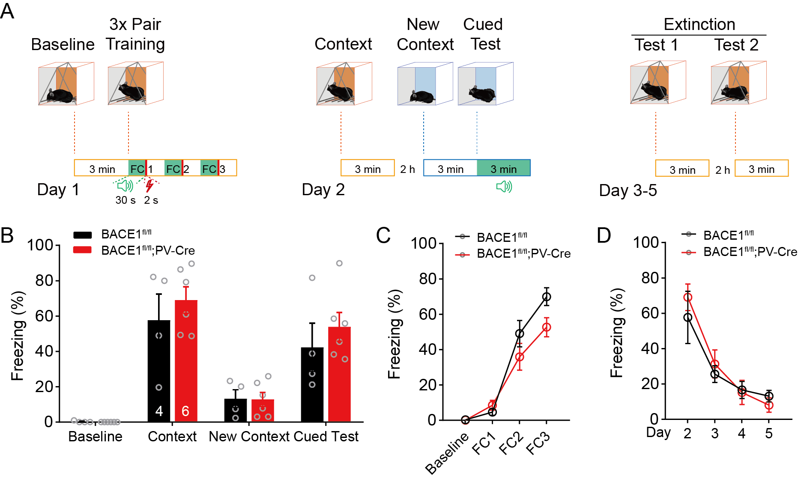
Supplementary Figure 5. BACE1 deletion in CA1 PV INs did not influence the encoding and the extinction of conditioned fear memory. A, schematic diagram of protocols for contextual fear conditioning and fear memory extinction. B, bar graph showing the percent of freezing time for animals (BACE1^{fl/fl}, BACE1^{fl/fl};PV-Cre, respectively) in different episodes of a test. The n values are shown in bars and indicate animals. C, percent of freezing time during three rounds of fear conditioning (FC1-FC3). D, statistical analysis for averaged percent of freezing time during day 3-day 5 of fear extinction. All data are presented as mean $±$ SEM, and two-way ANOVA followed by Bonferroni’s multiple comparisons test was used in B, C, D.
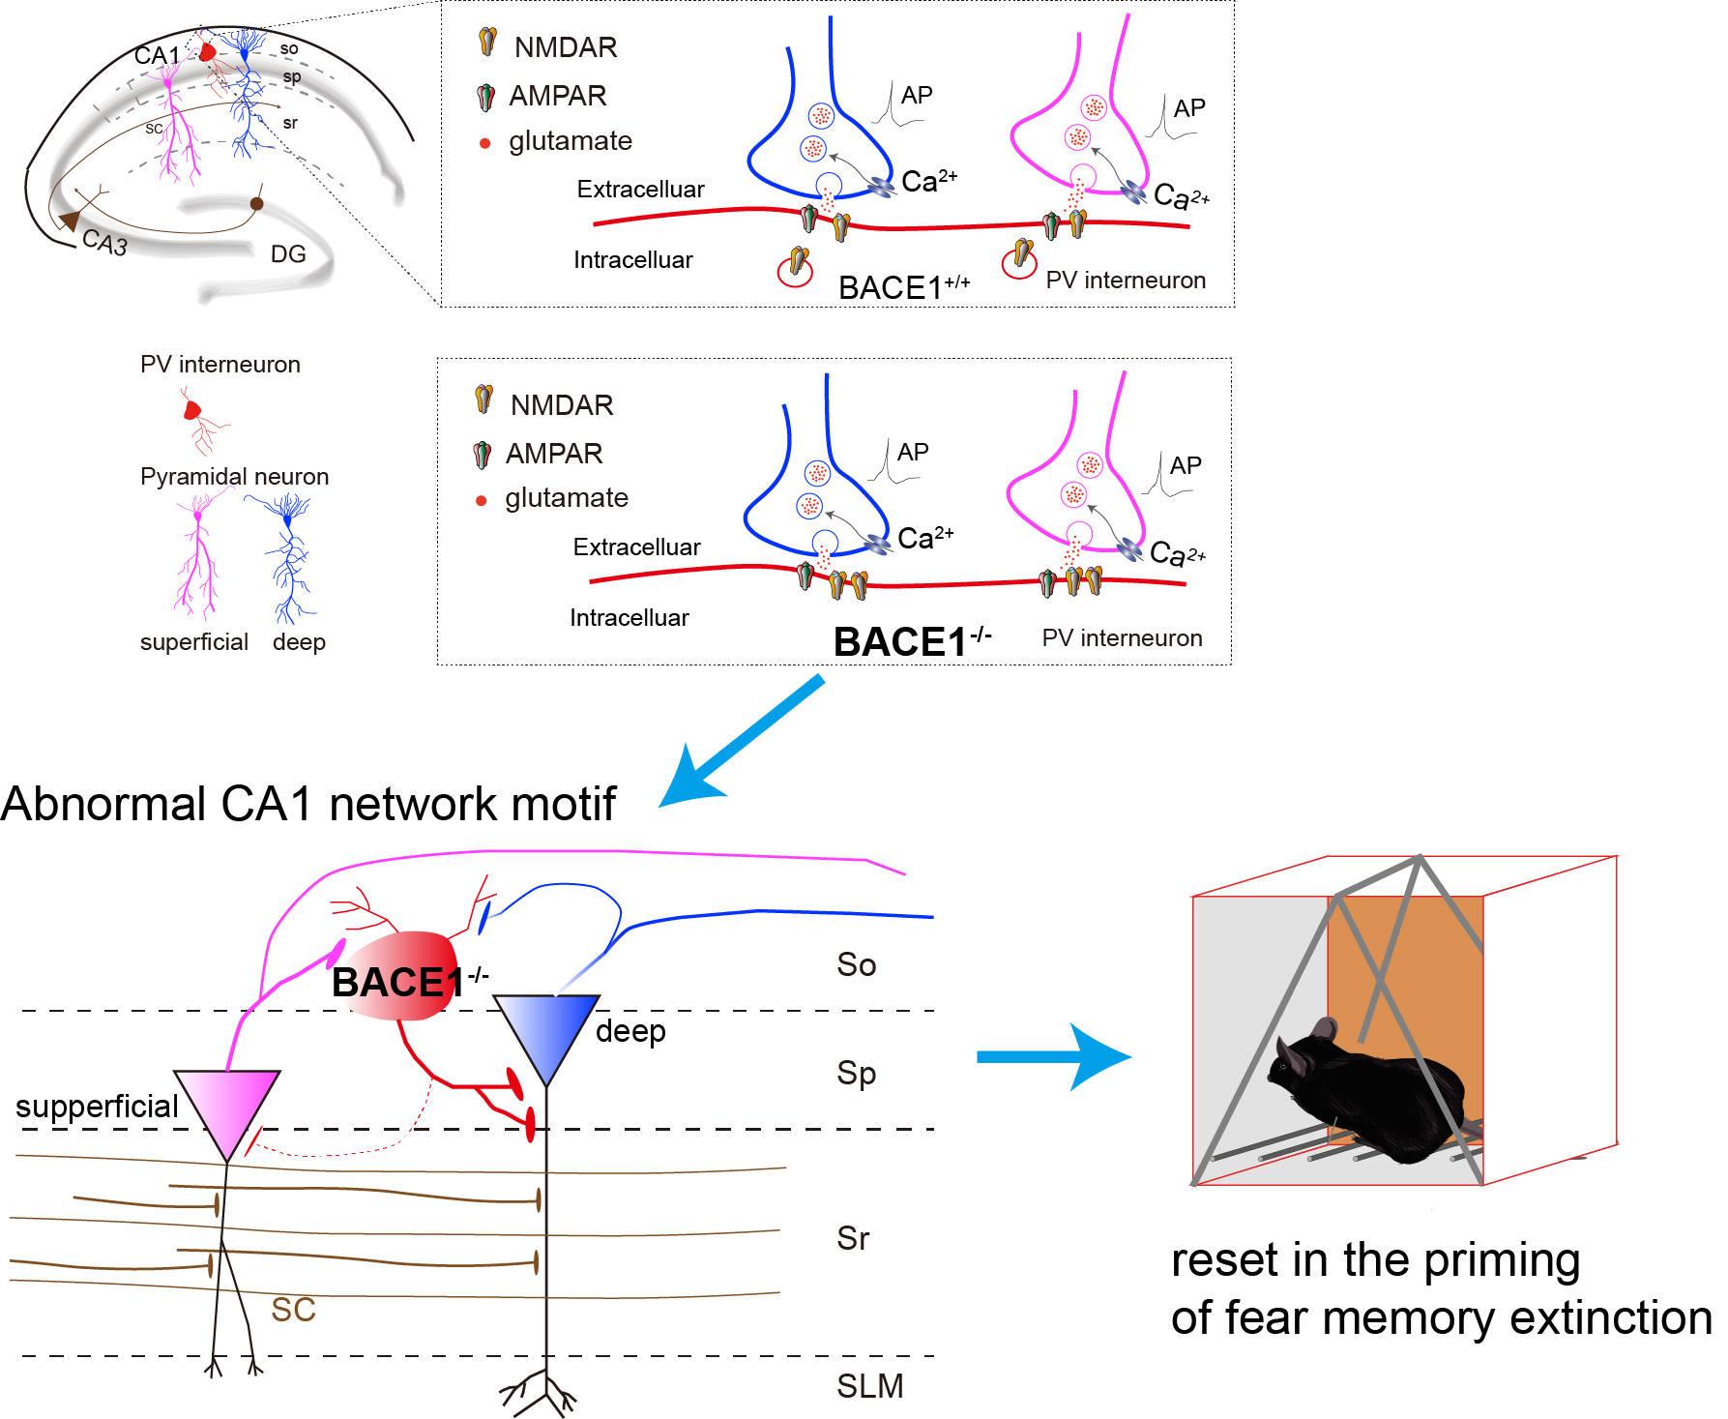
Supplementary Figure 6. The working model of BACE1 in PV INs in regulating the local circuit of hippocampal CA1. It is known that the microcircuit organization between the heterogeneous CA1 PNs and the adjacent PV INs established a preferential recurrent inhibitory motif from the superficial to the deep layer. Conditional BACE1 deficiency in dependence on its enzymatic activity exaggerated the NMDAR-mediated synaptic transmission onto PV INs in the CA1 microcircuit. It led to an escape of superficial PNs from the CA1 network motif, in which the excitatory outputs of deep CA1 PNs appeared to be eventually impaired, presumably as a consequence of these changes in the CA1 network, reset the priming of conditioned fear memory extinction.

