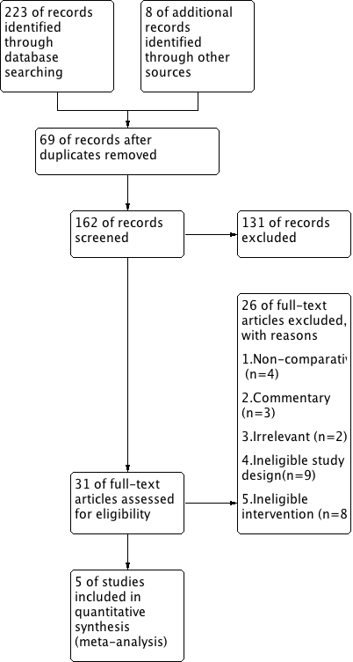
Flow diagram demonstrating the study selection process

