Supplementary Information for

The first hunting dog from Dmanisi: comments of social behaviour in Canidae and hominins.

Saverio Bartolini Lucenti^{1,2,*}, Joan Madurell-Malapeira^{3,4}, Bienvenido Martínez-Navarro^{5,6,7*}, Paul Palmqvist⁸, Lorenzo Rook¹, David Lordkipanidze⁹

¹ Earth Science Department, Paleo[Fab]Lab, University of Florence, Via G. La Pira 4, 50121 Firenze, Italy
² Natural History Museum, University of Florence, Via G. La Pira 4, 50121 Firenze, Italy
³ Institut Català de Paleontologia Miquel Crusafont, Universitat Autònoma de Barcelona, Edifici ICTA-ICP, c/ de les columnes s/n Campus de la UAB, Cerdanyola del Vallès, 08193, Barcelona, Spain
⁴ Department of Geology, Universitat Autònoma de Barcelona, Facultat de Ciències, Edifici C, Campus de la UAB, 08193 Cerdanyola del Vallès, Barcelona, Spain
⁵IPHES, Institut Català de Paleoecologia Humana i Evolució Social, C/ Marcel.lí Domingo s/n, Campus Sescelades, Edifici W3, 43007 Tarragona, Spain
⁶ Area de Prehistòria, Universitat Rovira i Virgili (URV), Avda. Catalunya 35, 43002 Tarragona, Spain
⁷ ICREA, Pg. Lluís Companys 23, 08010 Barcelona, Spain
⁸ Departamento de Ecología y Geología, Universidad de Málaga, Campus de Teatinos, 29071 Málaga, Spain
⁹ Georgian National Museum, 3, Rustaveli ave., Tbilisi-0105, Georgia

*joined corresponding authors: Saverio Bartolini Lucenti and Bienvenido Martínez-Navarro
Email: sbartolinilu@unifi.it; bienvenido.martinez@icrea.cat

- Taxonomic remarks on Canis (Xenocyon)
In the last two decades, molecular phylogenies have shown the that the hypercarnivorous L. pictus and C. alpinus are part of a monophyletic clade that includes all the species of the genus Canis (including wolves, coyotes, African golden wolves, golden jackals and Ethiopian wolves^{7,8}), whereas the black-backed and the side-stiped jackals stem out of this clade and are generally referred to the genus Lupulella Hilzheimer, 1906⁶¹ or to Lupulella and Schaeffia Hilzheimer, 1906, respectively (if these two African taxa do not belong to a monophyletic clade⁶²).
Despite the genetic evidence, the evolutionary history of wild dogs (both African and Asian one) is still elusive and matter of debate between scientists, especially due to the fragmentary nature of their fossil record. Indeed, although abundant and widespread across Eurasia, as well as Africa, from 2.5 Ma till the appearance of extant species in the Middle Pleistocene, several alternative taxonomical solutions were used in the last century to accommodate large-sized hypercarnivorous taxa (as summarized by Wang et al.⁶). The Hungarian paleontologist Milos Kretzoi^{17,63} proposed two extinct genera for the probable ancestors of the extant species: Xenocyon Kretzoi, 1938 and Sinicuon Kretzoi, 1941. In his view, the former was related to the lineage of extant African wild dog (as the genotype species is Xenocyon lycaonoides Kretzoi 1938) whereas the second should represent the ancestor of Cuon, as the name suggests. Part of the querelle surrounding the taxonomical nomenclature of fossil wild dogs may partially be due to the confusion made by Kretzoi himself describing those genera (as Tedford et al.¹⁰ noted). For instance, the name Sinicuon peii Kretzoi,1941 was used by the Hungarian paleontologist to include the canid material coming from Zhoukoudian Locality 18 described by Pei⁶⁴. Nevertheless, the year before Teilhard de Chardin⁵² had already ascribed the specimens to Cuon dubius. Wang et al.⁶ note that the chosen name hints the perplexity that the French paleontologist had to the true relationships between the Zhoukoudian specimens and extant dholes. Perplexity, indeed, reasonably motivated by the evident presence of the m3 on the mandibles from Zhoukoudian Loc. 18. Further complication in this taxonomical and evolutionary history scenario are: the reports by Thenius⁶⁵ of this species (by him attributed to “Cuon dubius stehlini”) from the French locality of Rosiéres (later reascribed to X. lycaonoides by Schütt, 1973); and the true occurrence of a large-sized dhole (Cuon alpinus priscus Thenius, 1954) together with the other hypercarnivorous canid X. lycaonoides in Mosbach II (Germany⁶⁶). Although the name Sinicuon did not catch on much (e.g., used Cuon⁶⁷; or used Xenocyon¹⁰), some authors rekindled the interest for this genus. Qiu et al.⁹ attributed a single specimen of a hypercarnivorous canid from Longdan in the new combination Sinicuon dubius, following the interpretation of Sinicuon as the intermediate form between fossil Canis and Cuon as proposed by Kretzoi⁶³, whereas Xenocyon would be related to Lycaon. Sharing this hypothesis, Wang et al.⁶ ascribed the hemimandible fragment from Zanda Basin (Himalayan region) to Sinicuon cf. S. dubius.
The issue of Xenocyon is similarly complicated. Describing the material from Gombasek, Kretzoi¹⁷ ascribed the sample of a large-sized canid to two species: “Canis” gigas Kretzoi, 1938 (:128) and X. lycaonoides (Kretzoi, 1938: 132). In 1941, Kretzoi⁶³ restudied this fauna and realized the synonymy between the two taxa and used X. gigas (in accordance with the priority rules of zoological nomenclature). The following year, Kretzoi⁶⁸ noticed that the name Canis gigas was preoccupied and therefore chose a new genotypic species name, Canis spelaeoides Kretzoi, 1942. Such a name was used only by Musil⁶⁹, in the description of the Xenocyon from Stránska Skála, and Schütt⁶⁶ revised the taxonomy of the genus and concluded that X. lycaonoides had priority on all other specific names, as the original genotypic species. Schütt’s view is nowadays commonly shared among paleontologists^{5,10,11,18,21,30,70}.
Two autoapomorphic features distinguish the extant L. pictus and C. alpinus from other living Canidae, in addition to derived hypercarnivorous teeth morphologies. The African wild dog does not show the I metacarpal, whereas extant dhole does not retain the m3. Those diagnostic features lead several authors to avoid using the generic names of the extant wild dogs for fossil species with hypercarnivorous adaptations yet retain both those features, i.e., of uncertain affinity, preferring in their stead Xenocyon^{10,66} or Sinicuon⁶.
Martínez-Navarro & Rook⁵ proposed to consider the Early Pleistocene X. falconeri and X. lycaonoides as chronospecies in the phyletic line leading to extant L. pictus and, therefore, ascribed them to the genus Lycaon (vision shared by¹⁸). Although considering plausible a strong relationship between these species, especially “L.” lycaonoides, and L. pictus, the inclusion of the fossil species in the genus Lycaon renders Canis paraphyletic. Similarly, the doubtful interpretation of the large-sized canid remains of Coopers D (1.9-1.6 Ma⁷¹) and Gladysvale (<700 ka⁷²; or ca 1 Ma, unpublished data in¹³) as Lycaon sekowei Hartstone-Rose et al., 2010, poses taxonomical problems. The latter actually might not even be related to xenocyons for several morphologies similar to the Asian hypercarnivorous Canis chihliensis Zdansky, 1924. Some authors^{12,73} chose to include all species of the subtribe Canina to the genus Canis (i.e., including black-backed and side-striped jackals) thus reducing risk of paraphyly. Nevertheless, such an interpretation results unsatisfactory as it does not acknowledge the significant diagnostic morphologies of Lycaon, Cuon and Lupulella. Furthermore, Xenocyon may indeed serve as a valid denomination of all intermediate or uncertain Plio-Pleistocene taxa with distinctive hypercarnivorous features. Sinicuon could be used in a similar way, but in the original intentions of Kretzoi the specimens of Zhoukoudian Loc. 18 have to be considered closely related to the extant Cuon. Therefore, the use of Sinicuon has implications for its presumed affinity of fossil specimens/samples^{6, 9}. Our present knowledge of the true relationships between the extant and extinct species is utterly poor and thus the ascription of fossil forms to a different genus, hardly distinguishable from Xenocyon (i.e., there are no current valuable differential diagnosis between Sinicuon and Xenocyon), seems unsuitable. In order to avoid names suggestive of untested relationship with extant species, and thus privileging more parsimonious denominations, we choose here to follow Rook¹¹ and Sotnikova³⁰ in considering Xenocyon as a subgenus of Canis.

- Systematic Paleontology

Order Carnivora Bowdich, 1821.
Family Canidae Fischer, 1817.
Subfamily Caninae Fisher, 1817.
Tribe Canini Fisher, 1817.
Genus Canis Linnaeus, 1758.
Subgenus Xenocyon Kretzoi, 1938
Canis (Xenocyon) lycaonoides (Kretzoi, 1938)
Fig. 2
Referred material—D6327, left corpus fragment with p1-p3 (D6327a) and left m1 (D6327b).
Measurements—Table S1.
Anatomical Description— D6327 does not show significant degree of dental wear, which suggests that they belong to a single individual, probably a young adult. The corpus fragment of D6327 is rather high and stout. On the buccal side, two foramina are evident. The mesial one is wide and deep, with a distal margin ending under the p2 whereas the distal one, much smaller, under the mesial part of p3. There are no diastemata between the premolars. The protoconids of the premolars are high and sharp. The p1 has a single cuspid and an enlarged distolingual portion. The p2 possesses a small but evident distal cuspulid and a developed distal cingulid. The distal portion of the tooth is consistently enlarged compared to the mesial potion. The p3 is larger than the p2, with a more robust mesial portion. There is an evident distal accessory cuspulid and a prominent cingulid in the p2. The m1 is stout, in occlusal view, with a large paraconid and a high and sharp protoconid. The metaconid is closely attached to the protoconid and poorly individualized. In the talonid basin, the hypoconid is almost centralized and the entoconid is present, though considerably reduced, almost to a crest.
Comparison with other large-sized hypercarnivorous canids of Eurasia—The studied m1 from Dmanisi shows hypercarnivorous adaptations like the reduction of the metaconid and entoconid. The mandibular fragment is stout and high, like in other Early Pleistocene large-sized canids as C. (Xenocyon) antonii from Fan Tsun¹¹, “C. chihliensis” from Shanshenmiaozhou²¹, C. (Xenocyon) falconeri from Upper Valdarno (Del Campana, 1913) and C. (Xenocyon) lycaonoides from e.g., Venta Micena, Untermassfeld, Vallparadís Estació^{18,30,74} or the extant C. lupus, L. pictus or C. alpinus. Compared to their mesiodistal length, the premolars are higher than in other Canis (Xenocyon) species, in which the cuspids tend to be shorter. Nevertheless, in some specimens [e.g., VM-2255 and VM-2257, C. (Xenocyon) lycaonoides from Venta Micena¹⁸], the premolars show a similar morphology. However, this feature does not seem reliable, as it varies considerably in extant L. pictus and C. alpinus (Supplementary Material). For instance, in L. pictus, 56% of the examined specimens (16 out of 29 specimens) possessed more robust and shorter protoconids whereas 47% showed thinner and higher ones. The presence of distal accessory cuspulids on the p2 and the p3 is fairly common in Early Pleistocene C. (Xenocyon) falconeri and C. (Xenocyon) lycaonoides, and also in L. pictus, whereas it seems uncommon in the Middle Pleistocene forms of C. (Xenocyon) lycaonoides, but also in C. (Xenocyon) dubius and in C. alpinus. In contrast to extant L. pictus (18) C. (Xenocyon) from Dmanisi, C. (Xenocyon) falconeri from Upper Valdarno and C. (Xenocyon) lycaonoides from Eurasia do not possess accessory mesial cuspulids on the p2 or p3, just a sharp cristid on the mesial side of the protoconid.
The m1 is stout, as in C. (Xenocyon) falconeri and C. (Xenocyon) lycaonoides, and larger buccolingually compared to that of C. (Xenocyon) dubius from Zanda Basin⁶, Linyi⁶⁷ and Loc. 18⁵². One of the key features of the lower carnassial D6327b is the morphology of the entoconid. In Dmanisi specimen in contrast to C. (Xenocyon) falconeri, entoconid is reduced, but not as reduced in C. (Xenocyon) dubius from Zanda Basin and Loc. 18, and some Middle Pleistocene forms of C. (Xenocyon) lycaonoides (e.g., Cripple Sump Creek and Olyorian Fauna^{10,59}); Gombasek, Koněprusy C178¹⁷; Westbury-sub-Mendip⁵⁷; Zanushino and Chukochya³⁰. The development of the entoconid of the specimen from Dmanisi is more consistent with earlier forms of C. (Xenocyon) lycaonoides, like those of Early Pleistocene sites like Cueva Victoria, Trlica⁵⁶, Untermassfeld³⁰, Vallparadís Estació and Venta Micena¹⁸ (Fig. 3). Moreover, as Sotnikova³⁰ noted, the reduction of the m1 entoconid in Early Pleistocene C. (Xenocyon) lycaonoides, although remaining an important feature, has a certain degree of variation: in specimens coming from the same sample (e.g., in Lakhuti-2, Ma Fang, Nalaikha, and Untermassfeld) this cuspulid is simply reduced (e.g., F:AM 97046 from Ma Fang), while in others it is vestigial, only slightly emerging from a lingual cingulid (e.g., F:AM 97045 from Ma Fang). The latter condition is shared, and furtherly reduced, in several specimens from Middle Pleistocene localities, like those mentioned above (i.e., Koněprusy C178, Cripple Sump Creek). The position of the hypoconid in the m1 talonid is related to the development/reduction of the entoconid. In C. (Xenocyon) falconeri and C. (Xenocyon) antonii from Fan Tsun the talonid basin is bicuspidate, with the hypoconid not centred in this portion. Such shared morphology in these two taxa allowed Rook¹¹ and Martínez-Navarro & Rook⁵ to suggest a strong relationship between these species [C. (Xenocyon) gr. falconeri in¹¹]. In contrast, the hypoconid in C. (Xenocyon) lycaonoides tends to become larger, occupying the majority of the talonid, especially in those specimens where the entoconid is reduced to a lingual cuspulid-like cristid. The m1 talonid basin of the Dmanisi sample with almost centralized hypoconid and considerably reduced, crest-like entoconid, fits the early C. (Xenocyon) lycaonoides. This derived condition results in the transformation of the talonid basin of the lower carnassial from a basin-like depression into a trenchant heel, which represents a functional lengthening of the trigonid blade of the carnassial²⁸. In three out of the four living hypercarnivorous canids, the dhole, the painted dog and the South American bush dog (Speothos venaticus), the hypoconid is a single, large, centrally positioned, bladelike cusp. In the fourth hypercarnivorous species, the Eurasian and North American grey wolf (Canis lupus), the hypoconid is enlarged at the expense of the entoconid, as in C. (Xenocyon) lycaonoides, which represents a less advanced grade in the evolution towards hypercarnivory of a trenchant-like talonid.
Linear measurements of the specimens from Dmanisi show a large size comparable to early taxa and the Early Pleistocene C. (Xenocyon) lycaonoides. An extensive sample of fossil specimens was used to compare the relative length of the m1 trigonid as opposed to the m1 width in the known fossil Canis (Xenocyon) and living African hunting dogs (Fig. S1). The size variability of the fossil derived C. (Xenocyon) lycaonoides is fairly broad. Moreover, apparently the variability is not only between samples (chronologically referred to a time span more or less of one million years) but also within specimens of the same sample (e.g., Apollonia-1⁵³; or Zasukhino³⁰). It is worth noting that the variance showed by C. (Xenocyon) lycaonoides is more or less comparable to that of the extant L. pictus. This is also confirmed by Fig. S2: the relative size of the lower carnassial of the fossil taxon is of the same degree of magnitude of L. pictus. Unfortunately, earlier forms are poorly represented and known from few specimens, often incomplete, which prevents us from drawing inferences on their variability. Only C. (Xenocyon) dubius possibly increased the stoutness of the m1 in time, yet the low number of specimens discourage any hypotheses in this sense. Dmanisi m1 falls close to C. (Xenocyon) africanus from Olduvai bed I and also to medium- to large-sized C. (Xenocyon) lycaonoides, to which is close for the length of the trigonid.

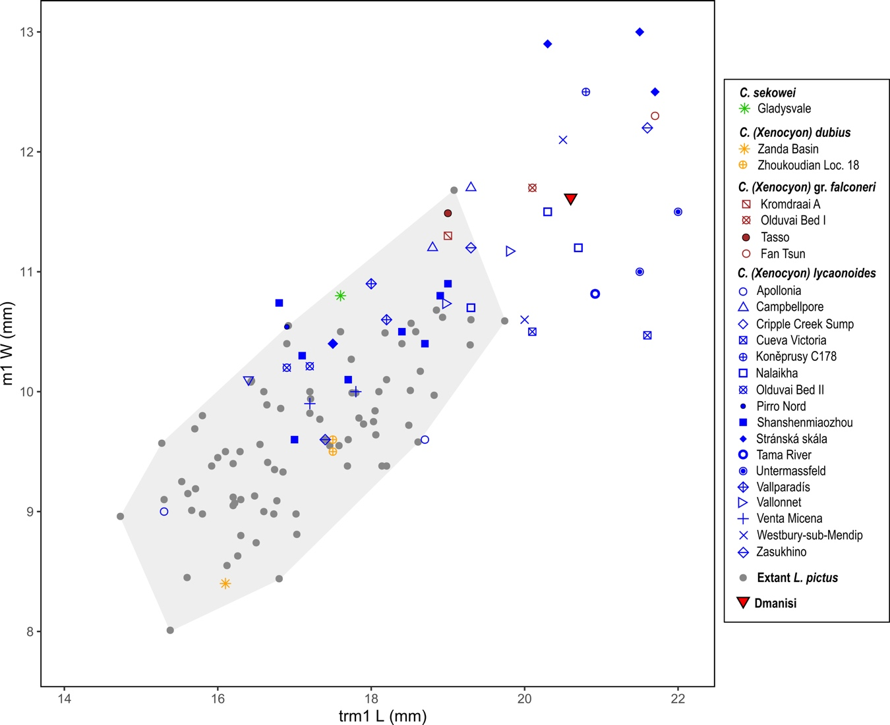

Figure S1. Scatter-plot comparing m1 trigonid length and m1 width in Pliocene-Early Pleistocene wild dogs and L. pictus. Gray shaded area is the range variability of extant African wild dog.

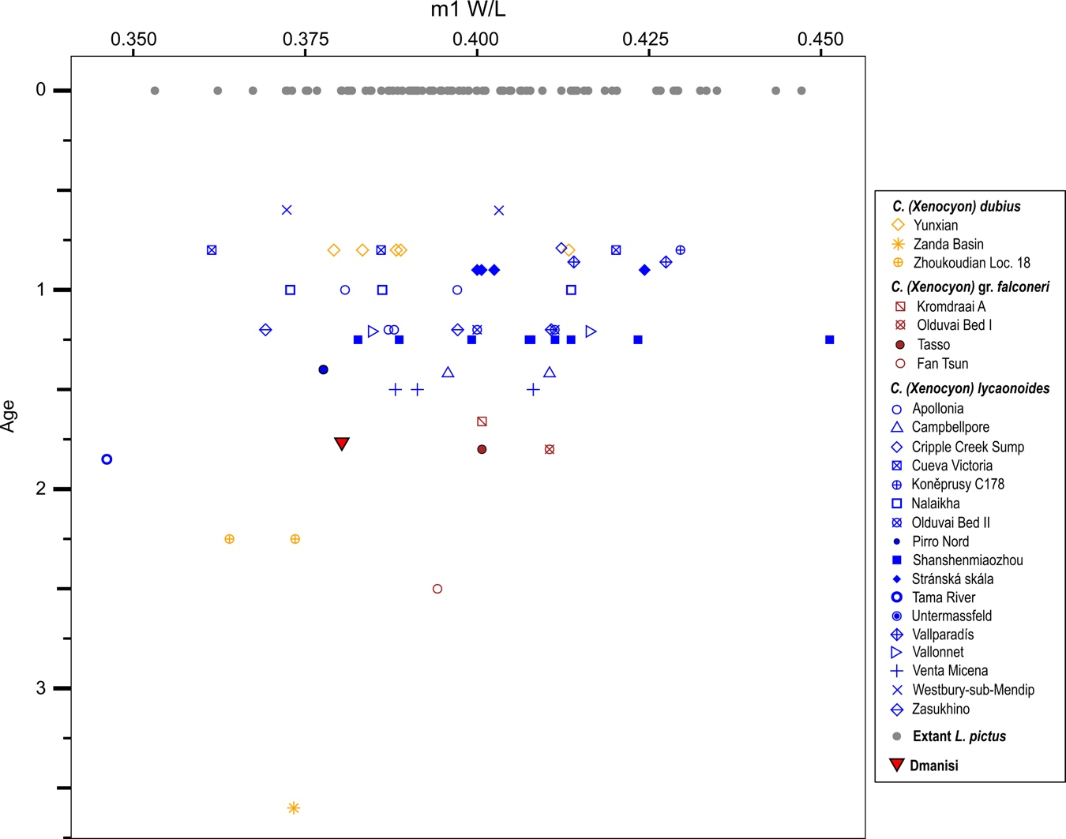

Figure S2. Distribution of m1 width and length ratio in fossil wild dogs (of the last 3.75 Ma) and in extant L. pictus.

Cat. Numb | Side | p1 L | p1 W | p2 L | p2 W | p3 L | p3 W | m1 L | m1 W | trm1 L | tdm1 L | tdm1 W | Mp1H | Mp2H
D6327 | L | 6.4 | 4.7 | 13.8 | 7.2 | 16.2 | 7.2 | 30.5 | 11.6 | 20.6 | 9.9 | 11.2 | 28.7 | 27.4

Table S1. Dental measurements of the Canis (Xenocyon) lycaonoides specimens from Dmanisi. Abbreviations: L, mesiodistal length; W, buccolingual width; tr, trigonid; td, talonid; Mp1H, height of the mandibular corpus at level of the distal side of the p1; Mp2H, height of the mandibular corpus at level of the distal side of the p2.

SI References

- Lindblad-Toh, K. et al. Genome sequence, comparative analysis and haplotype structure of the domestic dog. Nature 438, 803–819 (2005).
- Zrzavý, J. & ŘIčánková, V. Phylogeny of recent Canidae (Mammalia, Carnivora): relative reliability and utility of morphological and molecular datasets. Zool. Scr. 33, 311–333 (2004).
- Kretzoi, M. Weitere Beiträge zur Kenntnis der Fauna von Gombaszög. Ann. Hist. Nat. Mus. Hung. 34, 105–139 (1941).
- Pei, W. C. The upper cave fauna of Choukoutien. Palaeont. Sinica 10, 1–84 (1940).
- Thenius, E. Zur Abstammung der Rotwölfe (Gattung Cuon Hodgson). Österr. Zool. 5, 378–387 (1954).
- Schutt, G. Revision der Cuon-und Xenocyon-funde (Canidae, Mammalia) aus den Alt Pleistozänen Mosbacher Sanden (Wiesbaden, Hessen). Mainzer Naturwissenschaftliches Archiv. 12, 49–77 (1973).
- Wang, S. & Zhao, S. Additional note on the Cuon from Linyi, Shanxi province, China In Proceedings of the Tenth Annual Meeting of the Chinese Society of Vertebrate Paleontology (Ed. W. Dong) 63–68 (Beijing, China Ocean Press, 2006).
- Kretzoi, M. Präokkupierte und durch ältere zu ersetzende Säugetiernamen. Földtany Közl- öny 72, 345–349 (1942).
- Musil, R. Die Caniden der Stránská Skála. Anthropos 20, 77–106 (1972).
- Sotnikova, M. V. & Vislobokova, I. A. Pleistocene mammals from Lakhuti, Southern Tajikistan, USSR. Quatärpaläontologie 8, 237–244 (1990).
- Berger, L. R., De Ruiter, D. J., Steininger, C. M. & Hancox, J. Preliminary results of excavations at the newly investigated Coopers D deposit, Gauteng, South Africa: preliminary research reports: human origins research in South Africa. S. Afr. J. Sci. 99, 276–278 (2003).
- Lacruz, R. S. et al., Palaeontology and geological context of a Middle Pleistocene faunal assemblage from the Gladysvale Cave, South Africa. Palaeontol. Africana 114, 99–114 (2002).
- Werdelin, L. & Peigné, S. Carnivora In Cenozoic Mammals of Africa (Eds. Werdelin, L. & Sanders, W. J.) 603–657 (University of California Press, Berkeley, 2010).
- B. Martínez-Navarro, Revisión sistemática y estudio cuantitativo de la fauna de macromamíferos del yacimiento de Venta Micena (Orce, Granada) (Unpublished PhD dissertation, Universitat Autònoma de Barcelona, 1992).

