Appendix A. Magnetic configurations at NFO and ZNFO
Table A1 summarizes the different magnetic configurations considered for Ni ferrite, both with and without Zn substitutions.
Configuration | Sublattices
Configuration | Fe_{B} | Fe_{A} | Ni
c0 | + | - | +
c1 | + | + | +
c2 | + | + | -
c3 | + | - | -

Table A1 Schematic representation of the different magnetic configurations considered for NFO and ZNFO according to the spin orientation of the magnetic sublattices.
Appendix B. Evolution with U(Zn_{d}) of unrelaxed ZNFO
In Figure B1 we show the evolution with U(Znd) of the spin-resolved DOS of unrelaxed Znx Ni1−x Fe2 O4 at x=0.25 under the magnetic configurations shown in Table A1, considering Zn both at tetrahedral and octahedral sites. The results prove the smooth shift of the Zn d band with U(Znd), and the independence of the global electronic features from the position of the Zn d states, as described in Figure 9 for the relaxed structures.
Figure B2 shows the evolution with U(Znd) of the total energy and internal pressure of these systems, the upper panel being equivalent to Figure 9, but referred to the unrelaxed structures. Again the figure reflects a smooth dependence on U(Znd). It is also evident the robust stability of the ground state magnetic configuration of NFO, c0, no matter the Zn position or the U(Znd) value. The most notable difference with respect to the relaxed structures is the relative stability of ZnA and ZnB, although with and without relaxation ZnA tends to be favored as U(Znd) increases.
The internal pressure at the lower panel of Figure B2 is a measure of how comfortable is the system at the lattice parameter used in the calculation (that of NFO in our case). It goes to zero at the equilibrum volume. Figure B2 reflects the same results shown in the main text for the relaxed structures: the lattice contracts as U(Znd) increases, something already observed at ZFO. In addition, there is a different dependence with U(Znd) of the equilibrium volume for ZnA and ZnB, which correlates with the relative stabilities observed in the upper panel. This justifies why the relative stability of ZnA and ZnB varies with U(Znd) when the NFO lattice is kept fixed, while they become almost degenerate when the structure is allowed to relax.
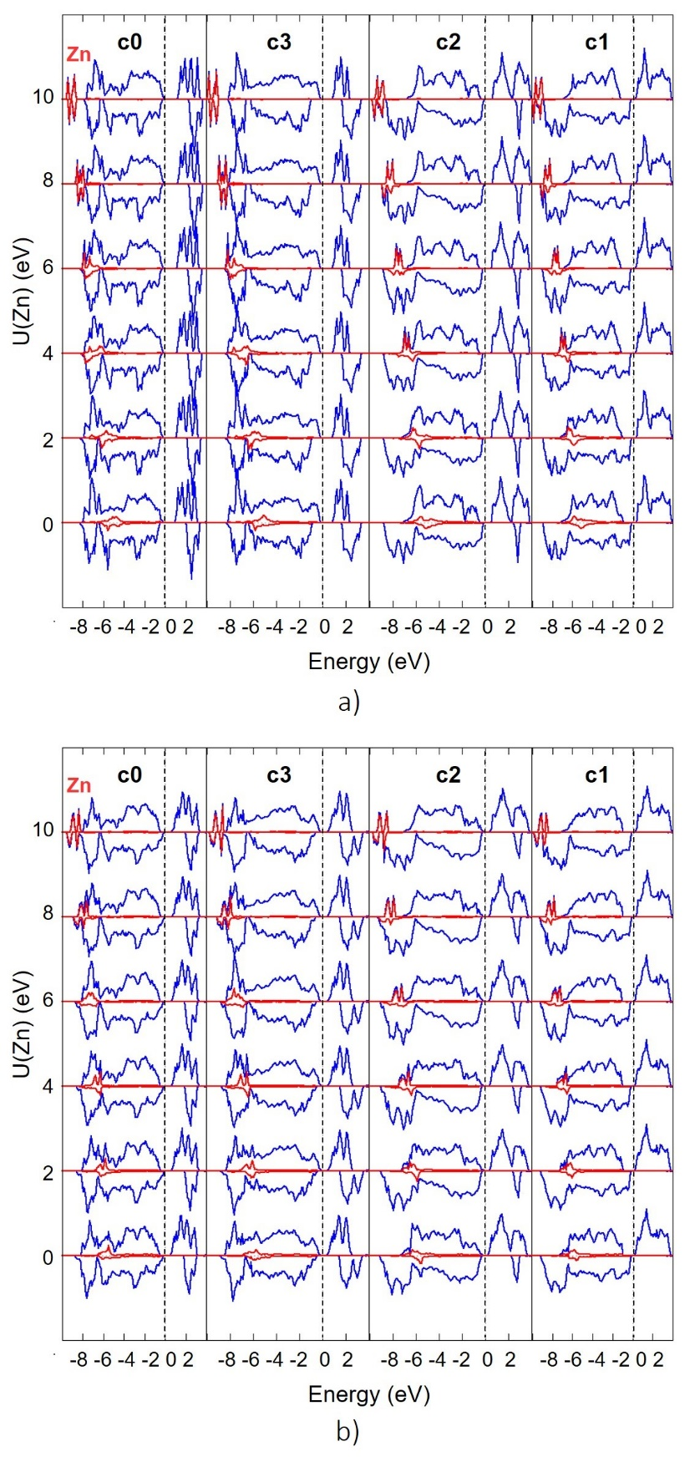
Figure B1 Evolution with U(Znd) of the spin-resolved DOS of unrelaxed ZNFO under x=0.25. Majority (minority) spin contributions are shown as positive (negative) values. a) and b) correspond to Zn at octahedral and tetrahedral sites respectively, while each column refers to a different magnetic order. The projection of the Zn states is represented by the red line.
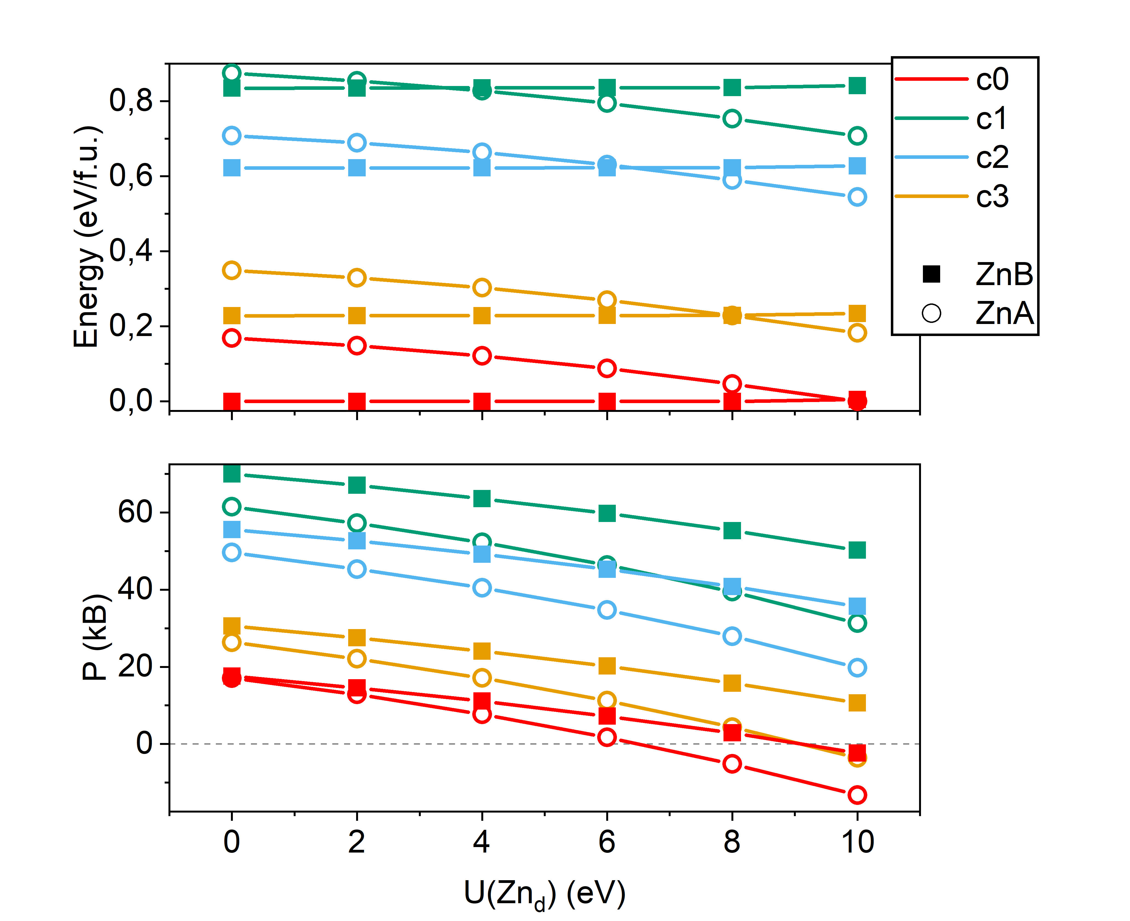
Figure B2 Evolution with U(Znd) of the total energy (top) and the internal pressure (bottom) of unrelaxed ZNFO at x = 0.25 under the magnetic configurations in Table A1. Structures with Zn at A (B) positions are represented by an empty circles (filled squares). The energy zero at each U(Znd) has been set at the most stable structure.
Appendix C. Zn distribution at ZNFO under x=0.50
Figure C3 shows the different atomic arrangements considered for ZNFO at x=0.50, named according to the distribution of Zn atoms at A and B sites. The corresponding relative distance between Zn-Zn closest neighbours is also provided. Modifying the distribution of Zn at B sites necessary alters that of Ni, and different combinations have been taken into account. Our calculations do not pretend to cover exhaustively all possibilities, but to identify the most stable structures, and the existence or not of a competition between configurations ZnA, ZnB and ZnAB that may affect the magnetic properties of the system.
The relative stability of each of these relaxed structures is shown in figure C4 as a function of U(Znd). The most relevant feature is the strong dependence of the atomic distribution on U(Znd), that affects mainly the hierarchy between configurations ZnA and ZnB. But in general the energy differences are low, evidencing that all these structures may be found at real samples. The results also indicate a tendency to favor sparse Zn distributions, even though the interatomic distance between Zn neighbours is not determinant. Other factors, as the distribution of Ni atoms, also influence the final energy of the system.
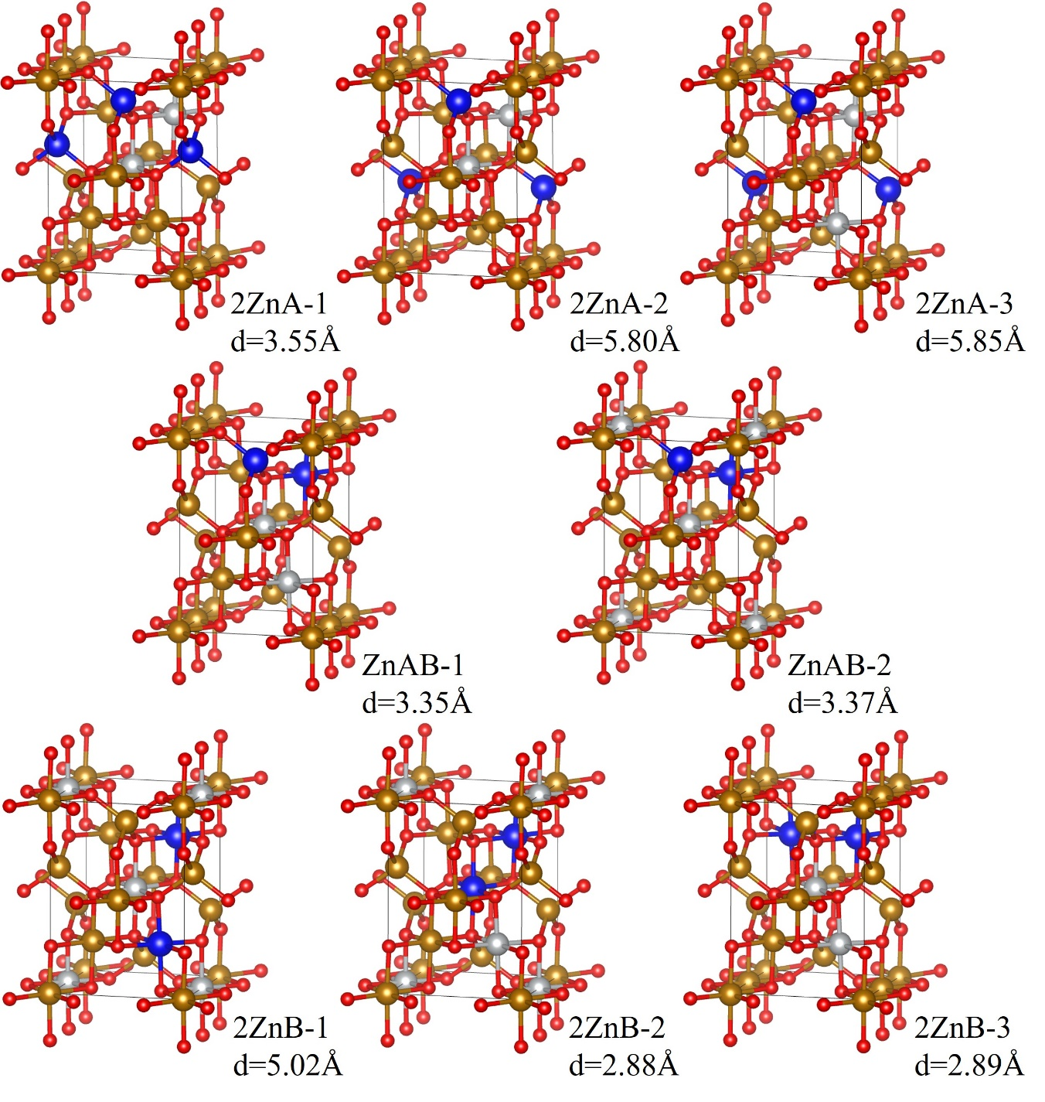
Figure C3 Structure of the different atomic distributions considered for ZNFO at x=0.50 under configurations ZnA, ZnB and ZnAB, indicating at each one the shortest Zn-Zn interatomic distance after relaxation. Zn, Ni, Fe and O atoms are represented respectively by blue, white, golden and red spheres.
It is known that the arrangement of Ni atoms does not have relevant consequences on the magnetism of NFO. Here, we have confirmed that, for each selected configuration (ZnA, ZnB or ZnAB), nor the local moments neither the net magnetization of the different structures in Figure C3 show any variation. In addition, both values of U(Znd) identify the same structure as the most stable for each configuration, allowing us to restrict our detailed study of the magnetic properties to three representative cases, namely, 2ZnA-3, 2ZnB-1 and ZnAB-1.
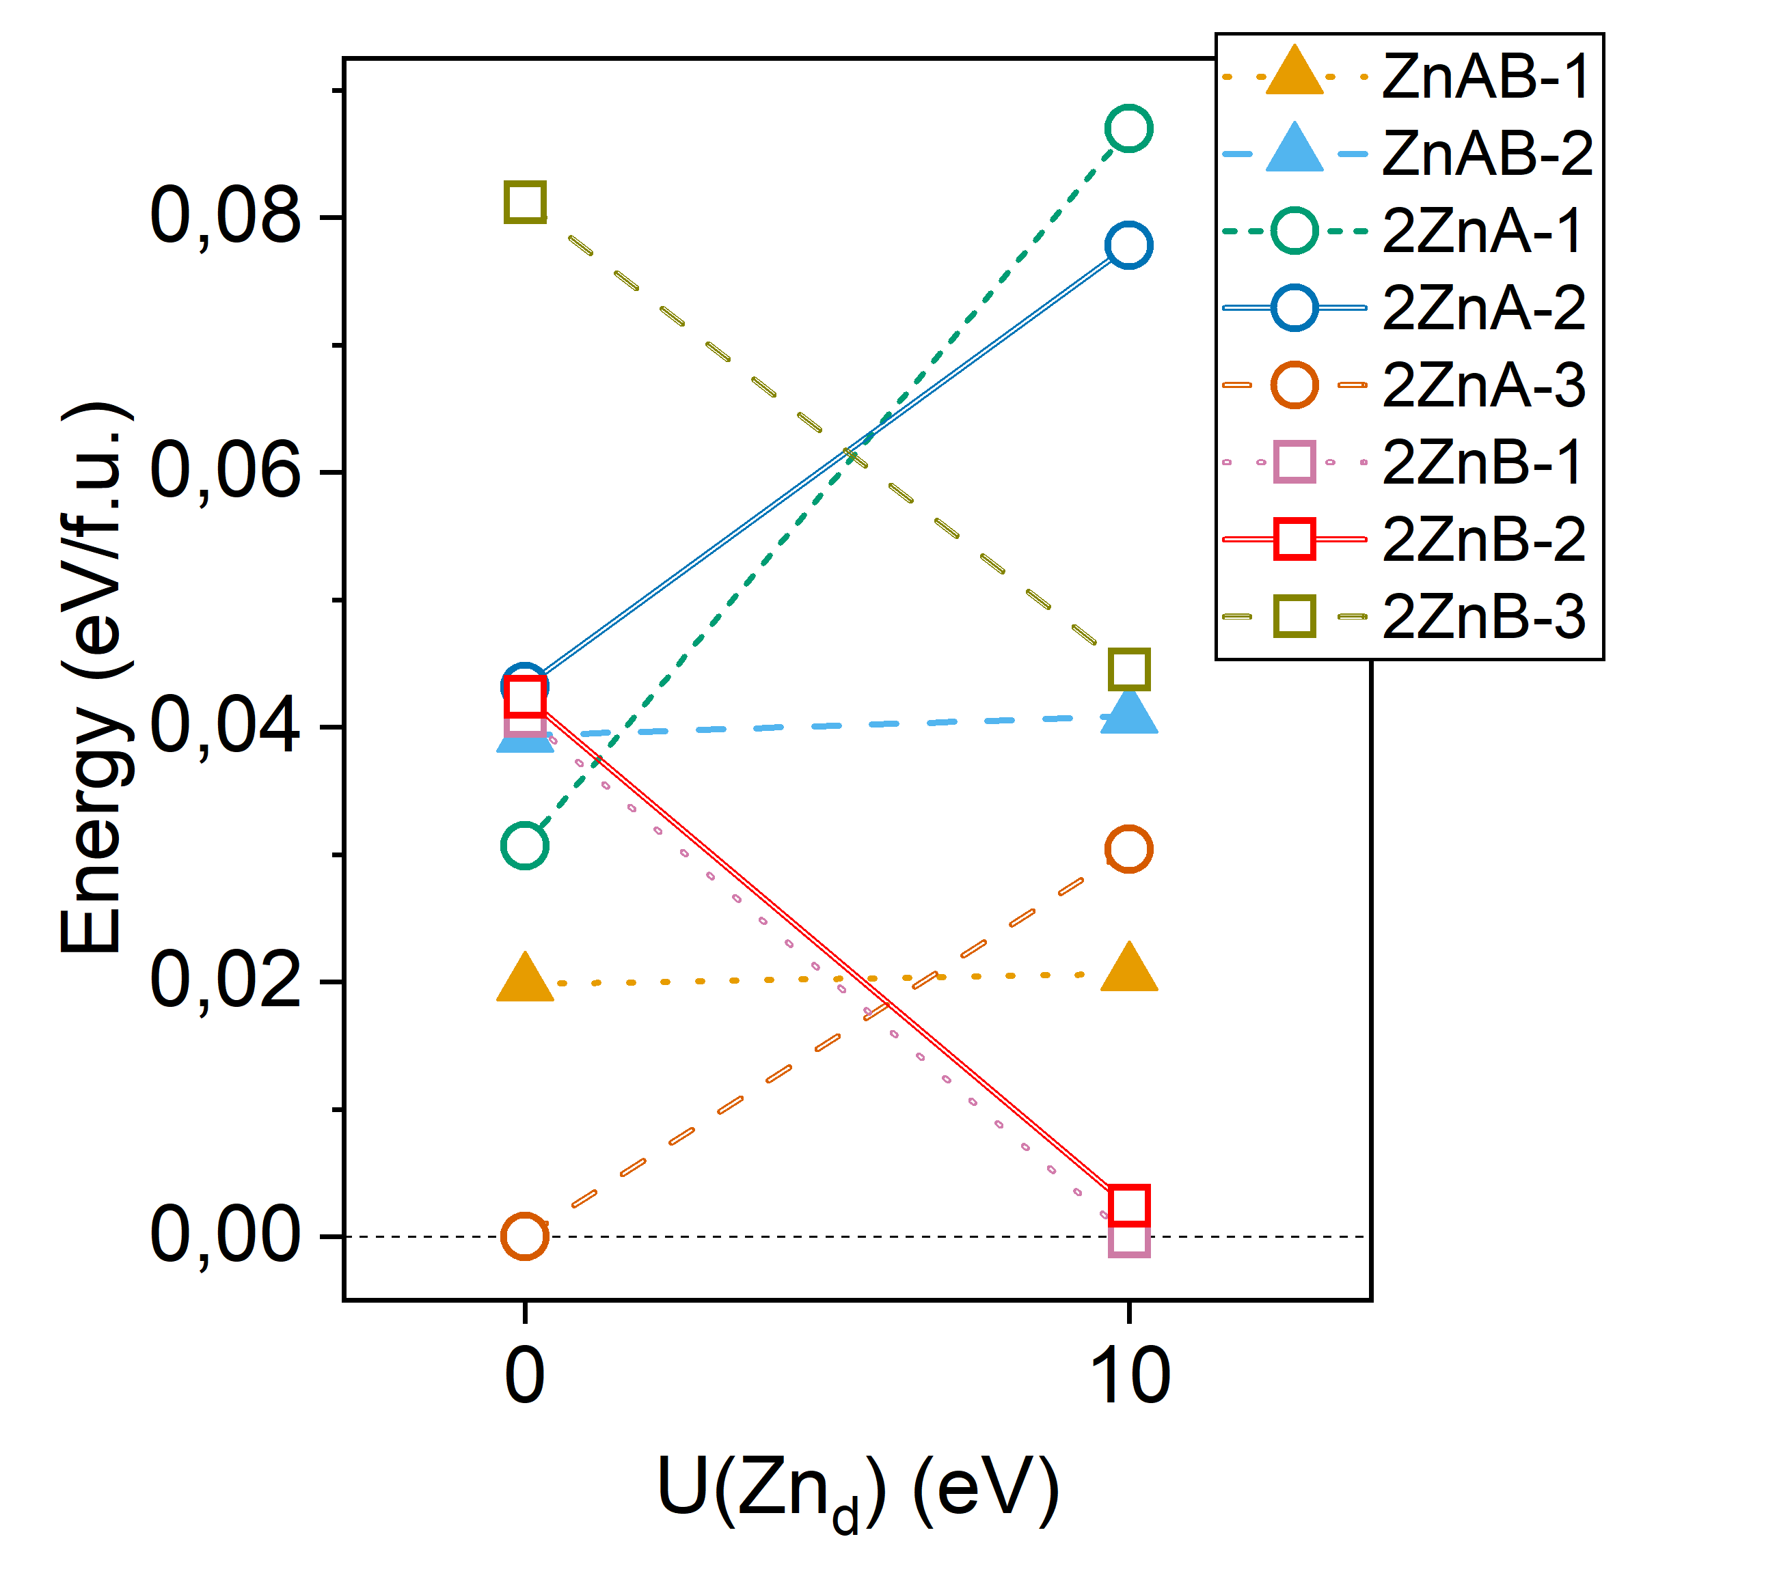
Figure C4 Total energy of relaxed ZNFO with x = 0.5 at the magnetic ground state c0 for the different Zn distributions shown in Figure C3. The energy zero at each U(Znd) has been set at the most stable structure. The line is a guide to the eye.

