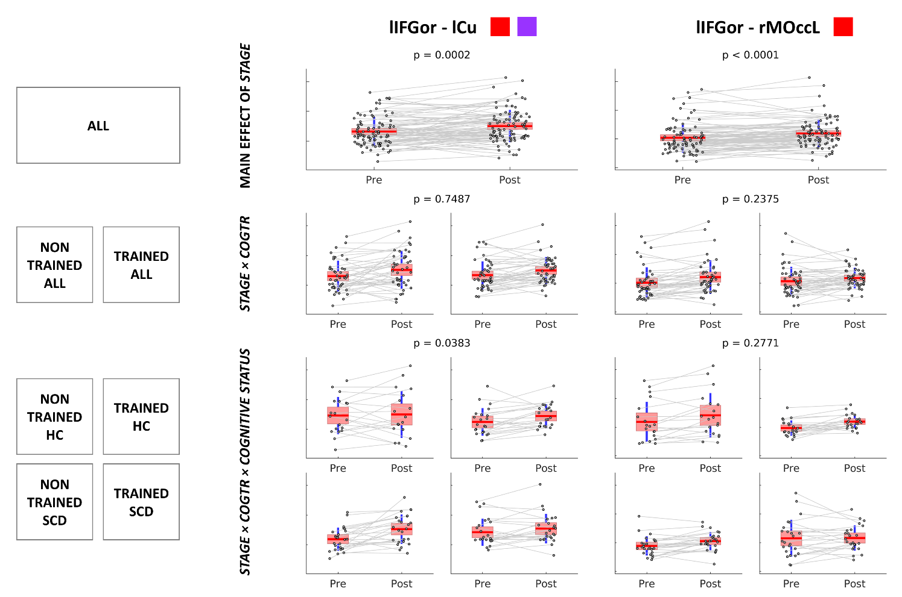
Additional Fig. 1 Boxplots. Boxplots of the FC values for each participant in the two MEG recordings for the connections where the main effect of stage, the double interaction effect between stage (pre-stage or post-stage) and CogTr (trained or non-trained), or the triple interaction effect between stage, CogTr, and cognitive status (HC or SCD) were significant (p < 0.05). For each connection, the upper panel represents the FC values in the pre-stage and the post-stage for the whole sample. The middle panel represents the FC values in the pre-stage and the post-stage separately for non-trained participants (left) and trained participants (right). The lower panel represents the FC value in the pre-stage and the post-stage separately for the non-trained HC group (upper row, left), non-trained SCD group (lower row, left), trained HC group (upper row, right), and trained SCD group (lower row, right). The boxplots inform of each participant’s FC values, the sample median, and the boundaries of the quartiles. The colored squares next to the abbreviated names of the connections emphasize the significant results for that connection: red (main effect of stage), green (double interaction between stage and CogTr), purple (triple interaction between stage, CogTr, and cognitive status).
