Table 2. Selected natural compounds properties and structure
SN | Plant Source | FoodDB/PUBCHEM ID | Compound | Class | Chemical formula | Molecular weigh | 2D structure
1 | Vegetable | FDB020228/42608105 | Agamanone | Flavonoid | C18H16O8 | 360.3148 | 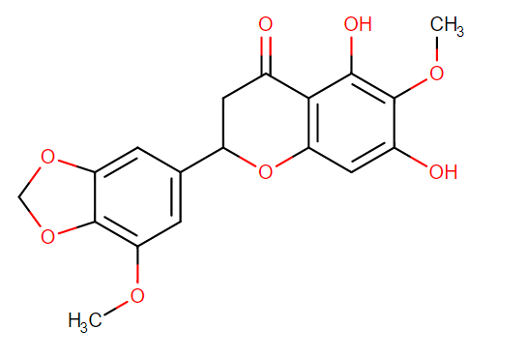
2 | Fruit/Vegetable/Tea | FDB002798/5280443 | Apigenin | Flavonoid | C15H10O5 | 270.2369 | 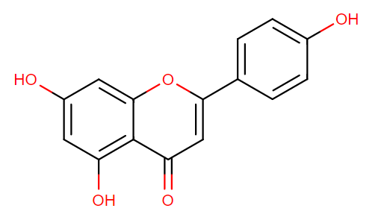
3 | Tea | FDB020039/70696494 | Blumeatin | Flavonoid | C16H14O6 | 302.2788 | 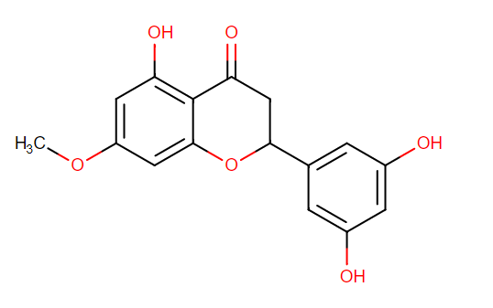
4 | Herb/Spice | FDB016641/325292 | Cadabicilone | Prenol lipids | C15H22O3 | 250.3334 | 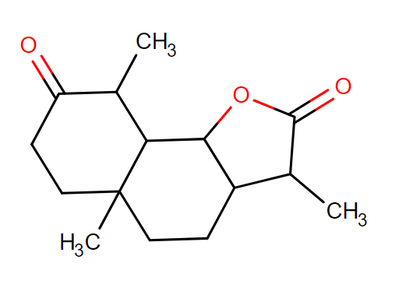
5 | Herb | FDB000638/86021565 | Cannithrene 2 | Phenanthrenes | C16H16O4 | 272.29 | 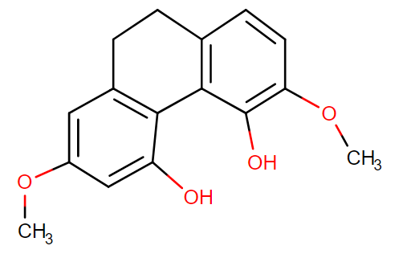
6 | Fruit | FDB016334/42608054 | Cerasinone | Flavonoid | C18H18O6 | 330.3319 | 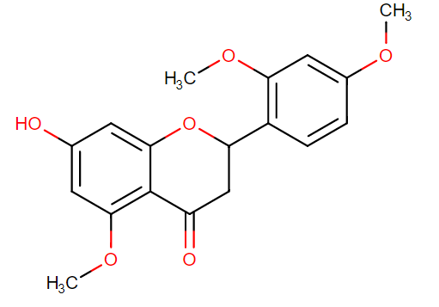
7 | Tea | FDB016700/160237 | Cirsiliol | Flavonoid | C17H14O7 | 330.2889 | 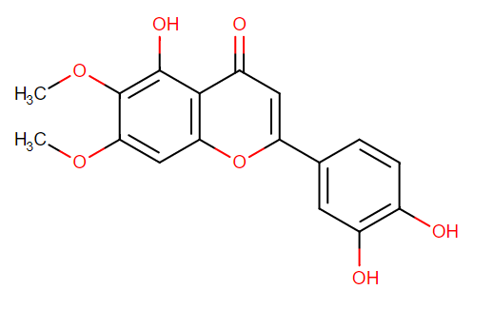
8 | Tea | FDB016702/162464 | Cirsilineol | Flavonoid | C18H16O7 | 344.3154 | 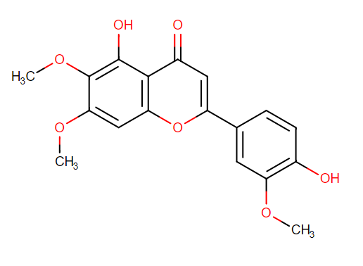
9 | Fruit/Spice/Bean | FDB002613/128853 | Delphinidin | Flavonoid | C15H11O7 | 303.2436 | 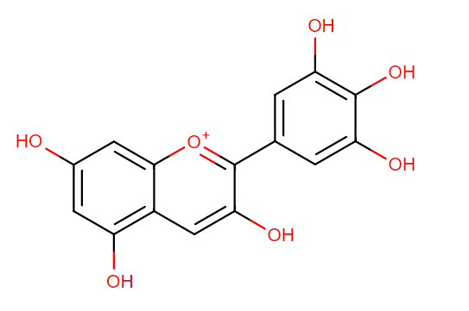
10 | Fruit | FDB000861/5281612 | Diosmetin | Flavonoid | C16H12O6 | 300.2629 | 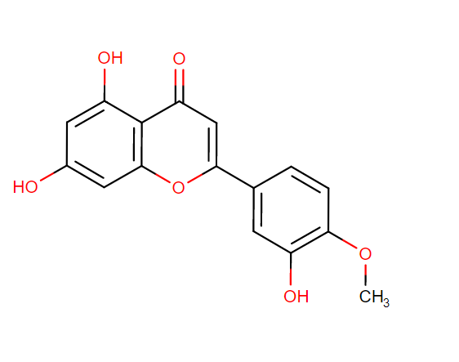
11 | Vegetable | FDB021096/91736606 | Edulisin III | Coumarin | C21H24O7 | 388.4111 | 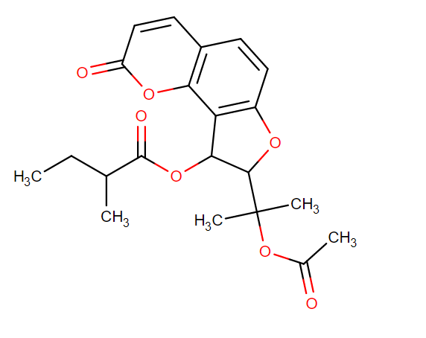
12 | Fruit | FDB001539/97214 | Eupatorin | Flavonoid | C18H16O7 | 344.3154 | 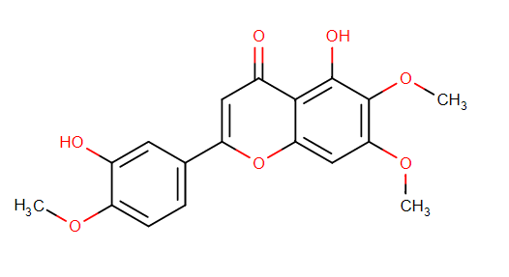
13 | Broad bean | FDB012022/5281618 | Geraldone | Flavonoid | C16H12O5 | 284.2635 | 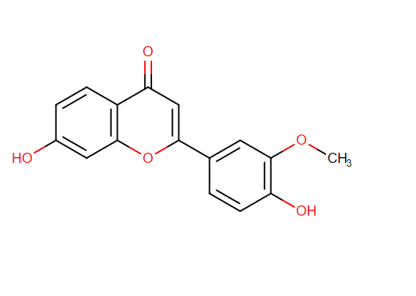
14 | fruit | FDB002677/72281 | Hesperetin | Flavonoid | C16H14O6 | 302.2788 | 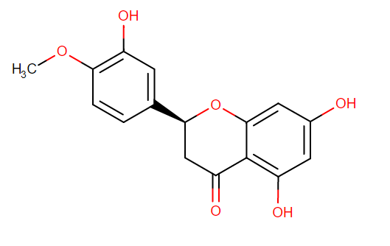
15 | Fruit | FDB016709/632135 | Isosinensetin | Flavonoid | C20H20O7 | 372.3686 | 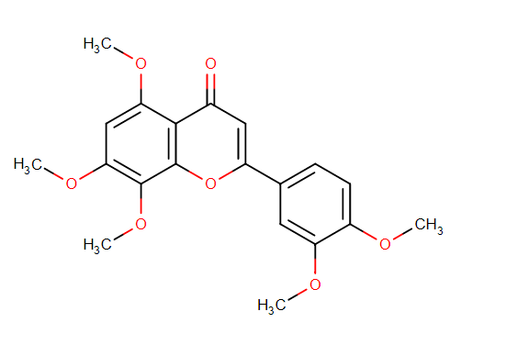
16 | Plant and herb | FDB013255/5280445 | Luteolin | Flavonoid | C15H10O6 | 286.2363 | 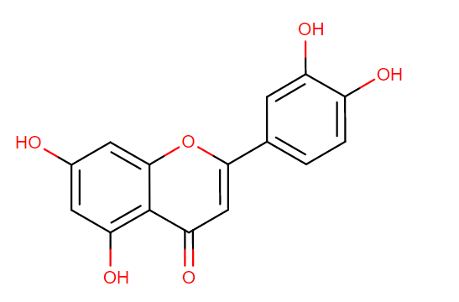
17 | Fruit | FDB020038/14539884 | Moracin P | 2-arylbenzofuran flavonoids | C19H18O5 | 326.3432 | 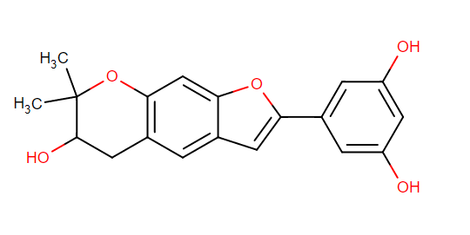
18 | Vegetable/Spice | FDB012724/5281672 | Myricetin | Flavonoid | C15H10O8 | 318.24 | 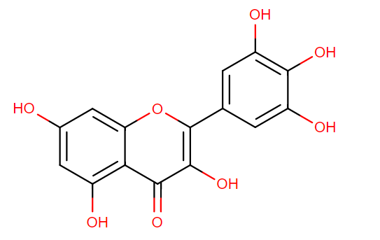
19 | Fruit | FDB016684/131752208 | Naringenin 5-rhamnoside | Flavonoid | C21H22O9 | 418.394 | 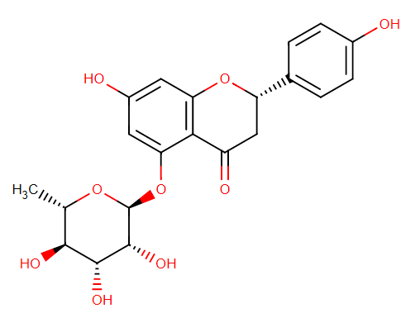
20 | Herb/Spice | FDB016562/22524411 | Neoliquiritin | Flavonoid | C21H22O9 | 418.394 | 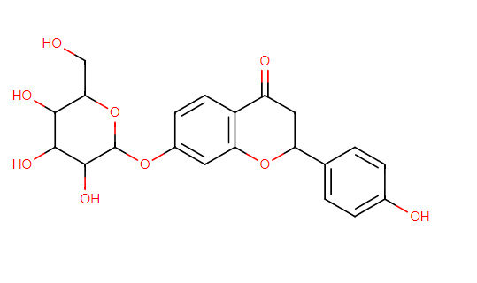
21 | Fruit | FDB019132/5372945 | N-(p-Hydroxyphenyl)ethyl p-hydroxycinnamide | Cinnamic acids | C17H17NO3 | 283.3218 | 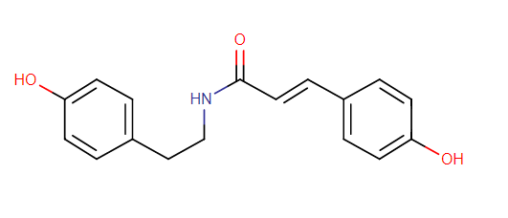
22 | Herb/Spice | FDB002744/5281678 | Patuletin | Flavonoid | C16H12O8 | 332.2617 | 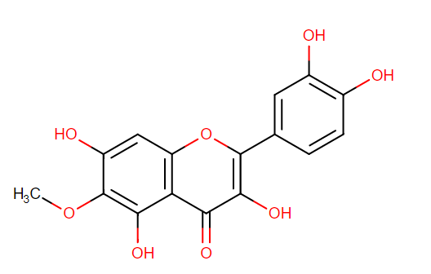
23 | Fruit | FDB016552/320054 | Persicogenin | Flavonoid | C17H16O6 | 316.3053 | 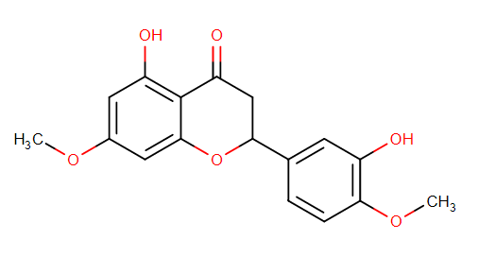
24 | Rice | FDB020930/10313699 | Phytocassane A | Prenol lipid | C20H28O3 | 316.4345 | 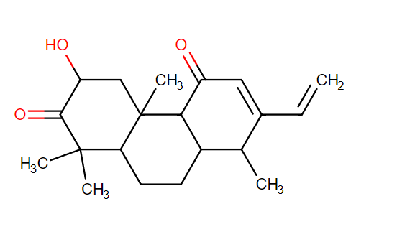
25 | Rice | FDB020929/10427023 | Phytocassane B | Prenol lipids | C20H30O4 | 334.4498 | 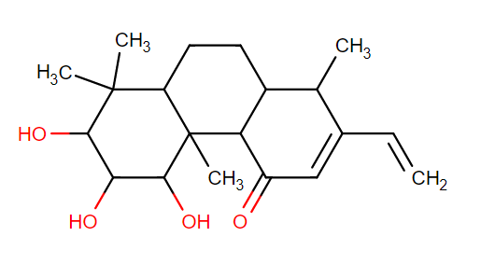
26 | Fruit | FDB020266/14841120 | Pinostrobin 5-glucoside | Flavonoid | C22H24O9 | 432.4206 | 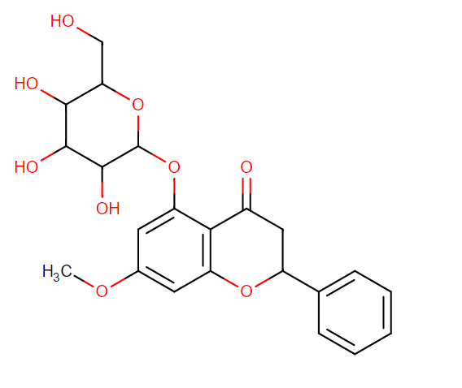
27 | Herb/Spice/Tea | FDB020421/131752876 | Pratenol A | Benzopyran | C14H12O5 | 260.2421 | 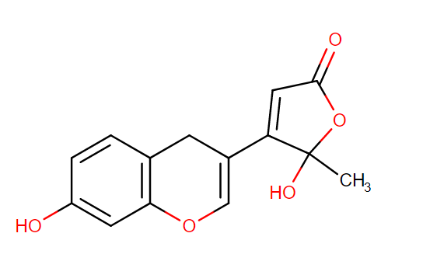
28 | Vegetable | FDB019048/119396 | Rheinanthrone | Anthracene | C15H10O5 | 270.2369 | 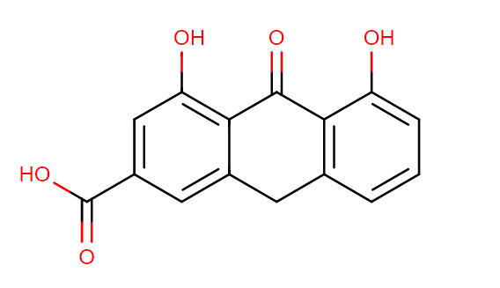
29 | Fruit | FDB005846/73607 | Sakuranin | Flavonoid | C22H24O10 | 448.42 | 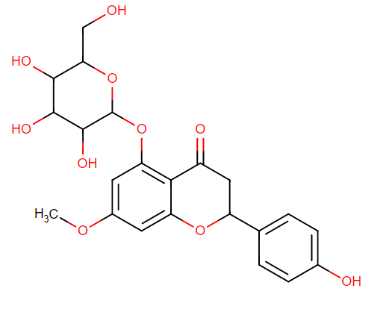
30 | Fruit | FDB015552/145659 | Sinensetin | Flavonoid | C20H20O7 | 372.3686 | 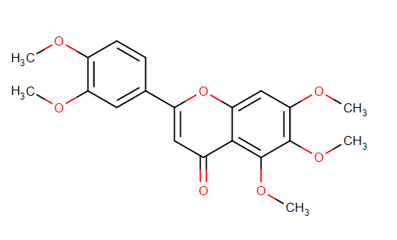
31 | Herb | FDB016383/5281699 | Tamarixetin | Flavonoid | C16H12O7 | 316.2623 | 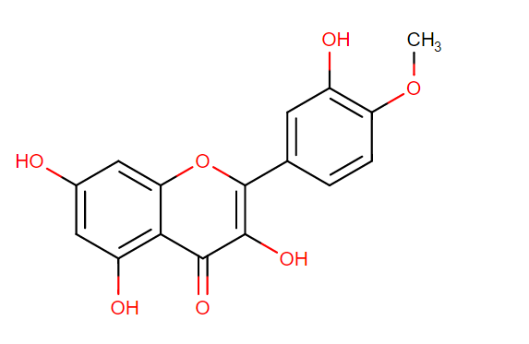
32 | Rice | FDB002440/5281702 | Tricin | Flavonoid | C17H14O7 | 330.2889 | 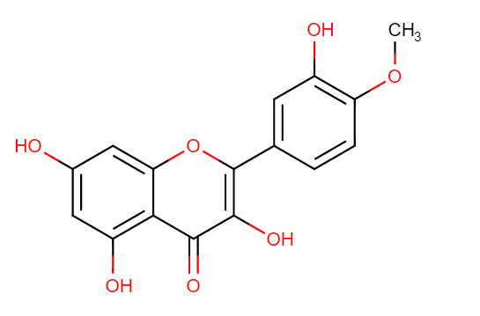
33 | Tea | FDB011738/332208 | 3',4',5'-Trimethoxyflavone | Flavonoid | C18H16O5 | 312.3166 | 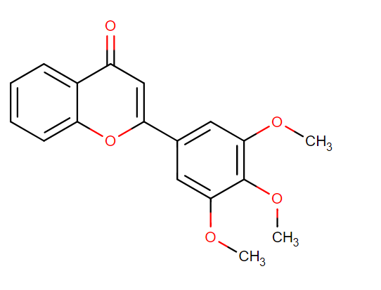
34 | Fruit | FDB020315/131752850 | 4'-Methylliquiritigenin 7-rhamnoside | Flavonoid | C22H24O8 | 416.4212 | 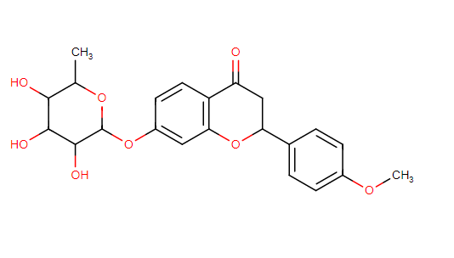
35 | Standard Drug | 68210102 | GSK126 |  | C31H38N6O2 | 526.67 | 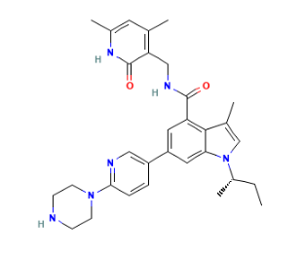
36 | Standard Drug | 39042 | Bezafibrate |  | C19H20ClNO4 | 361.82 | 