Running title: Water exchange rate and interspecies competition

RESEARCH ARTICLE
Effect of water exchange rate on interspecies competition between submerged macrophytes: Functional trait hierarchy drives competition

Ying Pan^{1†}, Duanyang Yuan^{1†}, Qihang Wu¹, Lin Jin¹, Mingli Xie¹,
Yang Gu¹, Changqun Duan^{1*}

¹ School of Ecology and Environmental Sciences & Yunnan Key Laboratory for Plateau Mountain Ecology and Restoration of Degraded Environments, Yunnan University, Kunming, Yunnan, 650091, China;

†Both authors contributed equally to this work

*Corresponding author: E-mail: chqduan@ynu.edu.cn (Changqun Duan);
Tel: +86 871 65033547; fax: +86 871 65033547

Figure S1 Illustration showing the experimental design for a given water-exchange model. White circles in the rectangles represent Vallisneria natans; Black dots in the rectangles represent Myriophyllum species.

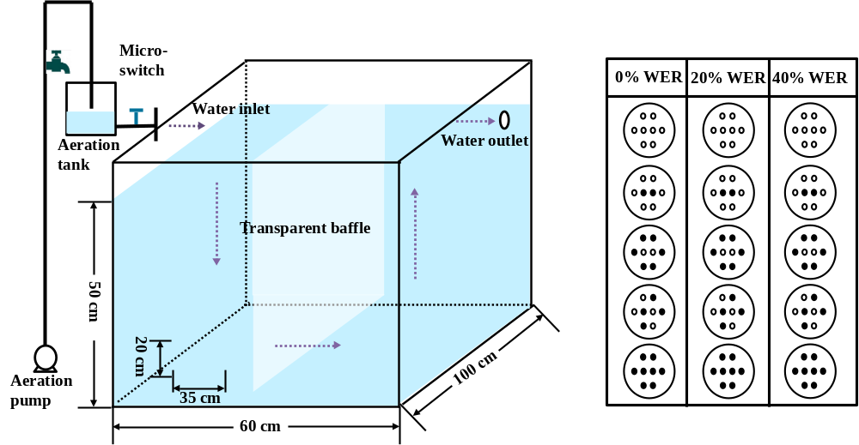
Figure S2 Relationships between water dissolved carbon dioxide in daytime with biomass accumulation and plant height under three levels of water exchange rates and five combination modes in two competing systems, determined by regression analysis.

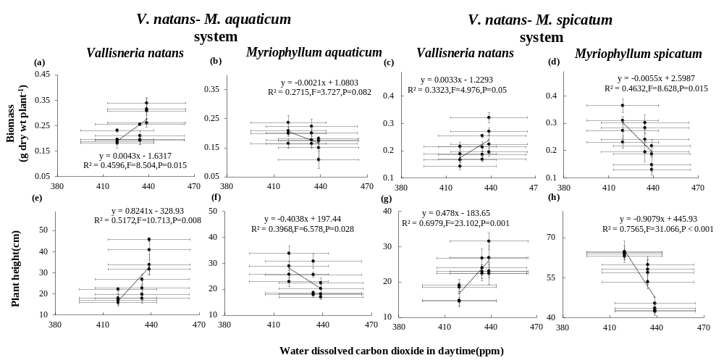

Figure S3 Relationships between water dissolved carbon dioxide in nighttime with biomass accumulation and plant height under three levels of water exchange rates and five combination modes in two competing systems, determined by regression analysis.

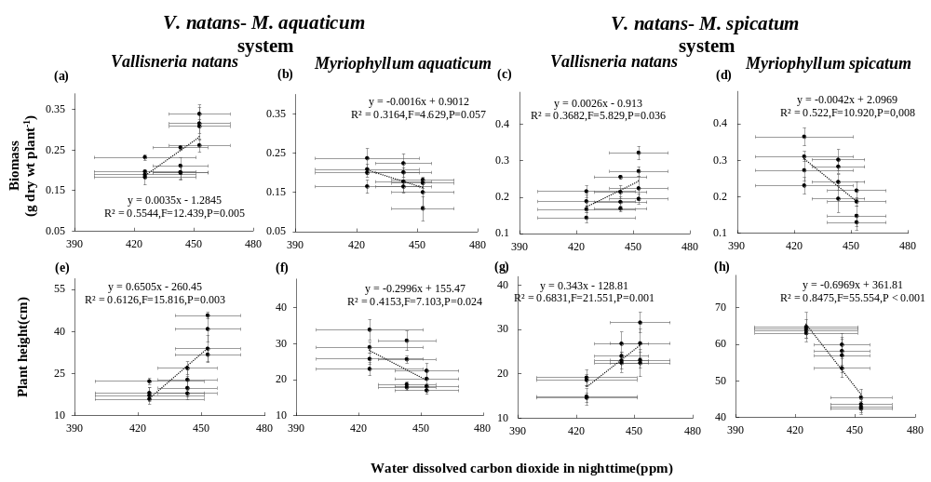
Figure S4 Relationships between water dissolved carbon dioxide in daytime with specific root length, below: above-ground biomass, root length, root diameter and branches per plant mass of Vallisneria natans under three levels of water exchange rates and five combination modes in two competing systems, determined by regression analysis.

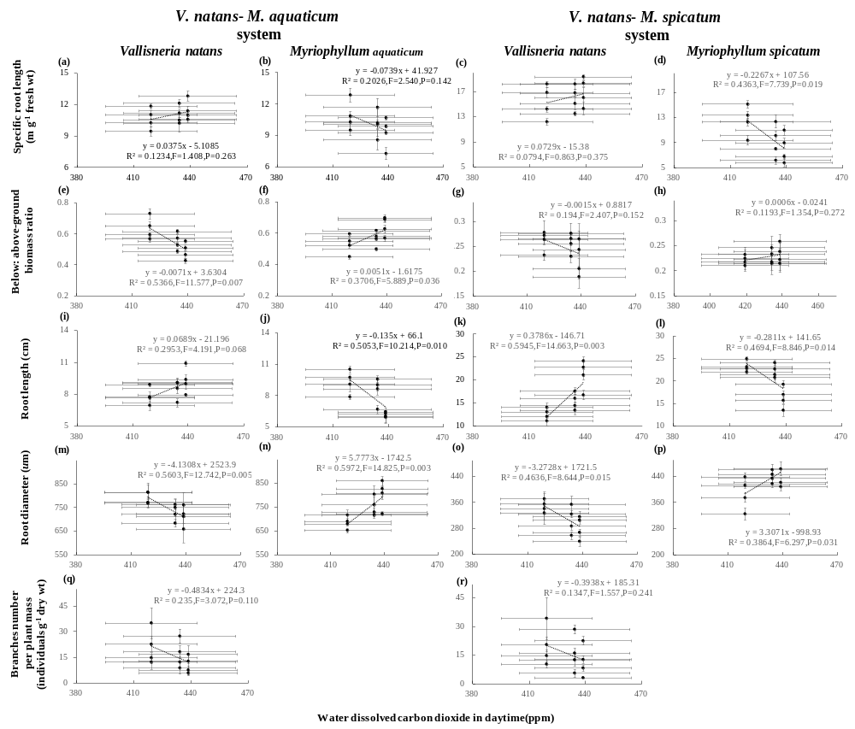

Figure S5 Relationships between water dissolved carbon dioxide in nighttime with specific root length, below: above-ground biomass, root length, root diameter and branches per plant mass of Vallisneria natans under three levels of water exchange rates and five combination modes in two competing systems, determined by regression analysis.

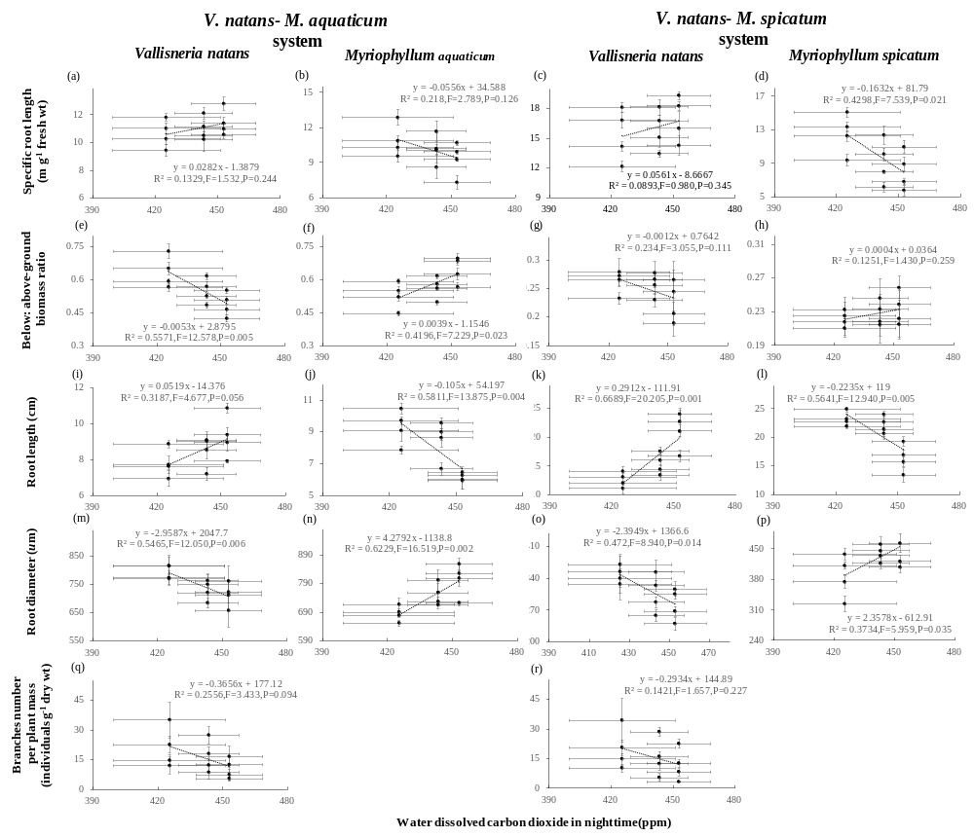
Figure S6 Relationships between plant height, specific root length, below: above-ground biomass, root length, and root diameter with plant biomass accumulation under three levels of water exchange rates and five combination modes in two competing systems, determined by regression analysis.

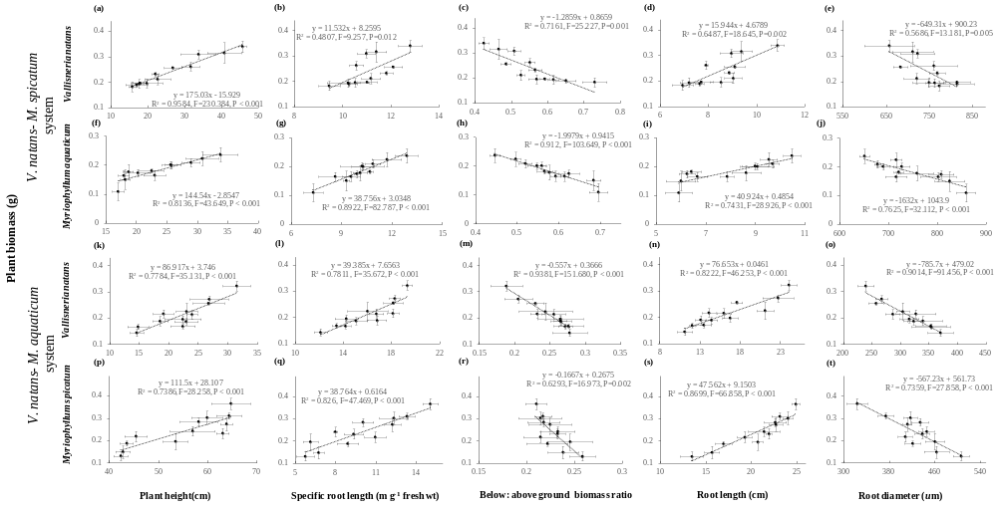
Figure S7 Variations (mean ± 1 SD, n = 12) in plant C: N ratio (a-d), plant C: P (e-g) and plant N: P ratio (i-l) under three levels of water exchange rates and five types of Planting proportion. Different letters indicate significant differences among treatments. Multiple comparisons of means were performed using the Tukey test at the 0.05 significance level.
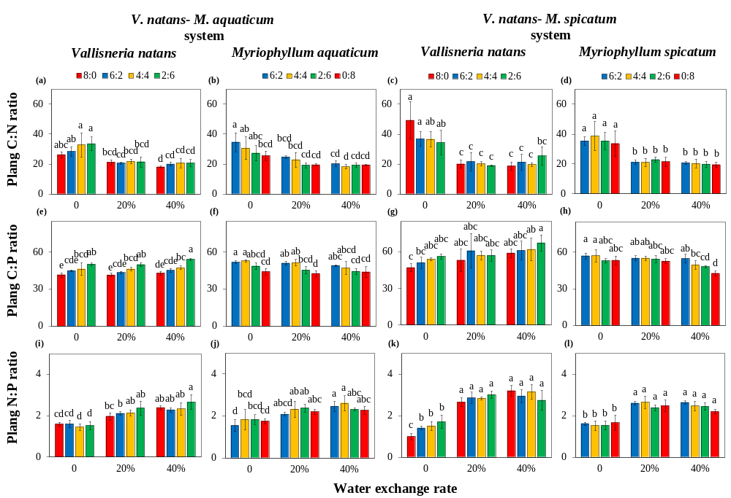

Figure S8 Relationships between plant height, specific root length, below: above-ground biomass, root length, and root diameter with plant carbon concentration under three levels of water exchange rates and five combination modes in two competing systems, determined by regression analysis.

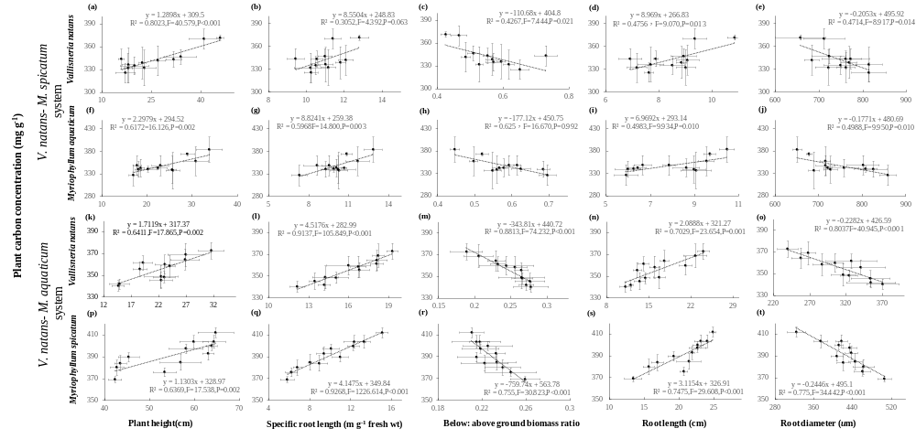
Figure S9 Relationships between plant height, specific root length, below: above-ground biomass, root length, and root diameter with plant nitrogen concentration under three levels of water exchange rates and five combination modes in two competing systems, determined by regression analysis.

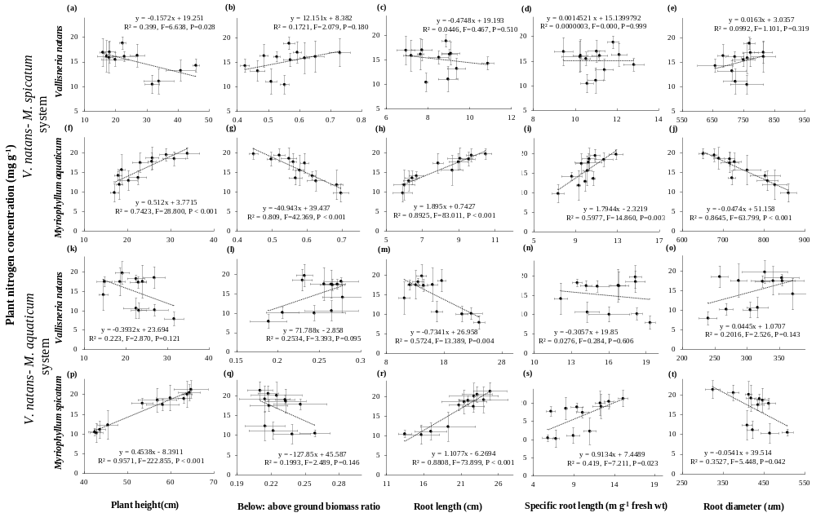
Figure S10 Relationships between plant height, specific root length, below: above-ground biomass, root length, and root diameter with plant phosphorus concentration under three levels of water exchange rates and five combination modes in two competing systems, determined by regression analysis.
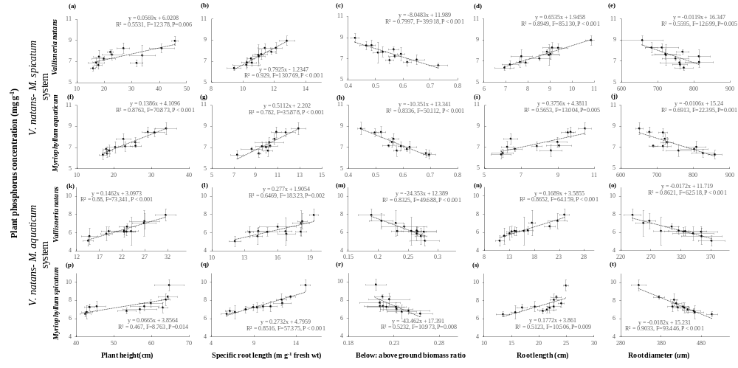
Figure S11 Relationships between plant biomass, plant height of co-cultured Vallisneria natans and Myriophyllum species, and branches per plant mass of V. natans with total relative yield in each competing system under three levels of water exchange rates and five combination modes in two competing systems, determined by regression analysis.

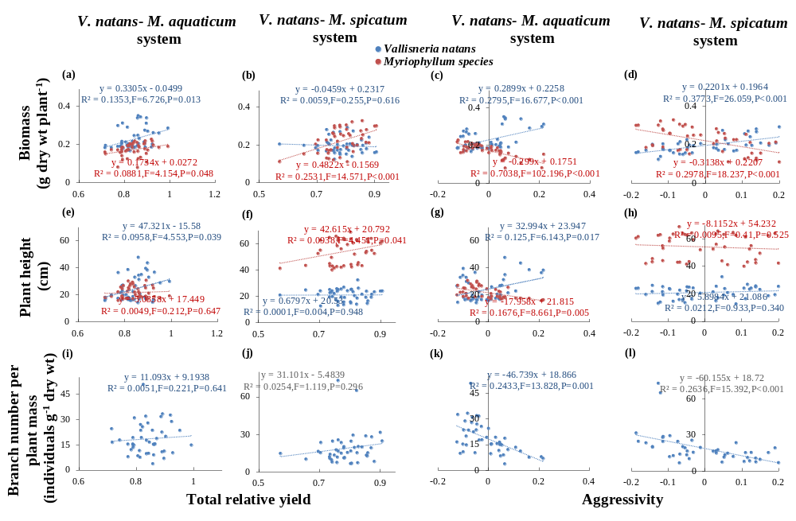
Figure S12 Relationships between below: above-ground biomass ratio, root length, specific root length, and root diameter of co-cultured Vallisneria natans and Myriophyllum species with total relative yield and aggressivity, in each competing system under three levels of water exchange rates and five combination modes in two competing systems, determined by regression analysis.

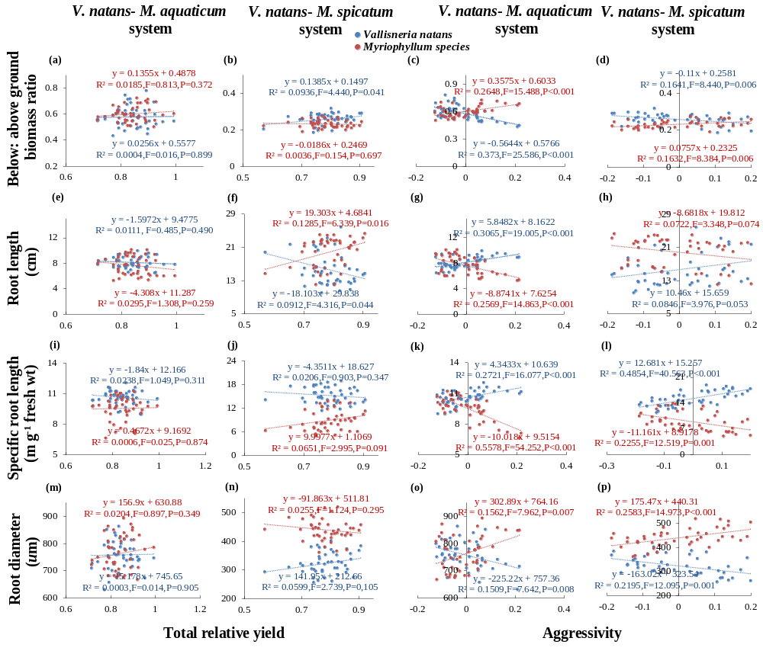
Figure S13 Relationships between plant carbon concentration, plant nitrogen concentration, and plant phosphorus concentration of co-cultured Vallisneria natans and Myriophyllum species with total relative yield and aggressivity in each competing system under three levels of water exchange rates and five combination modes in two competing systems, determined by regression analysis.

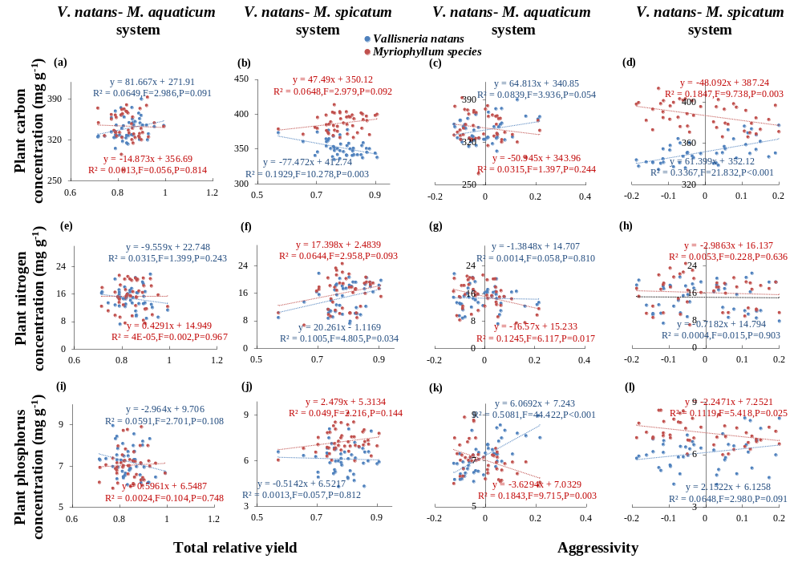
Figure S14 Relationships between plant C: N ratio, plant C: P ratio, and plant N: P ratio of co-cultured Vallisneria natans and Myriophyllum species with total relative yield and aggressivity in each competing system under three levels of water exchange rates and five combination modes in two competing systems, determined by regression analysis.

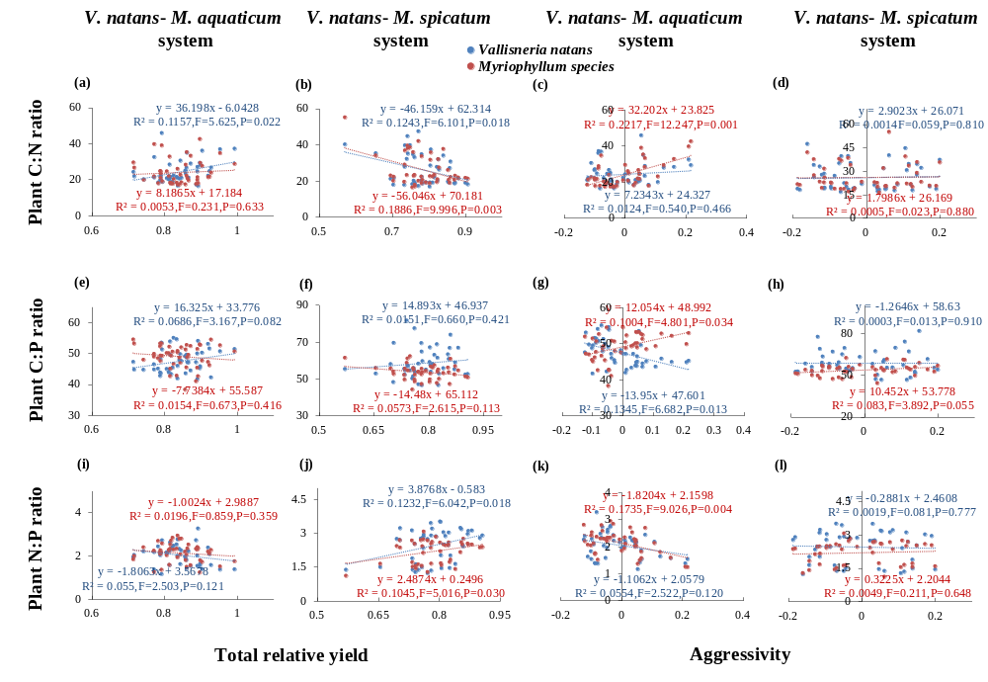

Table S1 Variations (means ± 1 s.d., n = 3) in dissolve oxygen (DO) concentration and dissolved carbon dioxide (DCD) concentration of the incoming water and chamber volume in treatments with different water-exchange rate (WER) during the 3-days-long experiment. Different letters indicate significant differences among treatments. Multiple comparisons of means were performed using the Tukey test at P = 0.05, following one-way ANOVAs.

 | WER | n | DO |  |  | DCD
 | WER | n | incoming water | chamber volume |  | incoming water | chamber volume
Day1 | 0 | 3 | - | 6.96±0.01a |  | - | 386.33±8.5a
Day1 | 20% | 3 | 7.05±0.02a | 6.46±0.03b |  | 316.00±0b | 405.33±9.29a
Day1 | 40% | 3 | 7.00±0.01a | 6.89±0.01b |  | 336.00±5.29b | 447.33±4.04a
Day2 | 0 | 3 | - | 7.42±0.01a |  | - | 370.00±6.56a
Day2 | 20% | 3 | 7.35±0.02a | 7.03±0.01b |  | 586.33±4.62b | 644.67±2.31a
Day2 | 40% | 3 | 7.30±0.01a | 7.07±0.01b |  | 409.00±16b | 586.00±3.61a
Day3 | 0 | 3 | - | 7.79±0.03a |  | - | 506.33±9.87a
Day3 | 20% | 3 | 7.49±0.02a | 6.92±0.05b |  | 444.33±3.51a | 564.67±8.39a
Day3 | 40% | 3 | 7.32±0.01a | 7.04±0.02b |  | 531.00±0b | 692.00±2.65a

Table S2 Results of the one-way repeated ANOVA (F and p values) showing the effects of water exchange rate (WER) on dissolved oxygen (DO) concentration and dissolved carbon dioxide (DCD) concentration in both daytime and nighttime during the 15-day-long experiment without ramets.

 | Time(T) | df | WER(W) | df | T × W | df
DO in daytime | 57.550*** | 7 | 716.961*** | 2 | 28.649*** | 14
DO in nighttime | 81.766*** | 7 | 857.425*** | 2 | 11.126*** | 14
DCD in daytime | 212.722*** | 7 | 30.200*** | 2 | 9.249*** | 14
DCD in nighttime | 56.909*** | 7 | 191.927*** | 2 | 9.231*** | 14
* P < 0.05; ** P < 0.01; *** P < 0.001

Table S3 Summary of the two-way ANOVAs determining effects of water exchange rate (WER) and combination mode (CM) on plant biomass, plant length, below: above-ground biomass ratio (B: A biomass ratio), root length, specific root length (SRL), root diameter, branch number per plant biomass of V. natans in V. natans- M. aquaticum system.

 |  | Biomass  (g plant⁻¹) | Plant height (cm) | B:A biomass  ratio | Root length (cm) | SRL  (m g⁻¹ fresh wt) | Root diameter (um) | branch number per plant biomass  (individual g⁻¹ dry mass)
V. natans
 | WER (W; df=2) | 71.791*** | 215.019*** | 264.342*** | 79.724*** | 16.800*** | 25.785*** | 28.795***
 | CM（C; df=3） | 10.806*** | 29.476*** | 134.694*** | 94.120*** | 67.074*** | 9.022*** | 47.054***
 | W x C | 1.111 | 0.416 | 0.539 | 5.431*** | 0.988 | 2.215 | 1.982
M. aquaticum
 | WER (W; df=2) | 22.303*** | 121.137*** | 262.751*** | 250.979*** | 36.868*** | 151.028***
 | CM（C; df=3） | 20.994*** | 98.190*** | 178.583*** | 51.860*** | 78.582*** | 50.761***
 | W x C | 0.521 | 6.462*** | 2.484* | 7.946*** | 2.084 | 4.247**
* P < 0.05; ** P < 0.01; *** P < 0.001

Table S4 Summary of the two-way ANOVAs determining effects of water exchange rate (WER) and combination mode (CM) on plant biomass, plant length, below: above-ground biomass ratio (B: A biomass ratio), root length, specific root length (SRL), root diameter, branch number per plant biomass of V. natans in V. natans- M. spicatum system.

 |  | Biomass  (g dyr wt plant⁻¹) | Plant height (cm) | B:A biomass  ratio | Root length (cm) | SRL  (m g⁻¹ fresh wt) | Root diameter (um) | branch number per plant biomass  (individual g⁻¹ dry mass)
V. natans
 | WER (W; df=2) | 104.337*** | 105.138*** | 17.279*** | 396.161*** | 22.681*** | 45.825*** | 21.752***
 | CM（C; df=3） | 93.950*** | 25.986*** | 20.432*** | 65.952*** | 129.977*** | 30.943*** | 84.310***
 | W x C | 3.142* | 2.153 | 1.340 | 6.062*** | 0.972 | 1.613 | 0.516
M. spicatum
 | WER（W; df=2） | 136.027*** | 293.090*** | 2.473 | 311.189*** | 228.807*** | 104.061***
 | CM（C; df=3） | 56.941*** | 4.935** | 10.412*** | 49.392*** | 192.610*** | 93.706***
 | W x C | 1.157 | 0.846 | 0.460 | 2.583* | 2.246 | 7.774***
* P < 0.05; ** P < 0.01; *** P < 0.001

Table S5 Summary of the Two-way ANOVAs determining effects of water exchange rate (WER) and combination mode on plant C, plant N, plant P, plant C: N ratio, plant C: P ratio and plant N: P ratio in the competing V. natans - M. aquaticum system.

Species |  | WER  (W; df=2) | CM  （C; df=3） | W × C
V. natans | TC | 12.850*** | 2.529 | 1.622
V. natans | TN | 27.056*** | 3.271* | 0.735
V. natans | TP | 12.746*** | 35.930*** | 0.412
V. natans | C:N | 55.546*** | 3.626* | 1.275
V. natans | C:P | 6.346** | 60.606*** | 1.065
V. natans | N:P | 111.691*** | 2.586 | 1.888
M. aquaticum | TC | 4.971* | 2.721 | 1.300
M. aquaticum | TN | 40.325*** | 6.121** | 0.222
M. aquaticum | TP | 14.827*** | 45.492*** | 0.940
M. aquaticum | C:N | 40.011*** | 5.480** | 1.409
M. aquaticum | C:P | 6.551** | 22.629*** | 1.248
M. aquaticum | N:P | 36.818*** | 2.300 | 1.081
* P < 0.05; ** P < 0.01; *** P < 0.001

Table S6 Summary of the Two-way ANOVAs determining effects of water exchange rate (WER) and combination mode (CM) on plant C, plant N, plant P, plant C: N ratio, plant C: P ratio and plant N: P ratio in the competing V. natans- M. spicatum system.

Species |  | WER  (W; df=2) | CM  （C; df=3） | W × C
V. natans | TC | 13.291*** | 22.497*** | 0.404
V. natans | TN | 58.768*** | 0.416 | 2.323*
V. natans | TP | 13.038*** | 6.198** | 0.510
V. natans | C:N | 85.356*** | 0.395 | 3.260**
V. natans | C:P | 11.191*** | 2.852* | 0.622
V. natans | N:P | 218.773*** | 2.098 | 4.437*
M. spicatum | TC | 78.313*** | 47.129*** | 1.493
M. spicatum | TN | 79.891*** | 1.540 | 0.246
M. spicatum | TP | 45.548*** | 21.842*** | 3.276**
M. spicatum | C:N | 70.866*** | 0.405 | 0.455
M. spicatum | C:P | 28.018*** | 12.352*** | 3.109*
M. spicatum | N:P | 120.301*** | 2.267 | 1.736
* P < 0.05; ** P < 0.01; *** P < 0.001

Table S7 Summary of the three-way ANOVAs determining effects of water exchange rate (WER), combination mode (CM) and competing system on relative yield (RY), total relative yield (RY_{T}) and aggressivity (Av).

 | WER  （W; df=2） | CM  （C; df=3） | Competing system  （CS; df=1） | W × C | W × CS | C × CS | W × C × CS
RY_{V} | 1.50 | 1806.97*** | 8.37** | 1.36 | 9.21*** | 2.42 | 1.05
RY_{M} | 1.17 | 1012.85*** | 7.71** | 1.30 | 2.79 | 0.61 | 1.428
RY_{T} | 0.108 | 13.46*** | 13.35*** | 0.89 | 6.32** | 1.73 | 0.58
Av | 2.87 | 115.45*** | 0.01 | 2.15 | 2.89 | 4.20* | 1.24
* P < 0.05; ** P < 0.01; *** P < 0.001

Table S8 Summary of the two-way ANOVAs determining effects of water exchange rate (WER) and combination mode (CM) on relative yield (RY), total relative yield (RYT) and aggressivity (Av) in these two competing systems.

 |  | RY_{V} | RY_{M} | RY_{T} | Av
V. natans -M. aquaticum system | WER  (W; df=2) | 15.152*** | 0.156 | 2.656 | 4.142*
 | CM  （C; df=3） | 1613.363*** | 412.294*** | 5.419** | 46.2085***
 | W x C | 3.807* | 1.447 | 0.263 | 3.751*
V. natans - M. spicatum system | WER  (W; df=2) | 1.875 | 4.950* | 4.032* | 1.977
 | CM  （C; df=3） | 652.698*** | 660.811*** | 10.790*** | 69.643***
 | W x C | 0.282 | 1.222 | 1.429 | 0.210
* P < 0.05; ** P < 0.01; *** P < 0.001

