Table S1 Comparison of effects of eight types of cryopreservation conditions (Table 2) on viabilities of Astrephomene gubernaculifera strain NIES-4017 (AG) and A. perforata strain NIES-564 (AP) without freezing and thawing, based on most probable number (MPN) methods
Conditions |  |  |  |  | MPN cell numbers in three cryotubes (/mL) (control)
Species/strain | Maturity of colonies/cells | Cryo-protectant |  | Total viability (range) % | MPN cell numbers in three cryotubes (/mL) (control)
AG | Immature | 3% | DMF | 77±75  (23-160) | 21000, 42000, 150000 (92000)
AG | Immature | 6% | DMF | 39±12  (25-46) | 23000, 42000, 42000 (92000)
AG | Immature | 3% | HA | 39±12  (25-46) | 23000, 42000, 42000 (92000)
AG | Immature | 6% | HA | 0.013±0.0072  (0.0067-0.021) | 6.2, 9.4, 19 (92000)
AG | Mature | 3% | DMF | 300±180  (180-500) | 7400, 9200, 21000 (4200)
AG | Mature | 6% | DMF | 140±69  (100-220) | 4200, 4200, 9200 (4200)
AG | Mature | 3% | HA | 210±150  (55-360) | 2300, 9200, 15000 (4200)
AG | Mature | 6% | HA | 0.071±0  (0.071-0.071) | 3, 3, 3 (4200)
AP | Immature | 3% | DMF | 74±45  (22-100) | 9200, 42000, 42000 (42000)
AP | Immature | 6% | DMF | 99±110  (22-220) | 9200, 23000, 92000 (42000)
AP | Immature | 3% | HA | 82±24  (55-110) | 23000, 38000, 42000, (42000)
AP | Immature | 6% | HA | 0±0  (0-0) | 0, 0, 0 (42000)
AP | Mature | 3% | DMF | 260±230  (22-500) | 2300, 9200, 21000 (4200)
AP | Mature | 6% | DMF | 120±85  (55-220) | 2300, 4200, 9200 (4200)
AP | Mature | 3% | HA | 57±40  (22-100) | 920, 2100, 4200 (4200)
AP | Mature | 6% | HA | 0±0  (0-0) | 0, 0, 0 (4200)

Fig. S1. Diagrammatic representation of the evolution of Astrephomene within the volvocine green algae, showing convergent evolution of germ-soma differentiation in spheroidal bodies.
The phylogeny is based on previous studies [1,2].

References
- Lindsey CR, Rosenzweig F, Herron MD. Phylotranscriptomics points to multiple independent origins of multicellularity and cellular differentiation in the volvocine algae. BMC Biol. 2012;19:182. doi:org/10.1186/s12915-021-01087-0.
- Yamashita S, Arakaki Y, Kawai-Toyooka H, Noga A, Hirono M, Nozaki H. Alternative evolution of a spheroidal colony in volvocine algae: developmental analysis of embryogenesis in Astrephomene (Volvocales, Chlorophyta). BMC Evol Biol. 2016;16:243. doi: 10.1186/s12862-016-0794-x.

Fig. S2. Comparison of autotrophic (left, mVT medium) and photoheterotrophic (right, mVTAC medium) growth in six-day-old cultures of four multicellular volvocine species (Astrephomene gubernaculifera strain NIES-4017, Volvulina steinii strain NIES-4471, Gonium pectorale strain NIES-2863 and Eudorina sp. strain NIES-3984), based on the quantitative measurement (Additional file 2: Text S1, Table S2).
Data are represented as mean cell number (± SE, n = 3).

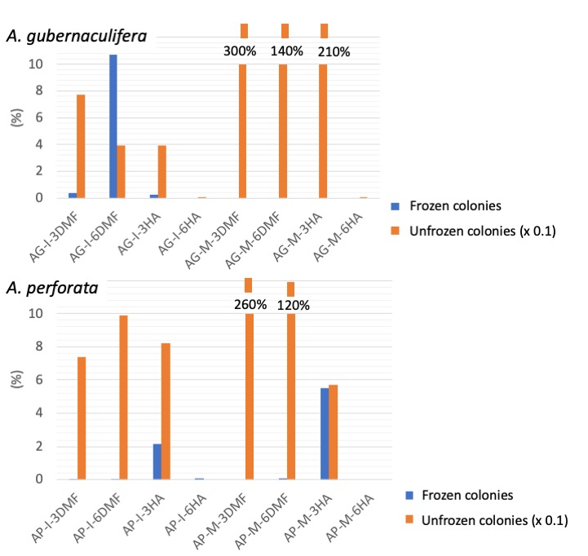
Fig. S3. Comparison of mean rates of MPN survivability between two species of Astrephomene under 16 different conditions (Table 2; Additional file 1: Table S1).
AG: A. gubernaculifera strain NIES-4017. AP: A. peforata strain NIES-564. I: immature colonies (Fig. 2A, C) in asexual life cycle (Fig. 1A). M: mature colonies (Fig. 2B, D) in asexual life cycle (Fig. 1A). 3(6)DMP: 3(6)% N,N-dimethylformamide. 3(6)HA: 3(6)% hydroxyacetone.

