Supplementary Information

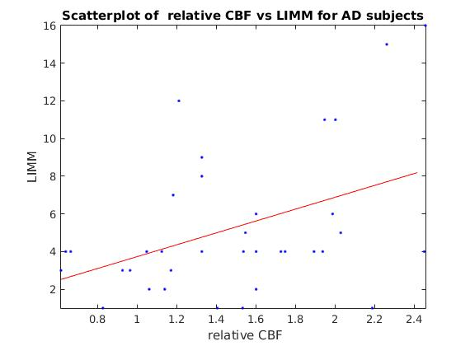 | 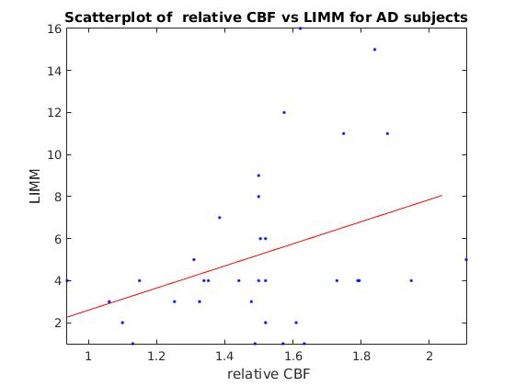

Figure S1: Scatter plots for the correlation of rCBF with LIMM on 2D PASL. Left: Scatter plot of rCBF on Angular Gyri with LIMM (r = 0.51, p-value = 0.003) for AD subjects. Right: Scatter plot of rCBF on Compositive MetaROI with LIMM (r = 0.45, p-value = 0.009) for AD subjects.
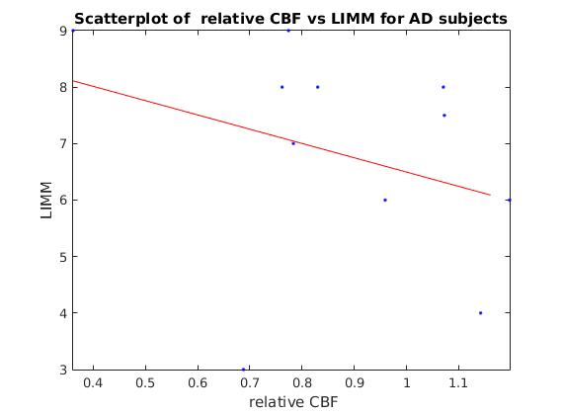 | 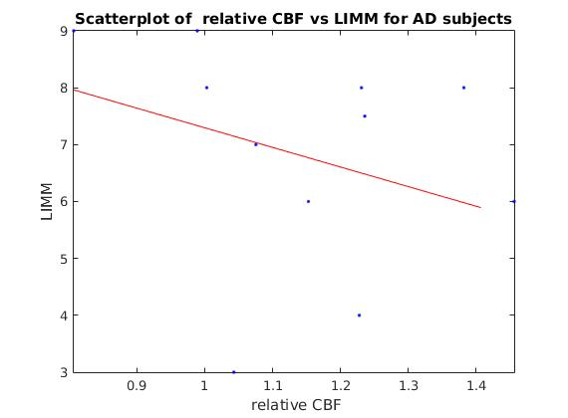
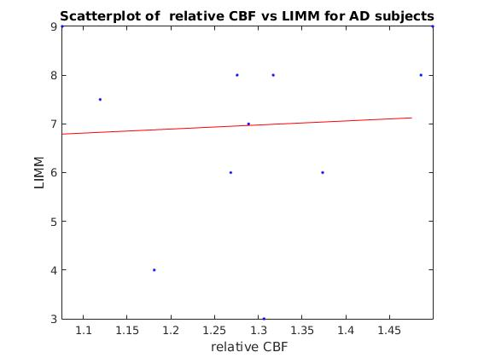

Figure S2: Scatter plots for the correlation of rCBF with LIMM on 3D PCASL. Left: Scatter plot of rCBF on Angular Gyri with LIMM (r = -0.74, p-value = 0.004) for AD subjects. Right: Scatter plot of rCBF on Compositive MetaROI with LIMM (r = -0.84 p-value = 0.0003) for AD subjects. Bottom left: Scatter plot of rCBF on Hippocampus with LIMM (r = -0.73 p-value = 0.005) for AD subjects

