Supporting Information
Angle-Independent Colored Fabrics Coated with Washable Antifouling Amorphous Photonic Crystals
Yin Fu^{a#}, Linbing Deng^{a#}, Xue Li,ª Haiying Tanª*, Jiuxiao Sunª, Qingwen Shiª, Guang Zheng^{b}*, Yuxin Wuª, Liangbo Zhu^{c}, Zaki Hossainª

ª State Key Laboratory of New Textile Materials and Advanced Processing Technologies and Key Laboratory of Textile Fiber and Products of Ministry of Education, College of Materials Science and Engineering, Wuhan Textile University, Wuhan 430200, China
^{b} Key Laboratory of Optoelectronic Chemical Materials and Devices of Ministry of Education, Jianghan University, Wuhan 430056, China
^{b} Key Laboratory of Optoelectronic Chemical Materials and Devices of Ministry of Education, Jianghan University, Wuhan 430056, China
^{c} High-Tech Organic Fibers Key Laboratory of Sichuan Province and China, Bluestar Chengrand Co., Ltd
# The author made equal contribution to this work
*Corresponding Authors. E-mail: hytan@wtu.edu.cn (H. T.); mzheng88@foxmail.com (G. Z.)

Table S1 Summarization of softness and permeability of the fabrics before and after PCs coating of PCo14.
 | Resilience | Softness | Smoothness | Permeability
PCo-14 | 33.24 | 80.50 | 63.63 | 59.5
Blue PCo14 | 17.85 | 78.03 | 65.55 | 23.4

Figure S1. SEM images of all the fabrics. (a) PCo15, (b) PCa30, (c) TTR24, (d) CSi07, (e) CPo20, (f) TCo10.

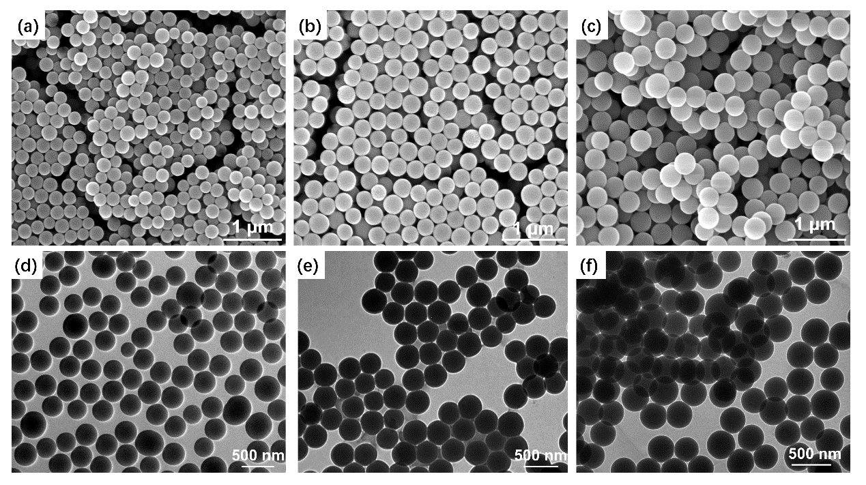
Figure S2. SEM and TEM images of SiO₂. (a) SEM image of SiO₂ with the diameter at 170 nm. (b) SEM image of SiO₂ with the diameter at 200 nm. (c) SEM image of SiO₂ with the diameter at 230 nm. (a) TEM image of SiO₂ with the diameter at 170 nm. (b) TEM image of SiO₂ with the diameter at 200 nm. (c) TEM image of SiO₂ with the diameter at 230 nm.

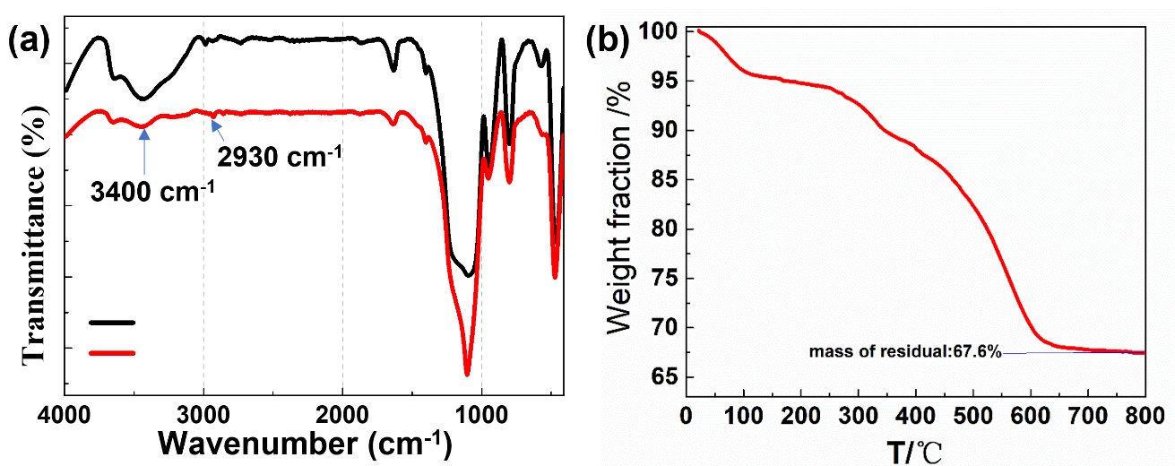
Figure S3 (a) The FTIR spectrum of the SiO₂ nanoparticle before and after modification. (b) Thermogravimetric analysis (TA) results of APCs coatings on the fabrics.
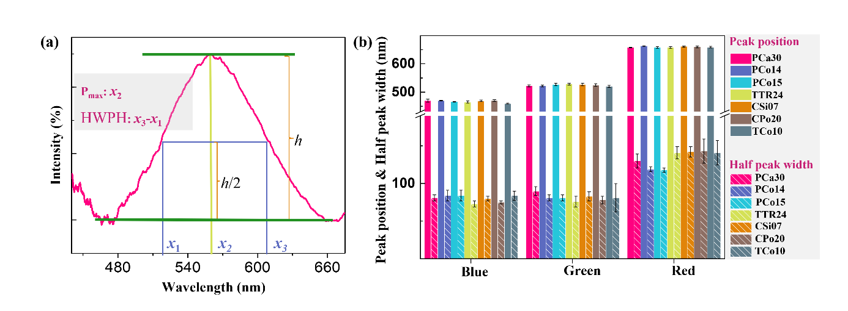
Figure S4 Properties of the structure-colored fabrics: (a) Schematically shows the determination of the maximum peak position (Pmax) and peak width at the half-peak height (PWHP); (b) Summarization of Pmax and PWHP for the blue, green and red colored fabrics.

