Table S1. Proportional hazards model fit to survival data (Wald test) for each food type separately.

 |  | Food=Scenedesmus |  | Food=Nannochloropsis
Source | DF | Wald ChiSquare | Prob>ChiSq | Wald ChiSquare | Prob>ChiSq
foodLevel | 1 | 18.67 | <0.0001 | 67.64 | <0.0001
Clone | 3 | 37.06 | <0.0001 | 3.16 | 0.37
foodLevel*Clone | 3 | 5.57 | 0.13 | 6.64 | 0.08

Table S2 General linear model analysis of the differences among of age groups (20-30 vs. 80-90 days), food type (Scenedesmus vs. Nannochloropsis), food concentration (2x10⁴ vs. 2x10⁵ cells/mL) and clones on time until immobilization (T_{imm}) in acute heat shock assays. Left: common garden comparison between 2 cohort of different ages. Right: longitudinal comparisons of individuals from the same cohort at two time points. Body length included in the model as a covariable. Block of measurements included in the model as a random block effect.

 | Common garden |  |  |  | Longitudinal
Source | DF | DF_{den} | F Ratio | P | DF | DF_{den} | F Ratio | P
L,mm | 1 | 87.73 | 0.39 | 0.53 | 1 | 167 | 3.29 | 0.07
age | 1 | 87.53 | 0.1 | 0.75 | 1 | 9.6 | 2.6 | 0.14
foodType | 1 | 87.02 | 4.04 | 0.048 | 1 | 164 | 5.34 | 0.022
age*foodType | 1 | 87.03 | 0.47 | 0.49 | 1 | 164.6 | 0.08 | 0.78
foodLevel | 1 | 87.09 | 0.45 | 0.5 | 1 | 166.8 | 15.44 | 0.0001
age*foodLevel | 1 | 87.29 | 10.01 | 0.0021 | 1 | 164.4 | 0.05 | 0.82
foodType*foodLevel | 1 | 87.09 | 0.013 | 0.91 | 1 | 165.5 | 1.15 | 0.28
age*foodType*foodLevel | 1 | 86.99 | 2.76 | 0.1 | 1 | 164.9 | 0.63 | 0.43
Clone | 3 | 87.08 | 12.39 | <0.0001 | 3 | 164 | 10.36 | <0.0001
age*Clone | 3 | 87.15 | 1.09 | 0.36 | 3 | 164 | 1.02 | 0.39
foodType*Clone | 3 | 87.2 | 0.95 | 0.42 | 3 | 165.7 | 0.8 | 0.5
age*foodType*Clone | 3 | 87.1 | 1.38 | 0.25 | 3 | 165.7 | 0.15 | 0.93
foodLevel*Clone | 3 | 86.96 | 1.32 | 0.27 | 3 | 164 | 0.08 | 0.97
age*foodLevel*Clone | 3 | 86.97 | 3.23 | 0.026 | 3 | 164.1 | 0.29 | 0.83
foodType*foodLevel*Clone | 3 | 86.97 | 0.67 | 0.57 | 3 | 164.2 | 0.56 | 0.64
age*foodType*foodLevel*Clone | 3 | 86.97 | 0.81 | 0.49 | 3 | 164.3 | 0.21 | 0.89

Table S3. Factors affecting lipid peroxidation (LPO) level in Daphnia males. REML analysis the effects of clones, tissue, and food types on LPO measured by fluorescent microscopy, with blocks of measurements as a random effect. LPO was calculated as the ratio of median green to total median green + median red fluorescence, Box-Cox transformed.

Source | DF | SS | F Ratio | Prob > F
Clone | 3 | 0.0900 | 22.94 | <0.0001
Food | 1 | 0.0361 | 27.58 | <0.0001
Clone*Food | 3 | 0.0527 | 13.44 | <0.0001
Tissue | 2 | 0.1297 | 49.59 | <0.0001
Clone*Tissue | 6 | 0.0389 | 4.96 | 0.0002
Food*Tissue | 2 | 0.00014 | 0.052 | 0.94
Clone*Food*Tissue | 6 | 0.00235 | 0.300 | 0.93
Block | 1 | 0.01763 | 13.49 | 0.0004
Error | 80 | 0.10458

A B
Fig. S1. Time until immobilization in Daphnia reared in either low (0.36 μg C/mL, white bars, L) or high (3.6 μg C/mL, gray bars, H) concentration of either Nannochloropsis (N) or Scenedesmus (S) food. Y – young Daphnia (20-30 days old); O – old Daphnia (80-90 days old), analyzed separately in a common garden, cross-cohort (A) and longitudinal, within-cohort (B) comparisons. Error bars are standard errors. Letters represent Tukey test pairwise differences estimated for young and old Daphnia and for A and B separately; groups that do not share a letter are significantly different (post-hoc P<0.05). Statistics in Table S2; pooled data analysis in main text Table 3.

Fig. S2. Comparison of LPO in young (20-30 days) vs. old (55-60 days) Daphnia (same data as on Main text Fig. 3. In both diets the short-lived clones (FI, IL) increase LPO with age, while long-loved clones (GB, HU) decrease.

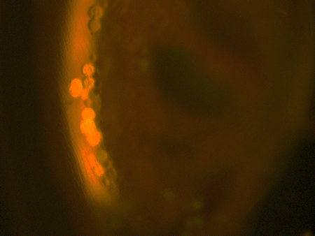
g

t
fb

Fig. S3. LPO in males. N – Nannochloropsis diet (purple); S – Scenedesmus diet (green). LPO measured as the ratio of green to green+red BODIPY C11 fluorescence. Inset shows the location of testes (t). Gut (g) labeled for a reference, not measured.

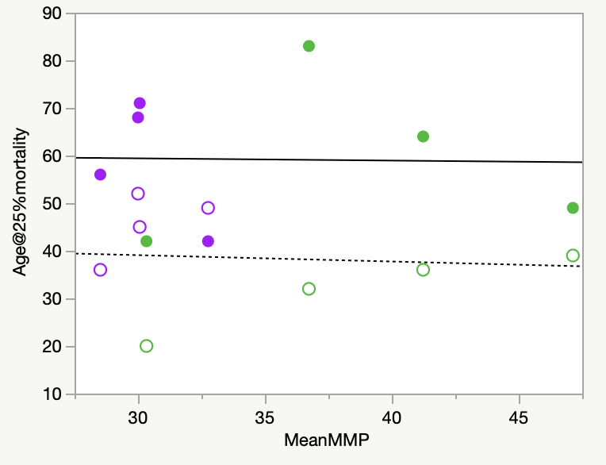
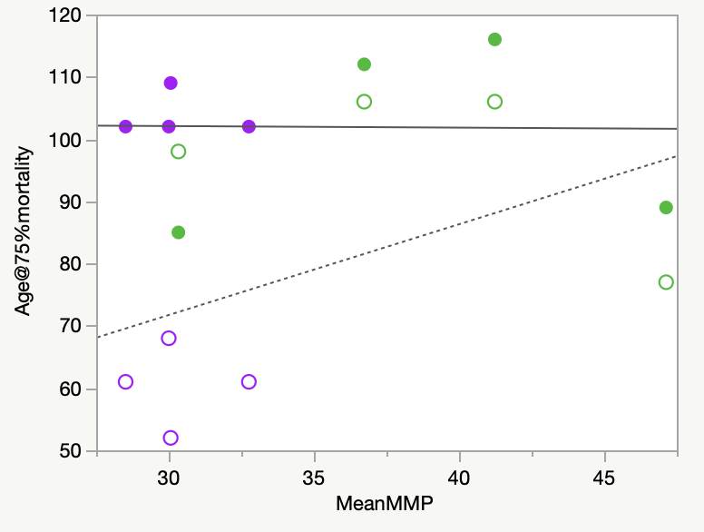

Fig. S4. No consistent effect of mitochondrial membrane potential, MMP, and lipid peroxidation, LPO, on age of 25 and 75 lifespan percentiles. Symbols as in Main text Fig. 6. Regression lines drawn separately for each food level; only P values <0.1 shown.

