The 27-gene IO score is associated with efficacy of PD-1/L1 inhibitors independent of FGFR expression in a real-world metastatic urothelial carcinoma cohort.

Supplemental Data:
Among the 108 patients with FGFR aberration UNC (n=14), we observed a clinically meaningful response for IO positivity despite the small cohort size.

Table S1. TCGA-BLAD analysis with and without the gene ITM2A.
Cohen’s κ = 0.99 | 26-genes IO score
27-genes IO score | IO Score | IO+ | IO-
27-genes IO score | IO+ | 175 | 1
27-genes IO score | IO- | 2 | 255

Figure S1. Forest plot representing Cox proportional hazards for clinical characteristics of the cohort (n=73) from 1-year progression-free survival or 2-year overall survival.

Figure S2. Kaplan-Meier estimates of IO score from patients with FGFR mutations or fusions. A) HR = 0.3001; 95%CI 0.08 – 1.17; p=0.082 B) HR = 0.6162; 95%CI 0.20 – 1.91; p=0.40
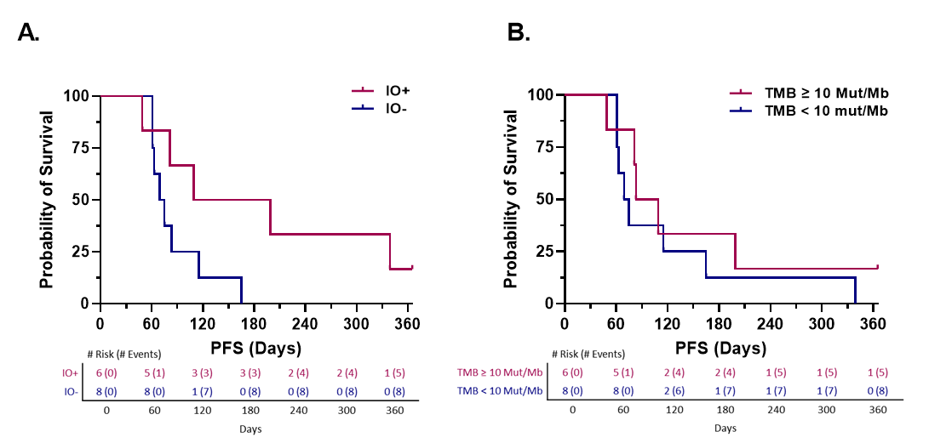

Figure S3. 1-yr PFS ECOG 2 from UNC cohort (n=11) median PFS IO- = 52 days; IO+ = 196.5 days; HR = 0.3156; 95%CI 0.06 – 1.55; p=0.156
