Supporting information

Table S1. Summary of the analysis of variance testing the independent and interactive effects of ground cover and sampling date on natural enemy abundance, piercing-sucking herbivory abundance and boring percentage.
Specific indicator | Statistical value | Ground cover | Sampling date | Gound cover × Sampling Date
Abundance of natural enemies | F | 208.39 | 12.52 | 7.59
Abundance of natural enemies | p | < 0.01 | < 0.01 | < 0.01
Abundance of piercing sucking herbivores | F | 70.38 | 177.38 | 1.89
Abundance of piercing sucking herbivores | p | < 0.01 | < 0.01 | 0.028
Boring percentages (%) | F | 161.65 | 40.33 | 5.36
Boring percentages (%) | p | < 0.01 | < 0.01 | < 0.01

Table S2. Summary of the analysis of variance testing the independent and interactive effects of ground cover and year on amount of commercial pesticides, amount of active ingredient in pesticide and fruit yield, respectively.
Specific indicator | Statistical value | Ground cover | Year | Ground cover × Year
Amount of commercial pesticides  (kg•ha⁻¹)  Amount of active ingredient in pesticide (kg•ha⁻¹)  Fruit yield | F | 286.03 | 4.54 | 1.85
 | Sig. | < 0.001 | 0.052 | 0.185
 | F | 213.28 | 0.70 | 0.90
 | Sig.  F | < 0.001  32.64 | 0.416  2.31 | 0.470  0.66
(t•ha⁻¹) | Sig. | < 0.001 | 0.150 | 0.590

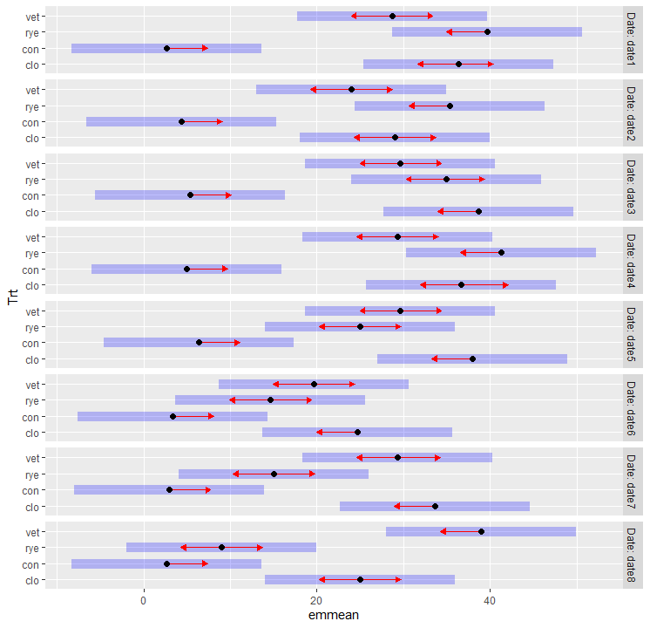
Natural enemy abundance
Figure S1. Graphical comparison of the interactive effect of ground cover (vet, hairy vetch; rye, ryegrass; con, control plot; clo, white colver) and sampling date on natural enemy abundance. The blue bars are confidence intervals for the EMMs, and the red arrows are for the comparisons among them. If an arrow from one mean overlaps an arrow from another group, the difference is not “significant,” based on the adjust setting (Tukey) and the value of alpha (0.05).

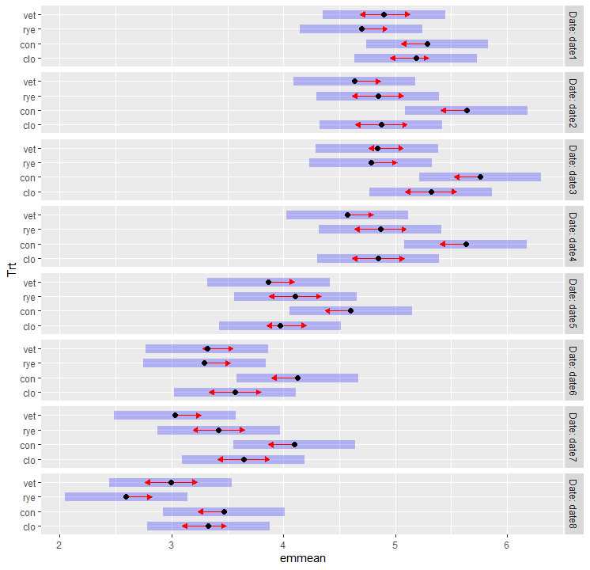
Figure S2. Graphical comparison of the interactive effect of ground cover (vet, hairy vetch; rye, ryegrass; con, control plot; clo, white colver) and sampling date on piercing-sucking herbivory abundance. The blue bars are confidence intervals for the EMMs, and the red arrows are for the comparisons among them. If an arrow from one mean overlaps an arrow from another group, the difference is not “significant,” based on the adjust setting (Tukey) and the value of alpha (0.05).
Piercing-sucking herbivory abundance

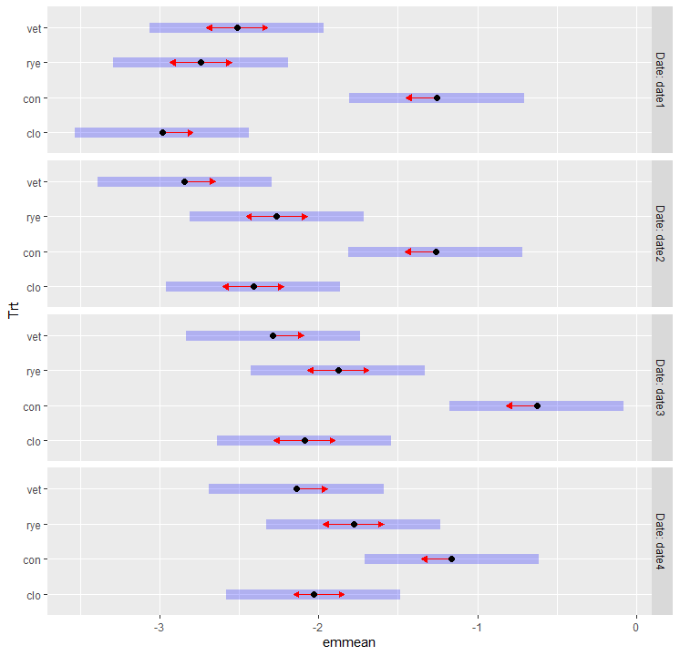
Boring percentage
Figure S3. Graphical comparison of the interactive effect of ground cover (vet, hairy vetch; rye, ryegrass; con, control plot; clo, white colver) and sampling date on boring percentage. The blue bars are confidence intervals for the EMMs, and the red arrows are for the comparisons among them. If an arrow from one mean overlaps an arrow from another group, the difference is not “significant,” based on the adjust setting (Tukey) and the value of alpha (0.05).

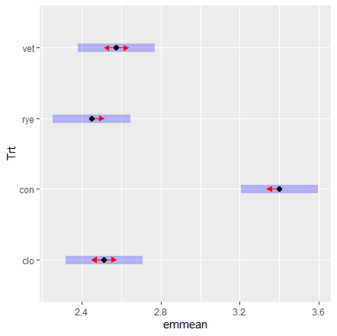
Amount of commercial pesticide
Figure S4. Graphical comparison of the effect of ground cover (vet, hairy vetch; rye, ryegrass; con, control plot; clo, white colver) on amount of commercial pesticide. The blue bars are confidence intervals for the EMMs, and the red arrows are for the comparisons among them. If an arrow from one mean overlaps an arrow from another group, the difference is not “significant,” based on the adjust setting (Tukey) and the value of alpha (0.05).

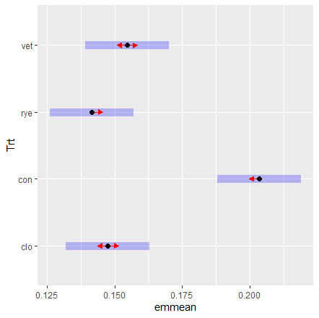
Amount of active ingredient in pesticide
Figure S5. Graphical comparison of the effect of ground cover (vet, hairy vetch; rye, ryegrass; con, control plot; clo, white colver) on amount of active ingredient in pesticide. The blue bars are confidence intervals for the EMMs, and the red arrows are for the comparisons among them. If an arrow from one mean overlaps an arrow from another group, the difference is not “significant,” based on the adjust setting (Tukey) and the value of alpha (0.05).

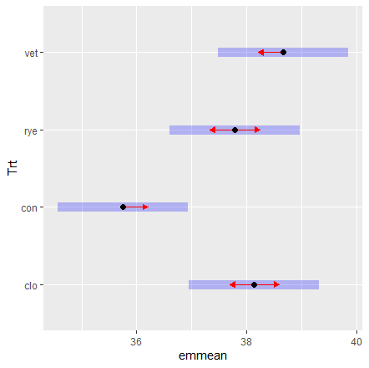
Pear fruit yield
Figure S6. Graphical comparison of the effect of ground cover (vet, hairy vetch; rye, ryegrass; con, control plot; clo, white colver) on pear fruit yield. The blue bars are confidence intervals for the EMMs, and the red arrows are for the comparisons among them. If an arrow from one mean overlaps an arrow from another group, the difference is not “significant,” based on the adjust setting (Tukey) and the value of alpha (0.05).

