Supplementary Information for
Exchange, catalysis and amplification of encapsulated RNA driven by periodic temperature changes.
Elia Salibi^{1§}, Benedikt Peter^{2§}, Petra Schwille²*, Hannes Mutschler¹*.
¹ TU Dortmund University, Department of Chemistry and Chemical Biology, Otto-Hahn-Str. 4a, 44227 Dortmund, Germany
² Max Planck Institute of Biochemistry, Department of Cellular and Molecular Biophysics, Am Klopferspitz 18, 82152 Martinsried, Germany
§Joint first author
*Corresponding authors

Table of Contents
Materials 1
Supplementary Tables 2
Supplementary Figures 3
Supplementary Figure 1: Secondary structures of RNA systems used in the study. 3
Supplementary Figure 2: Time course of hammerhead activity in vitro supplemented with sucrose. 4
Supplementary Figure 3: Hammerhead activity in GUVs. 5
Supplementary Figure 4: Effect of MgCl₂ on emulsion transfer GUV preparation. 6
Supplementary Figure 5: in vitro characterization of the enzymatically synthesized TAMRA-B-BHQ2 substrate. 7
Supplementary Figure 6: Membrane interactions of encapsulated RNA. 8
Supplementary Figure 7: Fluorescence intensity inside GUVs decreases upon freezing and thawing. 9
Supplementary Figure 8: Gel electrophoresis of RNA ligation by R3C ligase ribozyme F1 in vitro. 10
Supplementary Figure 9: R3C autocatalytic ligase tetrameric substrate complex. 11
Supplementary Figure 10: Serial transfer of Cy5-A and Hyper-A in vitro. 12
Supplementary Figure 11: in vitro characterization of F1 and Hyper-A under desired buffer conditions. 13
Supplementary Figure 12: Gel images of R3C ligase ribozyme F and the active substrate Hyper-A in vitro. 14
Supplementary Figure 13: Gel image showing the activity of the encapsulated R3C autocatalytic system under different numbers of freeze-thaw cycles. 15
Supplementary Figure 14: Effect of freeze-thaw (FT) cycling on GUV diameter. 16
Supplementary Figure 15: Gel image showing the activity of the encapsulated R3C system following serial dilutions in substrate encapsulated GUV feedstock. 17

Materials
1-palmitoyl-2-oleoyl-glycero-3-phosphocholine (POPC) was purchased from Avanti Polar. Atto 647N-functionalized DOPE (1,2-dioleoyl-sn-glycero-3-phosphoethanolamine) lipids were acquired from AttoTEC GmbH (Siegen, Germany) dissolved in chloroform at 1 mg/ml. For fluorescence detection inside GUVs, AlexaFluor568 NHS ester (Thermo Fischer Scientifics, Waltham, MA, USA) and HPLC-purified 5’-Atto488-(CA)13-3’ and 5’-Atto655-(CA)13-3’ oligonucleotides (both IDT, Coralville, IA, USA) were purchased. SensoPlate glass bottom microtiter plates (384 wells, V_{well} = 130 µL) were obtained from Greiner Bio-One and aluminium-coated sealing film ROTALIBO® was purchased from Carl Roth. All glass surfaces were passivated using a 10 mg/ml Pluronic F-127 (Sigma-Aldrich) solution according to the manufacturer’s instructions. Mineral oil, dimethyl sulfoxide (DMSO), Rotiphorese 40% (19:1 acrylamide:bis-acrylamide) ready-to-use solution, TEMED, chloroform, N-(2-Hydroxyethyl)piperazine-N′-(3-propanesulfonic acid) (EPPS), ethylenediaminetetraacetic acid (EDTA), sodium acetate (NaOAc), Triton X-100, bromophenol blue, ammonium persulfate (APS) and urea were all purchased from Carl Roth. Formamide, 5-Carboxy-tetramethylrhodamine N-succinimidyl ester (TAMRA-NHS-ester), polyethylene glycol 8000 (PEG8000), absolute ethanol, 2-propanol (isopropanol), D-glucose, boric acid, glacial acetic acid, sodium tetraborate hexahydrate (NaB) were purchased from Sigma. Magnesium chloride (MgCl₂) hexahydrate and tris(hydroxymethyl)aminomethane (Tris) were purchased from Th.Geyer. D-sucrose, dithiothreitol (DTT), spermidine and RNA-grade glycogen were purchased from Thermo Fisher. Gamma-aminohexyl-GTP and NTPs were purchased from Jena Bioscience. Sodium hydroxide pellets and 37% hydrochloric acid solution were purchased from VWR. E. coli inorganic pyrophosphatase (IPP), T4 RNA ligase 2 (T4Rnl2) and the Monarch RNA cleanup kit (50µg) were purchased from NEB. Pre-coated TLC plates were purchased from Machery-Nagel. DNA oligonucleotides were synthesized by IDT. RNA was either transcribed in-house or purchased from IDT when mentioned. Cellulose acetate filter spin columns (Spin-X) were bought from Costar. Ultrapure Milli-Q water (Millipore) was used for all experiments in this study.

Supplementary Tables
Table 1. Table of sequences used in this study.
Name | Length | 5' end | Sequence (5' to 3') | 3' end | Source | Reference
HH-min | 39 | - | GGGAGCUGAACUGAUGAGUCCGU  GAGGACGAAAGGCACA | - | IVT | Drobot et al 2018
HH-mut* | 39 | - | GGGAGCUGAACUAAUGAGUCCGU  GAGGACAAAAGGCACA | - | IVT | Drobot et al 2018
HH-FQ-Sub | 12 | FAM | UGCCUCUUCAGC | BHQ1 | IDT | Drobot et al 2018
HH-Sub | 27 | Cy5 | UUCACCUCAGAACUGUGCCUCUUCAGC | - | IDT | - this paper -
R3C ligase F | 66 | - | GGAAGUUGUUAUCACUUGUUACGUAAGUAACAC  UUUGGAUGGGUUGAAGUAUGAGACCGCAACUUA | - | IVT | Robertson et al 2014
Hyper-A | 52 | - | GGAAGUUGUUAUCACUUGUUACGUAAGUAACAC  UUUGGAUGGGUUGAAGUAU | - | IDT | Robertson et al 2014
Cy5-A* | 52 | Cy5 | GGAAGUUGUUAUCACUUGUUACGUAAGUAACAC  UUUGAAUGGGUUGAAGUAU | - | IDT | - this paper -
B | 14 | TP** | GAGACCGCAACUUA | - | IVT | Robertson et al 2014
rt-F | 66 | - | GGAAGUUGUGUCUUAAUGUUACGUAAGUAACAG  AUGGAAUUGGUUGAAGUAUGAGACCGCAACUUA | - | IVT | Olea et al 2016
rt-A-short | 10 | - | GGUCUCAUAU | - | IDT | Olea et al 2016
FQ-B | 19 | TAMRA-C6-TP** | GAGACCGCAACUUACACAU | BHQ2 | IVT + Ligation | Olea et al 2016
Penta-BHQ2 | 5 | P** | CACAU | BHQ2 | IDT | - this paper -
* Bases in bold red color are substitution mutations that render the sequences catalytically inactive.
** P = phosphate, TP = triphosphate

Supplementary Figures

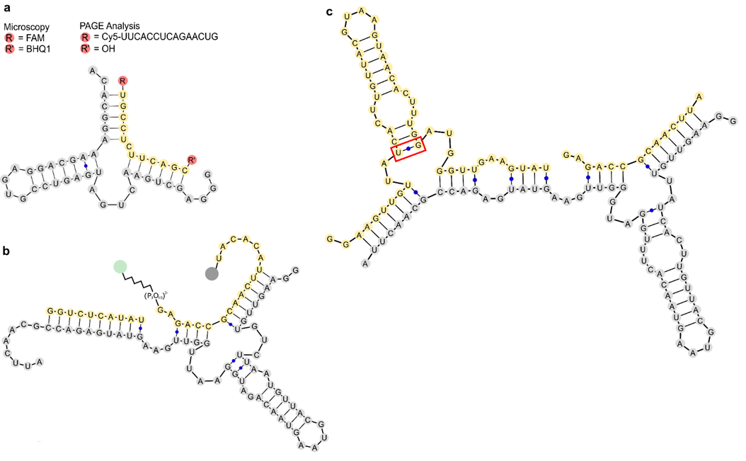

Supplementary Figure 1: Secondary structures of RNA systems used in the study.
a) The hammerhead ribozyme system shows the ribozyme in grey and the substrate in yellow. The substrate used for microscopy had a fluorophore and quencher attached to the 5’ and 3’ ends, respectively. The substrate for PAGE analysis instead only had a nucleotide linker region and fluorophore at the 5’ end. b) Structure of the R3C derived ligase (grey) and its modified substrate (yellow), adopted from Olea and Joyce 2016. Ligation results in the release of the fluorophore (green) and consequent increase in fluorescence. c) Structure of the R3C autocatalytic ligase F1 (grey) bound to its two substrates (yellow), from Robertson and Joyce 2014. The red box indicates the base pair that was mutated in this work from [U-G] to [U-A] in the Cy5-A version to downregulate background activity.

Supplementary Figure 2: Time course of hammerhead activity in vitro supplemented with sucrose.
a) Gel image and of the following reaction: 2.5 µM of hammerhead ribozyme was incubated with 5 µM Cy5-tagged HH-substrate with 900 mM sucrose, 4 mM magnesium chloride and 20 mM Tris-HCl pH 8.3. Samples were quenched at the indicated timepoints by the addition of 4 volumes of HH-RNA loading buffer (10 mM EDTA in Formamide). Samples were heat denatured at 85 °C for 5 minutes before loading onto a 20 % PAGE. b) Plot of HH-min cleavage yields from band intensity measurements of the gel image. Data points are fitted to an exponential plateau equation. Error bars represent standard deviation (N=3).

Supplementary Figure 3: Hammerhead activity in GUVs.
a-b) Control experiments of FT cycling on HH-sub cleavage with a) empty GUVs or b) the inactive HH-mut. The lack of fluorescence increase suggests that HH-FQ-sub is not cleaved by reaction conditions or FT-cycles. c) GUVs encapsulating 2.5 µM Cy5-tagged HH-substrate were mixed with GUVs containing only buffer, 5 µM HH-mut, or 5 µM HH-min and subjected to one freeze-thaw cycle followed by a 60-minute incubation at 37 °C. Samples were washed with outer phase buffer, concentrated and quenched in 2 volumes GUV loading buffer (25 mM EDTA, 0.3 % Triton X-100 in Formamide). They were heat denatured at 85 °C for 5 minutes before loading onto a 20 % PAGE. All scale bars represent 10 µm.

Supplementary Figure 4: Effect of MgCl₂ on emulsion transfer GUV preparation.
a) Confocal microscopy images of GUVs encapsulating a fluorescent marker (3 µM 5’-Atto655-(CA)13-3’) prepared with increasing magnesium in the R3C buffers. b) Mean fluorescence intensities of GUVs extracted from the confocal images showing a decrease in GUV intensity with increasing magnesium concentration. We thus work in a reasonable concentration range to ensure both sufficiently high ribozyme activity and compatibility with our GUV preparation method. Scale bar represents 20 µm.

Supplementary Figure 5: in vitro characterization of the enzymatically synthesized TAMRA-B-BHQ2 substrate.
a) Raw fluorescence of the FQ-B substrate before and after quencher attachment. Quenching efficiency is calculated to be 92 % using the equation QE = (1-(Fluorescence[TAMRA-B-BHQ2]/Fluorescence[TAMRA-B])) * 100. b) Single turnover kinetics employing 2 µM FQ-B and 5 µM each of rt-F and rt-A-short with 20 mM MgCl₂, pH 8.5 at 42 °C. Negative control contains only substrate in buffer. Reactions were assembled on ice then transferred to a microplate. Fluorescence emission was measured by exciting at 545 nm and detecting emission at 590 nm. Error bars represent standard deviation (N=3).

Supplementary Figure 6: Membrane interactions of encapsulated RNA.
a) Confocal microscopy images of the R3C ligase assay in GUVs before FT. Substrate vesicles (green) contained 10 µM FQ-B and 20 µM rt-A-short. b-d) Close-up of boxes in a). e) Fluorescence intensity across 2 GUVs along the dotted line shown in c). The peaks at the extremities suggest that the fluorescent RNA (FQ-B) is interacting with the inner leaflet of the membrane thus promoting a local increase in concentration. Scale bars represent 30 µm in (a) and 10 µm in b-d).

Supplementary Figure 7: Fluorescence intensity inside GUVs decreases upon freezing and thawing.
GUV intensity distributions before (grey) and after FT-cycling (blue). Vesicles initially contained 900 mM sucrose and 3 µM 5’-Atto655-(CA)₁₃-3’. GUV intensity distribution after freeze-thawing is shifted to lower intensities indicating content loss (CL) due to content dilution in the outer phase. Number n is accounting for the number of GUVs evaluated.

Supplementary Figure 8: Gel electrophoresis of RNA ligation by R3C ligase ribozyme F1 in vitro.
Activity was assayed in 50 mM EPPS buffer pH 8.5 supplemented with 20 mM magnesium chloride, 900 mM sucrose at 42 °C. The substrate concentrations were equal in control and in the reaction: 0.5 µM Cy5-A, 4.5 µM Hyper-A, and 12 µM B. The control has no ribozyme added. The reaction was seeded with 0.5 µM ribozyme. Samples were collected by quenching 1 µL in 9 µL R3C loading buffer (25 mM EDTA in formamide). They were then heat denatured at 85 °C for 5 minutes before loading onto a 12 % PAGE. The control reaction shows a band at the final time point corresponding to product formation, suggesting that residual activity in substrate oligonucleotides can catalyze the ligation reaction in absence of ribozyme.

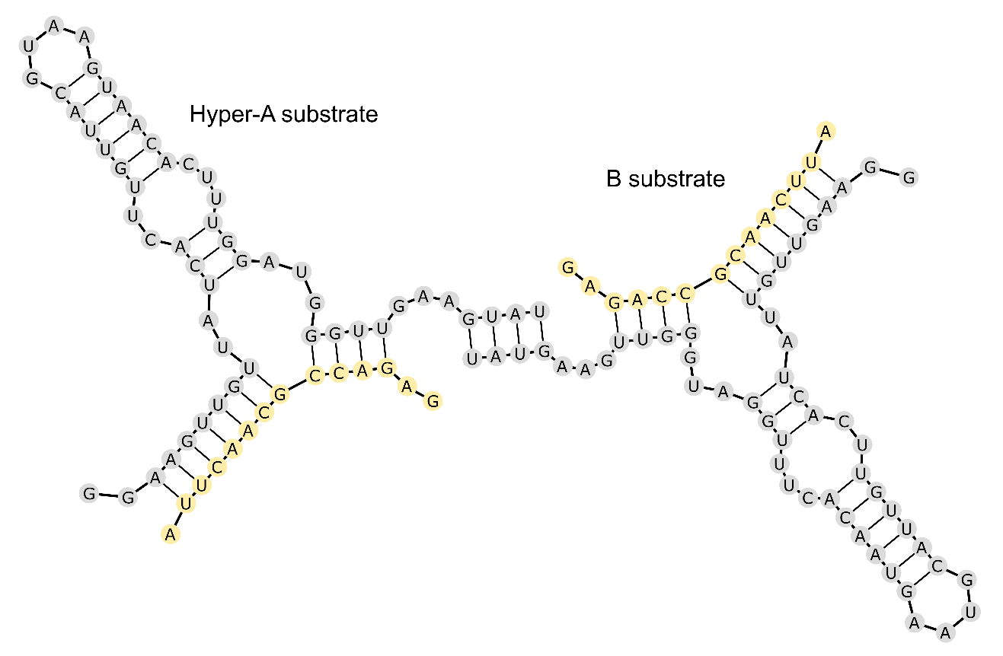

Supplementary Figure 9: R3C autocatalytic ligase tetrameric substrate complex.
Secondary structure of the 2A2B substrate tetramer that can form by complementary base pairing.

Supplementary Figure 10: Serial transfer of Cy5-A and Hyper-A in vitro.
Gel images and band intensity graphs showing the yield of newly synthesized ribozyme following serial transfers of the previous generations. (a) 10 µM Cy5-A were mixed with 10 µM of B and 1 µM ribozyme in 20 mM MgCl₂ at pH 8.5. The reaction was incubated for 30 minutes at 42 °C, after which 1 µL of the reaction was transferred to 9 µL of fresh substrate mix and the incubation was repeated. This was done several times to achieve 1x10⁶ dilution of the starting reactants. Samples were taken at the initial and final timepoints of a generation by quenching 1 µL of reaction with 9 µL R3C RNA loading buffer (25 mM EDTA in formamide). Samples were heat denatured at 85 °C for 5 minutes before loading onto a 12 % denaturing PAGE. The absence of new ribozyme in the later generations indicates that the product formed from the ligation of Cy5-A and B is indeed inactive. (b) 9 µM Hyper-A, 1 µM Cy5-A and 10 µM B were mixed without any ribozyme in 20 mM MgCl₂ at pH 8.5. Incubation, transfers and electrophoresis protocol was the same as in (a). The presence of a product band after the first incubation suggests that the Hyper-A substrate is also catalytically active. (c) Positive control showing 9 µM Hyper-A, 1 µM Cy5-A, 10 µM B and 1 µM F ribozyme were incubated in 20 mM MgCl₂ at pH 8.5. The system is autocatalytic because the product that forms can catalyze the formation of more product. Even after 1-million-fold dilution of the initial ribozyme (1 µM to 1 pM), roughly the same amount of product is obtained under the same incubation period as the first generation. Together these data prove that the Cy5-A substrate is in fact inactive while the Hyper-A substrate retains some activity.

Supplementary Figure 11: in vitro characterization of F1 and Hyper-A under desired buffer conditions.
Reaction cycles illustrating the ligation of inactive Cy5-A substrate to B substrate by a) F1 ribozyme or b) the Hyper-A substrate. c) Plot showing the ligation yields of different seeded concentrations for F1 or Hyper-A in 50 mM EPPS, 20 mM MgCl₂, 900 mM sucrose at 42 °C. Cy-A was present at 5 µM while B was at 7.5 µM. Gel images can be seen in Supplementary Figure 12. d) Plot showing the ligation yields of F1 and Hyper-A after 1 hour at 42 °C, as a function of initial seed concentration. In both plots, the data points were fitted with an exponential growth function. Error bars represent the standard deviation (N=3).

Supplementary Figure 12: Gel images of R3C ligase ribozyme F and the active substrate Hyper-A in vitro.
The ribozyme F and the Hyper-A substrate were seeded at different concentrations with 5 µM Cy5-A and 7.5 µM B substrate with 900 mM sucrose, 20 mM magnesium chloride and 50 mM EPPS at pH 8.5. Samples were incubated at 42 °C and quenched at the indicated times with 9 volumes of R3C loading buffer (25 mM EDTA in formamide, 0.01 % bromophenol blue). The samples were heat denatured at 85 °C for 5 minutes before loading onto 12 % PAGE.

Supplementary Figure 13: Gel image showing the activity of the encapsulated R3C autocatalytic system under different numbers of freeze-thaw cycles.
Substrate GUVs were mixed with empty GUVs or with GUVs encapsulating 1 µM ribozyme and were subjected to cycles of freezing and thawing followed by a 60-minute incubation period at 42 °C. GUVs were subsequently washed with outer phase, concentrated and resuspended in 1, 2 or 3 volumes of GUV loading buffer (25 mM EDTA, 0.3 % Triton X-100, 0.01 % bromophenol blue in formamide). Samples were heat denatured at 85 °C for 5 minutes before loading onto a 12 % PAGE.

Supplementary Figure 14: Effect of freeze-thaw (FT) cycling on GUV diameter.
a) Relative frequency plot of GUV count per GUV diameter before and after FT. b-d) The decrease in GUV diameter as a result of FT can be explained by b) local changes in osmolarity, c) ice crystal formation and d) passage of GUVs through tight channels formed by frozen water. GUVs contained 900 mM sucrose and 3 µM Alexa Fluor 568 NHS ester. The surrounding phase consisted of a 900 mM glucose solution. Red color corresponds to Atto 647N-DOPE. All scale bars represent 10 µm.

Supplementary Figure 15: Gel image showing the activity of the encapsulated R3C system following serial dilutions in substrate encapsulated GUV feedstock.
Substrate and ribozyme GUVs were prepared and combined, subjected to a freeze-thaw cycle and incubated for 60 minutes at 42 °C. Then, half the volume was sampled and the other half was transferred to an equal volume of fresh substrate feedstock GUVs and the cycle was repeated. Collected samples were washed with outer phase buffer, concentrated and suspended in 1-2 volumes GUV loading buffer (25 mM EDTA, 0.3 % Triton X-100, 0.01 % bromophenol blue in formamide). Samples were heat denatured at 85 °C for 5 minutes before loading onto a 12 % PAGE.

