Supplementary Material

Fig. S1 Cumulative gene frequency plot of BoLA-DRB3 alleles in Pyer Sein (red), Shwe Ni (violet) and Holstein-Friesian crossbreed (orange).

Fig. S2 Principal component analysis of BoLa-DRB3 gene pocket amino acid motifs frequencies in 18 populations. BW = Pyer Sein, GR = Shwe Ni, HoMy = Myanmar Holstein-Friesian crossbreed, NeBo = Bolivian Nellore, GirBo = Bolivian Gir, and BrxNe = Peruvian Brahman × Nellore crossbreed, HoJa = Holstein, ShJa = Japanese Shorthorn, JeJa = Jersey, WaJa = Japanese Black, HeCh = Chilean Hereford, BACh = Chilean Black Angus, RACh = Chilean Red Angus, ONCh = Chilean Overo Negro, OCCh = Chilean Overo Colorado, NaPh = Philippine Native, BrPh = Philippine Brahman and NaxBrPh = Native x Brahman Philippine crossbreed.
a.

b.
c.

d.
e.
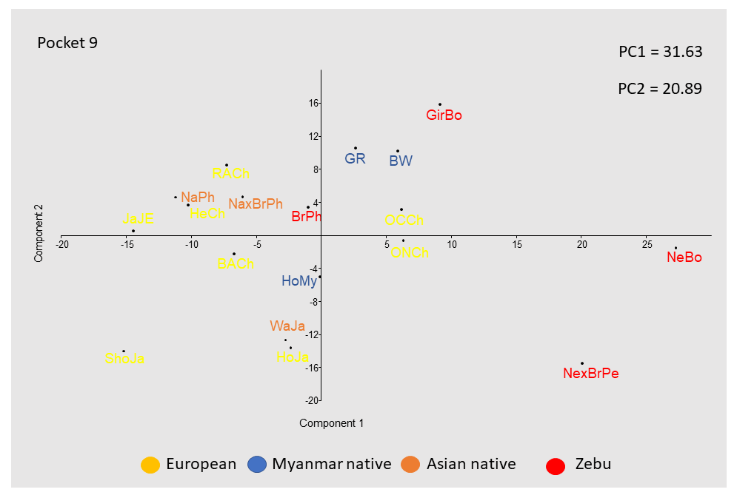

Fig. S3. Geographical distribution of sampling sites of Myanmar cattle that are indicated by a dot.

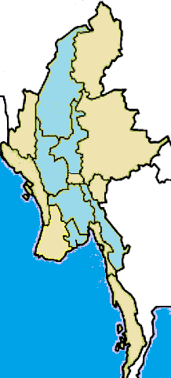
Bago Region
(N = 38)
Thailand
India
China
Sagaing Region
(N = 77)
Magway Region
(N = 46)
Yangon Region
(N = 44)
Kayin State
(N = 43)
Mandalay Region
(N = 46)
Laos
Indian Ocean

Table S1 Detailed information about the populations analyzed
Acronym | Sample size | Breed | Type | Origin (country) | Sampling country | Reference
BW | 163 | Pyersein | Zebu | Myanmar | Myanmar | Present work
GR | 69 | Shweni | Zebu | Myanmar | Myanmar | Present work
HoMy | 62 | Holstein x Friesian | taurine | Netherlands | Myanmar | Present work
HV | 66 | Hartón del Valle | taurine | Colombia | Colombia | Giovambattista et al., 2013
YA | 112 | Yacumeño Creole | taurine | Bolivia | Bolivia | Giovambattista et al., 2013
NeBo | 116 | Nellore | Zebu | Brazil | Bolivia | Takeshima et al., 2018
GirBo | 110 | Gir | Zebu | India | Bolivia | Takeshima et al., 2018
NexBrPe | 195 | Nellore × Brahman | Zebu mixed | - | Peru | Takeshima et al., 2018
HoJa | 102 | Japanese Holstein | taurine | Netherlands | Japan | Takeshima et al., 2003
ShJa | 100 | Japanese Shorthorn | taurine | Great Britain | Japan | Takeshima et al., 2003
JeJa | 69 | Japanese Jersey | taurine | Channel Island | Japan | Takeshima et al., 2003
WaJa | 200 | Japanese Black | taurine | Japan | Japan | Takeshima et al., 2003
HeCh | 49 | Hereford | taurine | Great Britain | Chile | Takeshima et al., 2015
BACh | 100 | Chilean Black Angus | taurine | Great Britain | Chile | Takeshima et al., 2015
RACh | 99 | Chilean Red Angus | taurine | Great Britain | Chile | Takeshima et al., 2015
ONCh | 124 | Chilean Overo Negro | taurine |  | Chile | Takeshima et al., 2015
OCCh | 136 | Chilean Overo Colorado | taurine |  | Chile | Takeshima et al., 2015
BrPh | 236 | Brahman | Zebu | USA | Philippines | Polat et al., 2014
NaPh | 482 | Philippine Native | taurine | Philippines | Philippines | Polat et al., 2014
NaxBrPh | 132 | Native x Brahman | Zebu mixed | - | Philippines | Polat et al., 2014

Table S2. Genetic distance between pair of populations estimated through F_{ST} (above) and Nei D_{A} distance (below). Pyer Sein (BW). Shwe Ni (GR), Myanmar Holstein-Friesian crossbreed (HoMy), Bolivian Nellore (NeBo), Bolivian Gir (GirBo), Peruvian Brahman × Nellore crossbreed (BrxNe), Japanese Holstein (HoJa), Japanese Shorthorn (ShJa), Japanese Jersey (JeJa), Japanese Black (WaJa), Chilean Hereford (HeCh), Chilean Black Angus (BACh), Chilean Red Angus (RACh), Chilean Overo Negro(ONCh), Chilean Overo Colorado (OCCh), Philippine native (NaPh), and Philippine Brahman (BrPh).

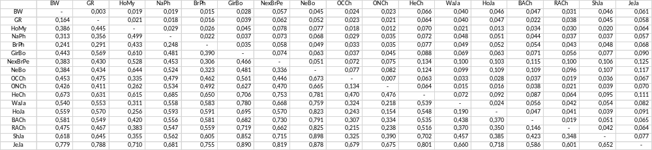

Table S3. Genetic distance between pairs of populations estimated by F_{ST} in (a) six Myanmar native (KN = Kayin, BN = Bago, SN = Sagaing, MdN = Mandalay, MgN = Magway, and YN = Yangon), and (b) four Myanmar Holstein-Friesian crossbreed (KF = Kayin, BF = Bago, SF = Sagaing, and YF = Yangon) populations.
a)
 | BN | KN | MdN | MgN | SN | YN
BN | 0
KN | 0.007 | 0
MdN | 0.023 | 0.022 | 0
MgN | 0.004 | 0.007 | 0.016 | 0
SN | 0.008 | 0.004 | 0.024 | 0.011 | 0
YN | 0.009 | 0.009 | 0.008 | 0.003 | 0.009 | 0

b)
 | BF | KF | SF | YF
BF | 0
KF | 0.014 | 0
SF | 0.003 | 0.031 | 0
YF | 0 | 0.015 | 0.011 | 0

