Supporting Information

Crystal anisotropy implications on the intrinsic magnetism in van der Waals FePS₃
Ellenor Geraffy^{*1}, Shahar Zuri¹, Milosz Marcin Rybak², Faris Horani¹, Adam K. Budniak¹, Yaron Amouyal³, Magdalena Birowska^{*2} and Efrat Lifshitz^{*1}
¹Schulich Faculty of Chemistry, Solid State Institute, Russell Berrie Nanotechnology Institute, and the Helen Diller Quantum Information Center, Technion – Israel Institute of Technology, Haifa, Israel

²Institute of Theoretical Physics, Faculty of Physics, University of Warsaw, Pasteura 5, Warsaw 02-093, Poland.

³Department of Materials Science and Engineering, Technion – Israel Institute of Technology, 3200003 Haifa, Israel

*Corresponding authors

1. Characterization of single crystal FePS₃
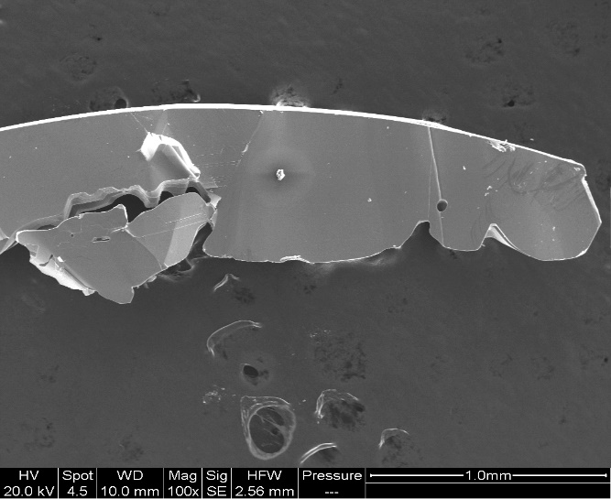
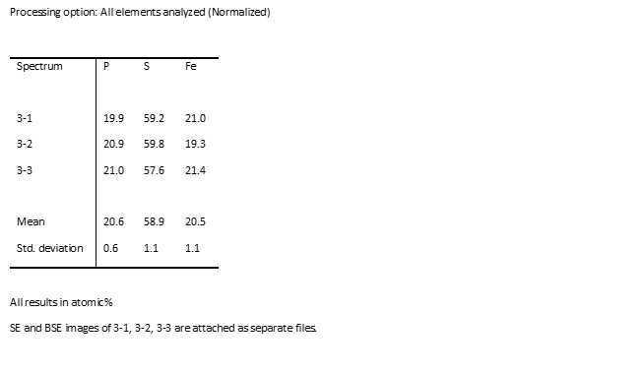
  - EDX measurements
(b)
(a)
Figure S1: EDX measurements of bulk FePS₃ synthesised via CVT. (a) Percentage breakdown of each element in FePS₃ bulk sample, (b) SEM image of FePS₃ sample using the secondary electron (SE) detector.

  - XRD measurements

Table S 1 Bond lengths of bulk FePS₃ at 140K
Atom | Atom | Length/Å |  | Atom | Atom | Length/Å
Fe1 | S1 | 2.5361(16) |  | S1 | P1 | 2.0244(17)
Fe1 | S1¹ | 2.5442(14) |  | S2 | Fe1⁴ | 2.5464(17)
Fe1 | S1² | 2.5442(14) |  | S2 | Fe1⁶ | 2.5464(17)
Fe1 | S1³ | 2.5361(16) |  | S2 | P1 | 2.031(3)
Fe1 | S2⁴ | 2.5464(17) |  | P1 | S1⁷ | 2.0244(17)
Fe1 | S2⁵ | 2.5464(17) |  | P1 | P1⁸ | 2.182(4)
S1 | Fe1¹ | 2.5442(14)

Table S 2 Bond angles of bulk FePS₃ at 140K
Atom | Atom | Atom | Angle/˚ |  | Atom | Atom | Atom | Angle/˚
S1 | Fe1 | S1¹ | 94.91(7) |  | S2⁴ | Fe1 | S2⁵ | 94.85(7)
S1¹ | Fe1 | S1² | 95.51(5) |  | Fe1 | S1 | Fe1³ | 84.49(5)
S1 | Fe1 | S1² | 85.13(5) |  | P1 | S1 | Fe1 | 103.14(8)
S1¹ | Fe1 | S1³ | 85.13(5) |  | P1 | S1 | Fe1³ | 103.23(8)
S1 | Fe1 | S1³ | 95.51(5) |  | Fe1⁴ | S2 | Fe1⁶ | 85.15(7)
S1² | Fe1 | S1³ | 179.05(8) |  | P1 | S2 | Fe1⁶ | 103.24(8)
S1 | Fe1 | S2⁴ | 179.57(5) |  | P1 | S2 | Fe1⁴ | 103.24(8)
S1¹ | Fe1 | S2⁵ | 179.57(5) |  | S1⁷ | P1 | S1 | 114.41(12)
S1¹ | Fe1 | S2⁴ | 85.12(5) |  | S1 | P1 | S2 | 114.05(7)
S1 | Fe1 | S2⁵ | 85.12(5) |  | S1⁷ | P1 | S2 | 114.05(7)
S1² | Fe1 | S2⁴ | 94.44(6) |  | S1⁷ | P1 | P1⁸ | 104.39(8)
S1³ | Fe1 | S2⁴ | 84.91(6) |  | S1 | P1 | P1⁸ | 104.39(8)
S1² | Fe1 | S2⁵ | 84.91(6) |  | S2 | P1 | P1⁸ | 103.88(14)
S1³ | Fe1 | S2⁵ | 94.44(6)
Table S 3 Bond lengths of bulk FePS₃ at RT

Atom | Atom | Length/Å |  | Atom | Atom | Length/Å
Fe1 | S1 | 2.539(3) |  | S1 | P1 | 2.030(3)
Fe1 | S1¹ | 2.547(3) |  | S2 | Fe1⁴ | 2.549(3)
Fe1 | S1² | 2.547(3) |  | S2 | Fe1⁶ | 2.549(3)
Fe1 | S1³ | 2.539(3) |  | S2 | P1 | 2.027(4)
Fe1 | S2⁴ | 2.550(3) |  | P1 | S1⁷ | 2.030(3)
Fe1 | S2⁵ | 2.549(3) |  | P1 | P1⁸ | 2.191(6)
S1 | Fe1¹ | 2.547(3)

Table S 4: Bond angles of bulk FePS₃ at RT
Atom | Atom | Atom | Angle/˚ |  | Atom | Atom | Atom | Angle/˚
S1 | Fe1 | S1¹ | 94.84(13) |  | S2⁴ | Fe1 | S2⁵ | 94.61(14)
S1¹ | Fe1 | S1² | 95.57(11) |  | Fe1 | S1 | Fe1³ | 84.43(11)
S1 | Fe1 | S1² | 85.09(11) |  | P1 | S1 | Fe1 | 103.25(14)
S1¹ | Fe1 | S1³ | 85.09(11) |  | P1 | S1 | Fe1³ | 103.34(11)
S1 | Fe1 | S1³ | 95.57(11) |  | Fe1⁴ | S2 | Fe1⁶ | 85.39(14)
S1² | Fe1 | S1³ | 179.03(10) |  | P1 | S2 | Fe1⁶ | 103.29(13)
S1 | Fe1 | S2⁴ | 179.53(7) |  | P1 | S2 | Fe1⁴ | 103.29(13)
S1¹ | Fe1 | S2⁵ | 179.53(7) |  | S1⁷ | P1 | S1 | 114.46(18)
S1¹ | Fe1 | S2⁴ | 85.28(12) |  | S1 | P1 | P1⁸ | 104.15(10)
S1 | Fe1 | S2⁵ | 85.28(12) |  | S1⁷ | P1 | P1⁸ | 104.15(10)
S1² | Fe1 | S2⁴ | 94.44(11) |  | S2 | P1 | S1⁷ | 114.15(11)
S1³ | Fe1 | S2⁴ | 84.90(11) |  | S2 | P1 | S1 | 114.16(11)
S1² | Fe1 | S2⁵ | 84.90(11) |  | S2 | P1 | P1⁸ | 104.04(18)
S1³ | Fe1 | S2⁵ | 94.44(11)

2. DFT+U calculations
Table S 5:DFT +U calculated energies for FePS₃ , assuming the lattice parameters and positions of the atoms taken from XRD measurements
Thermal energy [K] | dE [meV/atom] |  | Energy [eV/atom] | Energy [eV/cell] | Energy [Ry/cell]
1033.89 |  | 89.09 | -899.867 | -17997.34637 | -1322.780079 | FM
0.96 |  | 0.08 | -899.956 | -17999.12653 | -1322.910919 | Neél
1025.89 |  | 88.40 | -899.868 | -17997.36017 | -1322.781094 | Zigzag
612.70 |  | 52.79 | -899.903 | -17998.07225 | -1322.833431 | Stripe
0 |  | 0 | -899.956 | -17999.12819 | -1322.911041 | a/b Zigzag
29.01 |  | 2.50 | -899.953 | -17999.07817 | -1322.907365 | Striped Zigzag
31.05 |  | 2.67 | -899.953 | -17999.07466 | -1322.907107 | a/b Stripe

Table S 6: DFT+U calculated energies for MnPS₃
Thermal energy [K] | dE [meV/atom] | Energy [eV/atom] | Energy [eV/cell] | Energy [Ry/cell]
420.66 | 36.24 | -899.9203607 | -17998.40721 | -1322.85805 | FM
0 | 0 | -899.9566093 | -17999.13219 | -1322.911335 | Neél
69.653 | 6.00 | -899.9506073 | -17999.01215 | -1322.902512 | Zigzag
-0.56 | -0.04 | -899.9566583 | -17999.13317 | -1322.911407 | Stripe

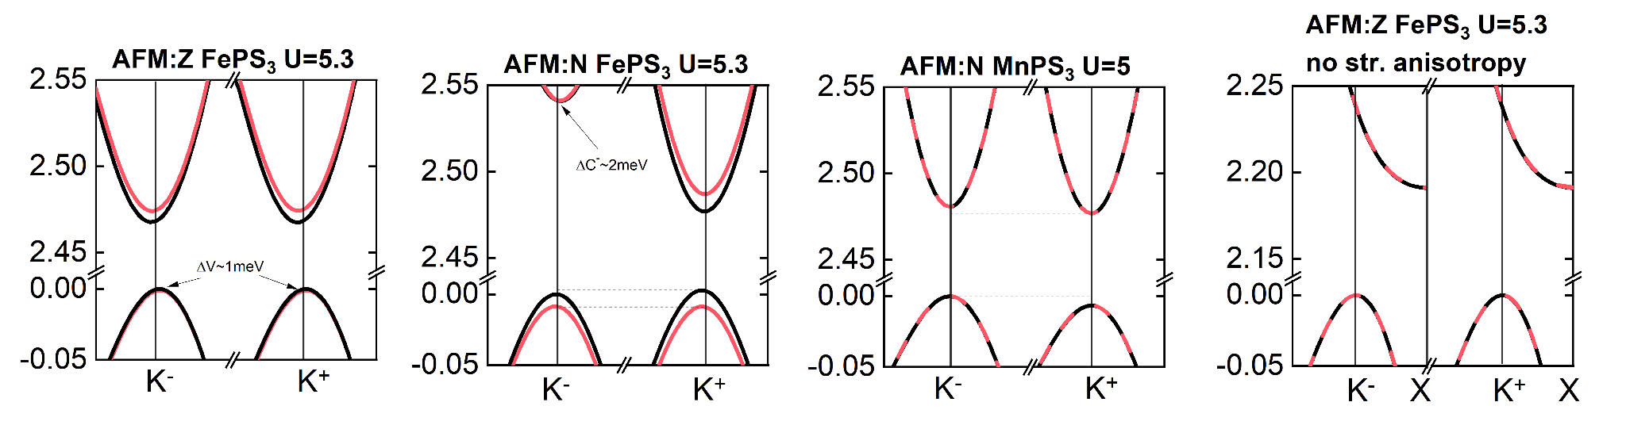
Figure S 2: Band structures in vicinity of Fermi level: using DFT+U+SOI (U=5.3eV for FePS3, U=5eV for MnPS₃

3. Optical Measurements
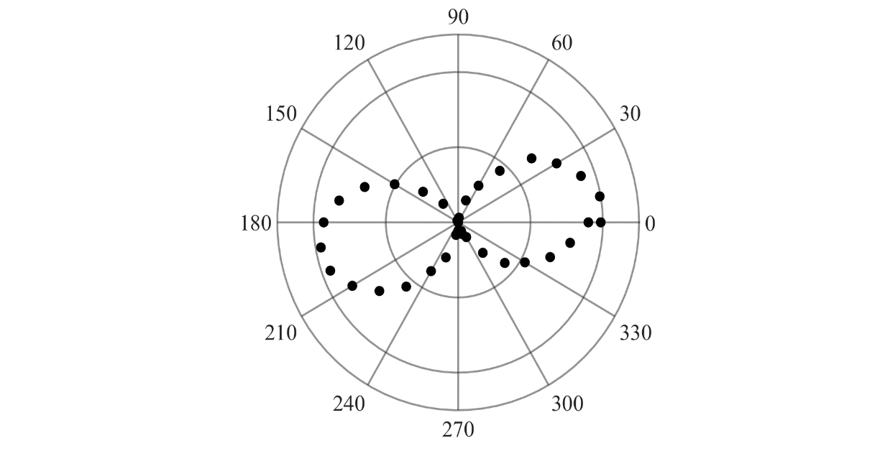
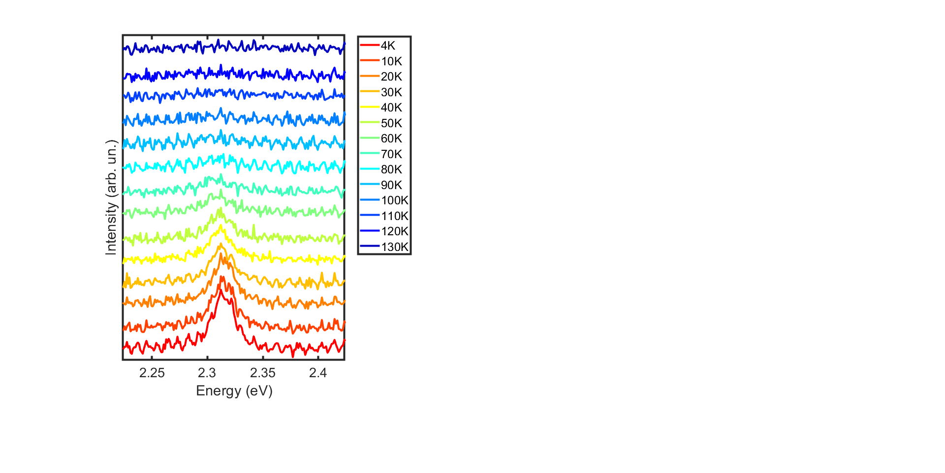
  - ME transition measurements
Intensity
1 2
Figure S 3: Optical measurements of ME transition. (a) Polar plot of linear polarization measurements of ME transition at 4K. (b) Temperature dependent measurements of ME transition, where T = 4-130K
(a)

  - Gaussian fits of PL spectra
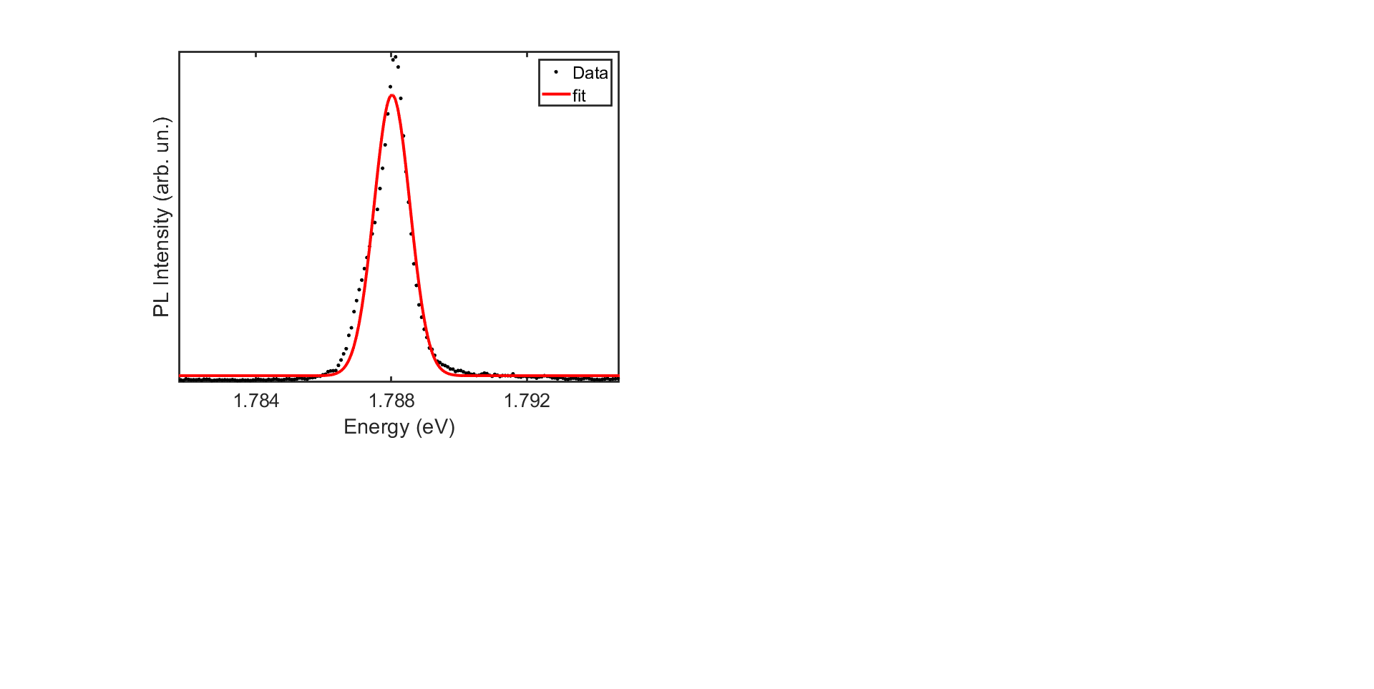
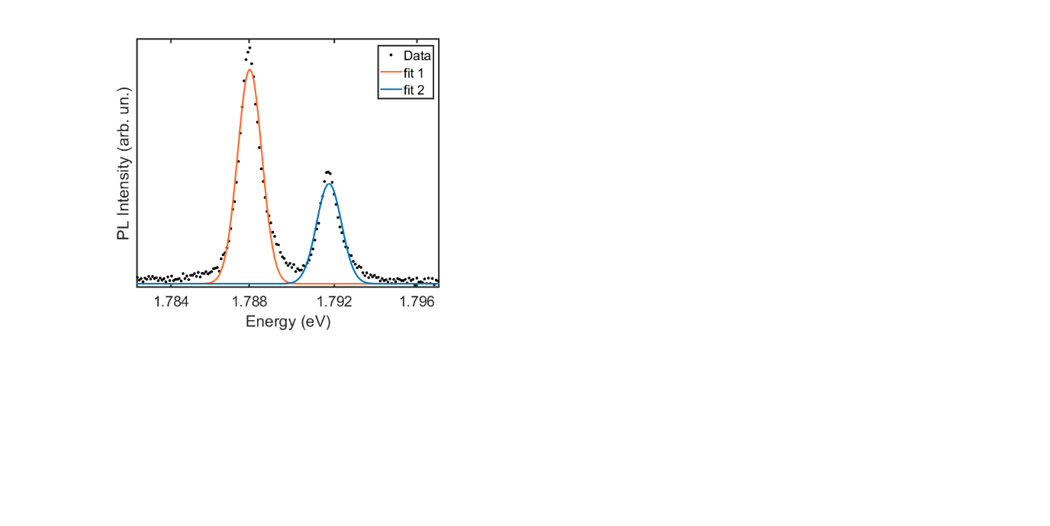
Figure S 4: Gaussian fits of LE transition at (a) 4K and (b) 70K.

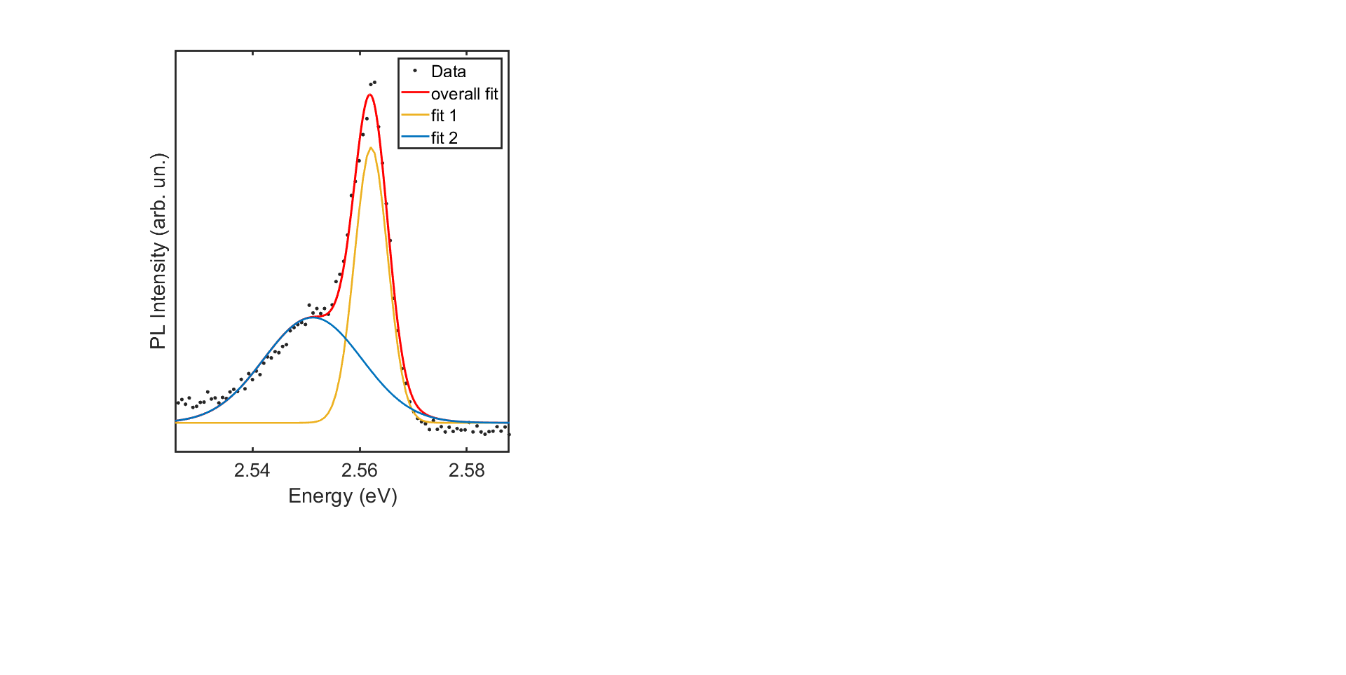
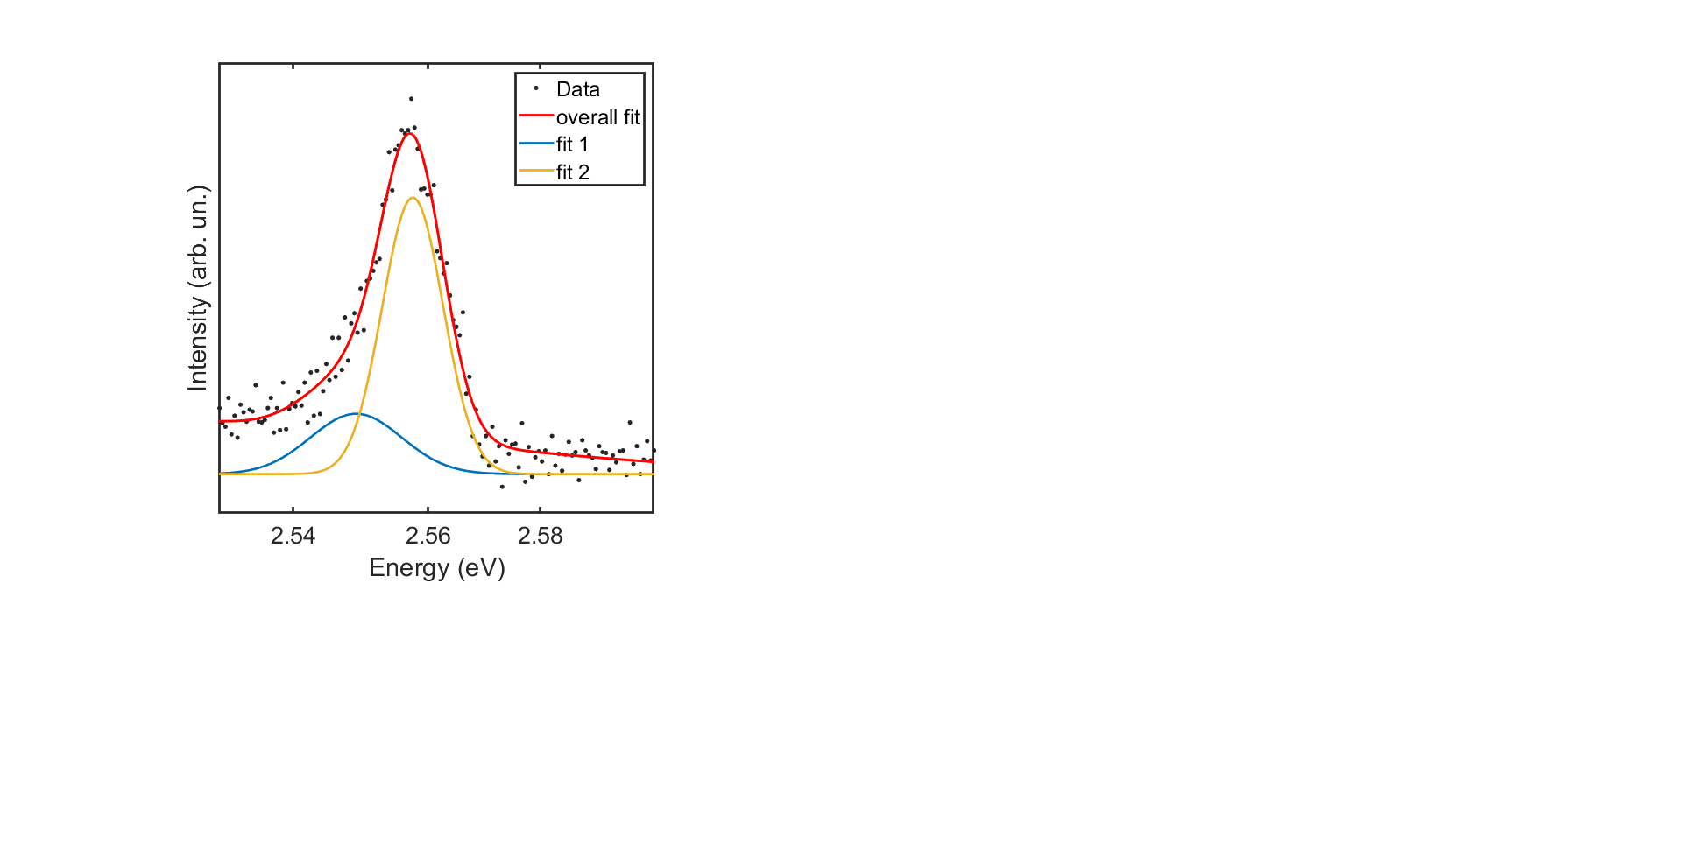
Figure S 5: Gaussian fits of HE transition at (a) 4K and (b) 70K

