Table 5 Good practice inclusive communication qualitative analysis.

Post copies plain text:
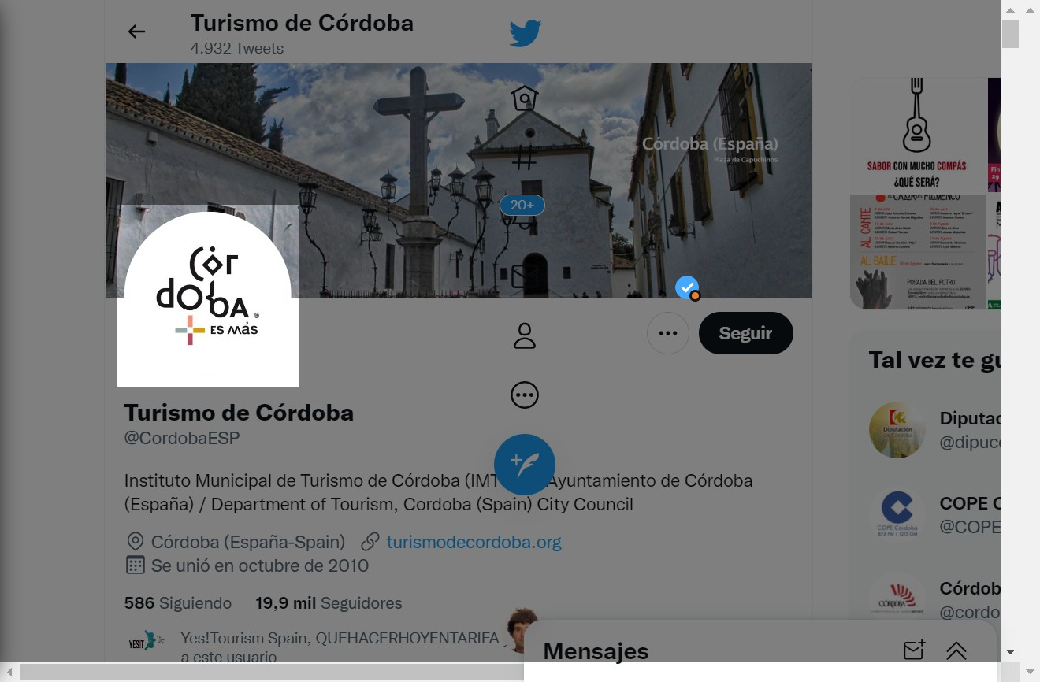 | 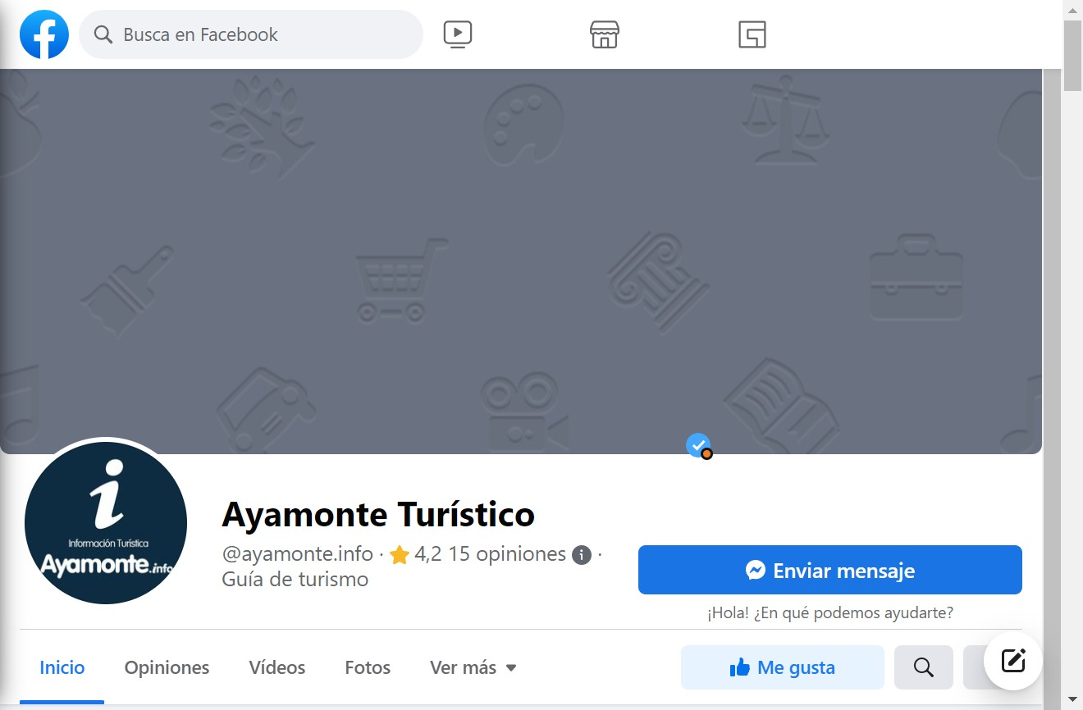 | 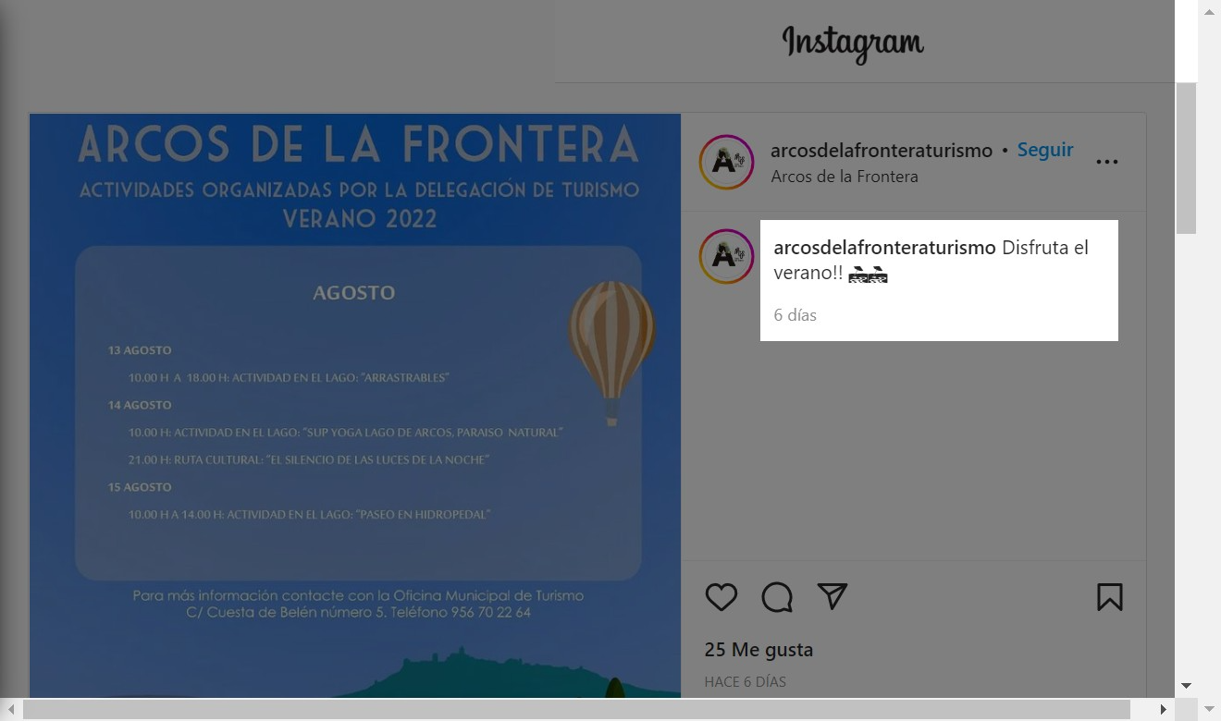
https://twitter.com/CordobaESP | https://www.facebook.com/ayamonte.info | https://www.instagram.com/arcosdelafronteraturismo/
Plain language: Half posted contents with 50,4% use plain text (clear and concise, not all assistive devices can identify alternative character sets, etc.) | Notes: Identify non-illustrative titles and copies concerning the contents of the posts. At other times, as in the case of Arcos, the content is minimal and lacks essential information. | Recommendation: Arial, Verdana or Helvetica fonts, minimum size 12 to 18. Legible headings with appropriate terminology.
Post images with alternative text:
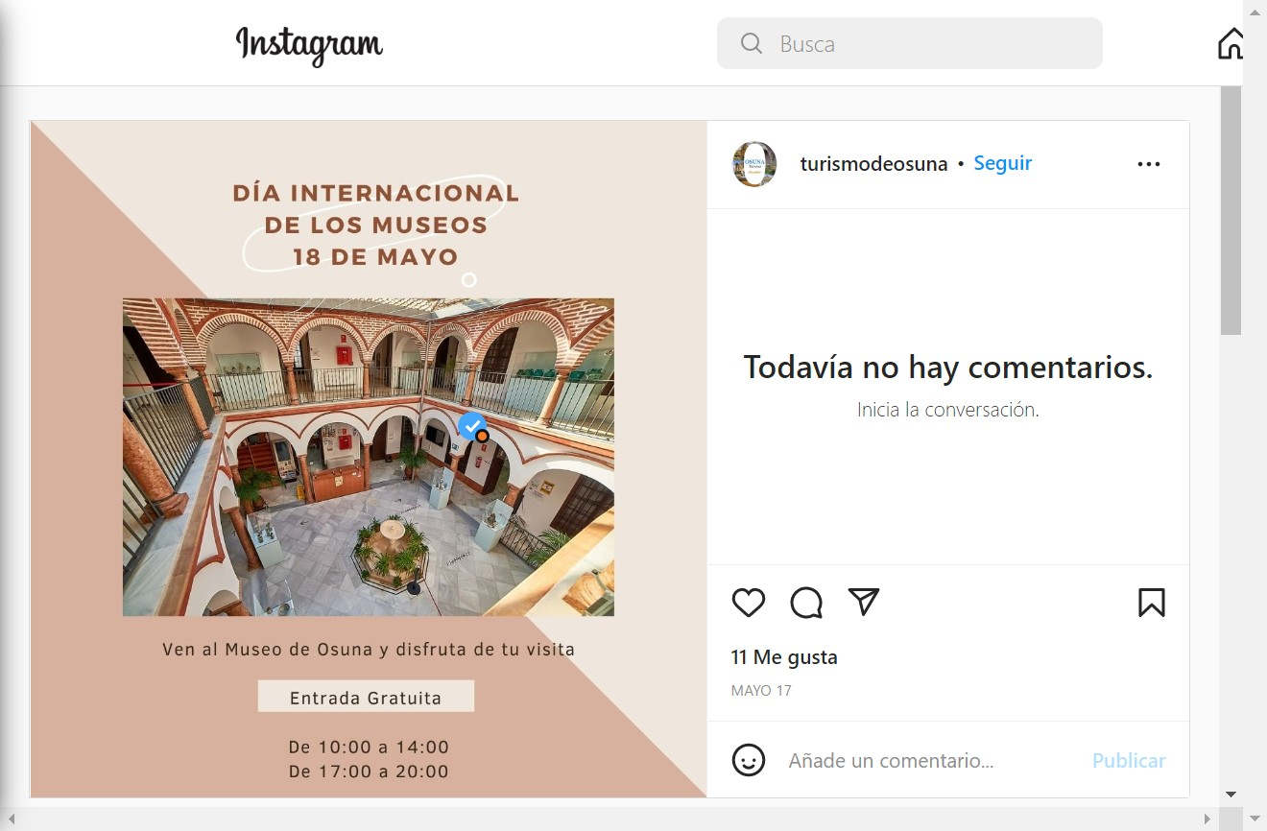 | 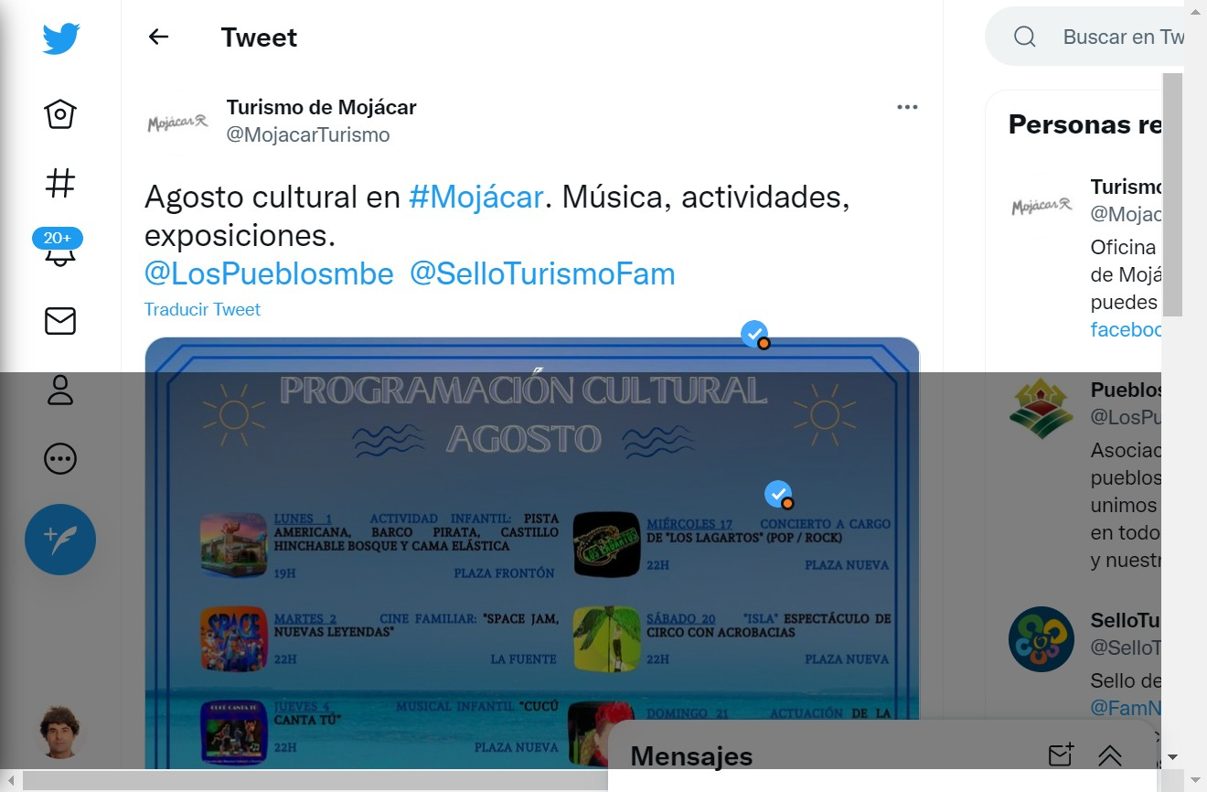 | 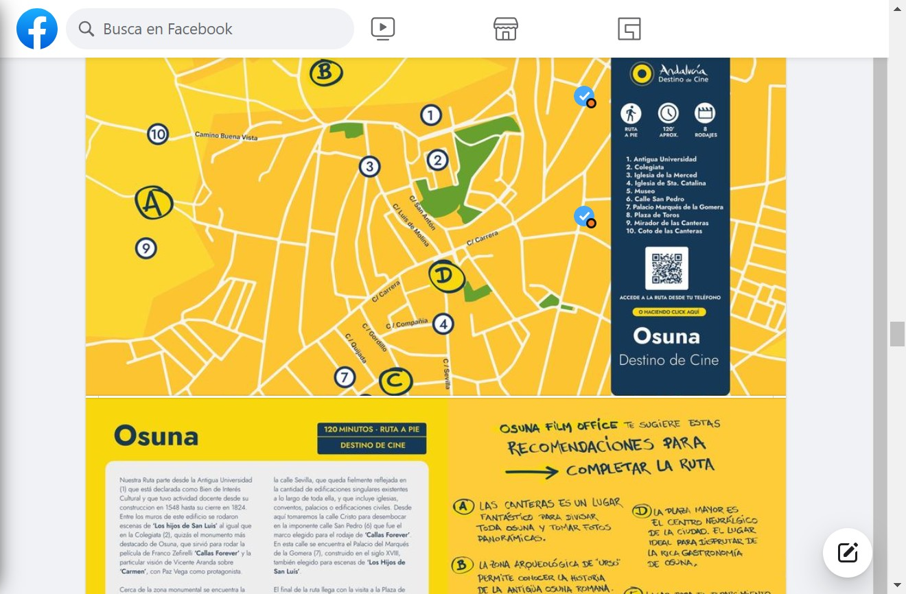
https://www.instagram.com/turismodeosuna/ | https://twitter.com/MojacarTurismo | https://www.facebook.com/oficinadeturismodeosuna
Alternative text: Almost inexistent, just 1,63% of images use alternative text (appropriate alt text for images, GIFs, etc.) | Notes: Generally, do not use alternative text for images. | Recommendation: Appropriated alt text for images or graphics, especially with the flattened copy from images.
Posting without captions:
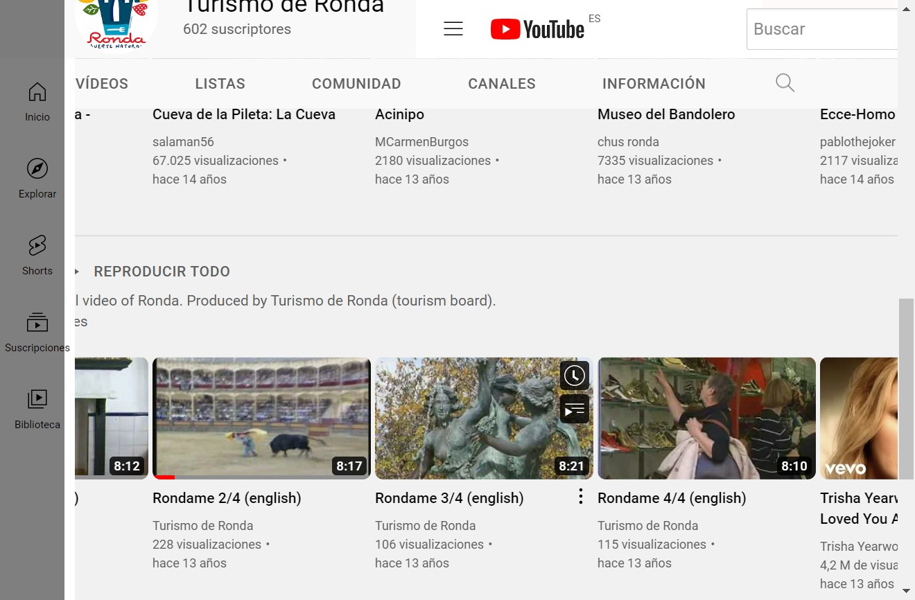 | 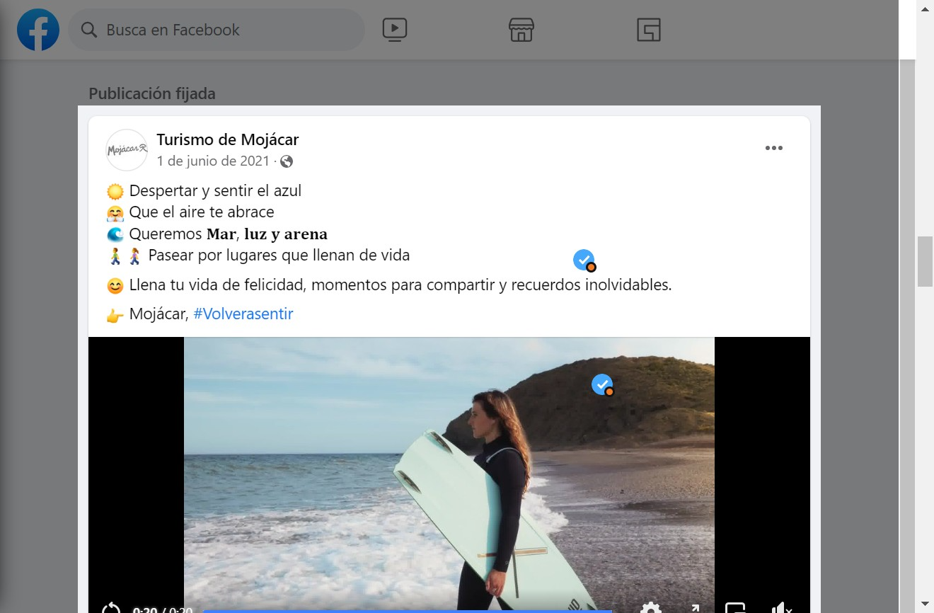 | 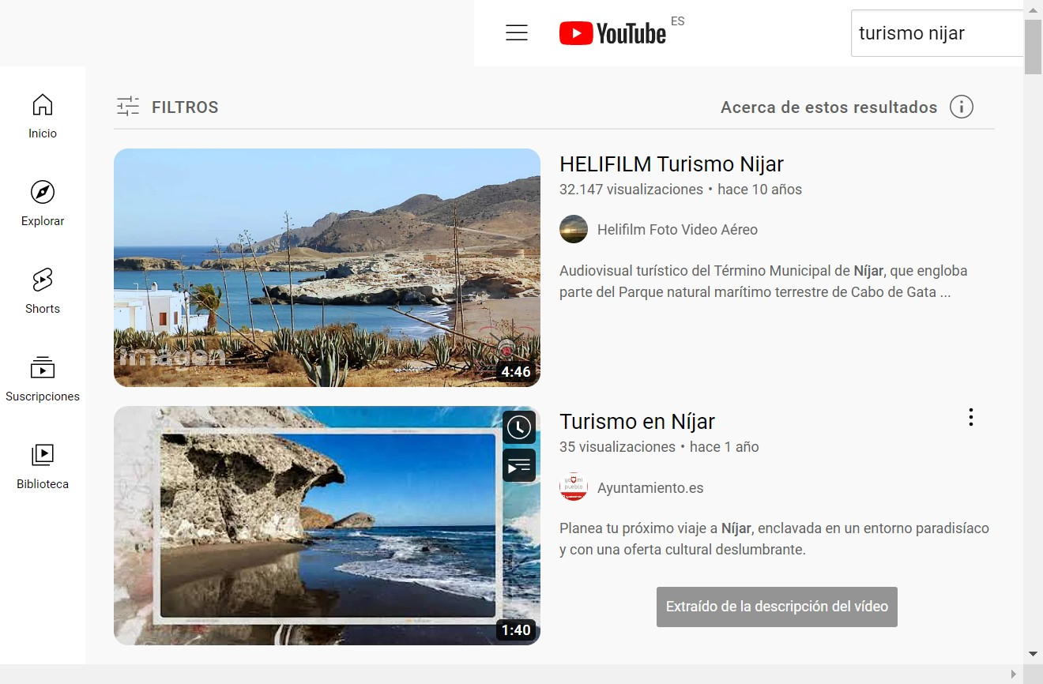
https://www.youtube.com/user/turismoderonda | https://www.facebook.com/TurismoMojacar | https://www.youtube.com/nijar
Captions: Just 8,94% use captions in videos (descriptions of visual elements, captioned all videos that contained dialogue or audio, etc) | Notes: Generally, do not use captions for videos. | Recommendation: Encourage the widespread use of captions when posts include videos.
Posting without transcriptions:
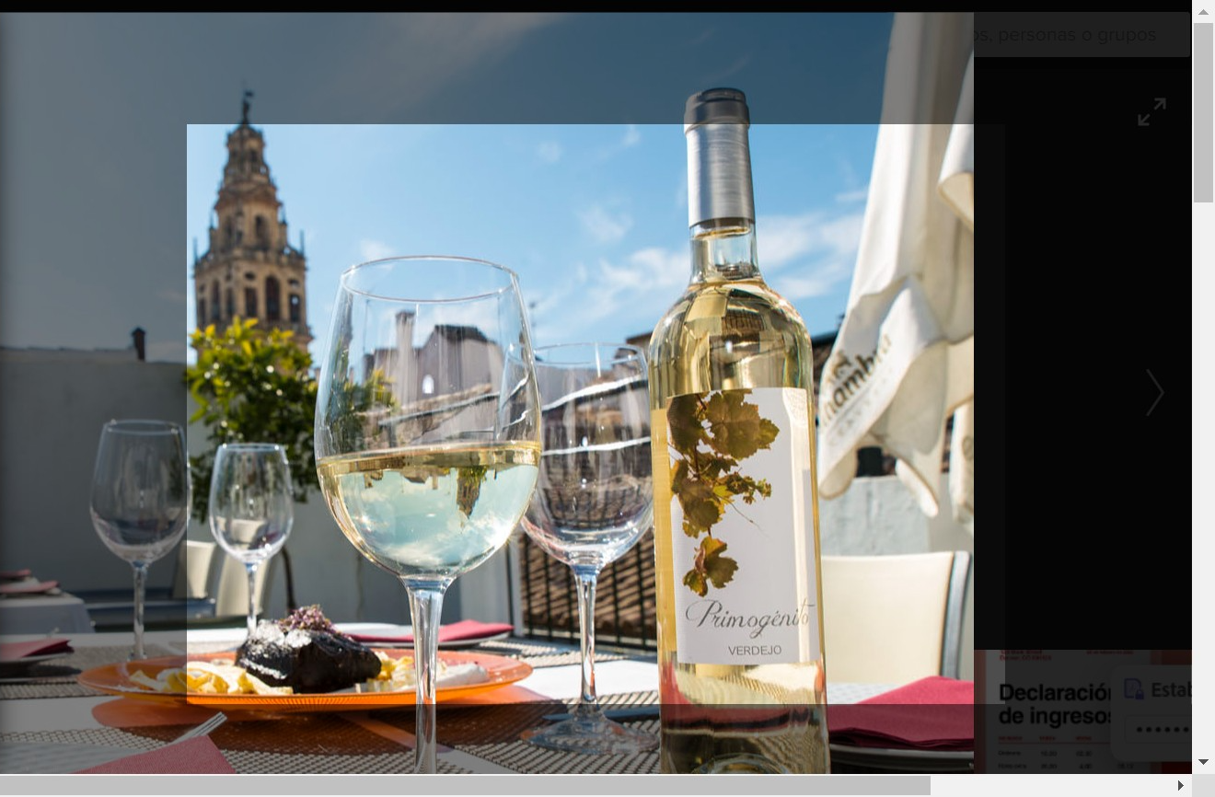 | 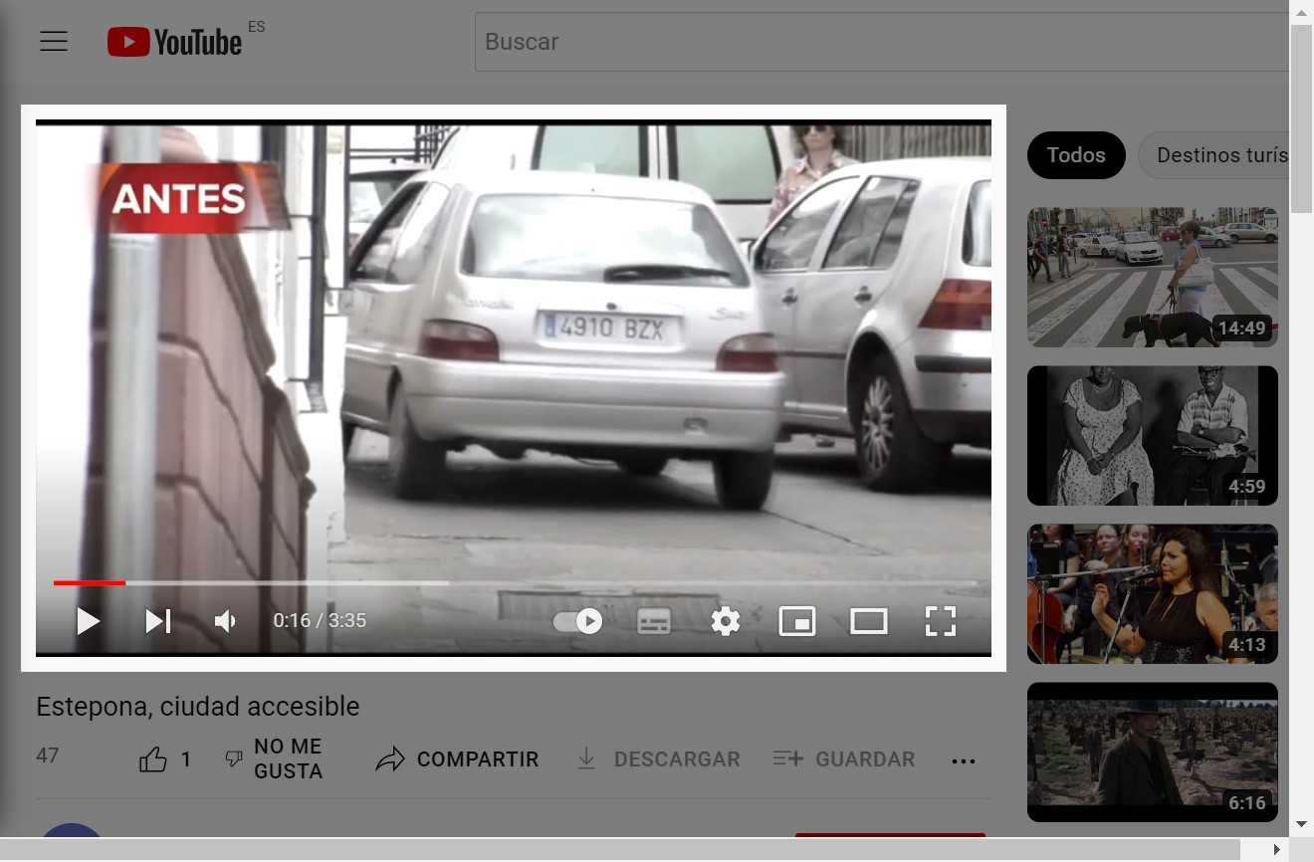 | 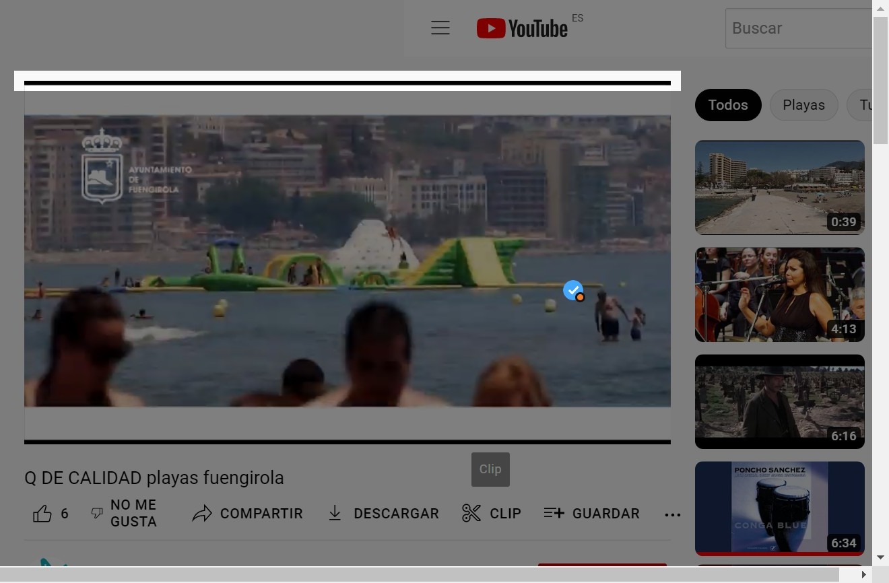
https://www.flickr.com/photos/cordoba/ | https://www.youtube.com/turismoestepona | https://www.youtube.com/fuengirola
Transcriptions: A few of posted contents with 4,06% use transcriptions. | Notes: Generally, do not use transcriptions for videos or audio-contents. | Recommendation: Encourage the widespread use of transcriptions with well-formatted transcripts available for any audio content.
From an excessive hashtag use to no use of them:
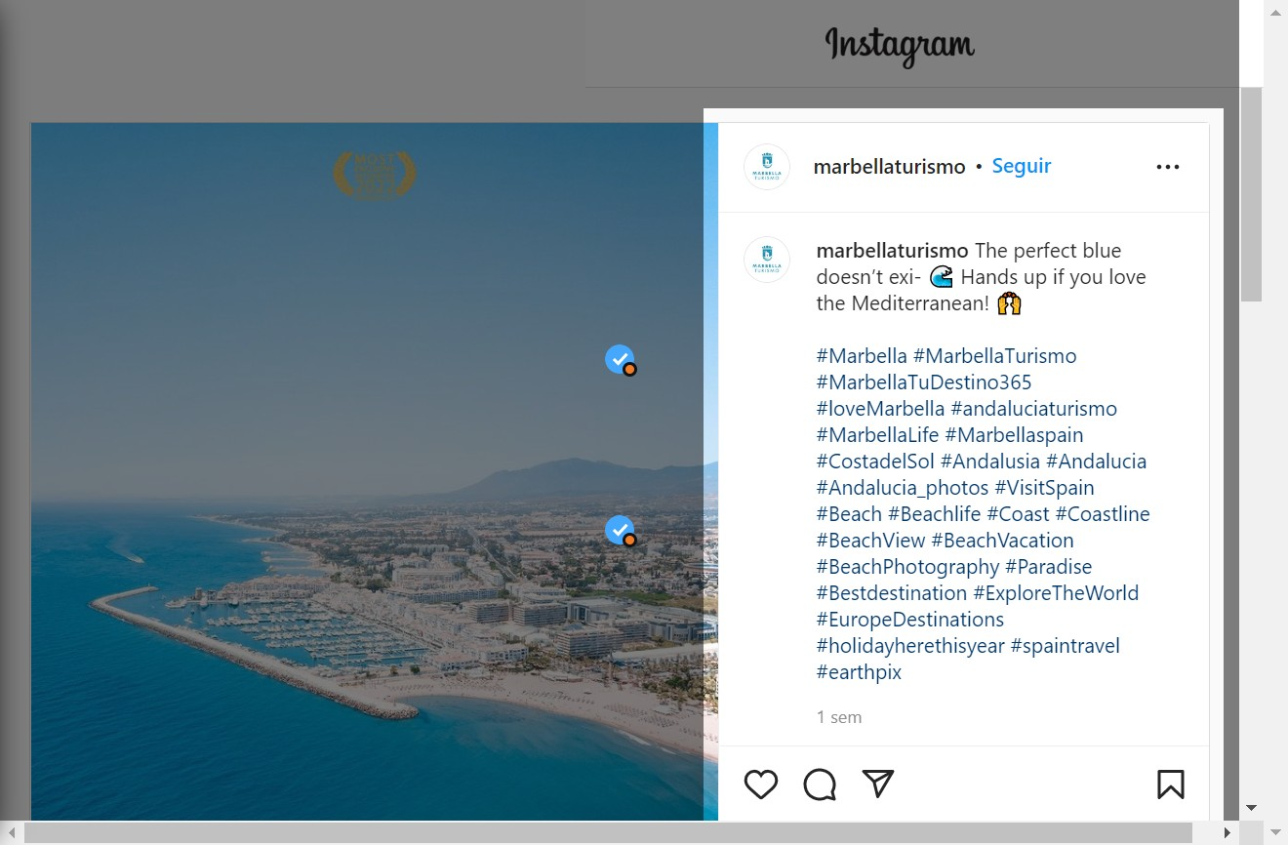 | 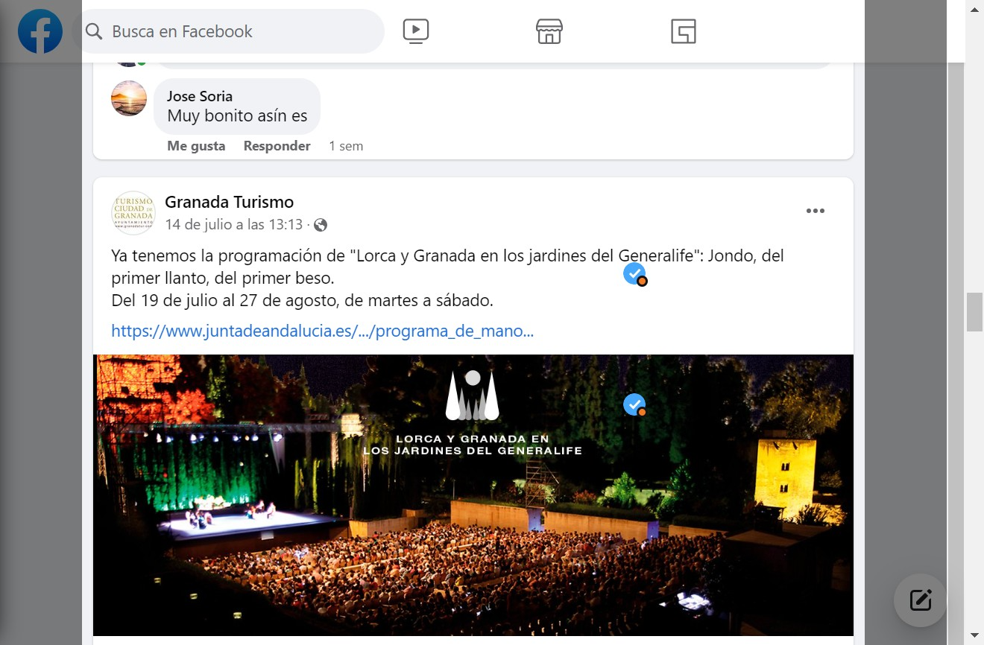 | 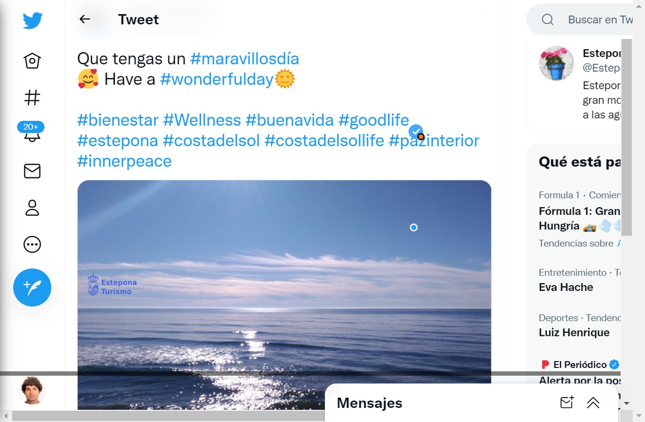
https://www.instagram.com/marbellaturismo/ | https:///www.facebook.com/granadaturismo | https://twitter.com/EsteponaTurAyto
Hashtags: 13,82% profiles use correctly hashtags. | Notes: From Marbella with abusive use or Estepona, which includes hashtags in the copy, making it difficult for screen readers, to Granada, where no hashtags are used, making it difficult for users to identify the content in their searches. | Recommendation: hashtags in moderation, multi-word hashtag in Camel Case, hashtags at the end of post.
Emojis in excess:
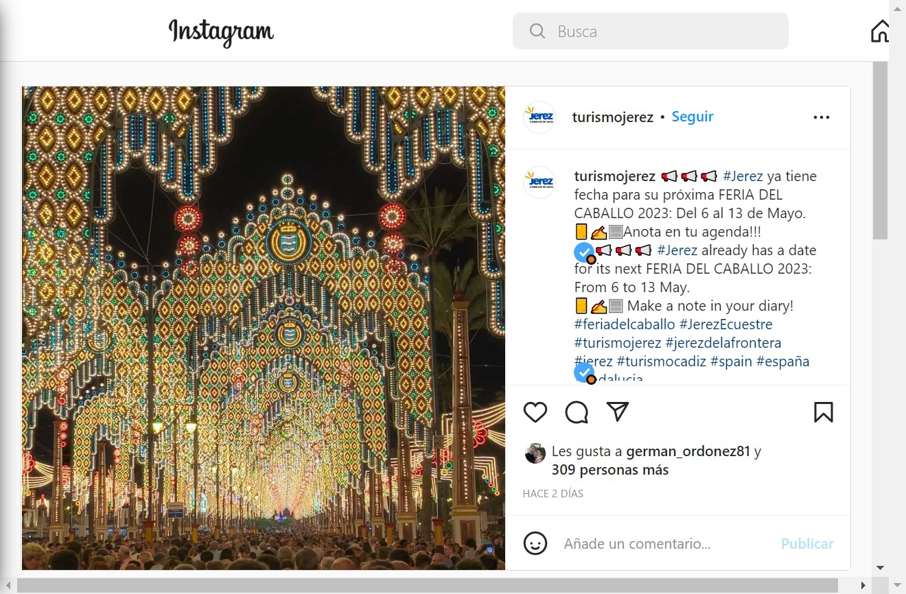 | 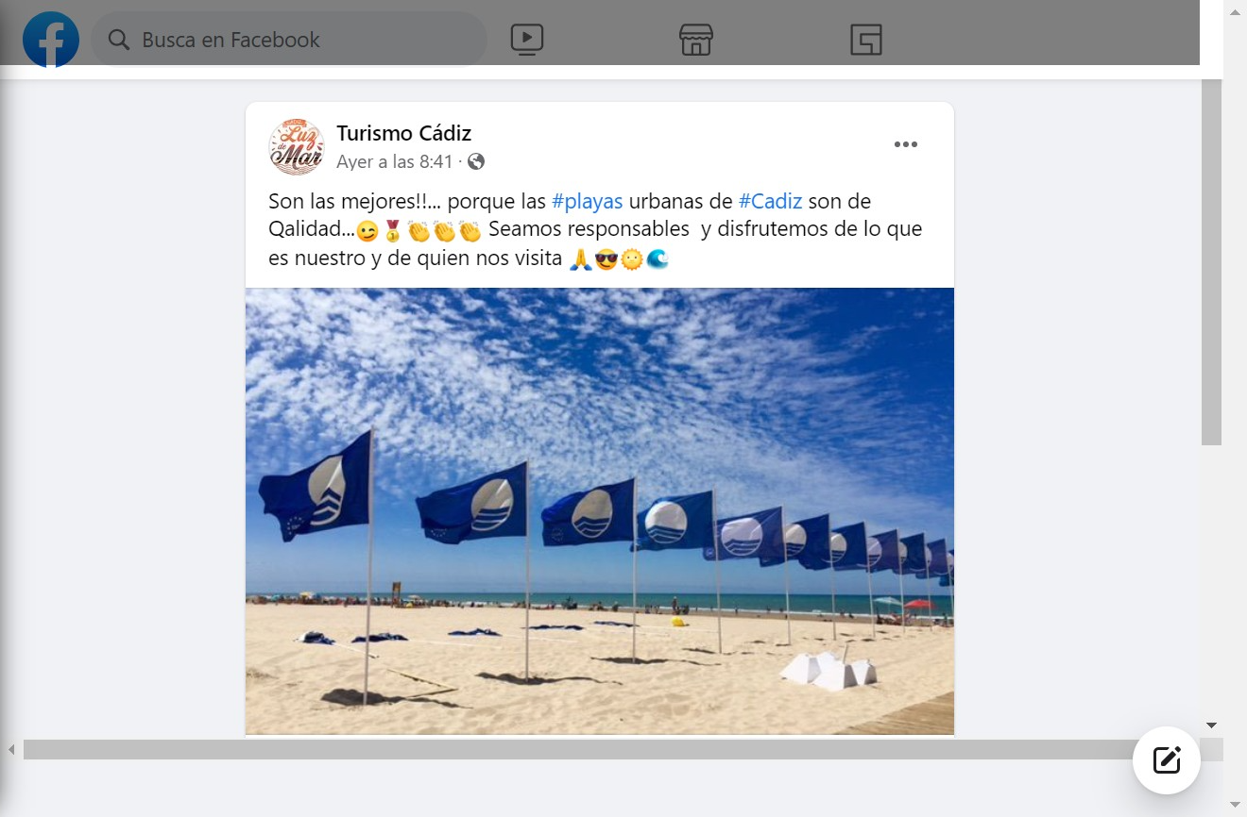 | 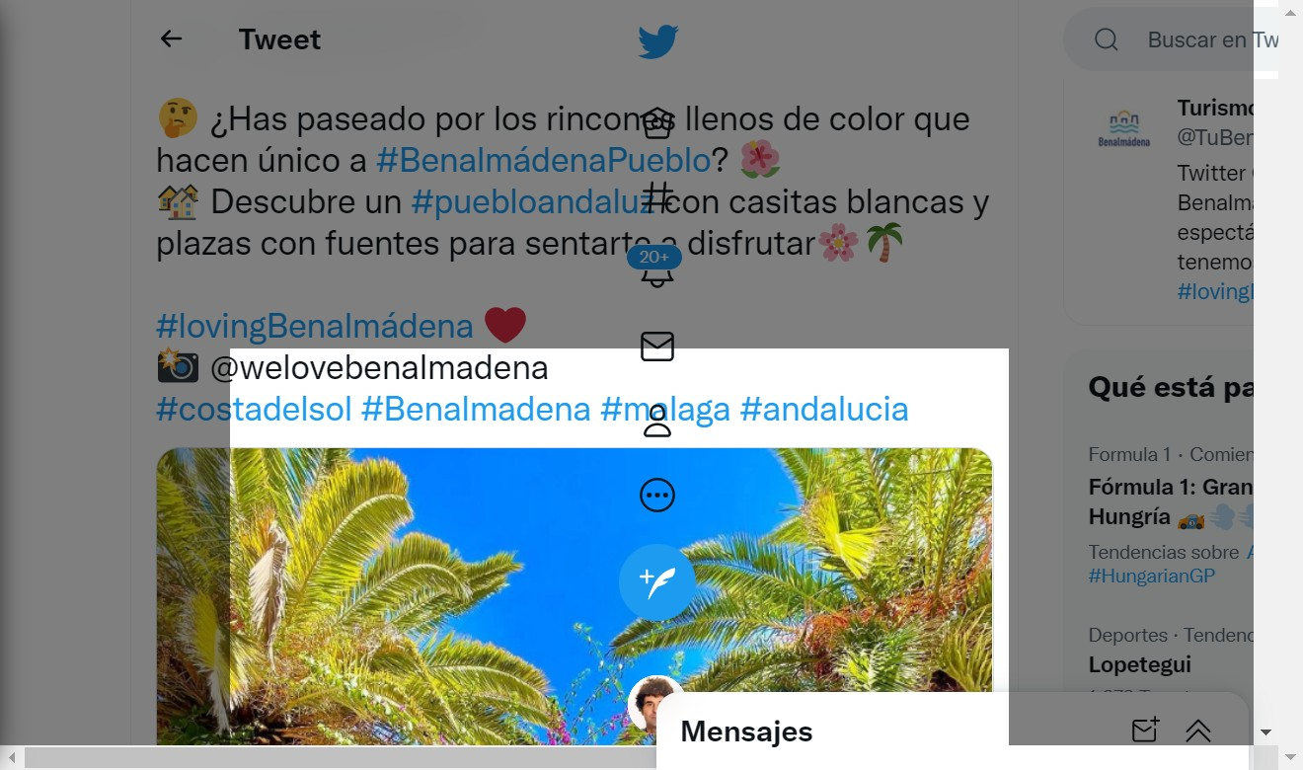
https://www.instagram.com/turismojerez/ | https://www.facebook.com/visitcadiz | https://twitter.com/tubenalmadena/
Emojis: 22% of profiles use correctly. | Notes: The abusive and inappropriate use of emojis is widespread, with the cases of Jerez, Cádiz and Benalmádena as examples. | Recommendation: Emojis in moderation, avoid emojis use as bullet points, avoid putting emojis in the middle of written copy, etc.

