9. Appendices

Appendix 1: Un-thinned woodlots in Kivuuvu

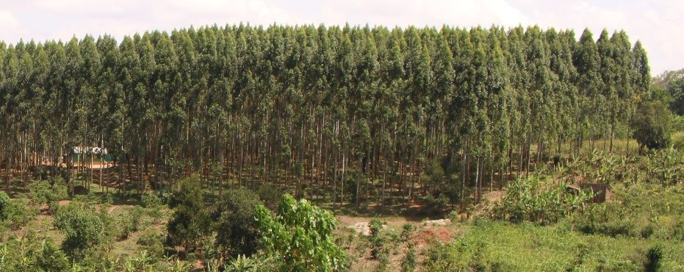
Source: Rawdata

Appendix 2: Recommended thinning regimes for Eucalyptus and pine

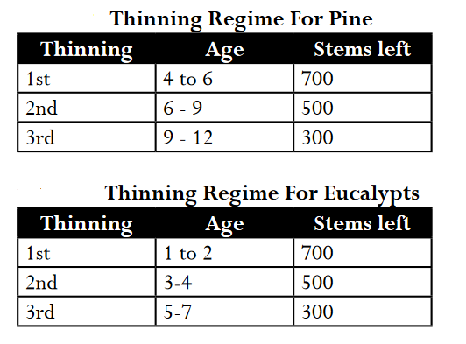
Source: SPGS Forestry and Tree Planting Guide, 2004

