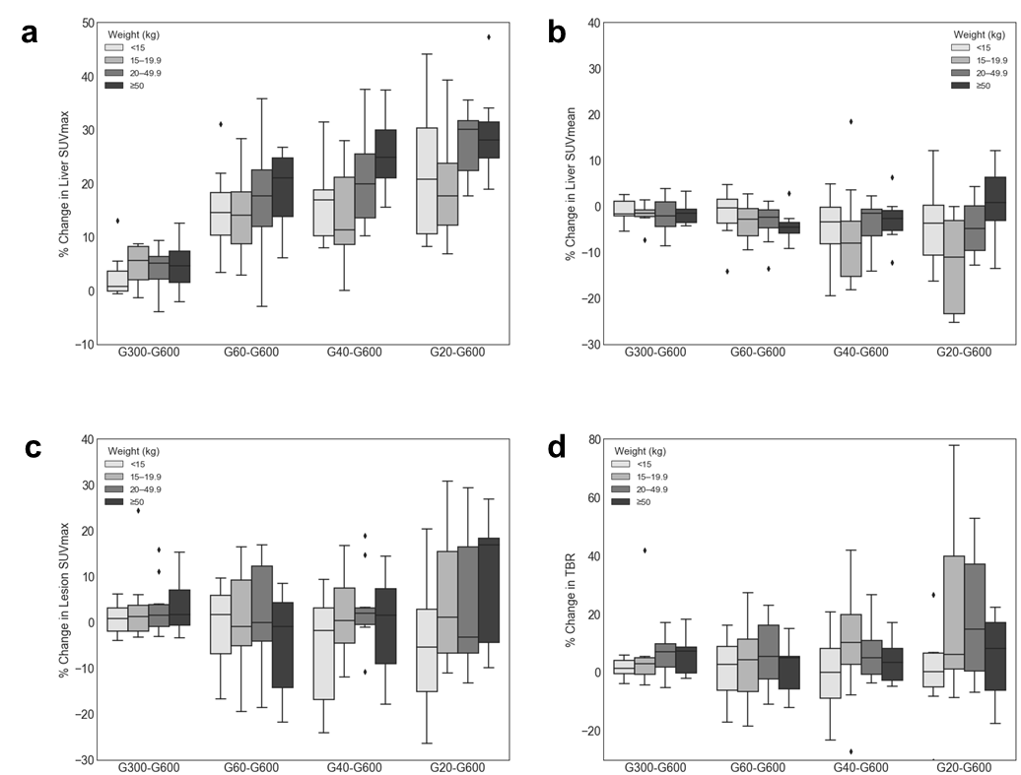
Supplementary Fig. 1 The bias and variability in the uptake measurements. Data were subgroup by body weight into <15 kg (n = 8), 15–19.9 kg (n = 8), 20–49.9 kg (n = 10), ≥ 50 kg (n = 7). Results shown for (A) SUV_{max} and (B) SUV_{mean} in the liver, (C) SUV_{max} in the lesion, (D) lesion-to-background ratio. The plot shows the percent changes compared to the full-dose images. G20s showed an substantial variation in lesion uptake. Subgroup difference were tested for age, body weight, BMI, no significance was found.
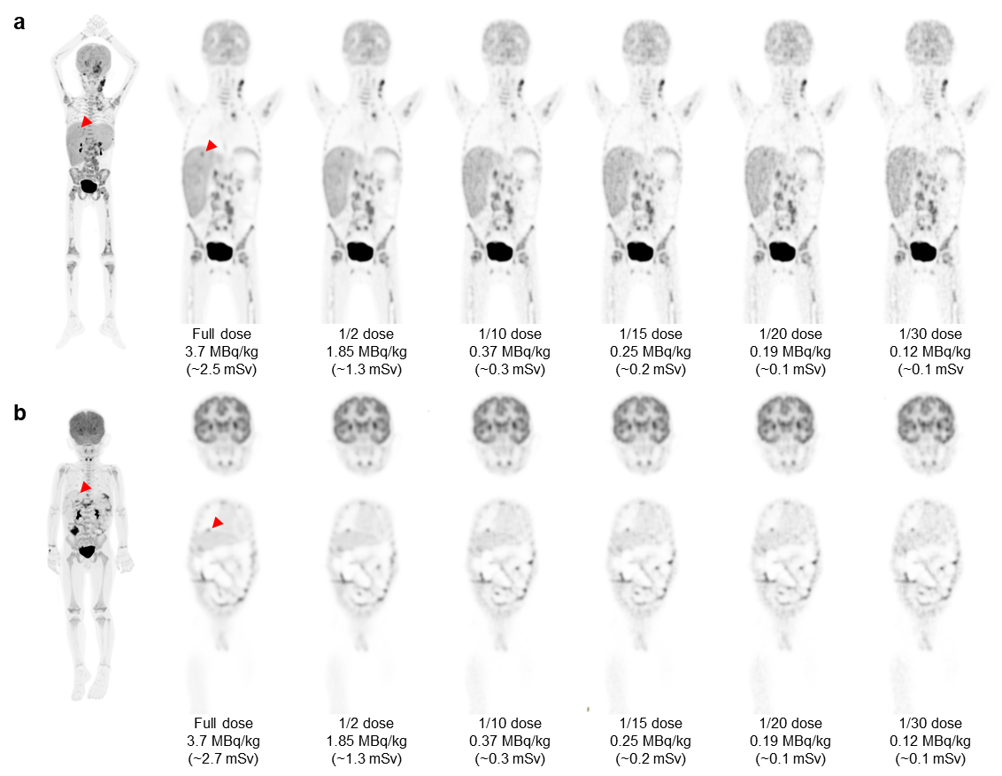
Supplementary Fig. 2 MIP of the full dose image and coronal view of the serial dose reduction image generated by reduced count. (a) An FDG-avid micro-lesion in the liver of a 7-year-old patient with neuroblastoma, with an SUVmax of 4.35 on the full-dose image. Note that the right lobe of liver was infiltrated with an increased SUVmax of 2.68 and an SD of 0.14 in the full-dose image. The lesion was identifiable as reduced down to 1/20-dose; were un-diagnosable at 1/30-dose. (b) A micro-lesion in the subcapsular region of the liver in a 3-year-old patient with Burkitt Lymphoma was diagnosable in all dose reduction setting. Data in the parentheses were estimated effective doses.

Supplementary Table 1 Likert scoring system for subjective PET image quality
 | Overall quality | Lesion conspicuity | Image noise
5 | state-of-the-art quality | well-defined | near-imperceptible noise
4 | superior to the average | fairly-defined | lower than regular image of daily practice
3* | regular quality of daily practice | hazy, recognizable | similar to regular image of daily practice
2 | barely diagnostic | ill-defined, impairing diagnostic confidence | increased noise, slightly worse than regular image of daily practice
1 | non-diagnostic | un-recognizable | excessive noise
* The scan protocol for daily practice in our center were as follows, all patients fasted for five to six hours prior to 18F-FDG administration. PET/CT scans were performed with integrated PET/CT scanner (Biograph mCT, Siemens Healthcare, Henkestr, Germany) with an axial FOV of 22.1 cm. Image data were acquired 60 ± 10 min after the 18F-FDG injection (3.7 ± 0.37 MBq [0.1mCi]/kg body weight). The emission images were obtained with six- to eight-bed positions (for patients with suspected lesions in the distal lower extremities, eight- to ten-bed positions were required). The acquisition time per bed position of emission images was for 1.5–2.0 minutes in three-dimensional (3D) mode. The PET images were reconstructed with a slice thickness of 2 mm in a 200 × 200 matrix, using the Ordered Subsets Expectation Maximization (OSEM) iterative image reconstruction method. PET, CT, and fused PET/CT images were generated for review on a Xeleris computer workstation (GE Medical Systems).
Supplementary Table 2 Actual injected activity and simulated injected activity
No. | Gender | Age (yr) | Height (cm) | Weight (kg) | Actual injected activity (MBq) | Simulated injected activity (MBq)
 |  |  |  |  | ~3.7 MBq/kg | 1.85 MBq/kg | 0.37 MBq/kg | 0.25 MBq/kg | 0.12 MBq/kg
1 | F | 0.8 | 70 | 8.5 | 32.9 | 16.5 | 3.3 | 2.2 | 1.1
2 | M | 1.4 | 77 | 10.2 | 40.0 | 20.0 | 4.0 | 2.7 | 1.3
3 | M | 1.9 | 82 | 10.0 | 40.0 | 20.0 | 4.0 | 2.7 | 1.3
4 | F | 2.1 | 87 | 12.0 | 38.1 | 19.1 | 3.8 | 2.5 | 1.3
5 | M | 2.2 | 83 | 10.0 | 40.0 | 20.0 | 4.0 | 2.7 | 1.3
6 | M | 3.2 | 98 | 15.1 | 58.1 | 29.0 | 5.8 | 3.9 | 1.9
7 | F | 3.7 | 98 | 13.5 | 54.0 | 27.0 | 5.4 | 3.6 | 1.8
8 | F | 3.7 | 105 | 14.5 | 55.5 | 27.8 | 5.6 | 3.7 | 1.9
9 | M | 3.8 | 110 | 15.0 | 61.8 | 30.9 | 6.2 | 4.1 | 2.1
10 | M | 4.7 | 105 | 16.7 | 65.5 | 32.7 | 6.5 | 4.4 | 2.2
11 | M | 4.9 | 107 | 15.8 | 61.1 | 30.5 | 6.1 | 4.1 | 2.0
12 | M | 5.1 | 105 | 16.2 | 61.4 | 30.7 | 6.1 | 4.1 | 2.0
13 | M | 5.5 | 110 | 17.1 | 65.1 | 32.6 | 6.5 | 4.3 | 2.2
14 | M | 6.0 | 121 | 21.7 | 92.5 | 46.3 | 9.3 | 6.2 | 3.1
15 | M | 6.1 | 110 | 14.8 | 58.1 | 29.0 | 5.8 | 3.9 | 1.9
16 | F | 6.3 | 118 | 26.0 | 93.6 | 46.8 | 9.4 | 6.2 | 3.1
17 | M | 6.4 | 115 | 18.2 | 69.2 | 34.6 | 6.9 | 4.6 | 2.3
18 | M | 7.1 | 113 | 17.0 | 65.9 | 32.9 | 6.6 | 4.4 | 2.2
19 | M | 7.8 | 128 | 30.0 | 112.1 | 56.1 | 11.2 | 7.5 | 3.7
20 | M | 9.1 | 119 | 21.1 | 79.6 | 39.8 | 8.0 | 5.3 | 2.7
21 | M | 10.5 | 145 | 31.0 | 118.4 | 59.2 | 11.8 | 7.9 | 3.9
22 | F | 10.8 | 151 | 31.5 | 114.7 | 57.4 | 11.5 | 7.6 | 3.8
23 | M | 11.3 | 145 | 38.2 | 141.7 | 70.9 | 14.2 | 9.4 | 4.7
24 | F | 12.0 | 162 | 50.1 | 184.6 | 92.3 | 18.5 | 12.3 | 6.2
25 | M | 12.3 | 162 | 42.0 | 155.4 | 77.7 | 15.5 | 10.4 | 5.2
26 | F | 12.4 | 150 | 50.0 | 183.9 | 91.9 | 18.4 | 12.3 | 6.1
27 | M | 14.1 | 159 | 36.1 | 134.3 | 67.2 | 13.4 | 9.0 | 4.5
28 | F | 15.0 | 156 | 43.0 | 159.1 | 79.6 | 15.9 | 10.6 | 5.3
29 | M | 15.6 | 165 | 55.0 | 203.1 | 101.6 | 20.3 | 13.5 | 6.8
30 | M | 15.8 | 176 | 57.0 | 210.5 | 105.3 | 21.1 | 14.0 | 7.0
31 | M | 16.8 | 172 | 58.5 | 217.9 | 109.0 | 21.8 | 14.5 | 7.3
32 | M | 17.0 | 158 | 51.0 | 188.7 | 94.4 | 18.9 | 12.6 | 6.3
33 | M | 17.6 | 169 | 58.0 | 213.9 | 106.9 | 21.4 | 14.3 | 7.1

Supplementary Table 3 Percentage Change of lesion uptake in dose reduced groups
 | G300s | G60s | G40s | G20s
Lesion SUV max | 2.8% ± 6.4% | -0.8% ± 11.1% | -0.3% ± 10.6% | 3.0% ± 15.1%
LBR | 5.1% ± 8.8% | 3.4% ± 11.9% | 5.2% ± 13.9% | 11.5% ± 22.7%
Percent change was calculated as subtracting the value in G600s from that of the dose reduced group and then divided by the value in G600s.
Supplementary Table 4 Description of the identified microlesions
No. | Age (Yr) | Sex | Diagnosis | Microlesion
 |  |  |  | Site | Short-diameter | long-diameter
1 | 3.2 | M | Non-Hodgkin's lymphoma | Subcutaneous nodule, shoulder, left | 0.6 | 0.6
2 | 15.6 | M | Rhabdomyosarcoma | Subcutaneous nodule, forehead | 0.5 | 0.5
3 | 17 | M | Schwannoma (neurilemoma) | Subcutaneous nodule | 0.9 | 1.8
4 | 3.7 | F | Rhabdomyosarcoma | Palatine tonsil, left | 0.7 | 1.1
5 | 6.4 | M | Nephroblastoma | Palatine tonsil, left | 1 | 1.2
6 | 6.1 | M | Non-Hodgkin's lymphoma | Vocal cord, right | 0.5 | 0.8
7 | 4.9 | M | Non-Hodgkin's lymphoma | Mesentery, right | 0.6 | 0.6
8 | 9.1 | M | Rhabdomyosarcoma | Esophagus, lower-thoracic | 0.5 | 0.7
9 | 7.8 | M | Ewing's sarcoma | Intraspinal nodule, at T12 level | 0.5 | 0.7
10 | 5.5 | M | Hodgkin's lymphoma | Cervical lymph node, IV, right | 0.6 | 0.7
11 | 1.9 | M | Langerhans cell histiocytosis | Cervical lymph node, II, right | 0.8 | 1
12 | 17.6 | M | Non-Hodgkin's lymphoma | Cervical lymph node, II, right | 0.5 | 0.6
13 | 10.8 | F | Nasopharyngeal carcinoma | Retropharyngeal lymph node, left | 0.5 | 0.6
14 | 15.8 | M | Nasopharyngeal carcinoma | Parotid lymph node, left | 0.5 | 0.7
15 | 15.0 | F | Nasopharyngeal carcinoma | Inguinal lymph node, right | 0.6 | 0.6
16 | 16.8 | M | T-cell acute lymphoblastic leukemia | Axillary lymph node, right | 0.4 | 0.7
17 | 12.3 | M | Ganglion cell tumors? | Cervical lymph node, II/III, right | 0.5 | 0.7
18 | 14.1 | M | Rhabdomyosarcoma | Cervical lymph node, II, right | 0.6 | 0.7
19 | 5.1 | M | Rhabdomyosarcoma | Inguinal lymph node, right | 0.6 | 0.6
20 | 10.5 | M | Myxoid liposarcoma | Cervical lymph node, II, right | 0.4 | 0.7
21 | 12.0 | F | Alveolar soft-part sarcoma | External iliac lymph node, left | 0.5 | 0.6
22 | 4.7 | M | Ewing's sarcoma | Cervical lymph node, II, right | 0.6 | 0.8
23 | 6.3 | F | Nephroblastoma | Retropharyngeal lymph node, right | 0.7 | 0.8
24 | 2.1 | F | Nephroblastoma | Retropharyngeal lymph node | 0.9 | 1.2
25 | 2.2 | M | Nephroblastoma | Cervical lymph node, II, right | 0.6 | 0.7
26 | 1.4 | M | Nephroblastoma | Cervical lymph node, II, right | 0.6 | 0.7
27 | 0.83 | F | Nephroblastoma | Cervical lymph node, II, right | 0.6 | 1
28 | 3.7 | F | Germ cell tumor | Cervical lymph node, II, right | 0.9 | 1.4
29 | 3.8 | M | Non-Hodgkin's lymphoma | Liver S8 | 0.7 | 0.8
30 | 7.1 | M | Nephroblastoma | Liver S7/S8 | 0.5 | 0.7
31 | 11.3 | M | Non-Hodgkin's lymphoma | Mandible, right | 0.5 | 0.5
32 | 6.0 | M | Non-Hodgkin's lymphoma | Pelvis, right | 0.6 | 0.8
33 | 12.4 | F | Osteosarcoma | Femur, right | 1 | 1.1

Supplementary Table 5 Examples of injected activity and estimate effective dose for administration of ¹⁸F-FDG for torso imaging
 | Example weight (kg) | Effective dose (mSv /MBq) * | Example Injected activity (MBq/kg)
 | Example weight (kg) | Effective dose (mSv /MBq) * | 3.7 | 1.85 | 0.74 | 0.37 | 0.25 | 0.12
Neonate (1 m) | 5 | 0.210† | 3.885 | 1.943 | 0.777 | 0.389 | 0.263 | 0.126
Child (1 y) | 10 | 0.095 | 2.960 | 1.480 | 0.592 | 0.296 | 0.200 | 0.096
Child (5 y) | 19 | 0.056 | 3.374 | 1.687 | 0.675 | 0.337 | 0.228 | 0.109
Child (10 y) | 32 | 0.037 | 3.789 | 1.894 | 0.758 | 0.379 | 0.256 | 0.123
Adolescent (15 y) | 58 | 0.024 | 4.721 | 2.361 | 0.944 | 0.472 | 0.319 | 0.153
Adolescent (17 y) | 64 | 0.019 | 4.499 | 2.250 | 0.900 | 0.450 | 0.304 | 0.146
*Stabin MG, Siegel JA. RADAR dose estimate report: a compendium of radiopharmaceutical dose estimates based on OLINDA/EXM Version 2.0. J Nucl Med. 2018;59:154–160. doi:10.2967/jnumed.117.196261
†Niven E, Nahmias C. Absorbed dose to very low birth weight infants from 18F-fluorodeoxyglucose. Health Phys. 2003;84:307-16. doi:10.1097/00004032-200303000-00003.

Supplementary Table 6 Image quality grading for time-activity product using total-body PET/CT (for paediatric dose study only)
Acquisition time (s [min]) | Injected activity (MBq)
Acquisition time (s [min]) | 3.70 | 2.78 | 1.85 | 1.48 | 1.11 | 0.74 | 0.56 | 0.37 | 0.25 | 0.12
600 [10] | 1.00 | 0.75 | 0.50 | 0.40 | 0.30 | 0.20 | 0.15 | 0.10 | 0.07 | 0.03
480 [8] | 0.80 | 0.60 | 0.40 | 0.32 | 0.24 | 0.16 | 0.12 | 0.08 | 0.05 | 0.03
300 [5] | 0.50 | 0.38 | 0.25 | 0.20 | 0.15 | 0.10 | 0.08 | 0.05 | 0.03 | 0.02
180 [3] | 0.30 | 0.23 | 0.15 | 0.12 | 0.09 | 0.06 | 0.05 | 0.03 | 0.02 | 0.01
120 [2] | 0.20 | 0.15 | 0.10 | 0.08 | 0.06 | 0.04 | 0.03 | 0.02 | 0.01 | 0.01
60 [1] | 0.10 | 0.08 | 0.05 | 0.04 | 0.03 | 0.02 | 0.02 | 0.01 | 0.01 | 0.00
40 [0.7] | 0.07 | 0.05 | 0.03 | 0.03 | 0.02 | 0.01 | 0.01 | 0.01 | 0.00 | 0.00
20s [0.3] | 0.03 | 0.03 | 0.02 | 0.01 | 0.01 | 0.01 | 0.01 | 0.00 | 0.00 | 0.00
*Green, recommended, optimal quality image can be obtained; Yellow and red, recommended under extreme conditions, suboptimal but diagnosable images can be obtained; Gray, not recommended, image obtained non-diagnostic.
†Data are estimated proportion of time-activity-product, set full-dose×full-acquisition time (3.70MBq/kg×10min/bed) as 1.00. The recommendation grade were given as follows, for proportion above that of full-dose×60s (0.10, subjective score 4+), green was given; for proportion above that of full-dose×40s (0.07, subjective score 3+), yellow was given; for proportion above that of full-dose×20s (0.03, subjective score 2+), red was given; for proportion below that of full-dose×20s (<0.03, subjective score <2), gray was given.
‡Note that this card resulted from a proof-of-concept study, and intended to direct further dose investigation.

