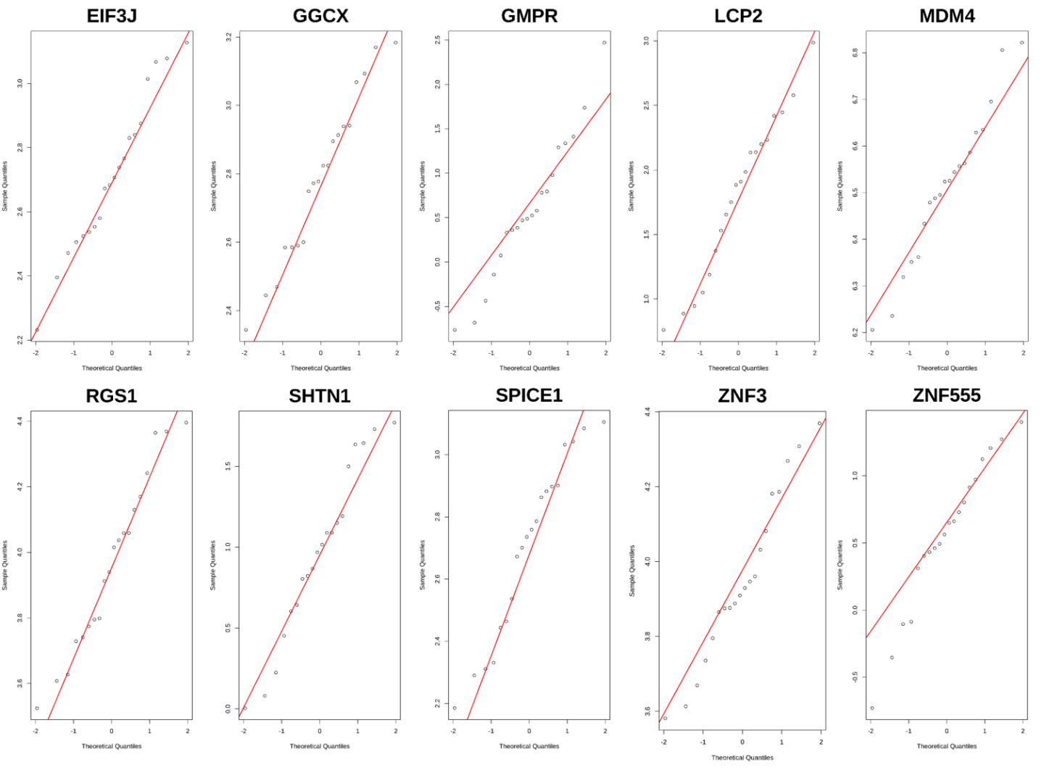
Supplementary Fig. S1. Quantile-Quantile plot
We conducted a normality checking for investigating a model adequacy using quantile-quantile plot. The shapiro-wilk's test was performed on the whole genes, and there are no significant genes.

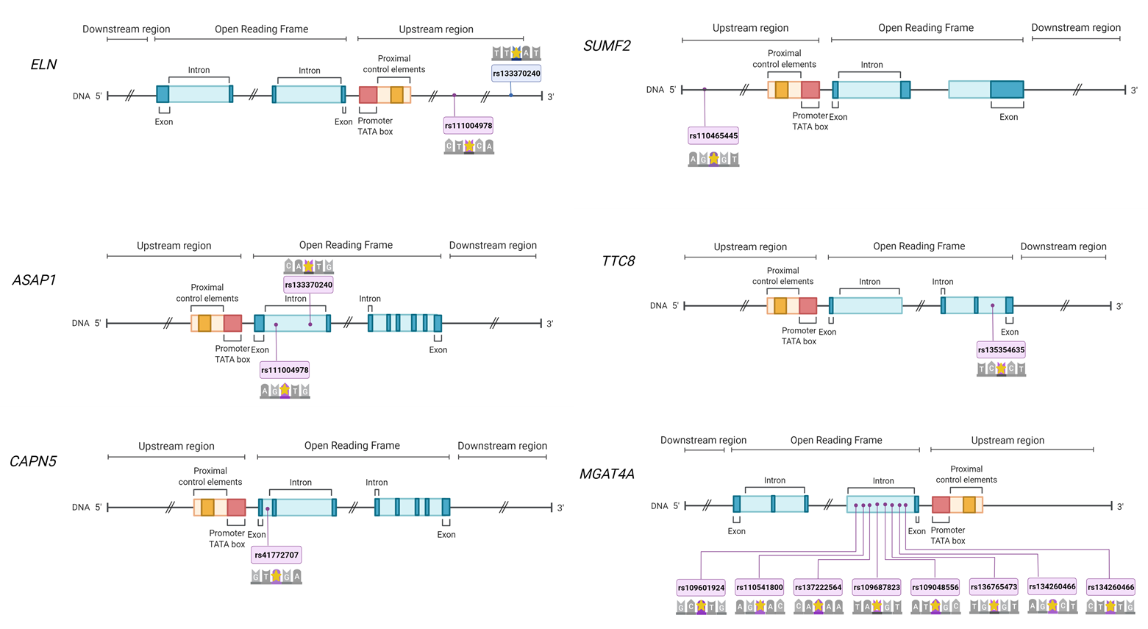

Supplementary Fig. S2. Structure of six core genes
Through this eQTL study, six core genes associated with cis-eQTL variants were obtained, and significant SNPs were marked with yellow stars. This figure is created with BioRender.com.

