Graphical Abstract
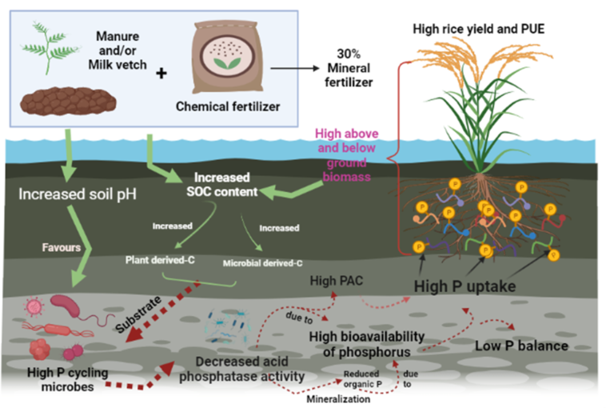
Graphical abstract depicting the theoretical framework as to how the responses to change in soil properties affects rice yield and phosphorus use efficiency (PUE) under long-term fertilization. SOC refers to soil organic carbon; PAC means phosphorus activation coefficient, P refers to phosphorus

