The SPL transcription factor genes are potential epialleles for crop improvement in chickpea (C. arietinum L.)
Sheel Yadav¹, Yashwant K. Yadava¹, Shashi Meena², Lalbahadur Singh¹, Rekha Kansal¹, Monender Grover³, Nimmy MS¹, C. Bharadwaj⁴, Vijay Paul², Kishor Gaikwad¹, P.K. Jain^{1*}
¹ICAR-National Institute for Plant Biotechnology, New Delhi, 110012, India
²Division of Plant Physiology, ICAR-Indian Agricultural Research Institute, New Delhi, 110012, India
³Centre for Agricultural Bioinformatics, Indian Council of Agricultural Research-Indian Agricultural Statistics Research Institute, New Delhi, 110012, India
⁴Division of Genetics, ICAR-Indian Agricultural Research Institute, New Delhi, 110012, India
*Corresponding author e - mail : jainpmb@gmail.com

S.No. | Primer | Forward Primer | Reverse Primer | Product size (bp)
qRT-PCR Primers
1 | Gene 1  ( LOC101492646) | AAGAGGCATTACTGGTCACTTT | CCAAGAAATTCAAGTTCCACATCC | 123
2 | Gene 8  (LOC101507206) | GCATGCCTCTCTCTTCATCAG | GGTTCCTATCTTCACAGTTTGAGT | 99
3 | Gene 9  (LOC101496293) | CACCATTCAGTGGAAGACTACA | GCAAGCTCCTAGCCATAGAAA | 108
4 | Gene 10  (LOC101502532) | GATCCAGAACATTCTAGGGCTTAT | AGCATGTCCAAGTTCACTTCT | 132
5 | Housekeeping gene  (GAPDH) | TGATGACCACCGTCCATTCCATCA | AGACATCAACAGTTGGGACACGGA | 105
BS-PCR Primers for Gene 7 ( LOC101498218, SPL 3)
1. | SPL 3 promoter P | TATTTTTTAGAATTATTTATGTGTTATGAG | ATATTTATCACTATCTTCCAATTTCCAAA | 297
2. | SPL 3 gene body P1 | TAAAAGTGGAAGATTTTTTTTATTTTTTTG | AAAAAAAATTCATAACAAAATCAATTCAAA | 247
3. | SPL 3 gene body P2 | TGTTTTGTTATGTAAATAATTGGTTAATTT | TTAAAAAAAACACTCCTAATTCAATTTAAT | 225
Primers used for determination of BS conversion efficiency
4. | Gene | TGGCTGACACTCAAACAACT | TCCCCAACAAGTTCCTCCTT | 240
Supplementary Table 1 Details of primers used in the study

Supplementary Table 2 Putative homologs of Arabidopsis anthocyanin biosynthesis genes identified in chickpea
S. No. | Gene | Arabidopsis Genome Initiative gene identifiers | Chickpea NCBI gene IDs
1. | SOC1  (SUPPRESSOR OF OVEREXPRESSION OF CONSTANS  1) | At2g45660
  LOC101488241
1. | SOC1  (SUPPRESSOR OF OVEREXPRESSION OF CONSTANS  1) | At2g45660 | LOC101493068
2. | DFR  (DIHYDROFLAVONOL-4-REDUCTASE) | At5g42800 | LOC101491984
2. | DFR  (DIHYDROFLAVONOL-4-REDUCTASE) | At5g42800 | LOC101492767
3. | PAP1  (PRODUCTION OF ANTHOCYANIN PIGMENT 1) | At1g56650 | LOC101490885
3. | PAP1  (PRODUCTION OF ANTHOCYANIN PIGMENT 1) | At1g56650 | LOC101507446
4. | TT8  (TRANSPARENT TESTA8) | At4g09820 | LOC101506726

Supplementary Fig. 1 PCR amplification with primers designed based on a gene sequence to estimate the BS conversion efficiency. L : 100 bp plus ladder; 1 and 3 : non-BS treated DNA for DS and DT genotypes, respectively; 2 and 4 : BS- treated DNA for DS and DT genotypes, respectively

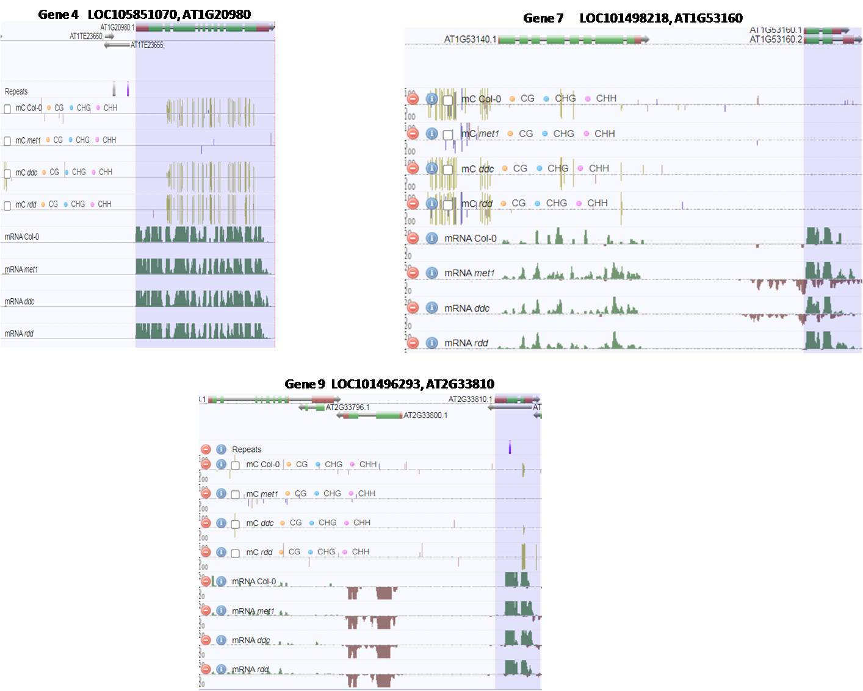
Supplementary Fig. 2 The methylation status of genes homologous to genes 4 (LOC105851070), 7 (LOC101498218) and 9 (LOC101496293) in Arabidopsis thaliana. The highlighted portion depicts the gene structure and methylation status with respect to CG, CHG and CHH methylation across the gene body and adjoining regions (Source : https://ecker.salk.edu/genome-browser/)

Supplementary Fig. 3 The log 2 FC for the DS genotype over the DT genotype, under drought stress conditions. Genes 1, 8, 9 and 10 are the genes with locus IDs LOC101492646, LOC101507206, LOC101496293 and LOC101502532, respectively. DT (T) and DS (T) refer to drought tolerant and drought sensitive genotypes, both under drought stress. The expression level of genes for the DT (T) was considered as control (expression = 1). Three biological and technical replicates were used for each experiment. Error bars indicate standard errors of means. All the differences in gene expression levels were found to be significant at p < 0.05 (Estimated through Student’s-t test)

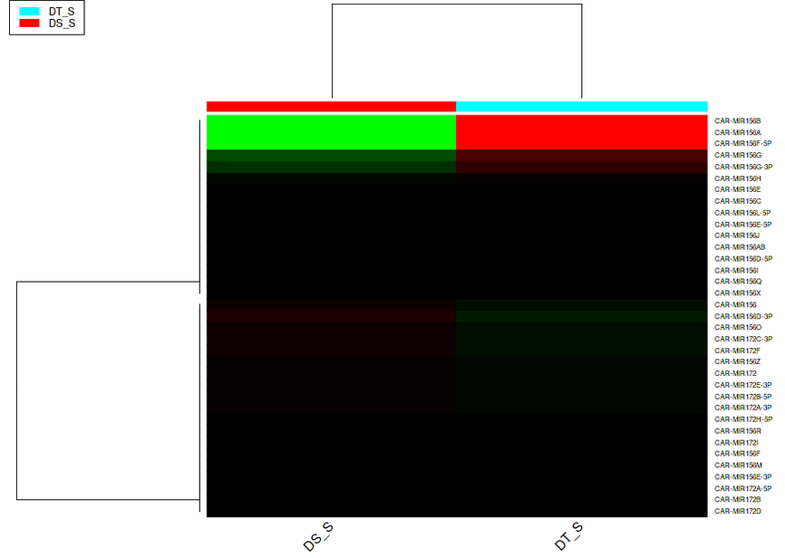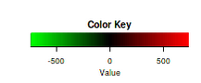
Supplementary Fig. 4 The results of small RNA sequencing analysis depicting the abundance (RPKM) of mir156, mir159, mir 171 and mir 172 for the DS (drought sensitive, ICC 1882) and DT (drought tolerant, ICC 4958) genotypes on exposure to drought stress. The heatmap was generated using normalized read counts obtained through small RNA sequencing experiment, by using the tool iDEP (http://bioinformatics.sdstate.edu/idep; Ge et al., 2018)

