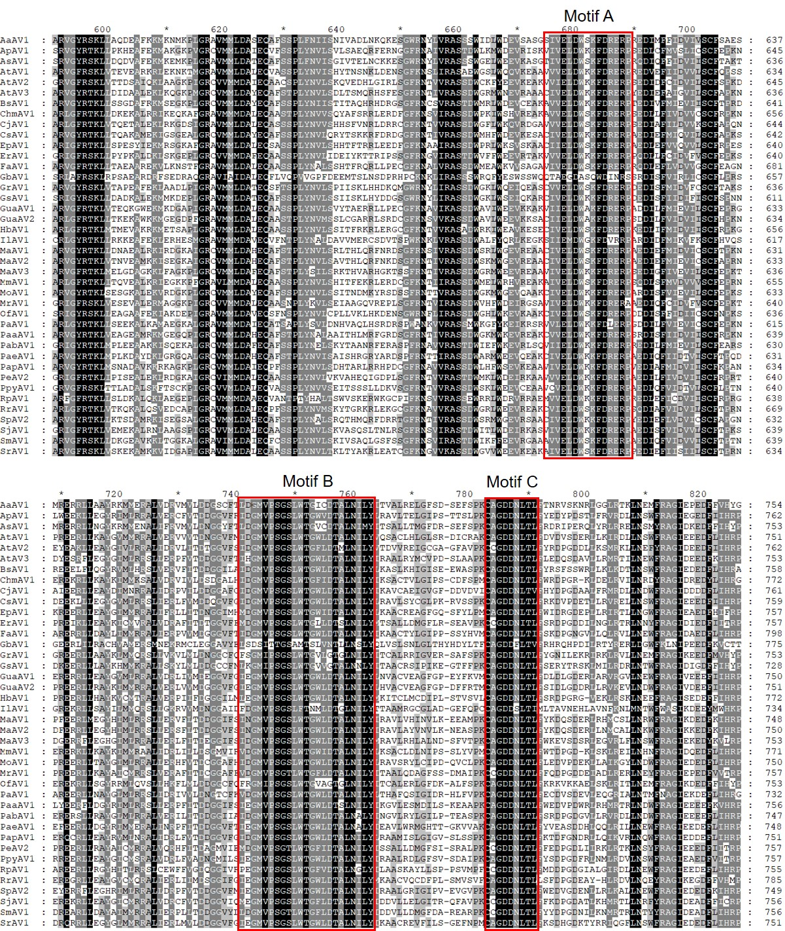
Fig. S1 Multiple Sequence Alignment showing the conserved RNA dependent RNA polymerase (RdRp) motifs in ORF1-2 encoded fusion protein sequences of identified viruses. Red boxes indicate the RdRp motifs A, B, C that are present in other plant amalgaviruses (Nibert et al., 2016)

