Additional file
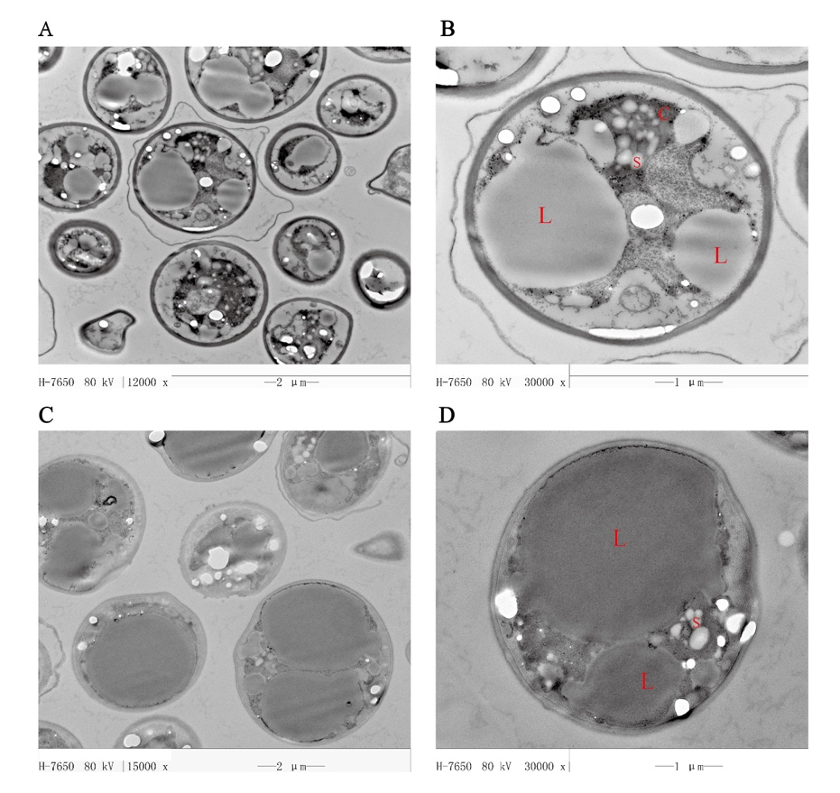
Fig. S1 TEM images of A. protothecoides cells from HC and MC. C: chloroplast; L: lipid bodies; S: starch granules. (A) Cells from the illuminated culture (×1.2K); (B) Cells from the illuminated culture (×3K); (C) Cells from the dark culture (×1.2K); (D) Cells from the dark culture (×3K).

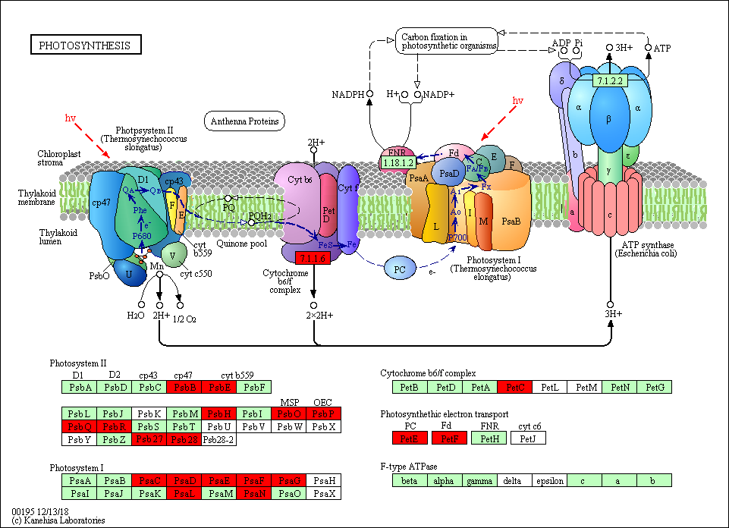
Fig. S2 DEPs in photosynthesis.

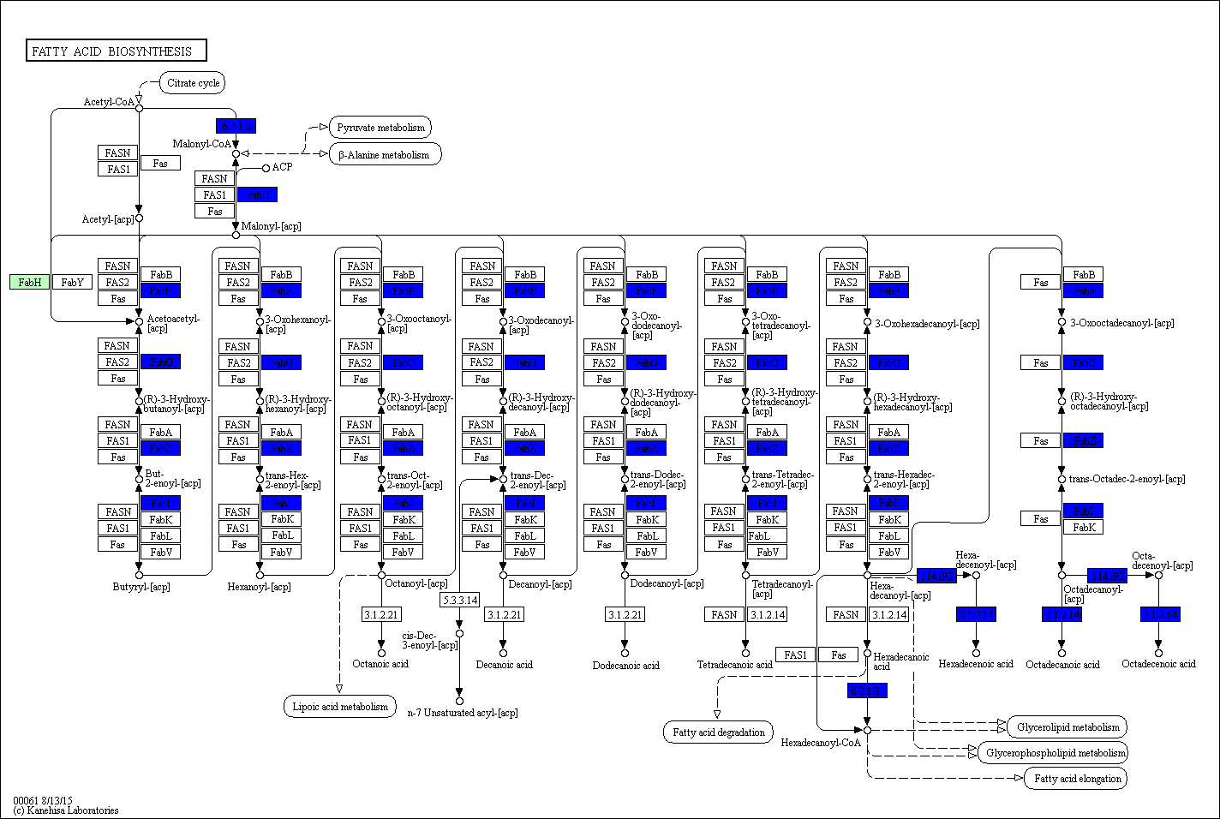
Fig. S3 DEPs in fatty acid biosynthesis.

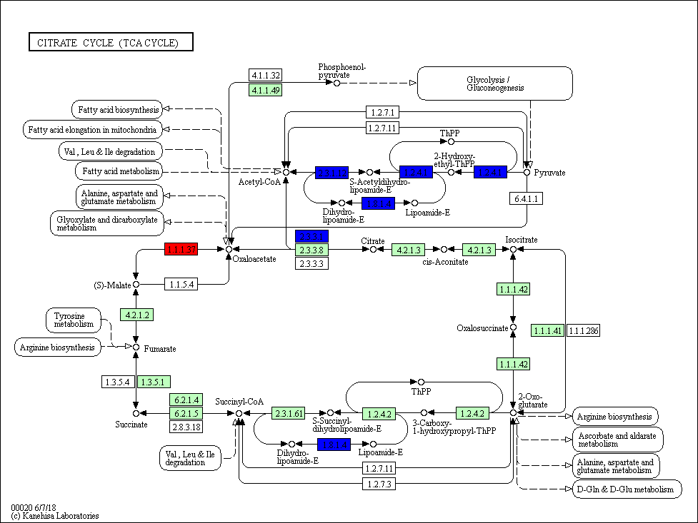
Fig. S4 DEPs in citrate cycle (TCA cycle).

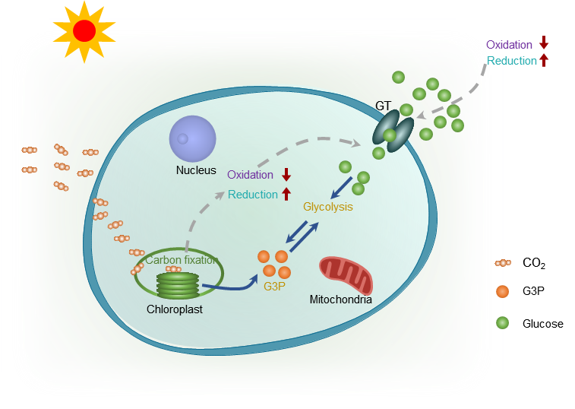
Fig. S5 Schematic representation of a theoretical model of how glucose assimilation in A. protothecoides is negatively influenced by light.

