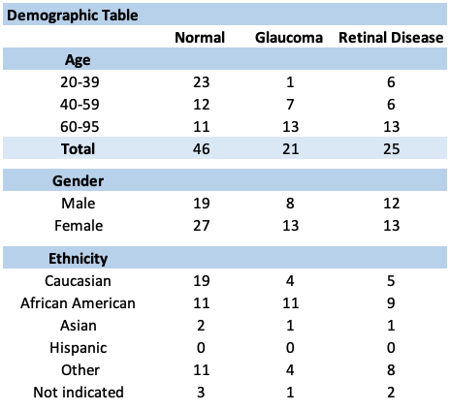
Table 1: A demographic breakdown of study participant subgroups.

Table 2: Garway-Health sensitivity and specificity values for all eyes (total = 84 eyes), controls (N = 31 eyes), and those with glaucoma (N = 22) and retinal diseases (N = 31 eyes).

Table 3: Ishihara color test comparison between VR analogues and in-office test results. Overall n = 110 eyes; control group n = 54 eyes; glaucoma n = 28 eyes; retinal disease group n = 28 eyes.
Table 4: Amsler grid non-inferiority comparison between VR analogue and in-office test results. Overall n=98 eyes; control group n=52 eyes, glaucoma group n=26 eyes, retinal disease group=20 eyes).

