Supplementary information for

Manipulating Exchange Bias in 2D Magnetic Heterojunction for High-performance Robust Memory Applications
Supplementary Figures
Fig. 1: Elemental analysis of FPSe bulk crystals.
Fig. 2: Elemental analysis of FGT bulk crystals.
Fig. 3: Magnetization measurements of FPSe and FGT bulk crystals.
Fig. 4: The Raman spectroscopy for FGT (green), FPSe (blue), and FPSe/FGT heterostructure (red).
Fig. 5: The unit cell for FPSe and for FGT built using BURAI (Quantum Expresso GUI).
Fig. 6: Layers in Molecular Dynamics simulations using LAMMPS for FPSe (bottom) and for FGT (top).
Fig. 7: Molecular dynamics simulation of interlayer coupling.
Fig. 8: Strain and interlayer distance evolution in the laser shock MD simulation.
Fig. 9: The optical microscope image, the atomic force microscope image, and the raman spectroscopy characterization of sample A.
Fig. 10: The Kerr hysteresis loops of pure FGT.
Fig. 11: The schematic diagram of the M-B model.
Fig. 12: The thickness dependences of H_{EB} in AFM/FM systems.
Fig. 13: The optical microscope image and the atomic force microscope image of sample B.
Fig. 14: The evolution of the coercive field on temperature and pressure before and after LS.
Fig. 15: The optical microscope image and the atomic force microscope image of FPSe/FGT/h-BN/FGT heterostructure (state 0 and 2).
Fig. 16: The optical microscope image and the atomic force microscope image of FPSe/FGT/h-BN/FGT heterostructure (state 1).
Fig. 17: TMR curves measurement of FPSe/FGT/h-BN/FGT at different temperatures before and after LS.
Fig. 18: TMR curves measurement of FGT/h-BN/FGT at 5 K with a bias current of 3 μA.
Fig. 19: The optical microscope image, the atomic force microscope image, and MOKE signal for sample C.
Supplementary Table
Table 1: Atomic positions (Å) in simulation cells at the ground state (image from BURAI).
Table 2: Energy states for different atomic configurations.
Table 3: Interatomic interactions model parameters.
Table 4: The summary of the peak pressures at 4 different laser intensities.
Table 5: The performance comparison before and after laser shocking.
Supplementary Note
Section 1. Characterization of bulk crystals
Section 2. Characterizations of heterostructures
Section 3. Parametrization of the force fields for FGT and FPSe intra and inter flake interatomic interactions.
Section 4. Molecular Dynamics simulations
Section 5. Conversion of laser power and pressure

Section S1. Characterization of bulk crystals
As shown in Supplementary Fig. 1 and 2, the quality, orientation, topography, and composition of the FGT and FPSe bulk crystals were checked by the SEM equipped with an EDS. The magnetizations of FGT and FPSe were measured by a superconducting quantum interference device (SQUID) from 4.2 K to 300 K with the magnetic field sweeping up to 9 T. Magnetization measurements of FPSe and FGT bulk crystals are shown in Supplementary Fig. 3. The T_{N} of FPSe and the T_{C} of FGT were extracted as 110 K and 230 K, respectively.

Section S2. Characterizations of heterostructures
The morphology and thickness of the three samples (sample A, sample B, and sample C) mentioned in the main text were characterized by atomic force microscopy.
As is shown in Supplementary Fig. 9, the thicknesses of FGT and FPSe are 18 nm and 24.4 nm in sample A, respectively. Sample A demonstrated the enhancement of pressure-induced magnetism coupling using out-of-plane pressure via laser shocking. The enhanced interlayer coupling of the FPSe/FGT heterostructure led to an impressive improvement of the EB field and blocking temperature. A comparison for samples before and after laser shocking is summarized in Supplementary Table 5. Supplementary Fig. 10 shows the typical MOKE curves of FGT (thickness: 23.4 nm) as a function of the magnetic field (B) from 5 K to 200 K. And their Kerr hysteresis loops remained symmetric relative to the zero point along the B-axis, suggesting a lack of H_{EB}.
To investigate the non-localized coupling mechanism of the horizontal pinning, we fabricated FPSe/FGT heterostructures with unconnected FGT (sample C), for comparison to the connected FGT (sample B) in terms of the Kerr signals. The optical images and atomic force microscope images of sample B and C are shown in Supplementary Fig. 6 and 7, respectively. The MOKE signals for unconnected FGT, connected FGT, and FPSe/FGT heterostructures of sample C were measured at 5 K. When FGT is connected to FPSe/FGT heterostructures, a consistent EB effect occurs. In contrast, FGT is not affected by the magnetic properties of the heterostructure. These results show that as long as the FGT is connected to FPSe/FGT, the extent of transverse propagation can be considerable, even exceeding 100 μm. In contrast, when there are cracks between FGT and FPSe/FGT heterostructures, the EB effect will not exist in the FGT at all, indicating that the connection is a necessary condition for the transverse propagation.

Section S3. Parametrization of the force fields for FGT and FPSe intra- and inter-flake interactions of FGT/FPSe.
The FPSe/FGT system has no dedicated force fields models in the literature. Therefore, we have built up our simplified force fields model that consists of 2- (Lennard-Jones) and 3-body (Axilrod Teller) interactions to represent the intraflake interatomic interactions and Lennard-Jones interlayer interactions. The modeling of the employed force field was divided into three main steps. The first step is determining the ground state of the atomic system via quantum mechanics self-consistency calculations. The second step consists of determining the energy of the same system in strained conditions also using quantum mechanics self-consistency calculations. The third step is to perform parameters search such that the energy differences between the different states of the atomic system determined in the first and second steps are close to the differences obtained employing the 2 (Lennard-Jones) and 3 -body (Axilrod Teller) interactions for the intralayer interatomic interactions, and Lennard-Jones interflake interactions in Molecular Dynamics simulations.

S.3.1. First step
We initially assembled the unit cell structure for each 2D material (Supplementary Fig. 5), stacking one FGT unit cell stacked on top and close to a FPSe unit cell, and run cell relaxation simulations to obtain the ground state configuration for the single flakes alone and the stacked system.
For the FGT, we used 6 K-points for all spatial dimensions while for FPSe we used 7 K-points for all spatial dimensions in the real space. We performed the quantum mechanics self-consistent field (SCF) calculations employing a norm-conserving pseudopotential of the PBE exchange-correlation flavor for Te atoms; an ultrasoft (PBE) pseudopotential for Fe and P atoms; an ultrasoft (PBE) pseudopotential with 115.767 Ry charge cutoff and 19.619 Ry wavefunction cutoff for Ge atoms; an ultrasoft (PBE) pseudopotential with 117.426 Ry charge cutoff and 22.216 Ry wavefunction cutoff for Se atoms.
The unit cell employed for FGT was in a hexagonal Bravais lattice with A = 3.991 Å, and C = 18.931 Å. The unit cell employed for FPSe was a triclinic one with A = 6.166 Å, B = 10.680 Å, C = 12.856 Å, $\text{α} \text{=} {\text{90}}^{\text{°}}$, $\text{β} \text{=} {\text{103.966}}^{\text{°}}$, and $\text{γ} \text{=} {\text{90}}^{\text{°}}$. The atomic positions for the optimized configuration (Supplementary Table 1), can then be determined via self-consistent calculations.

S.3.2. Second step
We then executed the self- consistent calculations for 3 different atomic positions configurations with distinct cell dimensions, i.e., different strain levels. The energy calculation results for all these configurations are shown in Supplementary Table 2 for FGT.

S.3.3. Third step
Employing identical cell geometry and atomic positions as in QM SCF calculations, we built the Molecular Dynamics (MD) simulations for each cell tested in QM. We assigned multiple combinations of parameters (${\text{ϵ}}_{\text{s}}$ and ${\text{Z}}_{\text{s}}$) using an array sampling in order to guarantee a good spread of parameters over the testing intervals. After all simulations were performed in MD, for all atomic configurations previously simulated in QM, we compared the states energy differences as done in Table S1, and the force field model parameters that resulted in the smallest errors between the MD and QM differences was selected as the final parameters (Supplementary Table 3).
The MD simulations (Supplementary Fig. 6) could then be performed as long as the atomic system was established, and the interatomic interactions could be represented using the parameters determined with the above procedure

Section S4. Molecular Dynamics simulations
The inter-layer coupling was studied employing Molecular Dynamics (MD) simulations. The simulations were designed in a 175 Å × 175 Å × 65 Å cell volume with periodic boundary conditions in all dimensions, and the time step was 0.3 fs. In this volume, a lower part (small z value) of FPSe had its lower Se atoms pinned for the z-direction. Then we intercalated two FGT and one FPSe on top of the pinned initial layer, as Supplementary Fig. 7 shows. Two- (Lennard-Jones, Eq. (1)) and three-body (Axilrod-Teller, Eq. (2)) interatomic interactions models were then set for each of the layers¹. Dispersive Lennard Jones interactions were employed for interatomic interactions between neighbor layers². An NVT ensemble (with a constant number of atoms, volume, and temperature) was employed.
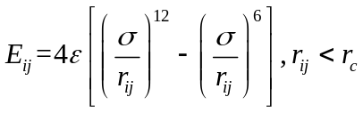 (1)
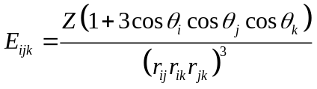 (2)
The coupling between flakes indicates that there are two possible equilibrium states. The existence of such equilibrium states is due to the nature of the inter-flake interatomic interactions nature. The relaxed/unstrained state presents both a weak repulsion force between the Se/Te flake edge atoms pairs which is counterbalanced by a weak attraction force between the P/Te, P/Fe, and Fe/Se atoms pairs. On the other hand, the strained equilibrium configuration presents a strong repulsion between the Se/Te atoms pairs that is counterbalanced by a strong attraction between the P/Te, P/Fe, and Fe/Se atoms pairs.
Supplementary Fig. 7 shows that, at the strained equilibrium state, the simultaneous attraction between the Fe atoms from the FGT and P atoms from the FPSe flakes, as well as repulsion between the Se atoms from the FPSe flakes and Te atoms from the flakes draw the Se and P atoms get closer in their z-axis coordinates, with respect to the unstrained configuration in the FPSe flake, and the Fe atoms closer to the Te atoms in their z-axis coordinates in the FGT flakes.
Subsequently, a simulation was conducted including a shock pulse of 14 GPa (similar to the experimental condition) and the shock pressure lasted for 150 fs (500 time steps) over the top FGT flake, which was initially positioned 3 Å above the unstrained flake’s equilibrium position to check if the shock can drive the equilibrium state transitions.
The system must overcome an energy barrier caused by the stronger inter-flake repulsion interaction between Se/Te atoms pairs until a stronger attraction term starts to be significant at a smaller inter-flake distance ($\text{\sim 4.2 Å}$). The 14 GPa pulse shock can overcome the inter-states energy barrier, making the multi-flake FPSe/FGT system equilibrated at a larger strain state and lower inter-flake spacing.
Supplementary Fig. 8 shows the evolution of out-of-plane strains for each flake in the shock simulation as well as the interlayer distance over time. There is a slight compressive strain overshoot at around 10 ps. The bottom layer of FPSe did not present this overshoot because of the z-pinned applied boundary condition. Supplementary Fig. 8 also shows that the magnitude of out-of-plane strain magnitude increases as soon as the shocking occurs.

Section S5. Conversion of laser power and pressure
The acting time of laser-induced plasma shock wave on a metallic material is extremely short, which is within tens of nanoseconds in general. In order to calculate the pressure of laser-induced plasma shock wave during laser shock process, a number of calculation models of shock wave pressure were proposed³. Among them, the one-dimensional model of shock wave pressure proposed by Fabbro ⁴ is well known and most universally acknowledged, which can reflect the change law of the peak pressure of laser-induced plasma shock waves with the laser pulse energy. The calculation formula for the peak pressure of laser-induced plasma shock waves is as follows:
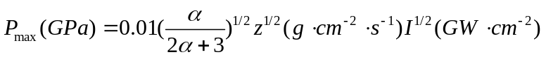 (3)
where, P_{max} is the peak pressure of laser-induced plasma shock wave; α is the fraction of absorbed laser pulse energy (typically sets to 0.1), and I is the laser intensity. And z is the combined acoustic impedance of the metallic material and the confinement layer, which can be calculated by the following relation:
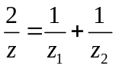 (4)
where z_{1,2} represents target materials (graphite) and constraint layer (glass), respectively^{5, 6}.
The calculation formula of laser power irradiance can be expressed as follows:
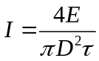 (5)
where, I is the laser intensity, E is the laser pulse energy, D is the laser spot diameter, and τ is the pulse duration.
Here, we used 4 different laser intensities within the pulse duration τ = 10 ps and D = 300 μm. Laser pulse energe is 80 μJ (10 % loss) and pulse frequency is 125 kHz. Table S4 lists the peak pressures under 4 different laser intensities.

Supplementary Fig. 1 | Elemental analysis of FPSe bulk crystals. SEM image, EDS maps and EDS elemental analysis of the FPSe bilk crystals respectively.

Supplementary Fig. 2 | Elemental analysis of FGT bulk crystals. SEM image, EDS maps and EDS elemental analysis of the FGT bulk crystals respectively.

Supplementary Fig. 3 | Magnetization measurements of FPSe and FGT bulk crystals. a, b Magnetic susceptibility as a function of temperature for FGT (a) and FPSe (b) single crystals along the c-axis. The T_{C} of FGT and the T_{N} of FPSe were extracted as 230 K and 110 K, respectively.

Supplementary Fig. 4 | Characterization of flakes. The Raman spectroscopy for FGT (green), FPSe (blue), and FPSe/FGT heterostructure (red).

Supplementary Fig. 5 | Unit cell of FPSe and FGT. The unit cell FPSe (left) and FGT (right) built using BURAI (Quantum Espresso GUI).

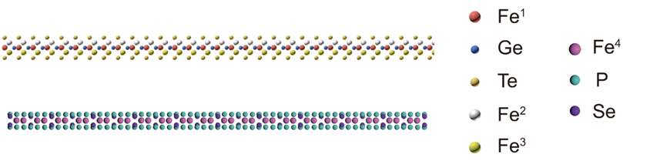
Supplementary Fig. 6 | Single-layer structures of FPSe and FGT. Layers in Molecular Dynamics simulations using LAMMPS for FPSe (bottom) and for FGT (top). On the FGT flake, the top, and bottom light-yellow atoms are Te atoms, the following white, darker yellow and red atoms are Fe atoms, and the blue atoms are Ge atoms. On the FPSe flake, the light blue atoms are Se atoms, the purple atoms are P atoms, and the pink atoms are Fe atoms.

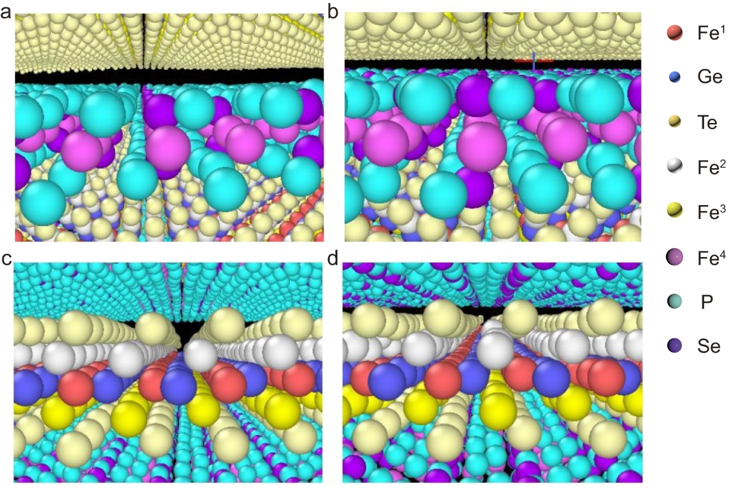
Supplementary Fig. 7 | Molecular dynamics simulation of interlayer coupling. a- d Flake FGT (bottom)/FPSe (top) system equilibrium states at unstrained (a and c) and strained (b and d) conditions.
Supplementary Fig. 8 | Strain and interlayer distance evolution in the laser shock MD simulation. Strain evolution in the laser shock MD simulation is shown for top FGT, middle FPSe, bottom FGT, and bottom FPSe, respectively. The interlayer distance of heterostructure is reduced from 0.66 nm to 0.42 nm.

Supplementary Fig. 9 | Characterization of sample A. a, b The optical microscope image (a) and the atomic force microscope image (b) of sample A. The thickness of FPSe and FGT is 18.0 nm and 24.4 nm, respectively.

Supplementary Fig. 10 | The Kerr hysteresis loops of pure FGT. a, The optical microscope image of pure FGT. b, The temperature-dependent Kerr loops for pure FGT, showing a lack of H_{EB}.

Supplementary Fig. 11 | The schematic diagram of the M-B model.

Supplementary Fig. 12 | The thickness dependences of H_{EB} in AFM/FM systems. a, b the t_{FPSe} dependences (a) and the t_{FGT} dependences (b) of H_{EB} in our exchange-biased AFM/FM systems.

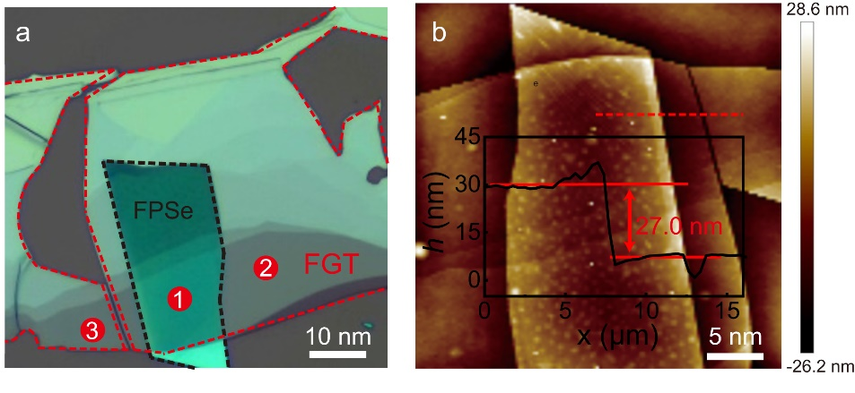
Supplementary Fig. 13 | Characterization of sample B. a, b The optical microscope image (a) and the atomic force microscope image (b) of sample B. Test positions 1, 2 and 3 represent FPSe/FGT, connected FGT, and unconnected FGT, respectively.

Supplementary Fig. 14 | The evolution of the coercive field on temperature and pressure. a, b The evolution of H_{C-L} and H_{C-R} on temperature and pressure before and after LS.

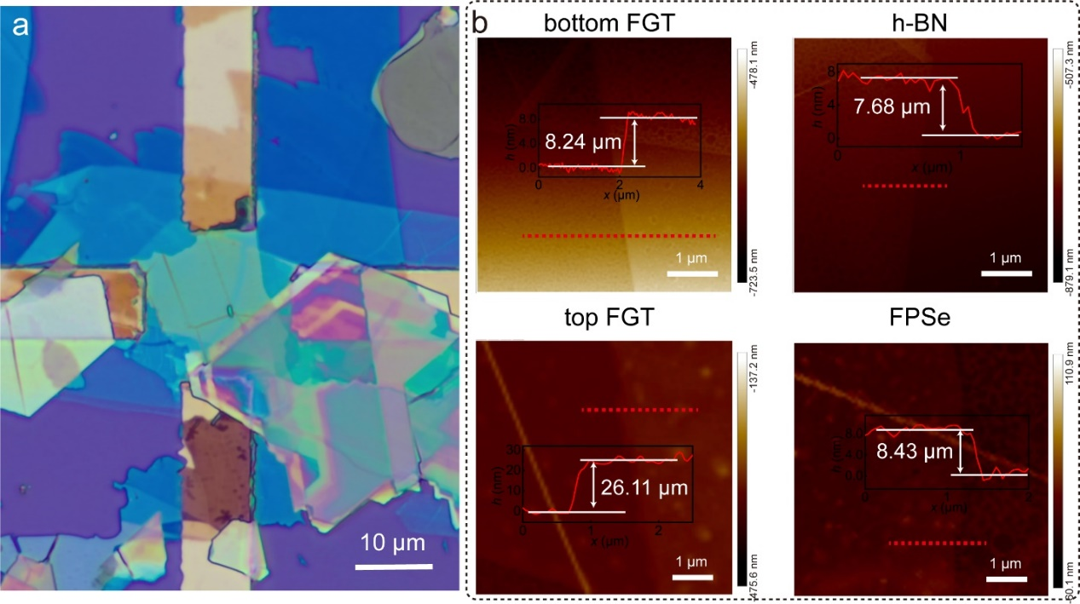
Supplementary Fig. 15 | Characterization of FPSe/FGT/h-BN/FGT heterostructure. The optical microscope image and the atomic force microscope image of FPSe/FGT/h-BN/FGT heterostructure (state 0 and 2).

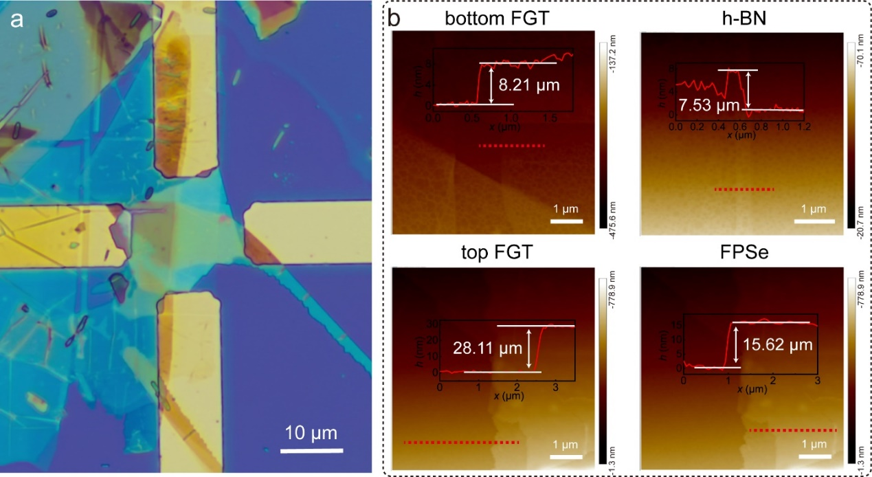
Supplementary Fig. 16 | Characterization of FPSe/FGT/h-BN/FGT heterostructure. The optical microscope image and the atomic force microscope image of FPSe/FGT/h-BN/FGT heterostructure (state 1).

Supplementary Fig. 17 | TMR measurement of a FPSe/FGT/h-BN/FGT vdW heterostructure. TMR curves measurement of FPSe/FGT/h-BN/FGT at different temperatures before and after LS.

Supplementary Fig. 18 | TMR measurement of FGT/h-BN/FGT vdW heterostructure. TMR curves measurement of FGT/h-BN/FGT at 5 K.

Supplementary Fig. 19 | Characterization and MOKE signal for sample C. a, b The optical image and the atomic force microscope image sample C. Position 1, 2, and 3 indicate FPSe/FGT, connected FGT, and unconnected FGT, respectively. c MOKE signal for unconnected FGT, connected FGT, and FPSe/FGT heterostructures, respectively, measured at 5 K. When FGT is connected to FPSe/FGT heterostructures, a consistent exchange bias effect occurs. In contrast, FGT is not affected by the magnetic properties of the heterostructure.

Table 1. Atomic positions (Å) in simulation cells at the ground state (image from BURAI).

Table 2. Energy states for different atomic configurations.

Table 3. Interatomic interactions model parameters. The superscripts for Fe atoms denote their locations as shown in Figure S9.

Table 4. The peak pressures at 4 different laser intensities.

Table 5. The performance comparison before and after laser shocking

References
1 Borysiuk, V. N., Mochalin, V. N. & Gogotsi, Y. Molecular dynamic study of the mechanical properties of two-dimensional titanium carbides Ti(n+1)C(n) (MXenes). Nanotechnology 26, 265705 (2015).
2 Motlag, M. et al. Laser-Shock-Induced Nanoscale Kink-Bands in WSe₂ 2D Crystals. ACS Nano 13, 10587-10595 (2019).
3 Gao, H. et al. Nanolithography. Large-scale nanoshaping of ultrasmooth 3D crystalline metallic structures. Science 346, 1352-1356 (2014).
4 Fabbro, R., Fournier, J., Ballard, P., Devaux, D. & Virmont, J. Physical study of laser‐produced plasma in confined geometry. J. Appl. Phys. 68, 775-784 (1990).
5 Rathod, V. T. A Review of Acoustic Impedance Matching Techniques for Piezoelectric Sensors and Transducers. Sensors (Basel) 20, 4051 (2020).
6 Zheng, Q., Braun, P. V. & Cahill, D. G. Thermal Conductivity of Graphite Thin Films Grown by Low Temperature Chemical Vapor Deposition on Ni (111). Advanced Materials Interfaces 3, 1600234 (2016).

