Supplemental Information

Scaling up Gas and Electric Cooking in Low- and Middle-Income Countries: Climate Threat or Mitigation Strategy with co-Benefits?

Recent evolution of clean cooking access
The global prioritization of clean cooking is reflected in the seventh Sustainable Development Goal (SDG7), which aims to achieve universal “access to affordable, reliable, sustainable and modern energy” by 2030¹. SGD7 is divided between access to electricity and clean cooking technologies. At a country level, the latter is tracked by measuring the proportion of the population with “primary reliance on clean fuels and technologies”. For this analysis, we follow the World Health Organization (WHO) definition of “clean” cooking fuels and technologies, which is based on the ability of the fuel and technology to attain levels of fine particulate matter (PM_{2.5}) and carbon monoxide (CO) recommended in the 2021 WHO Air Quality Guidelines². This includes solar, electric, biogas, natural gas, liquefied petroleum gas (LPG), and alcohol fuels including ethanol as well as pellet fuels burned in some types of advanced gasifier stoves³.

In the past decade, some regions have made considerable progress toward this objective, but in other regions progress is slow. For example, between 2010 and 2020, one analysis estimates that primary reliance on clean fuels in Central and Southern Asia increased by over 550 million people, shifting the SDG7 indicator from 38 to 61% of the population⁴. Similarly, in East and Southeast Asia, nearly 370 million people gained access between 2010 and 2020, which moved the SDG7 indicator from 51% to 65%⁴. However, in sub-Saharan Africa, during the same time period, primary reliance on clean fuels increased by fewer than 80 million, a shift from just 12 to 16% of the population, leaving 84% still reliant on wood, charcoal and other polluting fuels ⁴.

There are many clean cooking options that can contribute to achieving SDG7. However, much of the progress observed to date is a result of expanding access to liquefied petroleum gas (LPG). Indeed, over three quarters of the population that gained primary access to clean cooking between 2010 and 2020 in our sample countries did so by adopting LPG⁴. LPG advocates note that it is well-suited to near-term scale-up⁵, and many LMIC governments are prioritizing LPG as a clean fuel (including setting ambitious targets for scale)⁶. In addition to being very clean at the point of use, LPG is relatively simple to use. It requires minimal investment in infrastructure in comparison to grid-based electricity or piped gas, and petroleum companies already have a global presence with retail distribution centers scattered throughout urban and peri-urban areas worldwide⁷. These factors have all contributed to the rapid uptake of LPG throughout the Global South⁸.

Electricity accounts for most of the remaining increase in primary access to clean cooking between 2010 and 2020. However, though access to electricity is increasing rapidly throughout the global south, cooking with electricity is not common. Indeed, there are just 10 countries in which a majority of households in our sample use electricity as a primary cooking option⁴. Other clean cooking options like biogas, ethanol and solar thermal cookers, and cleaner fuels such as pellet biomass fuels burned in advanced stoves have been adopted in certain localities but have not achieved sufficient primary usage nor scale to appear explicitly in global datasets used for this analysis.

Derivation of useful energy delivered
There are numerous household surveys that collect information concerning choice of primary cooking fuel and stoves ^{e.g. 15}. However, few quantify the amount of fuel consumption, which is challenging to measure through self-reporting or during a brief household visit. For the current analysis, we used data from three recent nationally representative household surveys that attempted to quantify fuel consumption from Haiti, Rwanda, and Kenya^{16–18}. These surveys quantify use of each fuel by asking specifically about quantity and frequency of fuel purchased and/or collected. Fuel quantities were converted to ‘useful’ energy using the same calorific values and stove efficiencies used elsewhere in this analysis (Table S9). Overall, the median useful energy per capita in the three-country sample is 2.6 MJ/day (Figure S1-Left). However, there is some evidence that useful energy per capita is higher among solid fuel users than in households that rely primarily or exclusively on LPG. Indeed, this appears to be the case in the selected household surveys, where the median per capita useful energy among exclusive LPG users is 1.5 MJ/day (Figure S1-Right). Many other countries in our sample have higher rates of LPG use than the three countries for which we have detailed energy consumption data. Thus, we use 2 MJ/day, which is closer to per capita useful energy consumption among exclusive LPG users than the all-fuel median.

Figure S1: Daily useful energy per capita from three nationally representative surveys from all sources (left) and exclusive LPG users (right)
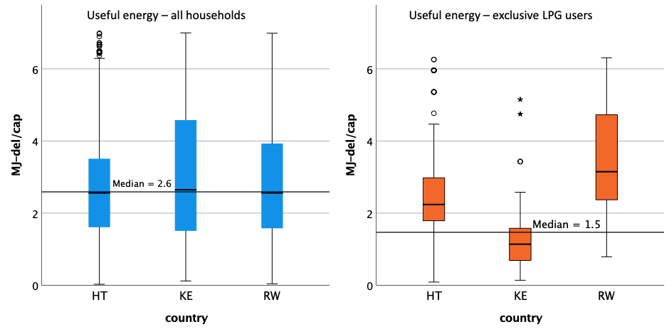

Key assumptions about Primary Fuel Choice in the BAU scenario

Historical rates of change
To project future fuel use in the BAU scenario, we used past patterns of shifts in primary fuel use and extended them into the future. Average annual rates of change in household fuel choices among rural and urban populations of each country in our sample are shown in Table S1.

Table S1: Annual rates of change in primary fuel from 2000 to 2020 from the WHO household fuel database ⁴
 |  | LPG |  | Biomass |  | Charcoal |  | Kerosene |  | Coal |  | Electricity
ISO3 | Country name | Rural | Urban | Rural | Urban | Rural | Urban | Rural | Urban | Rural | Urban | Rural | Urban
AFG | Afghanistan | 0.74% | 2.97% | -0.74% | -2.25% | -0.02% | -0.34% | 0.00% | 0.00% | 0.00% | -0.02% | 0.00% | -0.17%
AGO | Angola | 0.02% | -0.26% | 1.47% | 0.05% | -1.41% | 0.01% | 0.01% | 0.01% | 0.00% | 0.00% | 0.00% | 0.10%
BGD | Bangladesh | 0.28% | 1.21% | -0.28% | -1.08% | 0.00% | 0.00% | 0.00% | 0.00% | 0.00% | 0.00% | 0.01% | -0.01%
BEN | Benin | 0.02% | 0.36% | -0.43% | -1.39% | 0.44% | 1.61% | -0.05% | -0.05% | 0.01% | 0.04% | 0.00% | 0.01%
BOL | Bolivia (Plurinational State of) | 2.14% | 0.42% | -2.12% | -0.32% | 0.00% | 0.00% | -0.02% | -0.02% | 0.00% | 0.00% | 0.00% | -0.05%
BIH | Bosnia and Herzegovina | 0.08% | -0.24% | 0.64% | 0.78% | 0.01% | -0.01% | 0.00% | 0.00% | 0.00% | -0.18% | -0.73% | -0.32%
BWA | Botswana | -0.01% | -1.29% | -0.21% | 0.15% | 0.00% | 0.00% | -0.11% | -0.11% | 0.00% | 0.01% | 0.19% | 1.36%
BRA | Brazil | 1.32% | 0.14% | -1.45% | -0.12% | 0.12% | -0.01% | 0.00% | 0.00% | 0.00% | 0.00% | 0.00% | -0.01%
BFA | Burkina Faso | 0.01% | 1.07% | 0.01% | -1.48% | -0.02% | 0.44% | -0.01% | -0.01% | 0.00% | -0.01% | 0.00% | -0.01%
BDI | Burundi | 0.00% | -0.02% | 0.26% | -0.38% | -0.25% | 0.47% | 0.00% | 0.00% | 0.00% | -0.02% | 0.00% | -0.02%
CIV | Côte d'Ivoire | -0.06% | 0.86% | 0.51% | -0.57% | -0.35% | -0.31% | 0.00% | 0.00% | -0.02% | -0.02% | 0.00% | 0.04%
KHM | Cambodia | 0.58% | 2.58% | -0.78% | -2.16% | 0.14% | -0.66% | -0.01% | -0.01% | 0.00% | 0.00% | 0.07% | 0.26%
CMR | Cameroon | 0.07% | 1.03% | -0.05% | -0.97% | 0.05% | 0.32% | -0.09% | -0.09% | 0.00% | 0.02% | 0.00% | 0.02%
CAF | Central African Republic | 0.00% | 0.00% | 0.04% | -0.05% | -0.02% | 0.03% | 0.00% | 0.00% | 0.01% | 0.01% | 0.00% | -0.01%
TCD | Chad | -0.04% | 0.48% | 0.52% | 1.88% | -0.33% | -1.61% | -0.01% | -0.01% | -0.04% | -0.50% | -0.02% | -0.05%
CHN | China | 0.04% | -0.26% | 1.07% | 0.17% | 0.00% | 0.00% | 0.00% | 0.00% | -1.55% | -0.91% | 0.34% | 0.86%
COL | Colombia | 1.85% | 1.25% | -1.53% | -0.16% | 0.00% | 0.00% | -0.06% | -0.06% | -0.02% | -0.02% | -0.23% | -0.91%
COG | Congo | 0.08% | 1.67% | 0.04% | -0.77% | -0.13% | -1.04% | 0.02% | 0.02% | 0.00% | -0.01% | 0.01% | -0.19%
COD | Dem Rep of the Congo | 0.01% | 0.01% | 0.22% | -1.05% | -0.22% | 0.67% | 0.00% | 0.00% | 0.00% | 0.01% | 0.00% | 0.31%
DOM | Dominican Republic | 0.37% | 0.02% | -0.28% | 0.01% | 0.17% | 0.08% | 0.00% | 0.00% | -0.22% | -0.11% | 0.00% | 0.01%
ERI | Eritrea | 0.02% | 0.65% | -0.11% | 0.28% | 0.07% | 0.58% | -0.04% | -0.04% | 0.00% | 0.01% | 0.00% | -0.05%
ETH | Ethiopia | 0.00% | 0.00% | -0.03% | -1.06% | 0.03% | 1.05% | -0.01% | -0.01% | 0.00% | 0.01% | 0.00% | 1.02%
GMB | Gambia | -0.03% | -0.19% | 0.02% | -1.57% | 0.05% | 1.79% | 0.00% | 0.00% | 0.00% | 0.01% | 0.00% | 0.00%
GHA | Ghana | 0.35% | 1.30% | -0.89% | -0.59% | 0.55% | -0.59% | -0.02% | -0.02% | 0.00% | 0.00% | 0.00% | -0.02%
GTM | Guatemala | -0.24% | -0.30% | 0.20% | -0.26% | 0.00% | 0.00% | 0.01% | 0.01% | 0.00% | 0.00% | 0.01% | 0.45%
GIN | Guinea | 0.01% | 0.01% | -0.45% | -0.92% | 0.46% | 0.84% | -0.02% | -0.02% | 0.01% | 0.00% | 0.00% | 0.08%
GNB | Guinea-Bissau | 0.00% | -0.09% | -0.08% | -0.14% | 0.06% | 0.22% | 0.01% | 0.01% | 0.00% | 0.00% | 0.00% | 0.00%
HTI | Haiti | 0.02% | 0.04% | 0.05% | -0.14% | -0.07% | 0.39% | -0.02% | -0.02% | 0.00% | 0.01% | 0.00% | 0.01%
HND | Honduras | 0.37% | 0.96% | -0.33% | 0.18% | 0.00% | 0.00% | -0.08% | -0.08% | 0.00% | 0.00% | 0.05% | -0.19%
IND | India | 1.67% | 2.10% | -1.53% | -0.87% | 0.00% | 0.00% | -0.09% | -0.09% | -0.06% | -0.23% | 0.01% | 0.00%
IDN | Indonesia | 3.33% | 4.41% | -2.48% | -0.64% | -0.02% | -0.01% | -0.87% | -0.87% | -0.01% | -0.01% | 0.00% | -0.03%
IRN | Iran (Islamic Republic of) | 0.18% | 0.03% | -0.05% | 0.00% | 0.00% | 0.00% | -0.13% | -0.13% | 0.00% | 0.00% | 0.00% | 0.00%
KEN | Kenya | 0.16% | 1.54% | -0.41% | 0.64% | 0.16% | 0.10% | -0.05% | -0.05% | 0.12% | 0.01% | 0.00% | 0.01%
KGZ | Kyrgyzstan | -0.18% | -0.79% | 0.48% | 0.04% | -0.31% | -0.06% | 0.01% | 0.01% | -1.71% | -0.21% | 1.96% | 1.23%
LAO | Lao People's Dem Rep | 0.04% | 0.50% | -0.89% | -1.15% | 0.82% | 0.39% | 0.00% | 0.00% | 0.01% | -0.01% | 0.03% | 0.22%
LSO | Lesotho | 0.41% | 0.14% | 0.06% | -0.02% | 0.00% | 0.00% | -0.68% | -0.68% | 0.00% | -0.01% | 0.19% | 1.67%
LBR | Liberia | -0.01% | -0.02% | -0.25% | 0.21% | 0.30% | -0.10% | -0.01% | -0.01% | 0.00% | 0.00% | 0.00% | -0.01%
MDG | Madagascar | -0.01% | -0.05% | -0.33% | -0.54% | 0.34% | 0.55% | 0.00% | 0.00% | 0.01% | 0.04% | 0.00% | 0.01%
MWI | Malawi | 0.00% | 0.01% | -0.38% | -2.20% | 0.38% | 2.42% | 0.00% | 0.00% | 0.00% | 0.00% | 0.01% | -0.13%
MLI | Mali | -0.01% | -0.01% | -0.23% | -2.34% | 0.27% | 2.32% | -0.02% | -0.02% | 0.01% | 0.02% | 0.01% | 0.01%
MRT | Mauritania | 0.29% | 0.75% | -0.01% | 0.01% | -0.27% | -0.88% | 0.00% | 0.00% | 0.00% | 0.00% | -0.02% | 0.09%
MEX | Mexico | 0.43% | -0.33% | -0.44% | 0.28% | 0.01% | 0.01% | 0.00% | 0.00% | 0.00% | 0.00% | 0.01% | 0.05%
MNG | Mongolia | 0.02% | 0.15% | -0.74% | -1.38% | 0.00% | 0.00% | 0.00% | 0.00% | 0.16% | -0.06% | 0.53% | 1.29%
MOZ | Mozambique | 0.00% | 0.28% | -0.25% | -0.96% | 0.27% | 0.46% | 0.00% | 0.00% | 0.02% | 0.14% | -0.02% | 0.11%
MMR | Myanmar | 0.00% | 0.09% | 0.42% | -0.72% | -0.74% | -2.41% | 0.00% | 0.00% | -0.01% | -0.01% | 0.29% | 2.91%
NAM | Namibia | -0.01% | 0.18% | 0.05% | 0.21% | -0.04% | -0.02% | -0.02% | -0.02% | -0.01% | -0.01% | 0.06% | -0.31%
NPL | Nepal | 0.74% | 2.41% | -0.60% | -0.31% | 0.00% | 0.00% | -0.12% | -0.12% | 0.00% | 0.00% | 0.01% | 0.01%
NIC | Nicaragua | 0.10% | 1.56% | -0.06% | -1.35% | -0.01% | -0.04% | -0.01% | -0.01% | 0.00% | 0.00% | -0.01% | -0.09%
NER | Niger | -0.01% | 0.34% | 0.01% | -0.66% | 0.02% | 0.33% | -0.01% | -0.01% | 0.00% | 0.01% | 0.00% | -0.03%
NGA | Nigeria | 0.11% | 0.85% | -0.15% | -0.51% | 0.03% | 0.14% | -0.03% | -0.03% | 0.01% | 0.16% | 0.02% | 0.06%
PAK | Pakistan | 1.00% | 1.21% | -0.98% | -1.17% | 0.01% | 0.00% | -0.05% | -0.05% | 0.00% | 0.00% | 0.00% | 0.01%
PNG | Papua New Guinea | 0.04% | -0.28% | -0.11% | 1.01% | 0.01% | 0.01% | -0.06% | -0.06% | 0.00% | 0.00% | 0.12% | 0.41%
PRY | Paraguay | 0.74% | -0.09% | -1.30% | -0.42% | 0.04% | -0.32% | 0.00% | 0.00% | -0.01% | 0.00% | 0.51% | 0.82%
PER | Peru | 1.54% | 1.92% | -1.41% | -0.36% | -0.01% | 0.01% | -0.11% | -0.11% | 0.00% | -0.04% | 0.00% | -0.05%
PHL | Philippines | 0.32% | 0.47% | -0.44% | -0.19% | 0.29% | 0.29% | -0.15% | -0.15% | 0.00% | 0.01% | -0.01% | 0.06%
RUS | Russian Federation | 0.06% | 0.19% | 0.18% | 0.10% | 0.00% | 0.00% | 0.00% | 0.00% | 0.00% | 0.01% | -0.45% | -0.45%
RWA | Rwanda | 0.00% | 0.15% | -0.22% | -0.74% | 0.22% | 0.61% | 0.00% | 0.00% | 0.00% | -0.01% | 0.00% | -0.01%
SEN | Senegal | -0.18% | -1.24% | -0.14% | 0.23% | 0.28% | 0.95% | 0.00% | 0.00% | 0.00% | 0.00% | 0.04% | 0.06%
SRB | Serbia | 0.43% | 0.22% | -0.54% | -0.01% | 0.01% | 0.00% | 0.00% | 0.00% | -0.08% | -0.03% | 0.21% | -0.09%
SLE | Sierra Leone | 0.00% | 0.03% | 0.02% | -2.65% | 0.12% | 2.73% | -0.08% | -0.08% | 0.00% | 0.01% | 0.00% | 0.01%
SOM | Somalia | 0.00% | 0.12% | -1.21% | -0.75% | 1.24% | 0.54% | -0.02% | -0.02% | 0.00% | 0.00% | 0.01% | 0.04%
ZAF | South Africa | 0.00% | 0.06% | -1.01% | -0.04% | 0.00% | 0.00% | -0.91% | -0.91% | -0.16% | -0.14% | 2.05% | 0.95%
SSD | South Sudan | 0.00% | 0.00% | 0.11% | 0.27% | -0.04% | -0.16% | 0.00% | 0.00% | 0.00% | -0.01% | 0.00% | 0.00%
LKA | Sri Lanka | 0.51% | 0.88% | -0.40% | -0.42% | 0.00% | 0.00% | -0.08% | -0.08% | 0.00% | 0.00% | -0.01% | -0.04%
SDN | Sudan | 1.83% | 2.68% | -2.24% | -3.16% | 0.27% | 0.38% | 0.00% | 0.00% | 0.01% | 0.00% | 0.01% | 0.01%
TJK | Tajikistan | 1.71% | -0.28% | -2.98% | -0.95% | -0.01% | -0.02% | 0.00% | 0.00% | -0.01% | -0.01% | 1.25% | 1.25%
THA | Thailand | 1.61% | 0.12% | -0.75% | 0.09% | -0.84% | -0.15% | 0.00% | 0.00% | 0.00% | 0.00% | -0.02% | -0.05%
TLS | Timor-Leste | 0.01% | 0.13% | -0.06% | -1.44% | 0.00% | -0.01% | -0.02% | -0.02% | 0.00% | 0.00% | 0.10% | 0.94%
TGO | Togo | 0.02% | 0.88% | 0.22% | -0.18% | -0.17% | -0.68% | -0.04% | -0.04% | 0.00% | 0.00% | 0.00% | 0.03%
TUR | Turkey | 0.48% | 0.09% | -0.38% | -0.01% | 0.00% | 0.00% | 0.00% | 0.00% | 0.00% | 0.00% | 0.00% | -0.02%
TZA | Tanzania | 0.50% | 0.41% | -0.57% | -0.56% | 0.12% | 0.22% | -0.05% | -0.05% | -0.04% | -0.01% | 0.02% | 0.14%
UGA | Uganda | 0.00% | 0.03% | -0.37% | 0.69% | 0.41% | -0.26% | -0.02% | -0.02% | 0.00% | 0.01% | 0.00% | -0.16%
UKR | Ukraine | 0.02% | -0.21% | 0.05% | -0.02% | -0.01% | 0.00% | 0.00% | 0.00% | -0.11% | -0.12% | 0.02% | 0.37%
UZB | Uzbekistan | 0.02% | -0.04% | -0.08% | -0.01% | 0.00% | 0.00% | 0.00% | 0.00% | 0.00% | -0.01% | -0.03% | -0.01%
VNM | Viet Nam | 2.60% | 2.58% | -2.16% | -0.84% | -0.20% | -0.51% | -0.09% | -0.09% | -0.16% | -0.41% | 0.01% | -0.14%
YEM | Yemen | 0.08% | 0.03% | -0.13% | -0.01% | 0.01% | 0.00% | 0.05% | 0.05% | 0.00% | 0.00% | 0.00% | -0.01%
ZMB | Zambia | 0.00% | 0.01% | -0.29% | -0.28% | 0.24% | 0.59% | 0.00% | 0.00% | 0.00% | -0.01% | 0.05% | -0.31%
ZWE | Zimbabwe | 0.03% | 0.42% | -0.02% | 0.38% | 0.00% | 0.01% | 0.02% | 0.02% | 0.00% | 0.00% | -0.04% | -0.91%

Fuels used in the scenarios and fuel choice hierarchy
Simply applying past rates of change could result in the percentage of fuels used in a country exceeding 100%. To avoid this, we developed a “fuel hierarchy” based on the assumption that when households change primary cooking fuels, they are more likely to adopt cleaner fuels rather than more traditional/more polluting fuels [23]. Accordingly, to simulate this, we applied growth rates in the following order: LPG; Electricity; Kerosene; Charcoal; Biomass; and Coal (assumptions used for the fuel hierarchy are provided in SI Section 3). We use the same fuel grouping used by WHO in their analyses of current and future household fuel choice. WHO defines the following categories:

WHO fuel groups^{3,4} |  | Comment
Polluting | Biomass | This category includes fuelwood and other minimally processed solid organic material like crop residues and dung. Fuelwood is the dominant form of biomass used for cooking in LMICs, and for this assessment, we use emission factors for fuelwood to estimate climate impacts of biomass.
 | Charcoal | Charcoal is made from wood or other organic matter that is pyrolyzed (heated in an oxygen-poor environment so that volatile materials are driven off, leaving behind mainly elemental carbon). Charcoal is a common fuel in urban and peri-urban areas in some LMICs.
 | Coal | Fossil-based solid fuel commonly used for industrial heat and electricity production but also used as residential fuel in China, Mongolia, and few other LMICs.
 | Kerosene | Kerosene (also called paraffin) is a petroleum distillate used for cooking and lighting in many LMICs.
Clean | Gas | Gas includes LPG, piped natural gas, and biogas. Of these, LPG, a mix of butane and propane, is by far the most common residential cooking fuel in LMICs.
 | Electricity | Electricity is a popular source of primary cooking energy in a small number of LMICs. In this assessment, we assume that when electricity is used for cooking, it originates from the country’s national grid, and we estimate emissions based on each country’s current and projected future grid mixes.

We define a fuel choice hierarchy in the BAU scenario to ensure the total percentage of primary fuel choice does not exceed 100%. To address this, we assigned fuels using a hierarchical set of assumptions:

- When changing fuels, households prefer clean fuels over polluting so gas or electricity would be selected before kerosene, biomass or charcoal
- Fuels are prioritized in the following order: electricity, gas, kerosene, charcoal, coal (only in locations coal was in use at baseline), and biomass
- All fuel use adds to 100%
- If biomass drops to zero, so that gas, electricity, kerosene and/or charcoal reach 100% electricity and gas continue to grow and the other fuels decline
- If populations are saturated with 100% gas and electricity users before 2040, we assume electricity usage continues to grow, but gas usage decline

In the full transition scenarios, there were some instances in which the rate of decline of polluting fuels was higher under BAU than would have occurred by a 20-year shift to LPG (for example, cooking with coal in China, which is rapidly declining). In these cases, we use the BAU rate instead.

GREET Emission Factors

Crude oil
Crude oil is a major input in the production of fossil-derived cooking fuels such as LPG and kerosene and a key input in the transportation of all commercial cooking fuels. Rather than try to estimate the emissions from crude oil demand in every country in our model, we simulated a global mix by identifying the sources of global crude oil exports worldwide and assuming each country in the sample obtains either crude oil or refined products from this global mix. GREET includes life-cycle data from 7 potential sources of crude oil: the Middle East, Africa, Latin America, Canada, the US, and Mexico. To simulate a global export market in GREET, we used UN energy statistics to estimate each region’s share of global exports in 2018 ¹⁹. This allocation is shown in (Figure S2).

Figure S2: Percent of global exports of crude oil in 2018 ¹⁹
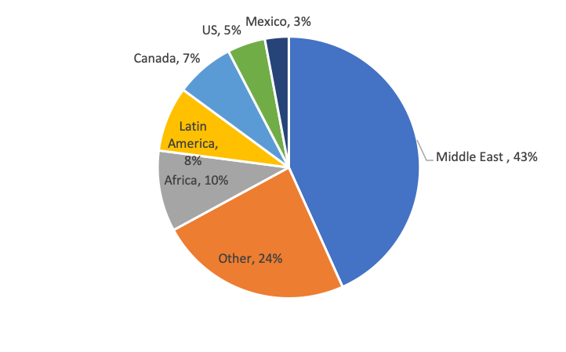
To estimate transportation distances of crude oil from producing countries to countries in our sample, we limited the analysis to the five top crude oil importers: China, India, Thailand, Turkey, and South Africa, which represent over 90% of the total crude oil imported by countries included in the analysis. We then calculated the average import distance based on a volume-weighted average of distances from each major exporter to these top-5 importers (Table S2).

Table S2: Export fractions and transport distance between crude oil producers and selected countries
Country/Region | % of global exports | Weighted average distance from 5 largest importers (km) ^{b}
Middle East | 43% | 9309
Africa | 10% | 8941
Latin America | 8% | 9349
Canada | 7% | 10621
US | 5% | 11734
Mexico | 3% | 11718
Other ª | 24% | 2244
ª Assumptions about distances for “other” exporters depended on the importing region. For China, we assumed the distance traveled was 3,200 km, which is the length of a pipeline between Taishet, Russia and Daqing, China, that transports roughly 50% of the oil traded between Russia and China ²⁰. India imports nearly all its oil from the US, Africa and the Middle East so “other” countries were not considered relevant ²¹. Thailand imports significant quantities from neighboring countries in SE Asia ²². For Turkey, we assumed “other” originated from Russia based on ²³, and for South Africa, we assumed “other” originated from India based on World Bank trade data ²⁴.
^{b} In all cases except the China-Russia pipeline, distances were estimated using an online shipping distance calculator ²⁵.

LPG and kerosene
For LPG and kerosene, the team assumed upstream emissions also result from fuel available on the global market. LPG is produced from both crude oil and natural gas; GREET allows users to set the proportion of LPG produced from each feedstock. We used the global average of 63% from natural gas and 37% from crude oil based on data from the WLPGA ²⁶. Kerosene is produced entirely from crude oil. For kerosene and the portion of LPG derived from crude oil, we used the same mix of global crude oil described in Table . To estimate the emissions from the global LPG trade, we identified the largest LPG importers in the sample (Table S3). Russia is self-sufficient in LPG supply, but the other major consumers import between 34 and 74% of LPG to meet total demand. As with crude oil, we estimate distances between major LPG exporters (Table S4). For kerosene, UN data indicated that nearly all the largest consumers are self-sufficient, so no estimates of long-distance transportation were necessary.

Table S3: Largest LPG consuming countries in the global sample ²⁶
Country | Production (kton) | Imports (kton) | Exports (kton) | Consumption (kton) | % of cons in sample (%) | pct imported
China | 40,615 | 20,521 | 1,407 | 59,729 | 39% | 34%
India | 12,768 | 14,521 | 455 | 27,046 | 18% | 54%
Russian Federation | 17,030 | 0 | 6,115 | 11,015 | 7% | 0%
Indonesia | 1,991 | 5,762 | 0 | 7,753 | 5% | 74%
Mexico | 3,372 | 4,313 | 21 | 7,665 | 5% | 56%
Total | 75,776 | 45,117 | 7,998 | 113,208 | 73% | 40%

Table S4: Major LPG exporting countries/regions ²⁶
Country/Region | % of global exports | Weighted average distance from 5 largest importers (km) ^{b}
Middle East | 35% | 9394
US | 32% | 10781
Other ª | 22% | 1583
Canada | 6% | 9628
Africa | 2% | 8394
Latin America | 2% | 8664
ª includes Russia, Australia, EU, and several Asian countries
^{b} In all cases except the China-Russia pipeline, distances were estimated using an online shipping distance calculator ²⁵.

Coal
GREET also includes upstream emissions data from coal extraction and processing. To simulate global rather than US-based coal, we changed the ratio of underground to surface mining from 30:70 to 60:40 based on data from the World Coal Institute ²⁷. We also altered the sulfur content of coal to match the average of Chinese coal, which is ~2% ²⁸.

Diesel used for ground transport
We also used GREET to estimate the emissions from road-based transportation of fossil fuels as well as charcoal. The sulfur content of diesel fuel is regulated and does not exceed 15 ppm in the US ²⁹, but varies widely in other countries. To reflect diesel fuel used in countries included in the sample, we used 540 ppm, which is the consumption-weighted average of sulfur in diesel fuel in sample countries based on 2019 data compiled by the International Council on Clean Transportation ³⁰.

Grid projections and emission factors
Future grid mixes were simulated using projections from the IEA’s World Energy Outlook (WEO) “Stated Policies” scenario through 2040, which include all world regions and major economies like Brazil, Russia, India, China, and South Africa (Table S5). Countries that were not explicitly included in WEO projections were assumed to follow the regional projection if it resulted in a cleaner grid over time. If the future regional mix was more polluting than the country’s own mix in 2020, we assumed that the country’s grid mix remained constant. Grid losses were accounted for using World Bank indicator data [27]. Plant-specific emissions are included in GREET’s database with some tunable parameters. GREET’s default values assume a US-based grid and power plant feedstock. We changed some parameters for coal, as mentioned above. Parameters for other feedstocks were left at their default values.

Table S5: Grid mix projections from WEO 2020 “Stated Policy” Scenario ³¹
Country/Region | Total (TWh) | Solar PV | Wind | Hydro | Biomass | Coal | Gas | Oil | Nuclear | Fossil fuels w/CCS
 | 2020
Brazil | 605 | 1.3% | 9.4% | 65.7% | 8.6% | 2.8% | 9.1% | 0.7% | 2.3% | 0.0%
Russia | 1057 | 0.1% | 0.1% | 17.9% | 0.3% | 15.8% | 44.5% | 0.7% | 20.4% | 0.0%
China | 7787 | 3.5% | 6.1% | 17.1% | 1.9% | 63.7% | 2.9% | 0.1% | 4.7% | 0.0%
India | 1609 | 4.0% | 4.2% | 10.8% | 3.4% | 70.0% | 4.3% | 0.5% | 2.9% | 0.0%
SE Asia | 1111 | 1.6% | 0.7% | 14.8% | 3.5% | 43.1% | 32.4% | 1.5% | 0.0% | 0.0%
S Africa | 251 | 1.8% | 3.9% | 0.4% | 0.3% | 87.7% | 0.0% | 0.0% | 4.9% | 0.0%
Africa w/o S Africa | 576 | 1.0% | 1.2% | 23.4% | 0.2% | 3.6% | 0.0% | 11.9% | 0.2% | 0.0%
Eurasia w/o Russia | 278 | 0.8% | 0.5% | 23.3% | 0.1% | 28.5% | 45.7% | 0.3% | 0.8% | 0.0%
Lat Am w/o Brazil | 672 | 2.1% | 3.1% | 44.1% | 2.8% | 7.4% | 27.8% | 10.3% | 1.6% | 0.0%
Asia w/o China and India | 3565 | 4.0% | 1.4% | 10.6% | 3.2% | 37.1% | 32.1% | 3.1% | 6.9% | 0.0%
Europe | 3952 | 4.5% | 13.1% | 16.7% | 6.0% | 15.0% | 21.4% | 1.3% | 21.2% | 0.0%
Middle East | 1188 | 0.9% | 0.2% | 1.0% | 0.0% | 0.2% | 71.0% | 25.9% | 0.6% | 0.0%
 | 2030
Brazil | 752 | 9.4% | 15.7% | 56.5% | 9.0% | 1.5% | 4.2% | 0.3% | 3.2% | 0.0%
Russia | 1253 | 0.5% | 1.6% | 15.6% | 0.6% | 11.5% | 52.1% | 0.3% | 17.5% | 0.0%
China | 10232 | 12.7% | 13.8% | 14.0% | 3.7% | 45.9% | 3.0% | 0.1% | 6.6% | 0.1%
India | 2545 | 16.3% | 7.9% | 8.9% | 3.1% | 54.6% | 4.7% | 0.2% | 4.3% | 0.0%
SE Asia | 1682 | 5.4% | 3.0% | 12.2% | 3.6% | 39.7% | 31.9% | 0.9% | 0.0% | 0.0%
S Africa | 278 | 7.2% | 13.7% | 0.7% | 2.5% | 68.3% | 2.2% | 0.0% | 5.0% | 0.0%
Africa w/o S Africa | 937 | 6.6% | 4.3% | 24.6% | 1.1% | 6.5% | 45.4% | 6.9% | 1.5% | 0.0%
Eurasia w/o Russia | 364 | 2.1% | 2.2% | 20.1% | 0.1% | 25.0% | 49.9% | 0.0% | 0.5% | 0.0%
Lat Am w/o Brazil | 864 | 7.3% | 8.4% | 48.6% | 3.5% | 2.6% | 23.0% | 4.4% | 1.1% | 0.0%
Asia w/o China and India | 4515 | 9.5% | 5.1% | 11.0% | 3.4% | 30.9% | 26.6% | 2.0% | 9.1% | 0.1%
Europe | 4601 | 10.9% | 24.9% | 16.4% | 6.4% | 5.5% | 17.3% | 0.5% | 16.9% | 0.2%
Middle East | 1616 | 4.9% | 1.6% | 1.8% | 0.4% | 1.1% | 71.1% | 15.2% | 3.2% | 0.0%
 | 2040
Brazil | 925 | 12.4% | 17.4% | 50.7% | 8.4% | 1.1% | 4.6% | 0.3% | 4.8% | 0.0%
Russia | 1377 | 0.9% | 3.8% | 15.4% | 2.3% | 9.5% | 48.4% | 0.1% | 18.3% | 0.0%
China | 11995 | 19.7% | 17.3% | 13.1% | 4.1% | 33.0% | 3.6% | 0.0% | 8.6% | 0.3%
India | 3853 | 32.7% | 13.3% | 8.0% | 2.8% | 32.8% | 4.1% | 0.1% | 5.8% | 0.0%
SE Asia | 2269 | 8.6% | 5.6% | 13.2% | 4.1% | 35.1% | 28.8% | 0.6% | 0.5% | 0.0%
S Africa | 328 | 12.5% | 24.7% | 1.2% | 4.9% | 40.9% | 5.5% | 0.0% | 7.6% | 0.0%
Africa w/o S Africa | 1380 | 13.7% | 7.8% | 23.6% | 1.7% | 4.0% | 36.8% | 4.5% | 1.4% | 0.0%
Eurasia w/o Russia | 465 | 2.8% | 3.2% | 18.6% | 0.3% | 21.0% | 52.2% | 0.0% | 1.7% | 0.0%
Lat Am w/o Brazil | 1087 | 11.2% | 10.9% | 46.5% | 3.9% | 1.2% | 19.9% | 2.1% | 2.5% | 0.0%
Asia w/o China and India | 5556 | 12.6% | 9.4% | 11.9% | 4.0% | 24.9% | 24.9% | 1.0% | 7.5% | 0.6%
Europe | 5191 | 12.5% | 33.3% | 16.0% | 6.4% | 3.3% | 13.3% | 0.2% | 13.4% | 0.1%
Middle East | 2230 | 10.9% | 5.1% | 1.7% | 1.1% | 1.0% | 64.9% | 10.0% | 3.6% | 0.0%

Table S6 shows emissions factors derived from GREET as described in the methods section of the main text.

Table S6: Life cycle grid emissions in grams per kWh of electricity produced from each type of power generation were estimated using GREET ³²
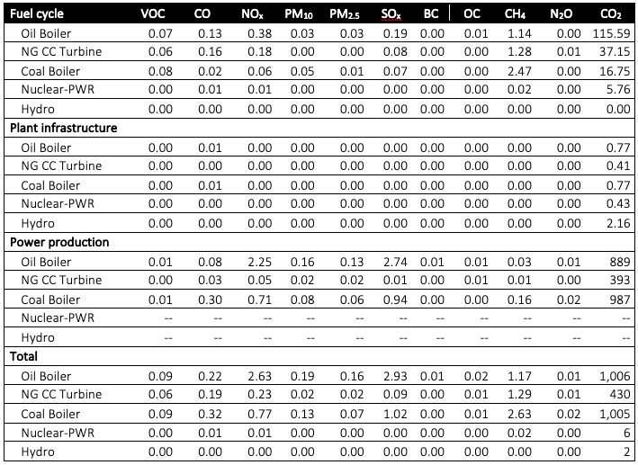

Table S6 shows life cycle emissions though generation of electricity at the power plant. However, grid losses can be substantial, particularly in LMICs. We account for grid losses using data from the World Bank, which has information from 56 of the 77 countries in our sample. Losses range from ~6% in China and Thailand to 60% or more in Togo and Haiti. Available data are shown in Table S7 . For countries lacking data, we used the average of losses weighted by electricity demand for cooking, which is ~8%.

Table S7: Grid losses in percent based on World Bank data ³³
Country Code | % losses |  | Country Code | % losses
AGO | 11.3 |  | MNG | 14.8
BGD | 11.4 |  | MOZ | 14.7
BIH | 8.2 |  | NAM | 36.2
BOL | 9.2 |  | NER | 41.8
BRA | 15.8 |  | NGA | 16.1
BWA | 11.0 |  | NIC | 20.8
CHN | 5.5 |  | NPL | 32.2
CIV | 14.3 |  | PAK | 17.1
CMR | 11.1 |  | PER | 11.0
COD | 21.4 |  | PHL | 9.4
COG | 44.5 |  | PRY | 6.6
COL | 10.7 |  | RUS | 10.0
DOM | 12.2 |  | SDN | 14.3
ERI | 12.9 |  | SEN | 12.9
ETH | 18.7 |  | SRB | 15.4
GHA | 22.6 |  | SSD | 5.7
GTM | 9.5 |  | TGO | 71.0
HND | 34.9 |  | THA | 6.1
HTI | 60.1 |  | TJK | 17.0
IDN | 9.4 |  | TUR | 14.8
IND | 19.3 |  | TZA | 17.7
IRN | 12.6 |  | UKR | 10.8
KEN | 17.6 |  | UZB | 8.8
KGZ | 23.7 |  | VNM | 9.3
KHM | 23.4 |  | YEM | 25.8
LKA | 11.4 |  | ZAF | 8.4
MEX | 13.7 |  | ZMB | 15.0
MMR | 20.5 |  | ZWE | 16.4

Applying the emission factors from Table S6 and loss factors from Table S7 to the grid mix described in Table S5 results in country-specific emission factors. In the base year 2018 emission factors ranged from over 1000 gCO₂e per kWh in countries that are heavily dependent on coal and/or have high grid losses to < 10 gCO₂e per kWh in countries that are heavily dependent on hydroelectric power. Emission factors per kWh consumed are shown in Figure S3.

Figure S3: Grid emission factors per kWh consumed based on the national mix in 2018 and projected mix in 2040
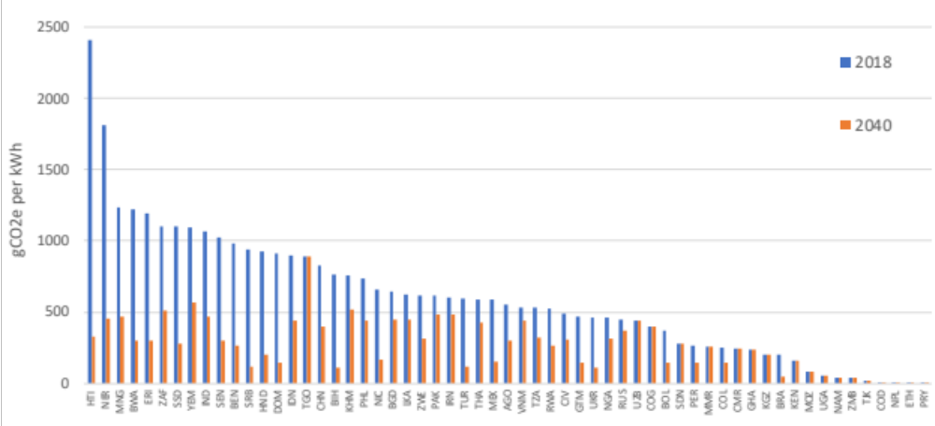

Accounting for non-renewable biomass
When there are imbalances between woody biomass harvest and regrowth, CO2 emitted during combustion is not fully sequestered by regenerating trees. This is called “non-renewable biomass” or NRB and the ratio of NRB to woody biomass consumption the “fraction non-renewable biomass” or fNRB. We use a country-specific pan-tropical estimate of fNRB from a previous study [6]. While these estimates cover most LMICs, some countries included in our sample were not included. For these countries, a LMIC-wide average of 28.8% fNRB was used. Country-level fNRB values are shown in Table S8.

Table S8: Country-level fNRB values ^{from 34}
Country | ISO3 | fNRB (%) |  | Country | ISO3 | fNRB (%)
Afghanistan | AFG | 25.7 |  | Mali | MLI | 28.5
Angola | AGO | 34.9 |  | Myanmar | MMR | 4.4
Burundi | BDI | 55.5 |  | Mongolia | MNG | 25.7
Benin | BEN | 19.3 |  | Mozambique | MOZ | 39.6
Burkina Faso | BFA | 47.1 |  | Mauritania | MRT | 69.1
Bangladesh | BGD | 50.9 |  | Malawi | MWI | 32.8
Bosnia and Herzegovina | BIH | 28.8 |  | Namibia | NAM | 45.3
Bolivia (Plurinational State of) | BOL | 22.2 |  | Niger | NER | 49.0
Brazil | BRA | 17.4 |  | Nigeria | NGA | 18.8
Botswana | BWA | 17.0 |  | Nicaragua | NIC | 31.9
Central African Republic | CAF | 35.2 |  | Nepal | NPL | 52.4
China | CHN | 16.5 |  | Pakistan | PAK | 83.3
Côte d'Ivoire | CIV | 35.2 |  | Peru | PER | 26.1
Cameroon | CMR | 9.0 |  | Philippines | PHL | 21.8
DR of the Congo | COD | 35.2 |  | Papua New Guinea | PNG | 31.2
Congo | COG | 35.2 |  | Paraguay | PRY | 29.1
Colombia | COL | 29.7 |  | Russian Federation | RUS | 28.8
Dominican Republic | DOM | 33.0 |  | Rwanda | RWA | 58.9
Eritrea | ERI | 67.6 |  | Sudan | SDN | 25.7
Ethiopia | ETH | 60.9 |  | Senegal | SEN | 33.3
Ghana | GHA | 27.7 |  | Sierra Leone | SLE | 21.7
Guinea | GIN | 24.1 |  | Somalia | SOM | 52.4
Gambia | GMB | 41.4 |  | Serbia | SRB | 28.8
Guinea-Bissau | GNB | 27.8 |  | South Sudan | SSD | 35.2
Guatemala | GTM | 31.7 |  | Chad | TCD | 23.7
Honduras | HND | 19.9 |  | Togo | TGO | 43.1
Haiti | HTI | 66.3 |  | Thailand | THA | 3.0
Indonesia | IDN | 41.1 |  | Tajikistan | TJK | 25.7
India | IND | 23.2 |  | Timor-Leste | TLS | 23.7
Iran (Islamic Republic of) | IRN | 25.7 |  | Turkey | TUR | 25.7
Kenya | KEN | 36.7 |  | Tanzania | TZA | 17.6
Kyrgyzstan | KGZ | 25.7 |  | Uganda | UGA | 61.1
Cambodia | KHM | 23.1 |  | Ukraine | UKR | 28.8
Lao PDR | LAO | 25.7 |  | Uzbekistan | UZB | 25.7
Liberia | LBR | 23.0 |  | Viet Nam | VNM | 11.7
Sri Lanka | LKA | 23.6 |  | Yemen | YEM | 25.7
Lesotho | LSO | 52.4 |  | South Africa | ZAF | 23.8
Madagascar | MDG | 26.6 |  | Zambia | ZMB | 33.8
Mexico | MEX | 25.9 |  | Zimbabwe | ZWE | 33.1

Cooking Upstream and End-Use Emission Factors

Table S9: Life-cycle emission factors for each fuel pathway (grams pollutant per MJ-delivered). Dashes indicate that emissions are negligible. Numerical superscripts refer to references used for each pollutant.
Production and processing | Biomass ª | Charcoal ª | Coal | Kerosene | LPG
CO | -- | 66.0 ³⁵ | 0.0100 ³² | 0.0200 ³² | 0.0300 ³²
NO_{x} | -- | 0.064 ³⁶ | -- | 0.0700 ³² | 0.0300 ³²
PM_{2.5} | -- | 1.05 ³⁵ | -- | -- | --
SO_{x} | -- | -- | -- | 0.0300 ³² | 0.0400 ³²
BC | -- | 0.000770 ³⁵ | 0.0130 ³² | 0.000700 ³² | 0.000300 ³²
OC | -- | 0.0285 ³⁵ | -- | -- | --
CH₄ | -- | 10.9 ³⁵ | 0.490 ³² | 0.210 ³² | 0.210 ³²
N₂O | -- | 0.0641 ³⁶ | -- | 0.000300 ³² | 0.000300 ³²
NMVOC | -- | 22.9 ³⁷ | -- | -- | --
CO₂ | -- | 687 ³⁵ | 1.44 ³² | 19.0 ³² | 22.5 ³²
Transportation
CO | -- | -- | -- | -- | 0.0100 ³²
NO_{x} | -- | 0.0100 ³² | 0.0100 ³² | 0.0100 ³² | 0.0600 ³²
PM_{2.5} | -- | -- | -- | -- | --
SO_{x} | -- | -- | -- | -- | 0.0200 ³²
BC | -- | -- | -- | 0.000100 ³² | 0.00110 ³²
OC | -- | -- | -- | -- | --
CH₄ | -- | -- | -- | -- | 0.0100 ³²
N₂O | -- | -- | -- | -- | 0.000100 ³²
NMVOC | -- | -- | -- | -- | --
CO₂ | -- | 1.87 ³² | 1.88 ³² | 0.6100 ³² | 6.41 ³²
End-use
CO | 24.9 ³⁵ | 38.5 ³⁷ | 23.1 ³⁶ | 1.20 ³⁶ | 0.525 ³⁶
NO_{x} | 0.0500 ³⁶ | 0.0632 ³⁶ | 0.475 ³⁶ | 1.20 ³⁶ | 0.0792 ³⁶
PM_{2.5} | 1.38 ³⁵ | 0.725 | 1.4 ³⁶ | 0.00300 ³⁶ | 0.0133 ³⁶
SO_{x} | 0.140 ³⁶ | 0.0700 ³⁶ | 1.61 ³⁶ | 0.00116 ³⁶ | 1.00E-05 ³⁶
BC | 0.300 ³⁵ | 0.013 ³⁷ | 0.00147 ³⁵ | -- | --
OC | 0.360 ³⁵ | 0.769 ³⁷ | 0.00411 ³⁵ | -- | --
CH₄ | 3.87 | 1.46 ³⁷ | 1.88 ³⁶ | 0.017 ³⁶ | 0.014 ³⁶
N₂O | -- | -- | -- | -- | --
NMVOC | 3.90 ³⁶ | 1.60 ³⁶ | 5.76 | 0.0260 ³⁶ | --
CO₂ | 634 ³⁵ | 404 ³⁷ | 572 | 151 ³⁶ | 137 ³⁶
Total ^{b}
CO | 24.9 | 105 | 23.1 | 1.22 | 0.565
NO_{x} | 0.0500 | 0.137 | 0.485 | 1.28 | 0.169
PM_{2.5} | 1.38 | 1.78 | 1.40 | 0.00300 | 0.0133
SO_{x} | 0.140 | 0.0700 | 1.61 | 0.0312 | 0.0600
BC | 0.300 | 0.0138 | 0.0145 | 0.000800 | 0.00140
OC | 0.360 | 0.797 | 0.00411 | -- | --
CH₄ | 3.87 | 12.4 | 2.37 | 0.227 | 0.234
N₂O | -- | 0.0641 | -- | 0.000300 | 0.000400
NMVOC | 3.90 | 24.5 | 5.76 | 0.0260 | --
CO₂ | 634 | 1090 | 575 | 171 | 166
ª To assess climate impacts, end-use CO₂ emissions from biomass and charcoal are adjusted by the country-specific fNRB factor listed in SI Section ‎7.
^{b} Total are the simple sum of Production and processing, Transportation, and End-use, rounded to three significant figures.

Energy Demand by Scenario Type

Figure S4: Comparison of energy demand by households in the BAU scenario (dashed lines) and IT (top), FT-LE (middle) and FT-Elec (bottom) scenarios. In each plot the data from alternative scenarios are shown with solid lines.
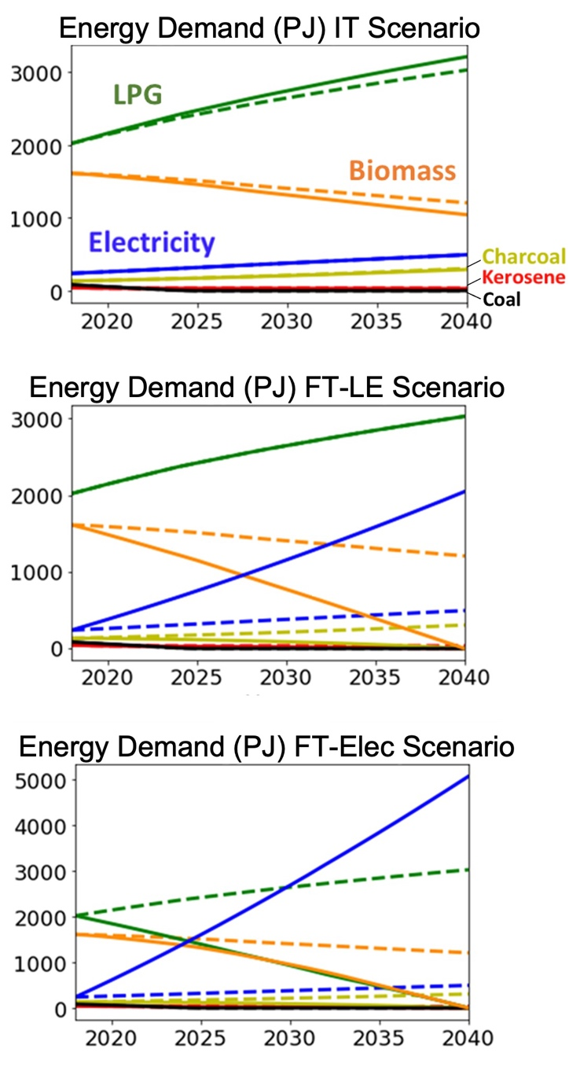

Emissions of health-damaging and climate forcing pollutants

Short-lived forcers
In the main text, we compare BC emissions at baseline and in 2040 across scenarios. In Figure S5 we show that NMVOCs and OC emissions follow similar patterns though NMVOCs are higher in 2040 than 2018 in both BAU and IT scenarios, while OC, like BC, is lower. Under full transitions to LPG and/or electricity, NMVOC and OC emissions are nearly eliminated.

Figure S5: Emissions of well-mixed NMHCs (A) and OC (B) at baseline and in 2040 for all scenarios
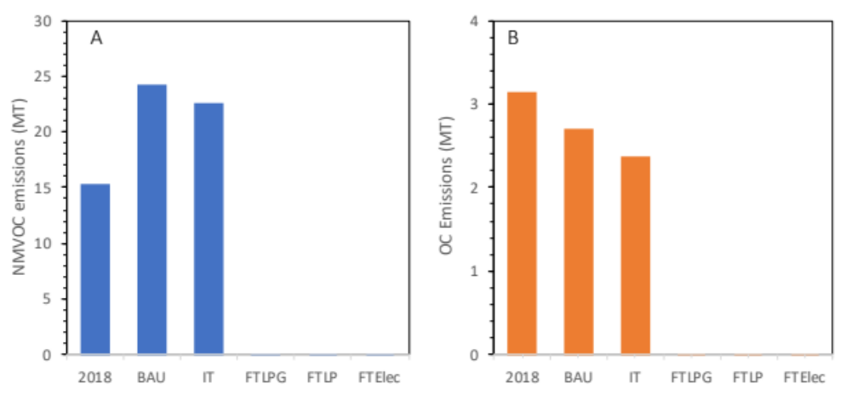

Regional breakdown
Emissions of health-damaging pollutants vary by region (Figure S6). In 2018, PM_{2.5} emissions were highest in the African and SE Asian regions. Under BAU, PM_{2.5} emissions decrease in every region by 2040 except Africa, where our projections show that they increase by >50% due to increased (mostly rural) biomass and (mostly urban) charcoal consumption. By 2040, a FT-LPG scenario results in large reductions in all regions including nearly 95% reduction in Africa.

Figure S6: Fuel-specific urban and rural emissions of PM_{2.5} by WHO region in the BAU and FT-LPG scenarios
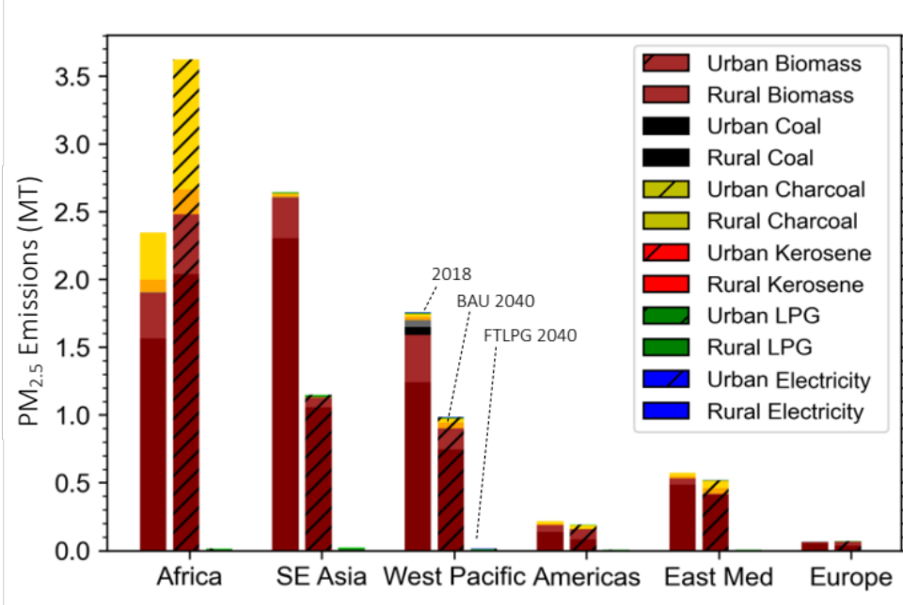

More detailed breakdown of GHG emissions

Country-level changes
The largest reductions in emissions between BAU and the three FT scenarios occur in countries with large populations of polluting fuel users that are projected to remain high under BAU, as well as countries with clean electricity production. These include Ethiopia, with reductions of 32-55 Mt CO₂e/yr by 2040 under the full transitions, Democratic Republic of the Congo (18-40 Mt CO₂e), Uganda (22-34 MtCO2e) and Pakistan (24-25 MT CO₂e). All these countries have large contributions from hydro-electric power in 2018: Democratic Republic of the Congo (99.7%), Ethiopia (92.7%), Uganda (89.1%) and Pakistan (30.7%), contributing to the large decline in GHGs.

Specific pollutants
Changes in emissions of specific GHGs vary. CO₂ and CH₄ emissions closely mirror CO₂e emissions described above. However, N₂O, behaves differently because N₂O emissions from electricity are higher N₂O increases 90% between 2018 and 2040 under the BAU scenario. N₂O emissions are ~70% lower in the FT-LPG scenario, but only 50% lower in the FT-E scenario and 10% higher in the FT-EO scenario.
SLCFs follow similar patterns: as explained in the main text, BC emissions decrease by ~17% between 2018 and 2040 in the BAU scenario and decline by ~12% under the IT scenario and are nearly eliminated under full transitions to LPG and/or electricity. OC and NMVOC emissions follow similar patterns. Both decrease slightly between 2018 and 2040 under BAU. In the IT scenario, OC emissions increase by roughly 12% relative to BAU, and are nearly eliminated in full transitions. NMVOCs decrease ~6% under IT and are also nearly eliminated under the full transitions. Other SLCFs, SO_{x}, NO_{x}, and CO, were discussed in the section on health damaging pollutants.

Changes in Emissions
Table S10: Pollutant-specific emissions in 2018 (all scenarios) and 2040 in each Scenario
 | 2018 | 2040
 | (all) | BAU | IT | FT-LPG | FT-LE | FT-Elec
CO₂ | 836.4297 | 948.0805 | 940.3771 | 825.8725 | 722.2453 | 645.9218
NMVOC | 15.31756 | 24.16058 | 22.61973 | 0.006155 | 0.022334 | 0.065279
CO | 70.64852 | 66.98022 | 60.1796 | 2.610679 | 1.784506 | 0.215057
NO_{x} | 0.600458 | 0.716758 | 0.730784 | 0.825862 | 0.690274 | 0.497227
PM₁₀ | 28.58372 | 21.72236 | 18.81904 | 0.007672 | 0.023125 | 0.06925
PM_{2.5} | 7.560072 | 6.454984 | 5.702069 | 0.064781 | 0.0542 | 0.040127
SO_{x} | 0.559818 | 0.441057 | 0.427742 | 0.338491 | 0.37649 | 0.561177
BC | 1.191671 | 1.001679 | 0.883463 | 0.006461 | 0.004674 | 0.001475
OC | 3.139732 | 2.699641 | 2.381576 | 0.000203 | 0.002149 | 0.006116
CH₄ | 6.609108 | 7.114238 | 6.566668 | 1.24873 | 1.265119 | 1.636891
N₂O | 0.006448 | 0.012221 | 0.011867 | 0.00363 | 0.005902 | 0.013497
CO₂e | 1138.421 | 1297.164 | 1281.208 | 1072.004 | 897.8612 | 694.3095

- Temperature and Uncertainty Results

Table S11: Temperature differences in 2040 relative to BAU for Different Scenarios (used for Figure 4C)
 | 5th percentile (K) | 50th percentile (K) | 95th percentile(K)
Full Electricity | -2.38E-02 | -5.08E-03 | 2.44E-02
FT-Elec | -2.47E-02 | -4.99E-03 | 2.67E-02
FT-LPG | -2.44E-02 | -4.67E-03 | 2.71E-02
IT | -2.67E-03 | -3.23E-04 | 3.51E-03

Table S12: Pollution-specific temperature differences in 2040 between FT-LPG and BAU, used for Figure 5A
Pollutant | 5th Percentile (K) | 50th Percentile (K) | 95th Percentile (K)
NMVOC | -6.00E-03 | -2.82E-03 | -5.70E-06
OC | 5.81E-03 | 1.89E-02 | 4.47E-02
NOx | 3.37E-05 | 7.50E-05 | 1.23E-04
Sox | 1.27E-04 | 2.55E-04 | 4.22E-04
N2O | -1.38E-05 | -1.06E-05 | -8.06E-06
CO2 | -5.01E-04 | -4.01E-04 | -3.20E-04
CH4 | -2.98E-03 | -2.31E-03 | -1.73E-03
CO | -6.99E-03 | -3.65E-03 | -5.67E-04
BC | -2.72E-02 | -1.46E-02 | -2.55E-03
Total | -2.44E-02 | -4.71E-03 | 2.68E-02

Table S13: Region- & pollution-specific temperature differences in 2040 between FT-LPG and BAU, used for Figure 5C
Region | NMVOC | OC | NOx | SOx | N2O | CO2 | CH4 | CO | BC
Africa | -2.10E-03 | 1.01E-02 | 0.00E+00 | 1.00E-04 | 0.00E+00 | -3.00E-04 | -1.40E-03 | -2.10E-03 | -7.70E-03
SE Asia | -1.00E-04 | 3.50E-03 | 0.00E+00 | 1.00E-04 | 0.00E+00 | 0.00E+00 | -3.00E-04 | -6.00E-04 | -2.70E-03
Europe | 0.00E+00 | 2.00E-04 | 0.00E+00 | 0.00E+00 | 0.00E+00 | 0.00E+00 | 0.00E+00 | 0.00E+00 | -2.00E-04
Americas | -1.00E-04 | 6.00E-04 | 0.00E+00 | 0.00E+00 | 0.00E+00 | 0.00E+00 | -1.00E-04 | -1.00E-04 | -4.00E-04
East Med | -2.00E-04 | 1.50E-03 | 0.00E+00 | 0.00E+00 | 0.00E+00 | -1.00E-04 | -2.00E-04 | -3.00E-04 | -1.20E-03
Western Pacific | -2.00E-04 | 3.10E-03 | 0.00E+00 | 0.00E+00 | 0.00E+00 | 0.00E+00 | -3.00E-04 | -5.00E-04 | -2.40E-03

References
1. UNDP. SUSTAINABLE DEVELOPMENT GOAL 7. Sustainable Development Knowledge Platform https://sustainabledevelopment.un.org/sdg7 (2020).
2. World Health Organization. WHO global air quality guidelines: particulate matter (‎PM2.5 and PM10)‎, ozone, nitrogen dioxide, sulfur dioxide and carbon monoxide. https://apps.who.int/iris/handle/10665/345329.
3. World Health Organization. Defining clean fuels and technologies. Clean Household Energy Solutions Toolkit https://www.who.int/tools/clean-household-energy-solutions-toolkit/module-7-defining-clean (2021).
4. Stoner, O. et al. Household cooking fuel estimates at global and country level for 1990 to 2030 - Supplemental Data. Nat Commun 12, 5793 (2021).
5. Global LPG Partnership. The Global LPG Partnership - Fact Sheet. 6 https://static1.squarespace.com/static/5633c4c2e4b05a5c7831fbb5/t/5b2bae2288251ba7a0589660/1529589286458/The+Global+LPG+Partnership+-+Executive+Summary+-+website+20+Jun+2018.pdf (2018).
6. Kypridemos Chris et al. Health and Climate Impacts of Scaling Adoption of Liquefied Petroleum Gas (LPG) for Clean Household Cooking in Cameroon: A Modeling Study. Environmental Health Perspectives 128, 047001 (2020).
7. Puzzolo, E. et al. Supply Considerations for Scaling Up Clean Cooking Fuels for Household Energy in Low- and Middle-Income Countries. GeoHealth 3, 370–390 (2019).
8. IEA. World Energy Outlook 2021. www.iea.org/weo.
9. Sika, J. M. From Nairobi in 2007 to Dakar in 2020. Africa Biogas Partnership Programme https://www.africabiogas.org/blog/from-nairobi-in-2007-to-dakar-in-2020/ (2019).
10. Meeks, R., Sims, K. R. E. & Thompson, H. Waste Not: Can Household Biogas Deliver Sustainable Development? Environ Resource Econ 72, 763–794 (2019).
11. Hyman, J. & Bailis, R. Assessment of the Cambodian National Biodigester Program. Energy for Sustainable Development 46, 11–22 (2018).
12. Mittal, S., Ahlgren, E. O. & Shukla, P. R. Barriers to biogas dissemination in India: A review. Energy Policy 112, 361–370 (2018).
13. Bond, T. & Templeton, M. R. History and future of domestic biogas plants in the developing world. Energy for Sustainable Development 15, 347–354 (2011).
14. KOKO Networks. 400,000 Kenyan Household Subscribers On KOKO’s Clean Fuel Platform. Koko News https://kokonetworks.com/news/400000-kenyan-household-subscribers-on-kokos-clean-fuel-platform/ (2022).
15. ICF. The DHS Program STATcompiler. http://www.statcompiler.com (2022).
16. EED & SEI. Kenya Cooking Sector Study: Assessment of the Supply and Demand of Cooking Solutions at the Household Level. 163 https://www.eedadvisory.com/resources/resources/ (2019).
17. Clean Cooking Alliance. Haiti Urban Household Energy Baseline Dataset. (2019).
18. MININFRA. National Survey on Cooking Fuel Energy and Technologies in Households, Commercial and Public Institutions in Rwanda. 113 (2020).
19. United Nations Statistics Division. UNdata | explorer. http://data.un.org/Explorer.aspx?d=EDATA (2021).
20. Wikipedia. Eastern Siberia–Pacific Ocean oil pipeline - Wikipedia. https://en.wikipedia.org/wiki/Eastern_Siberia%E2%80%93Pacific_Ocean_oil_pipeline#cite_note-upstream2-18 (2022).
21. Verma, N. U.S. becomes India’s second biggest oil supplier, Saudi plunges to No. 4. Reuters (2021).
22. International Trade Administration. Energy Resource Guide - Thailand - Oil and Gas. https://www.trade.gov/energy-resource-guide-thailand-oil-and-gas.
23. Energy Information Administration (EIA). TURKEY - Analysis. https://www.eia.gov/international/analysis/country/TUR (2017).
24. World Bank. South Africa Fuel Imports by country & region 2019. World Integrated Trade Solution (WITS) https://wits.worldbank.org/CountryProfile/en/Country/ZAF/Year/2019/TradeFlow/Import/Partner/all/Product/Fuels/Show/Partner%20Name;MPRT-TRD-VL;MPRT-PRDCT-SHR;AHS-WGHTD-AVRG;MFN-WGHTD-AVRG;/Sort/MPRT-TRD-VL/Chart/top10 (2022).
25. sea-distances.org. Shipping Distance Calculator. https://sea-distances.org/ (2022).
26. WLPGA. Statistical Review of Global LPG 2020. https://www.wlpga.org/publication/statistical-review-of-global-lpg-2021/.
27. World Coal Institute. The Coal Resource, A Comprehensive Overview of Coal. 44 https://www.scribd.com/document/18825349/The-Coal-Resource-A-Comprehensive-Overview-of-Coal-World-Coal-Institute (2005).
28. Hussain, R. & Luo, K. The Geological Availability and Emissions of Sulfur and SO2 from the Typical Coal of China. Aerosol and Air Quality Research 19, 559–570 (2019).
29. US EPA, O. Diesel Fuel Standards and Rulemakings. https://www.epa.gov/diesel-fuel-standards/diesel-fuel-standards-and-rulemakings (2015).
30. Miller, J. & Jin, L. GLOBAL PROGRESS TOWARD SOOT-FREE DIESEL VEHICLES IN 2019. Supplemental Table S2 https://theicct.org/sites/default/files/publications/Global_progress_sootfree_diesel_2019_20190920.pdf (2019).
31. IEA. World Energy Outlook 2020 – Analysis. (INTERNATIONAL ENERGY AGENCY, 2020).
32. Argonne National Laboratory. The Greenhouse Gases, Regulated Emissions, and Energy Use in Transportation (GREET) Model. (2021).
33. World Bank. World Bank Open Data. DataBank https://data.worldbank.org (2021).
34. Bailis, R., Drigo, R., Ghilardi, A. & Masera, O. The Carbon Footprint of Traditional Woodfuels. Nature Climate Change 5, 266–272 (2015).
35. Grieshop, A. P., Marshall, J. D. & Kandlikar, M. Health and climate benefits of cookstove replacement options. Energy Policy 39, 7530–7542 (2011).
36. US EPA. Life Cycle Assessment of Cooking Fuel Systems in India, China, Kenya, and Ghana. https://cfpub.epa.gov/si/si_public_record_report.cfm?dirEntryId=339679&Lab=NRMRL&simplesearch=0&showcriteria=2&sortby=pubDate&timstype=Published+Report&datebeginpublishedpresented.
37. Akagi, S. K. et al. Emission factors for open and domestic biomass burning for use in atmospheric models. Atmospheric Chemistry and Physics 11, 4039–4072 (2011).

For example, the African Biogas Partnership Program disseminated ~70,000 biogas digesters in 5 African countries between 2007 and 2019 ⁹. Similarly several million household-scale biogas digesters have been installed in South and Southeast Asia ^{10–13} . However, household survey data often combines biogas with LPG, so biogas does not appear explicitly. In addition, between late 2019 and early 2022, an ethanol fuel company claims to have reached ~400,000 users in Nairobi and adjacent counties in Kenya but data on ethanol uptake are not yet reflected in current household fuel datasets ¹⁴.
Higher useful energy among solid fuel users may be because solid fuel-burning stoves are not easily shut off; after the meal is cooked, the remaining fuel continues to burn. In contrast, stoves using LPG and other commercial fuels are easily shut off after cooking is complete, thus the same cooking task utilizes less “useful” energy.
We justify using a value for China because cooking electricity consumption in China represents over 60% of all electricity used for cooking in sample countries in 2018 and its share will increase under most scenarios.

