Journal: Microbial Ecology
Comparative Analysis of Chicken Cecal Microbial Diversity and Taxonomic Composition in Response to Dietary Variation using 16S rRNA Amplicon Sequencing
Zubia Rashid¹, Muhammad Zubair Yousaf², Syed Muddassar Hussain Gilani³, Sitwat Zehra¹, Ashaq Ali⁴, Abid Azhar¹ and Saddia Galani^{1*}
¹Karachi Institute of Biotechnology and Genetic Engineering, University of Karachi, Karachi, Pakistan; zubia.rashid2@gmail.com, ssitwat.zehra@kibge.edu.pk, aabid.azhar@kibge.edu.pk, sadia.galani@kibge.edu.pk
²School of Life Sciences, Forman Christian College University Lahore, Pakistan; mzubairyousaf@fccollege.edu.pk.
³Department of Agriculture and Agribusiness Management, University of Karachi, Karachi, Pakistan; gilani1294@gmail.com.
⁴State Key Laboratory of Virology, Wuhan Institute of Virology, Center for biosafety Mega-Science, Chinese Academy of Sciences, Wuhan, 430071, China; microbiologist_hu@hotmail.com

*Corresponding Author:
Saddia Galani, Ph. D.
Associate Professor
The Karachi Institute of Biotechnology
and Genetic Engineering (KIBGE),
University of Karachi,
Karachi-75270, Pakistan
Email: sadia.galani@kibge.edu.pk
Phone: +92-3368276928

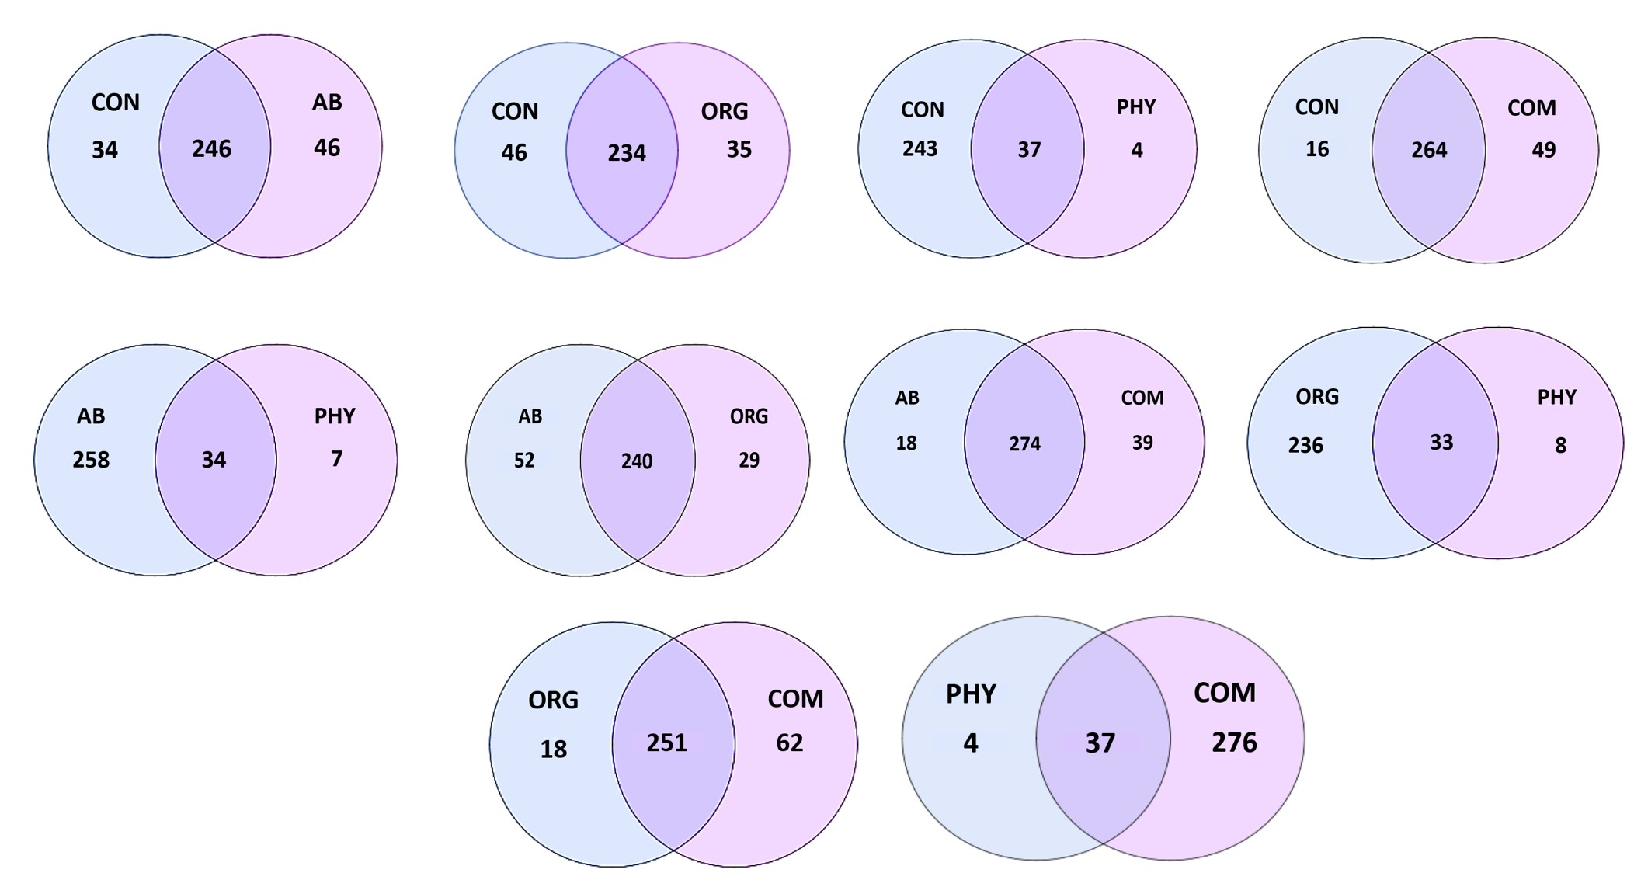

Online Resource 1: Alpha rarefaction curve of observed species, chao1, ACE, simpson and shannon against number of sequences in study groups. CON: control, AB: antibiotic group, PHY: phytogenic feed additives, ORG: organic acids, COM: combination.

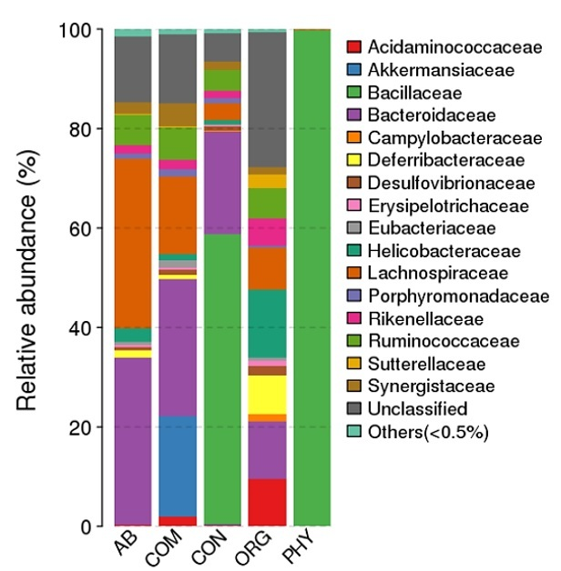

Online Resource 2:Venn diagrams showing illustrating unique/shared core microbiome in chicken cecum between study groups. CON: control, AB: antibiotic group, PHY: phytogenic feed additives, ORG: organic acids, COM: combination.

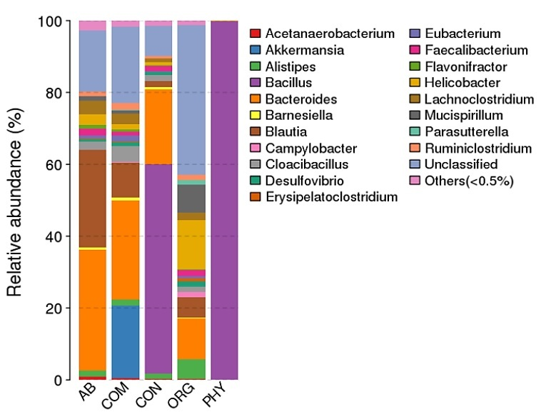

Online Resource 3: Relative abundance of family-level composition of the cecal microbiome of chicken. The color-coded bar plot displays the bacterial family distribution based on top 100 OTUs among different treatments. CON: control, AB: antibiotic group, PHY: phytogenic feed additives, ORG: organic acids, COM: combination.

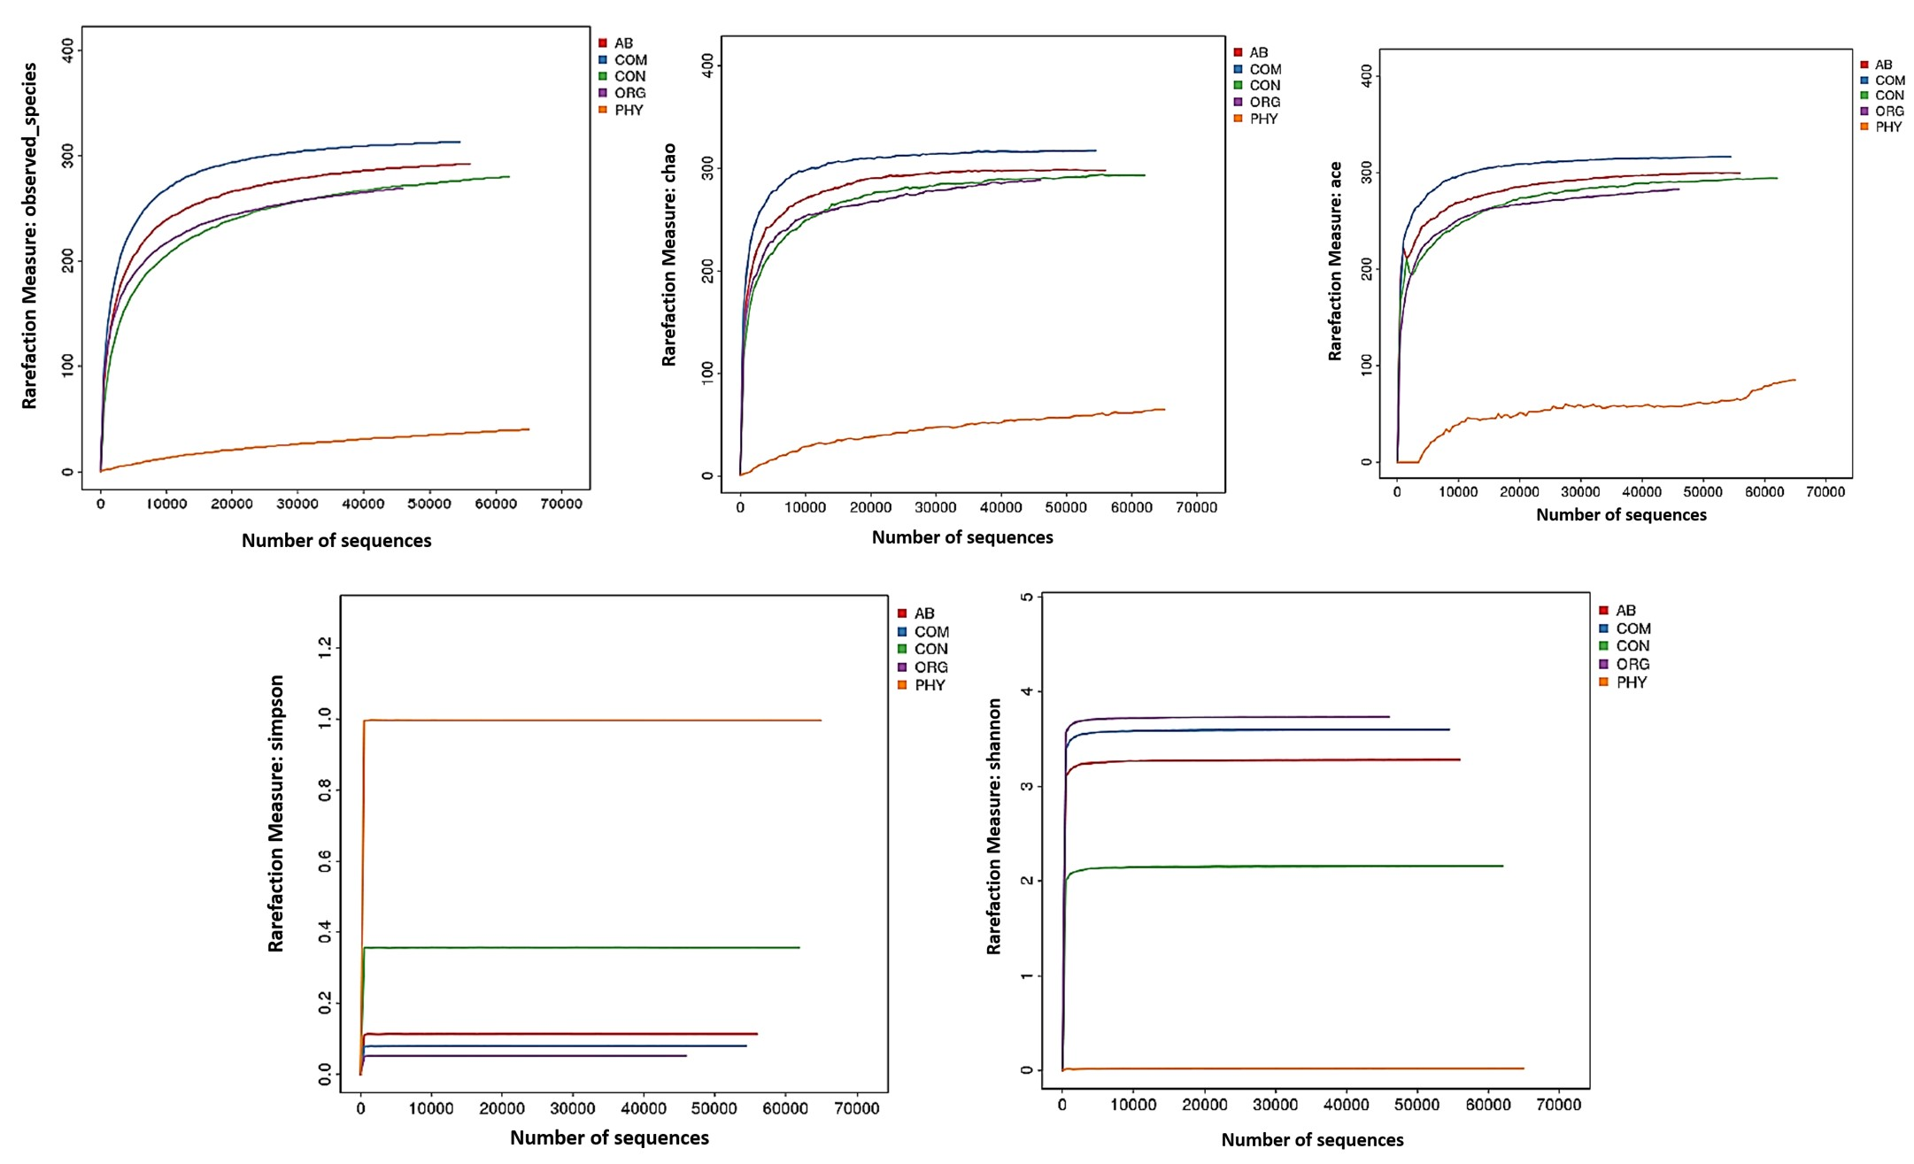

Online Resource 4:Relative abundance of genera-level composition of the cecal microbiome of chicken. The color-coded bar plot displays the bacterial genus distribution based on top 100 OTUs among different treatments. CON: control, AB: antibiotic group, PHY: phytogenic feed additives, ORG: organic acids, COM: combination.

