Prognostic and Therapeutic Value of LSM5 Gene in Human Brain Cancer Glioma: An Omics Database Exploration Approach
Md. Asad Ullah¹, Sayka Alam¹, Maisha Farzana², Abu Tayab Moin³, Chowdhury Nusaiba Binte Sayed Prapty², Umme Salma Zohora¹, Mohammad Shahedur Rahman^{1,4*}
¹Department of Biotechnology and Genetic Engineering, Faculty of Biological Sciences, Jahangirnagar University, Dhaka, Bangladesh
²Biotechnology Program, Department of Mathematics and Natural Sciences, School of Data and Sciences, BRAC University, Dhaka, Bangladesh
³Department of Genetic Engineering and Biotechnology, Faculty of Biological Sciences, University of Chittagong, Chattogram, Bangladesh
⁴Wazed Miah Science Research Center, Jahangirnagar University, Dhaka, Bangladesh

These authors contributed equally.

*Corresponding author:
Dr. Mohammad Shahedur Rahman
Professor,
Department of Biotechnology and Genetic Engineering, Faculty of Biological Sciences, Jahangirnagar University, Dhaka, Bangladesh
Email: rahmanms@juniv.edu

Supplementary Information
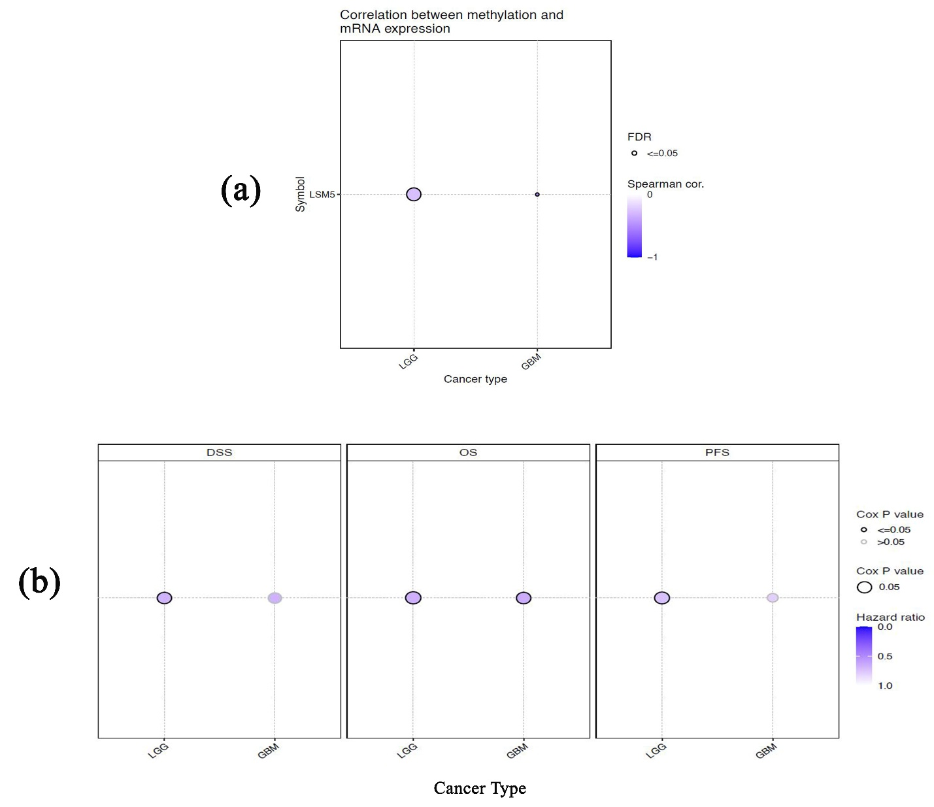

Supplementary Figure S1: (a) The dot-plot representation of the association between LSM5 methylation and its mRNA expression in glioma tissues. (b) The dot-plot represents the correlation between LSM methylation and the survival rates of glioma patients. DSS: disease-specific survival; OS: overall survival; PFS: progression-free survival.

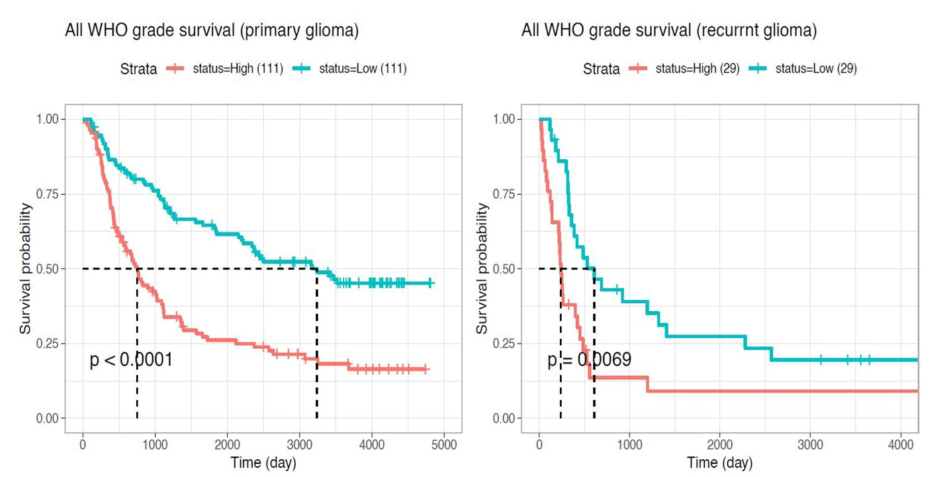

Supplementary Figure S2: The association between LSM5 expression and overall survival of glioma patients with primary glioma (left) and recurrent glioma (right). Red and paste color plot represent higher and lower LSM5 expressing groups, respectively. The vertical tick along the plot represents an event (death).

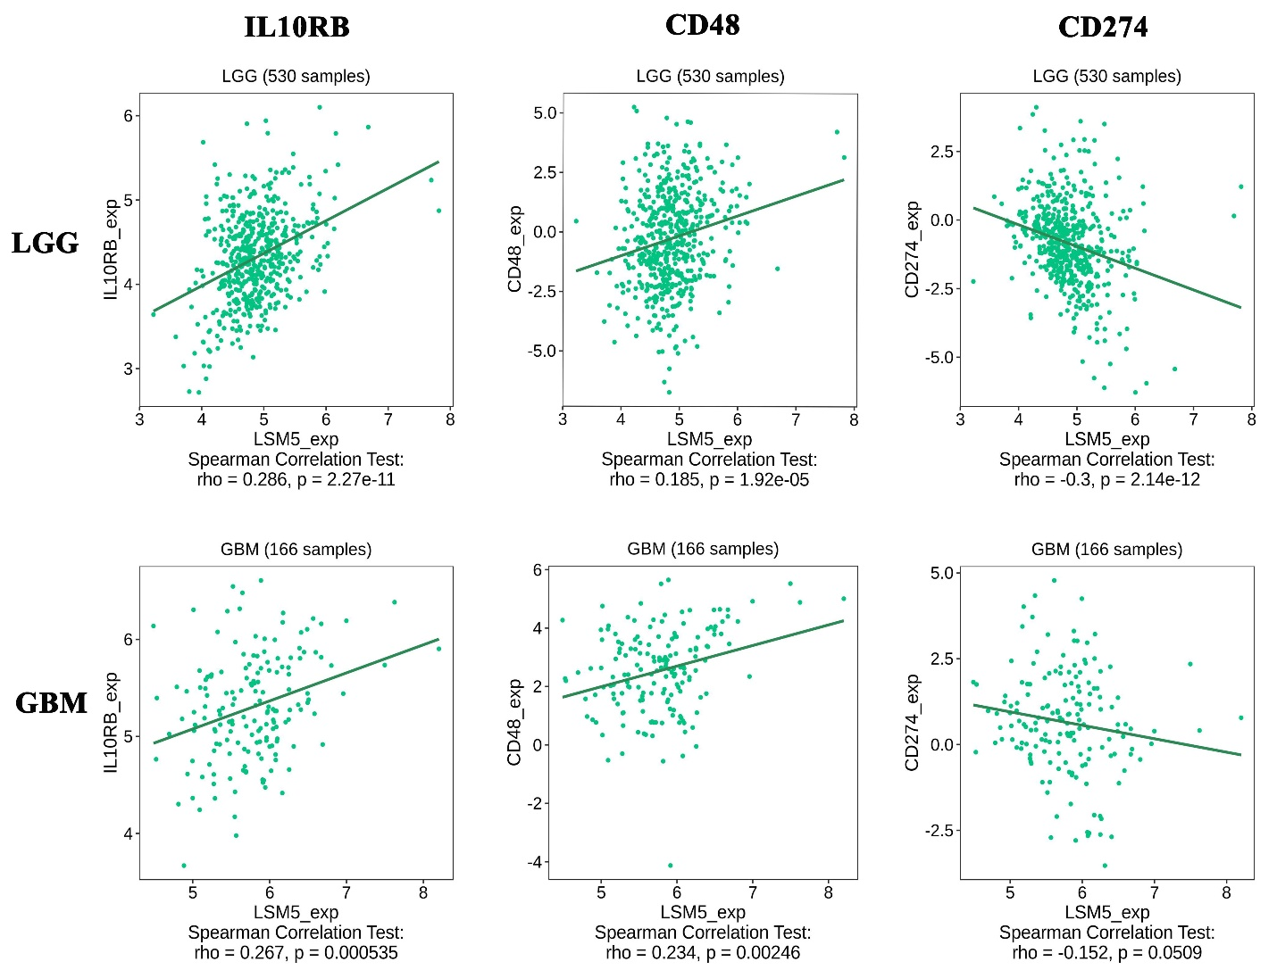

Supplementary Figure S3: Scatter plots showing the association between LSM5 mRNA expression and the infiltration levels of different immunomodulators in the glioma microenvironment.

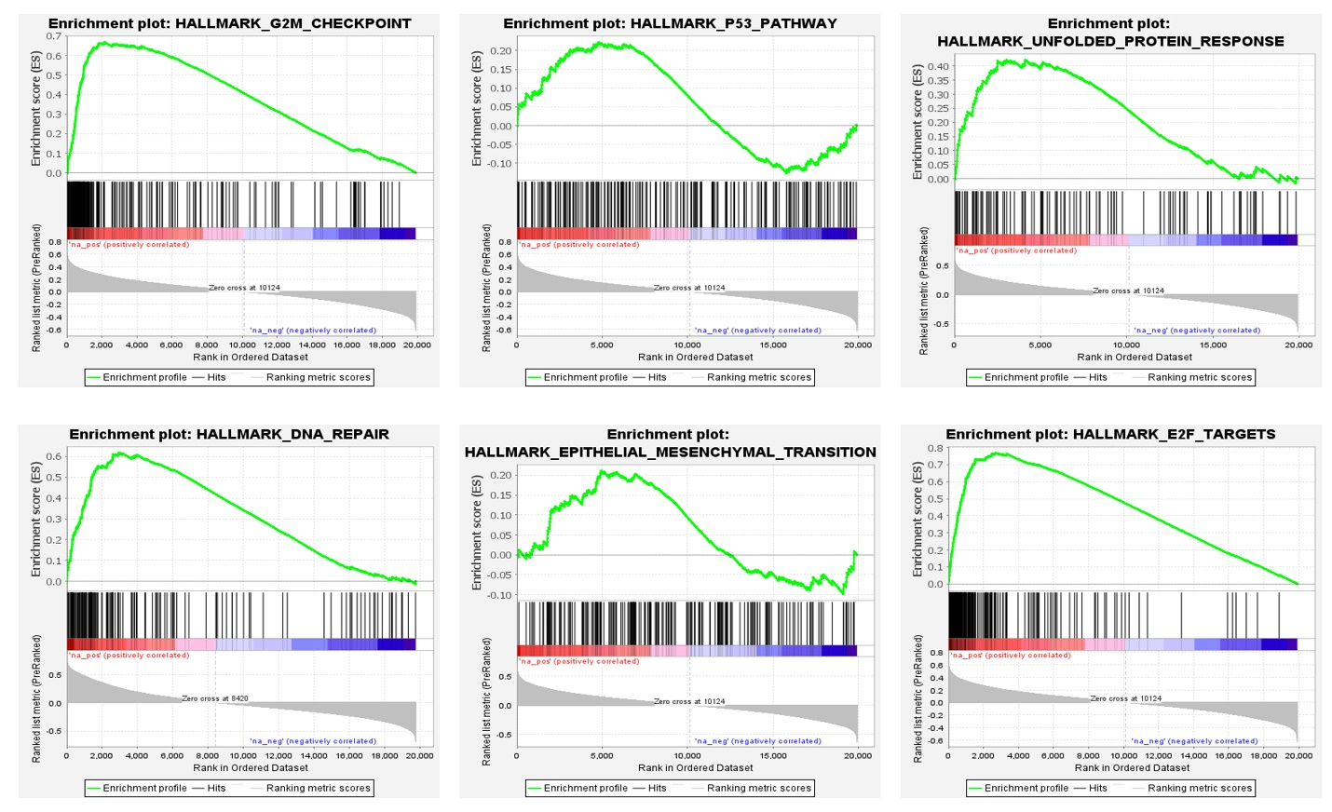

Supplementary Figure S4: The enrichment plots of gene set enrichment analysis on the neighbor genes of LSM5 in LGG and GBM tissues.

